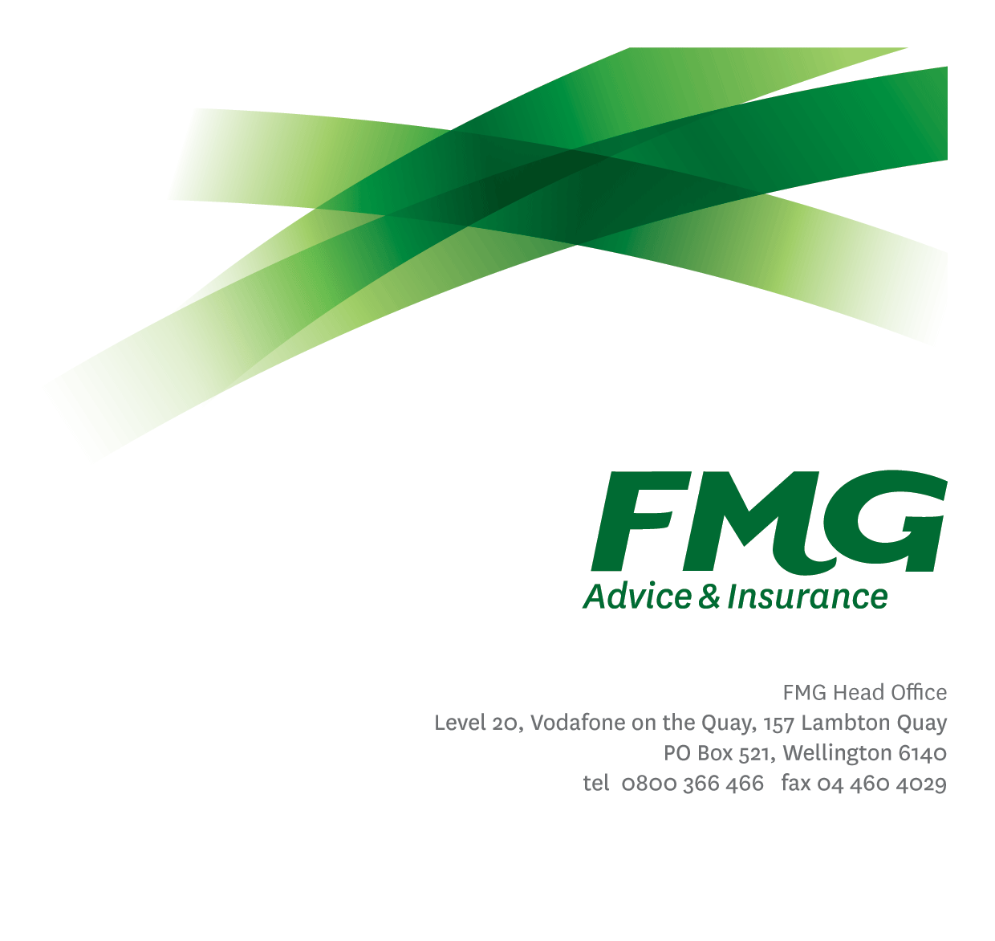
Payment Services Consultant
Position Description

Location: Palmerston North
Reporting to: Team Leader Payment Services
Business Unit: Payment Services
Direct Reports: Nil
Date Last Reviewed: May 2013

About FMG
Formed by farmers for farmers over a century ago, FMG is New Zealand’s leading rural insurer providing risk advice and insurance solutions for farmers, growers, commercial businesses, the lifestyle sector and domestic clients.
We’re proudly 100% New Zealand owned and operated and our focus is on helping our clients to achieve their goals. As a mutual organisation, we’re all about giving rural New Zealanders a better deal, and part of this involves reinvesting all profits back into the business to keep premiums low and ensure the future sustainability of the organisation.

FMG’s Values
The FMG brand represents promises about what customers can expect from us and each of us is responsible for delivering on these promises. Living our company values means we deliver the best brand experience for our customers. Our company values are:
- Do what’s right | - Make it happen
- We’re in it together | - Proud of who we are

Work Environment
We strive to provide an environment that promotes and fosters achievement. We place importance on career development and training to give our people the tools they need to succeed.
The Payment Services team is located within FMG House in Palmerston North and is tasked with effectively and efficiently collecting insurance premiums and debt for FMG, while keeping in mind that our aim is to retain FMG customers. This team is energetic in their dealings with customers and their queries and they retain their humour when most needed.

Purpose of the role
To provide effective management of all payment processes to ensure the prompt and efficient collection of insurance premium and related debt.

Key Responsibilities

Area | Responsibilities
FMG Company Values | - Promotes the “FMG Way” through displaying the values of FMG which are; do what’s right, make it happen; we’re in it together and proud of who we are.
Credit Control | - Effectively and efficiently manages the collection of insurance premiums and debt through direct payments, direct debits, agencies, with arrears letters and phone calls while contributing to the teams overall performance.
Payment Administration | - Responsible for the effective and efficient implementation of payment administration processes, including managing agency/business partner payment facilities.
Customer Service | - Ensures the delivery of superior customer service, to both internal and external contacts, by ensuring both staff and process meet customer expectations.
Credit Control Admin | - Assists in the effective functioning of the credit control process through the accurate, timely and efficient completion of the allocated credit administration duties.
Account Enquiries | - Ensures that account enquiries are investigated and corrective action is taken in a timely matter to resolve the issue and advise the customer of what the outcome is.
Risk and Quality | - Ensures overall compliance with legislation regulations and FMG policies through the use of established systems.
Reporting | - Provides accurate and timely reports to Team Leader Payment Services of issues relating to arrears, policy, process or the network.
Continuous process improvement | - Identifies opportunities for process improvement and investigates the feasibility of such improvements in consultation with the Team Leader Payment Services and or Head of Payment Services including providing subject matter expertise to projects as required
Payment Services Team | - Participates fully as a member of FMG through effectively and efficiently performing other duties as may be required from time to time. By providing proactive support and assistance and back up for other team members, while also communicating and sharing knowledge with others.
Health and Safety | - Complies with safety and wellbeing policy and procedures, including accident and incident reporting and hazard management requirements  - Works in a safe manner at all times and does not undertake activities without appropriate training

COMPETENCIES
*see competency framework for behaviours expected at each level | Expected Level
Customer Driven (Internal & External)  A commitment to understanding the needs and best interests of both internal and external customers, in order to provide them with outstanding customer service and help them to make informed decisions. | Competent*
Accountability  Taking personal ownership of decisions, behaviour, and development, and being responsible for how these actions impact on the wider organisation and customers. | Competent*
Adaptability  Demonstrating a willingness to engage in a changing environment and being flexible and comfortable working with change. | Competent*
Motivation and Drive  The determination to achieve goals and strive for excellence. | Competent*
Relationship Building  Developing and maintaining positive, professional relationships that are built on mutual trust and respect. | Competent*
Team Work  Making a positive contribution to the FMG team and collaborating effectively with others to achieve objectives. | Competent*

KNOWLEDGE
Business Awareness | Understands the internal workings of FMG and how business works; understands FMG's position in the advice and insurance market and knows the competition.
Administrative Knowledge | Knowledge of basic administration activities and processes.

SKILLS
Written Communication Skills | Able to write clear, concise reports.
Verbal Communications Skills | Communicates clearly in order to present information to persuade and influence others.
Listening Skills | Demonstrates active listening skills through eye contact, paraphrasing, appropriate body language and checking understanding.
Risk Assessment Skills | Identifies, understands and mitigates the risks that may impact on FMG's strategy, initiatives and reputation.

Relationship
External | Internal | Committees/Groups
- Customers  - FMG Business Partners  - Interested Parties  - Solicitors  - Banks | - Customer Service Teams  - Business Support Teams  - Financial Management  - Sales Network Staff | - Project Teams as required from time to time  - Being on an FMG Committee or Working Group

Financial Authority Levels
- No authority to approve or commit expenditure

Human Resources Authority Levels
- Not applicable

Agreement
I agree to the outline of the role as contained in this document and recognise that the contents may need to be amended from time to time to reflect changing business requirements.

I as Job holder, allow my Manager to gather information from third parties where necessary for the purposes of performance management.

Payment Services Consultant’s Name:
Signature:
Date:

