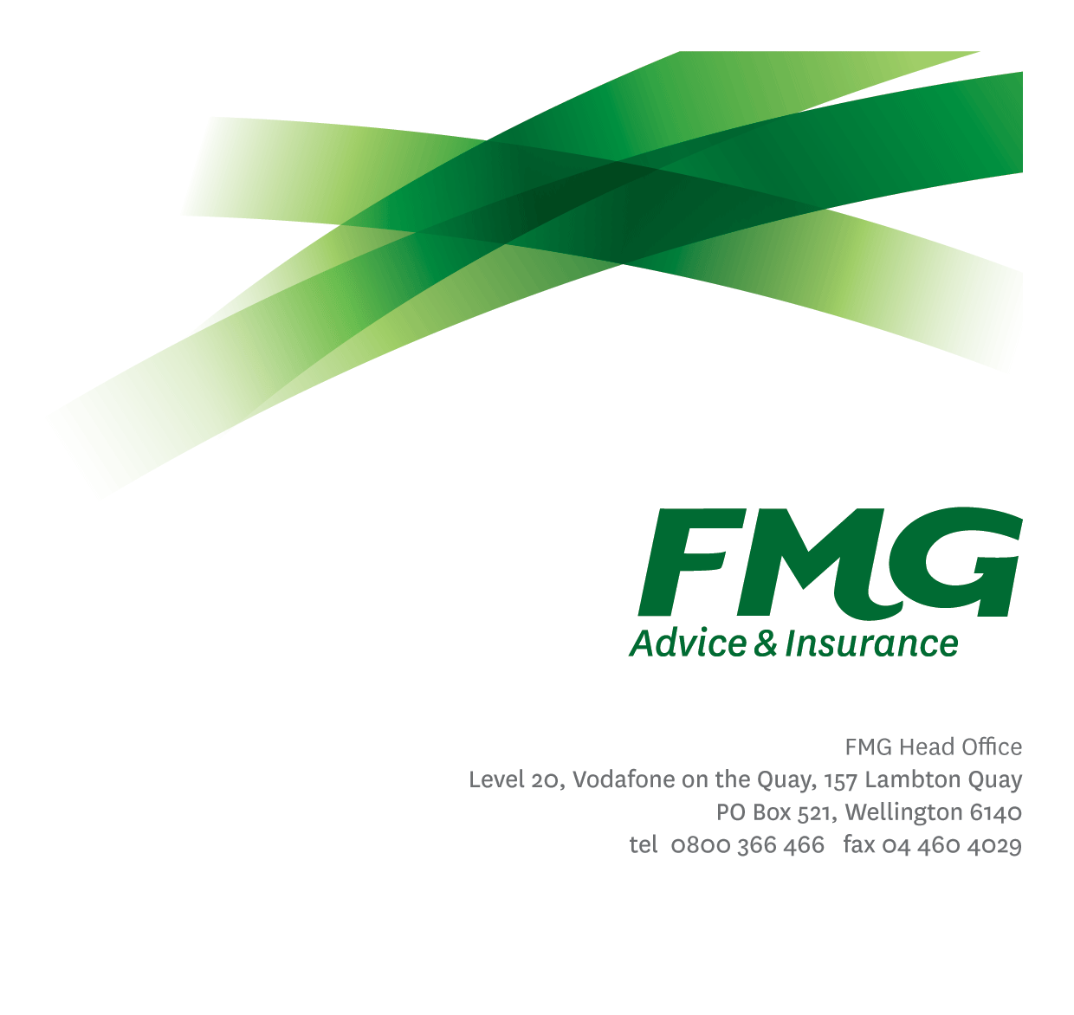
Senior Claims Adviser – Natural Hazards
Position Description

Location: Palmerston North / Christchurch
Reporting to: Manager, Natural Hazards
Business Unit: Claims
Direct Reports: 0
Date Last Reviewed: July 2024

About FMG
Formed by farmers for farmers over a century ago, FMG is New Zealand’s leading rural insurer providing risk advice and insurance solutions for farmers, growers, commercial businesses, the lifestyle sector and residential clients.
We’re proudly 100% New Zealand owned and operated and our focus is on helping our clients to achieve their goals. As a mutual organisation, we’re all about giving rural New Zealanders a better deal, and part of this involves reinvesting all profits back into the business to keep premiums low and ensure the future sustainability of the organisation.

FMG’s Values
The FMG brand represents promises about what customers can expect from us and each of us is responsible for delivering on these promises. Living our company values means we deliver the best brand experience for our customers. Our company values are:
- Do what’s right - Whāia te ara tika | - Make it happen - Whakatutukitia
- We’re in it together - Ko tātau tātau | - Proud of who we are - Whakahīhī i te whakapapa

Work Environment
We strive to provide an environment that promotes and fosters achievement. We place importance on career development and training to give our people the tools they need to succeed.
FMG’s Corporate Office is in Wellington and accommodates FMG’s Executive Leadership Team (ELT), Client Propositions & Online Services, People & Culture and Communications, Financial Management, Product & Pricing and Underwriting, Reinsurance, Business Information and Analysis, Legal and Compliance.
FMG’s largest regional office is in Palmerston North accommodating our National Sales & Advice Centre, Information Technology, Claims, Operations and Payments functions. In addition to the offices in Wellington, Palmerston North and Christchurch FMG has offices in 30 regional locations throughout New Zealand.

Purpose of the role
A Senior Claims Adviser – Natural Hazard’s role is to provide excellent customer service to FMG customers through the effective and efficient management of a portfolio of ‘Natural Hazard’ claims, applying the EQC Act and Natural Hazards Insurance (NHI) Act and the FMG policies appropriately and ensuring the client receives the highest level of customer experience.

Key Responsibilities
Area |  | Responsibilities
 | Customer Focus |  | - Takes responsibility and is accountable for delivering superior customer service with a Can-Do Attitude.  - Manages customer expectations, satisfies their needs and delivers on promises through an empowered & confident decision-making approach.
 | Claims Management |  | - Effective and efficient management of a claim’s portfolio, applying the EQC Act, NHI Act and FMG’s Policy Wording fairly and appropriately.
Team Support & Coaching |  | - Provide technical expertise for other Natural Hazard & Claims team members.  - Coach/mentor/set an example for Claims Team members.
Problem Solving |  | - Uses initiative to gather, analyse and evaluate options and develop innovative working solutions.  - Uses a common sense approach to make sound, well-informed decisions which are mutually agreeable.
Relationship Management |  | - Establishes and maintains professional relationships with internal and external stakeholders.
Risk Management |  | - Understands, supports and contributes to FMG’s Risk Management strategy.
Compliance |  | - Ensures compliance with legislation, regulations, contractual agreements and FMG policies through the use of established systems.
Claims Team & Individual Performance |  | - Actively participates and contributes to the development and maintenance of a performance culture, achieving team goals; including the Claims Strategic Plan and Objectives while identifying personal training and development needs.
Risk & Quality |  | - Ensures overall compliance with legislation regulations and FMG policies through the use of established systems.
Wellbeing & Safety |  | - Complies with Wellbeing & Safety policy and procedures, including accident and incident reporting and hazard management requirements.  - Works in a safe manner at all times and does not undertake activities without appropriate training.
COMPETENCIES
*see competency framework for behaviours expected at each level |  |  |  | Expected Level
Customer Driven (Internal & External)  A commitment to understanding the needs and best interests of both internal and external customers, in order to provide them with outstanding customer service and help them to make informed decisions. |  |  |  | Advanced*
Accountability  Taking personal ownership of decisions, behaviour, and development, and being responsible for how these actions impact on the wider organisation and customers. |  |  |  | Intermediate*
Adaptability  Demonstrating a willingness to engage in a changing environment and being flexible and comfortable working with change. |  |  |  | Intermediate*
Motivation and Drive  The determination to achieve goals and strive for excellence. |  |  |  | Intermediate*
Relationship Building  Developing and maintaining positive, professional relationships that are built on mutual trust and respect. |  |  |  | Intermediate*
Team Work  Making a positive contribution to the FMG team and collaborating effectively with others to achieve objectives. |  |  |  | Competent*
Critical Analysis  The capability to identify key issues, trends, or important facts from information and to question and probe. |  |  |  | Competent*

KNOWLEDGE
Legal Knowledge | Has legal knowledge e.g. indemnity, liability, the Privacy Act etc.
Product Knowledge | Is knowledgeable about both the EQC Act, NHI Act and FMG's insurance policies and packages, the differences between them, and the appropriateness of each in different situations.
Risk/Insurance Knowledge | Understands risk and how to apply both the EQC Act, NHI Act and FMG's policies to situations; is knowledgeable about compliance requirements; understands the insurance process and how claims are managed; knows industry partners and competitors.
Specialist Knowledge | Understand the claims process to get claims settled.  Understand Natural Hazards Commission (NHC) Toka Tū Ake’s policies, Processes and Procedures.

SKILLS
 | Written Communication Skills | Able to write clear, concise and persuasive proposals and reports.
 | Verbal Communications Skills | Communicates clearly in order to present information to persuade and influence others.
 | Listening Skills | Demonstrates active listening skills through eye contact, paraphrasing, appropriate body language and checking understanding.
 | Financial Skills | Able to calculate excesses, premiums, and interpret budgets and forecasts.
 | Risk Assessment Skills | Identifies, understands and mitigates the risks that may impact on FMG's strategy, initiatives and reputation.

Relationships
External | Internal | Committees/Groups
- NHC SME’s  - NHC Toka Tū Ake  - External Assessors  - Repairers  - Suppliers  - Brokers  - Clients  - Other insurance providers | - Claims Team  - Underwriting  - Sales, Advice & Service Team  - Risk Quality Team  - People & Culture | - As required

Financial Authority Levels
- No authority to commit or approve expenditure.

People & Culture Authority Levels
- Not applicable.

Agreement
I agree to the outline of the role as contained in this document and recognise that the contents may need to be amended from time to time to reflect changing business requirements.

I as Job holder, allow my Manager to gather information from third parties where necessary for the purposes of performance management.

Name: _______________________

Signature: ____________________

Date: ________________________

