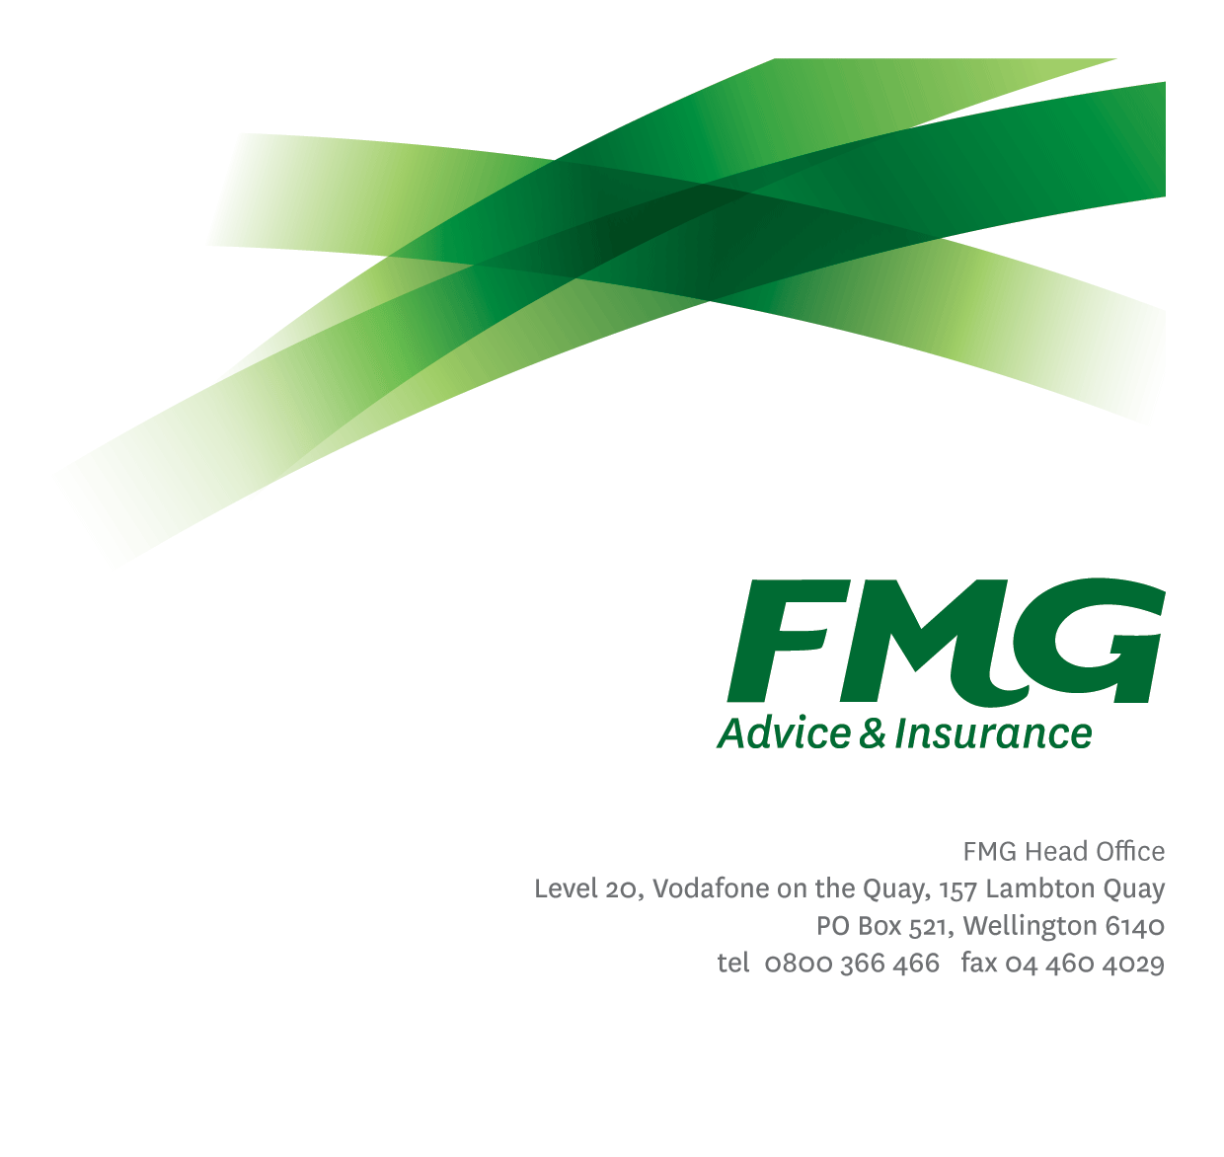
Claims Consultant
Position Description

Location: Palmerston North
Reporting to: Claims Team Leader
Business Unit: Advice & Insurance
Direct Reports: Nil
Date Last Reviewed: August 2018

About FMG
Formed by farmers for farmers over a century ago, FMG is New Zealand’s leading rural insurer providing risk advice and insurance solutions for farmers, growers, commercial businesses, the lifestyle sector and domestic clients.
We’re proudly 100% New Zealand owned and operated and our focus is on helping our clients to achieve their goals. As a mutual organisation, we’re all about giving rural New Zealanders a better deal, and part of this involves reinvesting all profits back into the business to keep premiums low and ensure the future sustainability of the organisation.

FMG’s Values
The FMG brand represents promises about what customers can expect from us and each of us is responsible for delivering on these promises. Living our company values means we deliver the best brand experience for our customers. Our company values are:
- Do what’s right | - Make it happen
- We’re in it together | - Proud of who we are

Work Environment
We strive to provide an environment that promotes and fosters achievement. We place importance on career development and training to give our people the tools they need to succeed.
Our Claims team is based in Palmerston North and is tasked with continually delivering on FMG’s claims ‘promise’. Our team vision is to focus on delivering the Claims experience to our customers that is better than the best'. To meet this goal the team focuses on providing a world class claims service to our customers on a day to day basis which enables claims to be settled in a timely and accurate manner while maintaining a strong customer focus and mitigating risks to FMG’s ongoing profitability.
The Claims team has a fun, open work environment where we support our colleagues in enjoying what we do while providing FMG customers with the highest level of service and claims / insurance expertise.

Purpose of the role
A Claims Consultants role is to provide excellent customer service to FMG customers through the effective and efficient management of a claims portfolio while to the greatest extent possible administering the reinstatement of our customers’ financial position to the same level prior to the loss occurring.

Key Responsibilities

Area | Responsibilities
FMG Values | - To promote the “FMG Way” through displaying the values of FMG which are do what’s right, make it happen, we’re in it together and proud of who we are
Customer Focus | - Takes responsibility and is accountable for delivering superior customer service with a Can Do Attitude, achieving “win win” outcomes.  - Manages customer expectations, satisfies their needs and delivers on promises through an empowered & confident decision making approach.
Claims Management | - Effective and efficient management of a claims portfolio while to the greatest extent possible administering the reinstatement of our customers’ financial position to the same level prior to the loss occurring.
Problem Solving | - Uses initiative to gather, analyse and evaluate options and develop innovative working solutions.  - Uses a common sense approach to make sound, well-informed decisions which are mutually agreeable.
Relationship Management | - Establishes and maintains professional relationships with internal and external stakeholders
Risk Management | - Understands, supports and contributes to FMG’s Risk Management strategy
Compliance | - Ensures compliance with legislation, regulations and FMG policies through the use of established systems
Claims Service Team and Individual Performance | - Actively participates and contributes to the development and maintenance of a performance culture, achieving team goals; including the Claims Strategic Plan and Objectives while identifying personal training and development needs.
Risk and Quality | - Ensures overall compliance with legislation regulations and FMG policies through the use of established systems.
Health and Safety | - Complies with safety and wellbeing policy and procedures, including accident and incident reporting and hazard management requirements  - Works in a safe manner at all times and does not undertake activities without appropriate training

COMPETENCIES
*see competency framework for behaviours expected at each level | Expected Level
Customer Driven (Internal & External)  A commitment to understanding the needs and best interests of both internal and external customers, in order to provide them with outstanding customer service and help them to make informed decisions. | Intermediate*
Accountability  Taking personal ownership of decisions, behaviour, and development, and being responsible for how these actions impact on the wider organisation and customers. | Intermediate*
Adaptability  Demonstrating a willingness to engage in a changing environment and being flexible and comfortable working with change. | Intermediate*
Motivation and Drive  The determination to achieve goals and strive for excellence. | Intermediate*
Relationship Building  Developing and maintaining positive, professional relationships that are built on mutual trust and respect. | Intermediate
Team Work  Making a positive contribution to the FMG team and collaborating effectively with others to achieve objectives. | Competent*
Critical Analysis  The capability to identify key issues, trends, or important facts from information and to question and probe. | Competent*

KNOWLEDGE
Qualifications | Relevant Tertiary Qualification desirable
Business Awareness | Understands the internal workings of FMG and how business works; understands FMG's position in the advice and insurance market and knows the competition.
Product Knowledge | Is knowledgeable about FMG's insurance policies and packages, the differences between them, and the appropriateness of each in different situations.
Systems Knowledge | Knowledge of the following systems is required:  Genisys, Atrack, FMG Claims Calculator
Risk/Insurance Knowledge | Understands risk and how to apply FMG's policies to situations; is knowledgeable about compliance requirements; understands the insurance process and how claims are managed; knows industry partners and competitors.
Specialist Knowledge | Understand the claims process to get claims settled.

SKILLS
Written Communication Skills | Able to write clear, concise and persuasive proposals and reports.
Verbal Communications Skills | Communicates clearly in order to present information to persuade and influence others.
Listening Skills | Demonstrates active listening skills through eye contact, paraphrasing, appropriate body language and checking understanding.
Financial Skills | Able to calculate premiums, and interpret budgets and forecasts.
Risk Assessment Skills | Identifies, understands and mitigates the risks that may impact on FMG's strategy, initiatives and reputation.

Relationship
External | Internal | Committees/Groups
- External assessors  - Repairers  - Suppliers  - Brokers  - Other insurance providers | - Service Centre  - Internal Assessors  - Rural Managers  - Other FMG Staff | - As required

Financial Authority Levels
- No authority to commit or approve expenditure

Human Resources Authority Levels
- Not applicable

Agreement
I agree to the outline of the role as contained in this document and recognise that the contents may need to be amended from time to time to reflect changing business requirements.

I as Job holder, allow my Manager to gather information from third parties where necessary for the purposes of performance management.

Name:

Signature:

Date:

