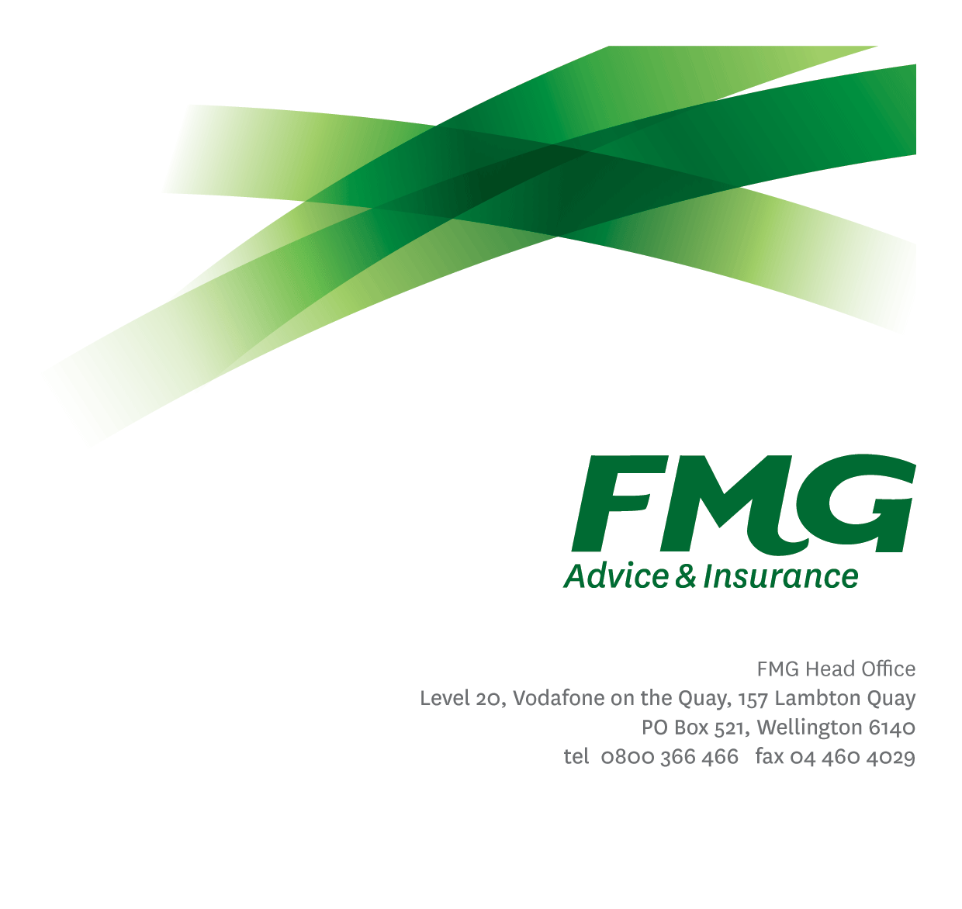
Senior Project Manager
Position Description

Location: Palmerston North, Wellington, Christchurch
Reporting to: Manager Project Management Office
Business Unit: Strategy and Enablement
Direct Reports: Nil
Date Last Reviewed: Feb 2026

About FMG
Formed by farmers for farmers over a century ago, FMG is New Zealand’s leading rural insurer providing risk advice and insurance solutions for farmers, growers, commercial businesses, the lifestyle sector and domestic clients.
We’re proudly 100% New Zealand owned and operated, and our focus is on helping our clients to achieve their goals. As a mutual organisation, we’re all about giving rural New Zealanders a better deal, and part of this involves reinvesting all profits back into the business to keep premiums low and ensure the future sustainability of the organisation.

FMG’s Values
The FMG brand represents promises about what customers can expect from us and each of us is responsible for delivering on these promises. Living our Mutual’s values means we deliver the best brand experience for our customers. Our Mutual values are:
- Do what’s right | - Make it happen
- We’re in it together | - Proud of who we are

Work Environment
We strive to provide an environment that promotes and fosters achievement. We place importance on career development and training to give our people the tools they need to succeed.
The Strategy and Enablement team culture is based on open and honest communication, where authority and accountability are clear. Both challenges and opportunities are shared to bring about delivering the best solution FMG, whilst improving FMG’s core capabilities.
Based in Palmerston North, Wellington or Christchurch, you will work with the wider Strategy and Enablement team, along with any key stakeholders from FMG offices around the country. You will be mainly focused on delivery of projects prioritized to support FMG Strategic goals.

Purpose of the role
To manage on behalf of FMG, intended projects and/or associated activities to successful completion in accordance with agreed standards and behaviours while taking a leading role in helping grow the internal capability of the Project Management team. This role will also assist the Head of Project Management Office in the definition and promotion of professional project management practices across FMG.
Key Responsibilities

Area | Responsibilities
Project Management | - Manages the delivery of full life cycle projects across both FMG Business and technology projects as identified by the Enterprise Portfolio Management Office.  - Projects are delivered to specification, within budgets and agreed timeframes  - Client signoff obtained  - Projects are managed in accordance with published management standards  - Ability to pick projects up at any stage of delivery  - Completes projects in a safe manner, with a high level of commitment to Wellbeing and Safety
Leadership | - Communicate and share information with the team on a regular basis both formally and informally.  - Promotes and champions the approved methods and standards applied to current and future projects and communication channels.
Project Evaluation / Procurement | - Administers and maintains a standard process which allows the investigation & evaluation of technical options for projects  - Evaluation criteria and report prepared  - Where required manage the Procurement process  - Provide quality assurance to other FMG projects along with recommendations as required.  - Managing multiple vendors as part of the delivery team.
Project Requirements and Documentation | - Manage in accordance with the documented SDLC, the development of required deliverables.  - Technical Specification production does not require excessive translation between business and developer
Relationship Management | - Liaises with business units and Information Services and assists with the establishment of processes and procedures for the administration of any new or enhanced systems  - Documented Service Level Agreement negotiated with, and signed by customer and appropriate Information Services management or their representative.  - Liaises with Senior Stakeholders.
Information Technology Advice and Consultancy | - Assists or initiates investigation of alternative solutions and make recommendations.
Vendor Management | - Manages relevant external supplier relationships.  - Vendor and FMG responsibilities clearly defined and ensures Vendor understands FMG’s requirements.
Service Support | - Demonstrates a customer centered approach by ensuring work is completed on time and to a high standard. Given the nature of services provided by Strategy and Enablement, this may require working outside of normal business hours or working additional hours particularly in respect to regular out-of-hours maintenance activity, operator activity and project work.
Other Duties | - Completes other tasks as requested in agreed time frames and provision of appropriate progress reports to the satisfaction of the Head of Project Management Office.
Wellbeing and Safety | - Complies with safety and wellbeing policy and procedures, including accident and incident reporting and hazard management requirements  - Works in a safe manner at all times and does not undertake activities without appropriate training
FMG Values | - To promote the “FMG Way” through displaying the values of FMG which are do what’s right, make it happen, we’re in it together and proud of who we are

COMPETENCIES
*see competency framework for behaviours expected at each level | Expected Level
Customer Driven (Internal & External)  A commitment to understanding the needs and best interests of both internal and external customers, in order to provide them with outstanding customer service and help them to make informed decisions. | Advanced*
Accountability  Taking personal ownership of decisions, behaviour, and development, and being responsible for how these actions impact on the wider organisation and customers. | Advanced*
Adaptability  Demonstrating a willingness to engage in a changing environment and being flexible and comfortable working with change. | Advanced*
Motivation and Drive  The determination to achieve goals and strive for excellence. | Advanced*
Relationship Building  Developing and maintaining positive, professional relationships that are built on mutual trust and respect. | Advanced*
Team Work  Making a positive contribution to the FMG team and collaborating effectively with others to achieve objectives. | Advanced*
Critical Analysis  The capability to identify key issues, trends, or important facts from information and to question and probe. | Intermediate*
Change Leadership  The drive to initiate opportunities to address FMG’s organisational needs and to communicate change in a way that gains buy-in and support from others | Advanced*
Strategic Thinking  The capacity to stand apart from the day-to-day and take a long-term, big picture view of the business. | Competent*

KNOWLEDGE
Qualifications | Relevant Tertiary Qualification required
Experience | At least 5 years in a Project Manager role
Business Awareness | Understands the internal workings of FMG and how business works; understands FMG's position in the advice and insurance market and knows the competition.
Specialist Knowledge | An understanding of Project Management Methodologies and how best to apply them in a variety or project sizes and complexity.

SKILLS
Written Communication Skills | Able to write clear, concise and persuasive proposals and reports.
Listening Skills | Demonstrates active listening skills through eye contact, paraphrasing, appropriate body language and checking understanding.
Verbal Communications Skills | Effectively presents information to others, both informally and in meetings.
Financial Skills | Able to calculate and understand financial information e.g. profit & loss, forecasts.
Technology Skills | Can expertly use relevant software and technology to its full capacity.
Risk Assessment Skills | Identifies, understands and mitigates the risks that may impact on FMG's strategy, initiatives and reputation.

Relationship
External | Internal | Committees/Groups
- Suppliers  - Contractors  - Consultant Organisations  - FMG’s Business Partners | - Project Sponsors, Stakeholders, steering group members  - BIS Team  - All other FMG Employees | - Working Groups  - Steering Groups

Financial Authority Levels
- Managing identified project budget and associated expenditures (in some cases of approximately $1 million)

Human Resources Authority Levels
- May help select team members for projects in conjuction with the appropriate line manager.
- No authority to dismiss staff

Agreement
I agree to the outline of the role as contained in this document and recognise that the contents may need to be amended from time to time to reflect changing business requirements.

I as Job holder, allow my Manager to gather information from third parties where necessary for the purposes of performance management.

