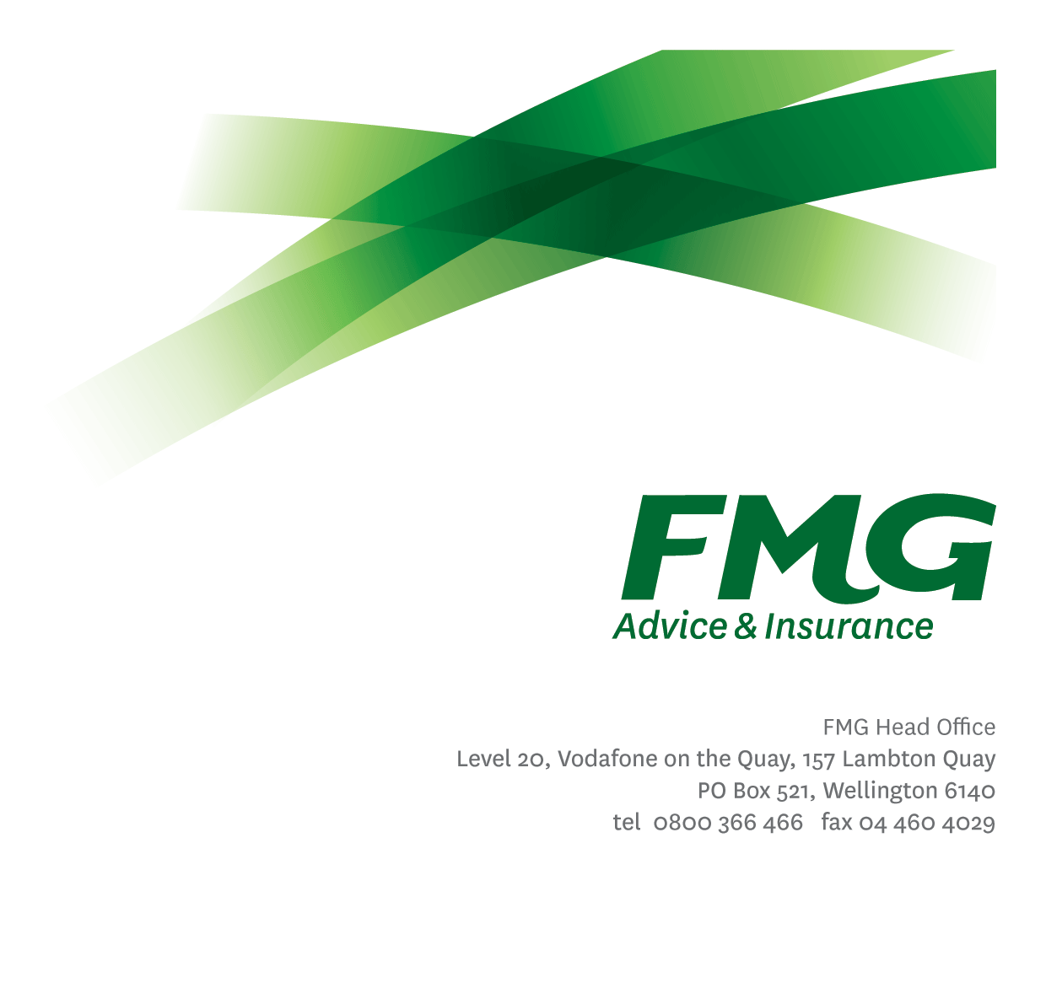Assessor, Motor & Machinery

*Position Description*

*Location:* As per Personal Terms

*Reporting to:* Manager, Motor & Machinery Assessing

*Business Unit:* Claims

*Direct Reports:* 0

*Date Last Reviewed:* July 2024

### *About FMG*

***Formed by farmers for farmers over a century ago, FMG is New Zealand’s leading rural insurer providing risk advice and insurance solutions for farmers, growers, commercial businesses, the lifestyle sector and residential clients.***

***We’re proudly 100% New Zealand owned and operated and our focus is on helping our clients to achieve their goals.  As a mutual organisation, we’re all about giving rural New Zealanders a better deal, and part of this involves reinvesting all profits back into the business to keep premiums low and ensure the future sustainability of the organisation.***

### *FMG’s Values*

The FMG brand represents promises about what customers can expect from us and each of us is responsible for delivering on these promises. Living our company values means we deliver the best brand experience for our customers. Our company values are:

|  |  |
| --- | --- |
| * Do what's right - Whāia te ara tika | * Make it happen - Whakatutukitia |
| * We're in it together - Ko tātau tātau | * Proud of who we are - Whakahīhī i te whakapapa |

### *Work Environment*

We strive to provide an environment that promotes and fosters achievement. We place importance on career development and training to give our people the tools they need to succeed.

FMG’s Head Office is located in Wellington and accommodates FMG’s Executive Leadership Team (ELT), Client Propositions & Online Services, People & Culture and Communications, Financial Management, Product & Pricing and Underwriting, Reinsurance, Business Information and Analysis, Legal and Compliance.

FMG’s largest regional office is located in Palmerston North accommodating our National Sales & Advice Centre, Information Technology, Claims, Operations and Payments functions. In addition to the offices in Wellington, Palmerston North and Christchurch FMG has offices in 30 regional locations throughout New Zealand.

### *Purpose of the role*

An Assessor, Motor & Machinery is tasked with managing all aspects of FMG’s digital motor vehicle and machinery claims to determine policy coverage, quantifying loss, assessing all damages, preparing repair specifications and managing the repair process.

This role will also be involved in the proactive initiation and management of relationships and networks related to the work carried out whilst at the same time maintaining a high level of customer service limits.

### *Key Responsibilities*

| Area | Responsibilities |
| --- | --- |
| Claims Assessment | * Ensures that vehicular or machinery damage is digitally assessed in a timely and accurate manner while maintaining a strong customer focus and minimising costs to FMG. * Proactively manage inbound and outbound communications with all FMG clients regarding their claim – as required. * Ensures FMG Claims Best Practices are followed in conjunction with the Fair Insurance Code. * Provide advice and information relevant to the client’s claims needs; along with using initiative to gather, analyse and evaluate options and develop innovative working solutions to progress the clients’ claim. * Take responsibility and is accountable for delivering superior customer service with a Can-Do Attitude, achieving “win win” outcomes and with a common-sense approach. * Proactively contacts customers / service providers to progress claims where FMG are awaiting information from them. * Manages customer expectations with effective communications and realistic timeframes, satisfies their needs and delivers on promises through an empowered & confident decision making approach. * Undertaking of tasks that support excellent customer service for the wider Claims team. |
| Claims Service Team and Individual Performance | * Actively participates and contributes to the development and maintenance of a performance culture, achieving team goals; including the Claims Strategic Plan and Objectives while identifying personal training and development needs. |
| Relationship Management | * Establishes and maintains professional relationships with internal and external stakeholders. |
| FMG Values | * Promotes the “FMG Way” through displaying the values of FMG which are: Do what’s right, Make it happen, We’re in it together, Proud of who we are. |
| Risk Management & Compliance | * Ensures compliance with legislation, regulations and FMG policies through the use of established systems. * Undertakes regular audit processes of FMG’s network of Preferred Service Provider ‘self assessment’ claims. * Understands, supports and contributes to FMG’s Risk Management strategy. |
| Wellbeing and Safety | * Complies with safety and wellbeing policy and procedures, including accident and incident reporting and hazard management requirements. * Works in a safe manner at all times and does not undertake activities without appropriate training. |

|  |  |
| --- | --- |
| **COMPETENCIES** | |
| *\*see competency framework for behaviours expected at each level* | *Expected Level* |
| **Customer Driven (Internal & External)**  A commitment to understanding the needs and best interests of both internal and external customers, in order to provide them with outstanding customer service and help them to make informed decisions. | Intermediate* |
| **Accountability**  Taking personal ownership of decisions, behaviour, and development, and being responsible for how these actions impact on the wider organisation and customers. | Intermediate* |
| **Adaptability**  Demonstrating a willingness to engage in a changing environment and being flexible and comfortable working with change. | Intermediate* |
| **Motivation and Drive**  The determination to achieve goals and strive for excellence. | Intermediate* |
| **Relationship Building**  Developing and maintaining positive, professional relationships that are built on mutual trust and respect. | Intermediate* |
| **Team Work**  Making a positive contribution to the FMG team and collaborating effectively with others to achieve objectives. | Intermediate* |
| **Critical Analysis**  The capability to identify key issues, trends, or important facts from information and to question and probe. | Intermediate* |

|  |  |
| --- | --- |
| **KNOWLEDGE** | |
| **Business Awareness** | Understands the internal workings of FMG and how business works; understands FMG's position in the advice and insurance market and knows the competition. |
| **Product Knowledge** | Is knowledgeable about FMG's insurance policies and packages, the differences between them, and the appropriateness of each in different situations. |
| **Systems Knowledge** | Knowledge of the following systems is required:  ClaimsCenter, CRM, Genesys Cloud, Onbase. |
| **Rural Knowledge** | Understands the rural community and keep up to date with the economic, political, and environmental issues affecting our customers. |
| **Risk/Insurance Knowledge** | Understands risk and how to apply FMG's policies to situations.  Is knowledgeable about compliance requirements.  Understands the insurance process and how claims are managed.  Knows industry partners and competitors.  Has legal knowledge e.g. indemnity, liability, the Privacy Act etc. |
| **Specialist Knowledge** | Mechanical/engineering/machinery/heavy and light motor vehicle knowledge.  Understand the Claims process to get claims settled. |

|  |  |
| --- | --- |
| **SKILLS** | |
| **Written Communication Skills** | Able to write clear and concise letters, reports and emails. |
| **Verbal Communications Skills** | Communicates clearly in order to present information to persuade and influence others. |
| **Listening Skills** | Demonstrates active listening skills through eye contact, paraphrasing, appropriate body language and checking understanding. |
| **Technology Skills** | Can expertly use relevant software and technology to its full capacity e.g. MS Word, Excel and PowerPoint. |
| **Risk Assessment Skills** | Identifies, understands and mitigates the risks that may impact on FMG's strategy, initiatives and reputation. |
| **Financial Skills** | Able to calculate excesses. |

### *Relationship*

|  |  |  |
| --- | --- | --- |
| External | Internal | Committees/Groups |
| * FMG Clients * Other Insurance Providers * Repairer Network * Suppliers * External Assessors | * Wider Assessing Team Wider Claims Team | * As delegated |

### *Financial Authority Levels*

* No authority to commit or approve expenditure

### *People & Culture Authority Levels*

* Not applicable

### *Agreement*

I agree to the outline of the role as contained in this document and recognise that the contents may need to be amended from time to time to reflect changing business requirements.

I as Job holder, allow my Manager to gather information from third parties where necessary for the purposes of performance management.

Name: __________________________

Signature: _______________________

Date: ___________________________