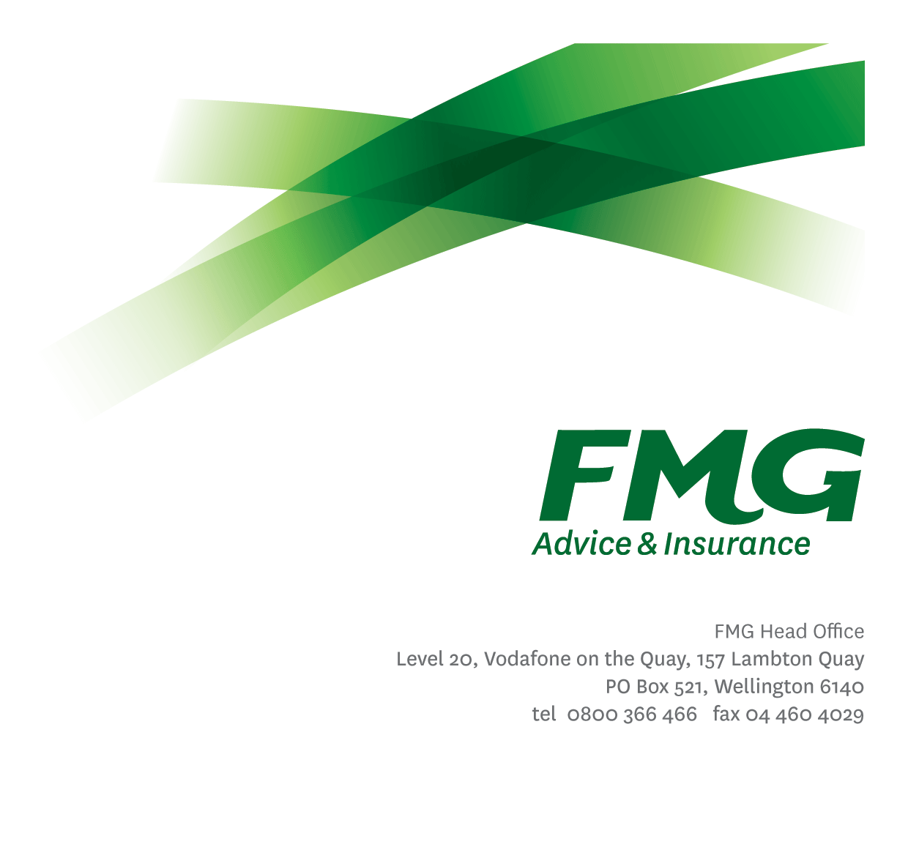Senior Change Manager – Strategic Projects

*Position Description*

*Location:* Palmerston North or Wellington

*Reporting to:* Head of Change Management

*Business Unit:* People and culture

*Direct Reports:* Nil

*Date Last Reviewed:* June 2025



### *About FMG*

***Formed by farmers for farmers over a century ago, FMG is New Zealand’s leading rural insurer providing risk advice and insurance solutions for farmers, growers, commercial businesses, the lifestyle sector and domestic clients.***

***We’re proudly 100% New Zealand owned and operated, and our focus is on helping our clients to achieve their goals.  As a mutual organisation, we’re all about giving rural New Zealanders a better deal, and part of this involves reinvesting all profits back into the business to keep premiums low and ensure the future sustainability of the organisation.***



### *FMG’s Values*

The FMG brand represents promises about what customers can expect from us and each of us is responsible for delivering these promises. Living our company values means we deliver the best brand experience for our customers. Our company values are:

|  |  |
| --- | --- |
| * Do what’s right | * Make it happen |
| * We’re in it together | * Proud of who we are |



### *Work Environment*

We strive to provide an environment that promotes and fosters achievement. We place importance on career development and training to give our people the tools they need to succeed.

FMG’s Head Office is in Wellington and accommodates FMG’s Executive Leadership Team (ELT), Client Propositions & Online Services, People & Culture, Marketing, Communications, Financial Management, Product & Pricing and Underwriting, Reinsurance, Business Information and Analysis, Legal and Compliance.

FMG’s largest regional office is in Palmerston North accommodating our National Sales & Advice Centre, People and Culture, Information Technology, Claims, Operations and Payments functions. In addition to the offices in Wellington, Palmerston North and Christchurch FMG has offices in 30 regional locations throughout New Zealand

The Senior Change Manager - Strategic Projects contributes to the delivery of Strategic Projects which are not delivered within the Product Management framework. Based in Palmerston North or Wellington, the Senior Change Manager - Strategic Projects works alongside Change Managers and other key stakeholders from FMG offices around the country. They also share their knowledge and expertise to contribute to evolving the Change Management Framework and Approach



### *Purpose of the role*

The Senior Change Manager - Strategic Projects enables the achievement of QBP approved Strategic Project benefits using the Change Management Framework and Approach. They effectively prepare, execute, and support change in FMG to ensure that business objectives are achieved by addressing all aspects of the people side of change. The Senior Change Manager - Strategic Projects will assess the change impact, determine the appropriate change approach, and deliver change-related activities.

The Senior Change Manager - Strategic Projects will work with other Change Managers to ensure the delivery and execution of the deliverables and activities to enable the adoption and embedment of the change across FMG. They will also partner with Change Managers, Change Leaders, Project Managers, key stakeholders, project teams, delivery teams and subject matter experts to provide expertise, guidance and tools to enable and support impacted employees to embrace the change.

The Senior Change Manager - Strategic Projects will contribute to the evolution of the Change Management Framework and Approach to ensure its ongoing usefulness, relevance and application across the Mutual and the collective view of change governance and reporting



### *Key Responsibilities*

| Area | Responsibilities |
| --- | --- |
| Change Management Technical Expertise | * Work collaboratively with Change Managers, managers and leaders, taking a “whole of organisation” approach to the delivery of the people side of change for the Mutual. * Be an advocate for Change Management and promote the value it provides throughout FMG, within their project(s) context. * Provide specialist technical advice and recommendations in Change Management. * Educate others on the Change Management, Leadership and Capability services available and on how to accurately assess change management needs, within their project(s) context. * Contribute and guide to the evolution of the Change Management Framework and Approach to ensure its ongoing usefulness, relevance and application across the Mutual * Contribute to the delivery of governance and reporting to support the creation of a collective view of change, from their project context |
| Impact Analysis | * Understand the proposed ‘future state’ for FMG arising from assigned project(s) and define the changes required from the current state. * Understand and articulate the change and impact on all FMG employees and clients, resulting from the change |
| Change Management Planning | * Apply the Change Management Framework to determine change management approach and identify activities to be undertaken to support assigned project(s). * Identify, execute and coordinate change management activities to achieve benefits and support impacted employees. * Provide expertise and guidance around knowledge and ability building activities for assigned project(s). |
| Communication and Stakeholder Engagement | * Coordinate and assist with the development and maintenance of change management communications plans and schedules for assigned project(s) * Assist with the preparation and delivery/distribution of any communication materials for project(s) as required. |
| Change training | * Partner with Learning and Development and relevant stakeholders to develop training plans and materials to ensure adoption and proficiency of the change |
| Transition Planning | * Coordinate with relevant managers and leaders to develop the plan for transition of project(s) into run-state to ensure benefits are achieved. |
| Relationship Management | * Maintain effective working relationships across FMG, including Change Managers, and relevant third parties * Establish effective working relationships with all the key stakeholders of project(s) including the Sponsor, Owner and employees within all business units of FMG. |
| Personal Development | * Proactively acquire and develop skills, knowledge, techniques, and experience relating to building change capability and embedding change. |
| FMG Values | * Promote the “FMG Way” - display the values of FMG which are do what’s right, make it happen, we’re in it together and proud of who we are. |
| Wellbeing & Safety | * Comply with safety and wellbeing policy and procedures, including accident and incident reporting and hazard management requirements * Work in a safe manner always and does not undertake activities without appropriate training |

|  |  |
| --- | --- |
| **COMPETENCIES** | |
| *\*see competency framework for behaviours expected at each level* | *Expected Level* |
| **Customer Driven (Internal & External)**  A commitment to understanding the needs and best interests of both internal and external customers, in order to provide them with outstanding customer service and help them to make informed decisions. | Advanced* |
| **Accountability**  Taking personal ownership of decisions, behaviour, and development, and being responsible for how these actions impact on the wider organisation and customers. | Intermediate* |
| **Adaptability**  Demonstrating a willingness to engage in a changing environment and being flexible and comfortable working with change. | Advanced* |
| **Motivation and Drive**  The determination to achieve goals and strive for excellence. | Intermediate* |
| **Relationship Building**  Developing and maintaining positive, professional relationships that are built on mutual trust and respect. | Advanced* |
| **Team Work**  Making a positive contribution to the FMG team and collaborating effectively with others to achieve objectives. | Advanced* |
| **Change Leadership**  The drive to initiate opportunities to address FMG’s organisational needs and to communicate change in a way that gains buy-in and support from others. | Advanced* |
| **Critical Analysis**  The capability to identify impacts, key issues, trends, or important facts from information provided and to question and probe. | Advanced* |

|  |  |
| --- | --- |
| **KNOWLEDGE** | |
| **Qualification Required** | Relevant Tertiary Qualification desirable. Prosci certification essential. |
| **Business Awareness** | Understands the internal workings of FMG and how business works; understands FMG's position in the advice and insurance market and knows the competition. |
| **Product Knowledge** | Is knowledgeable about FMG’s insurance products and the differences between them and the appropriateness of each in different situations. |
| **Specialist Knowledge** | Proven experience working successfully with Change Management methodologies (such as Prosci) and delivering change in complex initiatives.  Knowledge and understanding of the project lifecycle i.e., requirements, design, build, test, and transition. |

|  |  |
| --- | --- |
| **SKILLS** | |
| **Written Communication Skills** | Able to write clear, concise and persuasive proposals and reports. |
| **Verbal Communication Skills** | Communicates clearly to present information to persuade and influence others. |
| **Listening Skills** | Demonstrates active listening skills through eye contact, paraphrasing, appropriate body language and checking understanding. |
| **Technology Skills** | Can expertly use relevant software and technology to its full capacity e.g. MS Word, Excel and PowerPoint. |
| **Risk Assessment Skills** | Identifies, understands, and can put in place plans to mitigate risks and manage issues. |
| **Leadership skills** | Experience at leading and managing others to deliver change. |

### *Relationships*

|  |  |  |
| --- | --- | --- |
| **External** | Internal | Committees/Groups |
| * External service providers | * BIS * P&C * Subject Matter Experts * All FMG employees * Leadership Teams * EPMO and PMO * Change Managers * Learning and Development team * Communications team | * Change Management Team * Project Teams and Working Groups * Project Steering Groups and Committees * Change Leader Groups * Change Champion Groups |



### *Financial Authority Levels*

* No authority to commit or approve expenditure

### *Human Resources Authority Levels*

* Not applicable



### *Agreement*

I agree to the outline of the role as contained in this document and recognise that the contents may need to be amended from time to time to reflect changing business requirements.

I as Job holder, allow my Manager to gather information from third parties where necessary for the purposes of performance management.

|  |  |
| --- | --- |
| Senior Change Manager – Strategic Projects’ Name: |  |
| Signature: |  |
| Date: |  |

|  |  |
| --- | --- |
| Manager Project Management Office’s Name: |  |
| Signature: |  |
| Date: |  |