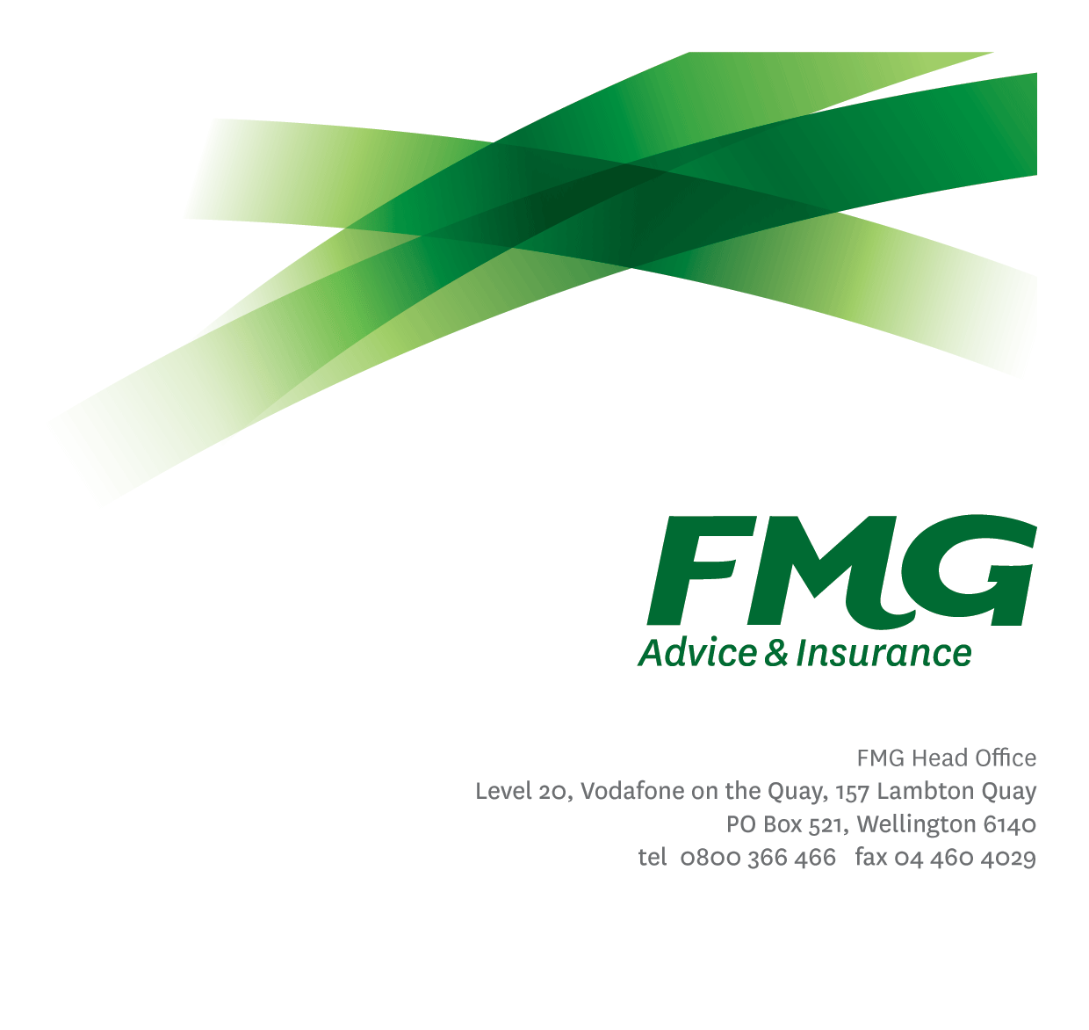Loss Adjuster
Position Description

Location: As per Personal Terms
Reporting to: Manager, Loss Adjusting
Business Unit: Claims
Direct Reports: Nil
Date Last Reviewed: July 2024

About FMG
Formed by farmers for farmers over a century ago, FMG is New Zealand’s leading rural insurer providing risk advice and insurance solutions for farmers, growers, commercial businesses, the lifestyle sector, and domestic clients.
We’re proudly 100% New Zealand owned and operated, and our focus is on helping our clients to achieve their goals. As a mutual organisation, we’re all about giving rural New Zealanders a better deal, and part of this involves reinvesting all profits back into the business to keep premiums low and ensure the future sustainability of the organisation.

FMG’s Values
The FMG brand represents promises about what clients can expect from us and each of us is responsible for delivering on these promises. Living our company values means we deliver the best brand experience for our clients. Our company values are:
- Do what's right - Whāia te ara tika | - Make it happen - Whakatutukitia
- We're in it together - Ko tātau tātau | - Proud of who we are - Whakahīhī i te whakapapa

Work Environment
We strive to provide an environment that promotes and fosters achievement. We place importance on career development and training to give our people the tools they need to succeed.
FMG’s Head Office is located in Wellington and accommodates FMG’s Executive Leadership Team (ELT), Client Propositions & Online Services, People & Culture and Communications, Financial Management, Product & Pricing and Underwriting, Reinsurance, Business Information and Analysis, Legal and Compliance.
FMG’s largest regional office is located in Palmerston North accommodating our National Sales & Advice Centre, Information Technology, Claims, Operations and Payments functions. In addition to the offices in Wellington, Palmerston North and Christchurch FMG has offices in 30 regional locations throughout New Zealand.

Purpose of the role
To manage all aspects of FMG’s property damage and vehicular claims to determine policy coverage, quantifying loss, assessing, and adjusting all damages, preparing repair specifications/scope of works, and managing the repair process (Some types of machinery assessed may be of a specialised nature). This role will involve the proactive initiation and management of relationships and networks related to the work carried out whilst at the same time maintaining a high level of customer service limits.

Key Responsibilities

Area | Responsibilities
FMG Values | - Promotes the “FMG Way” through displaying the values of FMG which are: Do what’s right, Make it happen, We’re in it together, Proud of who we are.
Claims Assessment | - Ensures that damage, whether property or vehicular is assessed in a timely and accurate manner while maintaining a strong client focus and minimising costs to FMG.
Risk Management | - Provides support in the Claims process through the effective and efficient management of the assessment and reporting property and vehicular damage claims, within delegated limits.  - Implements strategies and initiatives that will enhance FMG’s ability to provide comprehensive risk management services to clients in conjunction with the Claims colleagues and Sales Advice and Service Team.
Administration | - Completes and coordinates necessary administrative duties in a timely manner through efficient and effective self-management
Relationship Management | - Establishes and maintains professional relationships with third party organisations to provide FMG with business gains.
Internal Customer Service | - Ensures the provision of excellent client service through providing assistance to FMG employees when required.
External Relationship and Network Management | - Proactively builds monitors and manages a wide-ranging network of relationships in order to contribute and improve the image and outcome of FMG within the marketplace to our clients.
Expense Management | - Manages expenditure prudently through effective purchasing.
Compliance | - Ensures overall compliance with legislation regulations and FMG policies through the use of established systems
Team Participation | - Contributes to the Claims team through active participation.
Health & Safety | - Complies with safety and wellbeing policy and procedures, including accident and incident reporting and hazard management requirements.  - Works in a safe manner at all times and does not undertake activities without appropriate training

COMPETENCIES
*see competency framework for behaviours expected at each level | Expected Level
Customer Driven (Internal & External)  A commitment to understanding the needs and best interests of both internal and external customers, in order to provide them with outstanding client service and help them to make informed decisions. | Intermediate*
Accountability  Taking personal ownership of decisions, behaviour, and development, and being responsible for how these actions impact on the wider organisation and clients. | Intermediate*
Adaptability  Demonstrating a willingness to engage in a changing environment and being flexible and comfortable working with change. | Intermediate*
Motivation and Drive  The determination to achieve goals and strive for excellence. | Intermediate*
Relationship Building  Developing and maintaining positive, professional relationships that are built on mutual trust and respect. | Intermediate*
Team Work  Making a positive contribution to the FMG team and collaborating effectively with others to achieve objectives. | Intermediate*
Critical Analysis  The capability to identify key issues, trends, or important facts from information and to question and probe. | Intermediate*

KNOWLEDGE
Qualifications | Relevant Tertiary Qualification required
Business Awareness | Understands the internal workings of FMG and how business works; understands FMG's position in the advice and insurance market and knows the competition.
Rural Knowledge | Understands the rural community and keep up to date with the economic, political, and environmental issues affecting our clients.
Risk/Insurance Knowledge | Understands risk and how to apply FMG's policies to situations; is knowledgeable about compliance requirements; understands the insurance process and how claims are managed; knows industry partners and competitors.
Specialist Knowledge | Appropriate Building Industry experience and knowledge.

SKILLS
Written Communication Skills | Able to write clear, concise reports.
Verbal Communications Skills | Effectively presents information to others, both informally and in meetings.
Listening Skills | Demonstrates active listening skills through eye contact, paraphrasing, appropriate body language and checking understanding.
Risk Assessment Skills | Can put in place plans to mitigate risks and manage issues.
Driving Skills | Full driver’s license required.

Relationship
External | Internal | Committees/Groups
- FMG Clients  - Contractors  - Repairer Network  - Suppliers  - External Assessors | - Senior Loss Adjuster  - Executive team  - All FMG employees  - All Claims Staff | - As delegated

Financial Authority Levels
- No authority to approve or commit expenditure

Human Resources Authority Levels
- Not applicable

Agreement
I agree to the outline of the role as contained in this document and recognise that the contents may need to be amended from time to time to reflect changing business requirements.

I as Job holder, allow my Manager to gather information from third parties where necessary for the purposes of performance management.

Name: _______________________________

Signature: ____________________________

Date: ________________________________

