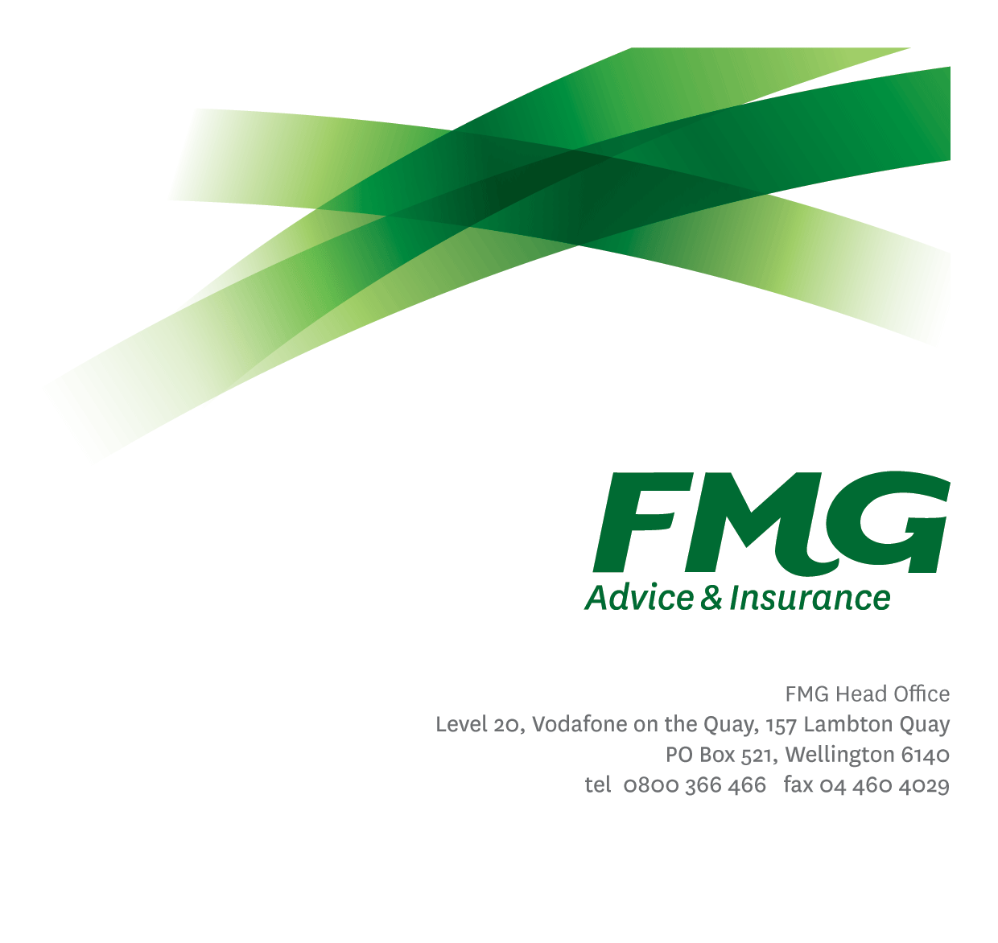
Procurement Specialist
Position Description

Location: Wellington or Palmerston North
Reporting to: Head of Property & Procurement
Business Unit: Finance & Risk Services
Direct Reports: Nil
Date Last Reviewed: March 2023

About FMG
Formed by farmers for farmers over a century ago, FMG is New Zealand’s leading rural insurer providing risk advice and insurance solutions for farmers, growers, commercial businesses, the lifestyle sector and domestic clients.
We’re proudly 100% New Zealand owned and operated and our focus is on helping our clients to achieve their goals. As a mutual organisation, we’re all about giving rural New Zealanders a better deal, and part of this involves reinvesting all profits back into the business to keep premiums low and ensure the future sustainability of the organisation.

FMG’s Values
The FMG brand represents promises about what customers can expect from us and each of us is responsible for delivering on these promises. Living our company values means we deliver the best brand experience for our customers. Our company values are:
- Do what’s right | - Make it happen
- We’re in it together | - Proud of who we are

Work Environment
We strive to provide an environment that promotes and fosters achievement. We place importance on career development and training to give our people the tools they need to succeed.

The Legal & Risk Management team is intrinsically connected to FMG’s core purpose of providing a better deal for rural New Zealand. The Procurement Team is responsible for delivering value for money, supporting innovation and most importantly enabling the business, through the provision of procurement expertise, to adopt solutions which achieve saving, synergies and efficiencies for the benefit of the wider organisation and our clients.

Purpose of the role
This role is responsible for effectively and efficiently supporting the planning and delivery of FMG’s procurement processes with an overall aim to achieve cost saving and to ensure a seamless customer experience to the wider organization.

Key Responsibilities
Area | Responsibilities
Stakeholder Management | - Supports the Head of Property & Procurement in relevant stakeholder engagement and translate stakeholder requirements into workable solutions which meet their and FMG’s client needs.  - Act as the key point of contact for assigned categories with relevant stakeholders.  - Engage as required and work with stakeholders on business plans including strategy, market engagement and SRM activities.  - Collaborate with relevant cross-functional teams and provide procurement and supply chain knowledge to aid the decision making process.
Supplier Relationship Management | - Act as a focal point for the relevant business unit for the relationship management and communication of assigned suppliers included where appropriate an escalation point for issues which may arise.  - In support of the Head of Property & Procurement develop and execute Supplier Relationship Management (SRM) strategies that deliver the required performance and drive continuous improvement through the life of the Agreements.  - For top tier suppliers use best practice tools i.e. balanced scorecards throughout the life of the contract to manage the relationship.  - Administer Key Performance Indicators as agreed.
Market Knowledge and Experience | - Using best practice processes, tools and resources gain an in depth and leading industry understanding of assigned categories across the value drivers including commercial, sustainability, operational excellent and innovation.  - Execute an agreed plan of regular strategy reviews either linked to new requirements, contract renewals or market activity/supplier developments.
Market Engagement and Sourcing | - Supports the Head of Property & Procurement in developing sourcing strategies for assigned categories that deliver value from the market.  - Engage with the market and utilise best practice procurement life cycle processes to achieve the outcomes required by the wider business.  - Train, mentor, and provide guidance to employees about the procurement life cycle.
Fleet Management | - Effectively and efficiently manage FMG’s vehicle fleet.  - Build and develop a collaborative relationship with FMG’s preferred lease provider and drive value to the business.
Compliance | - Collaborates with the Legal Counsel to ensure appropriate legal compliance is adhered to, contractual obligations are met and business outcomes achieved.  - Monitor and review policy compliance and take necessary steps to prevent non-compliance.  - Ensure overall compliance with legislation regulations and FMG policies through the use of established systems.  - Maintain a centralised contract database and physical file.
Risk Management | - Assist the Head of Property & Procurement to identify and manage risk or perceived potential risks and take necessary action to protect FMG interests.
Wellbeing & Safety | - Demonstrate a commitment to workplace safety and wellbeing practices.  - Promote and support initiatives that contribute to a healthy and safe working environment for employees, visitors and contractors.  - Ensure compliance with safety and wellbeing policy and procedures, including accident and incident reporting and investigation, hazard management, induction, training and supervision, employee participation and supplier management.
Team Membership | - Participate fully as a member of FMG through the effective and efficient performing of other duties as may be required from time to time.
Project Work | - Complete projects and other work as assigned by the Head of Property & Procurement
FMG Values | - Promote the “FMG Way” through displaying the values of FMG which are do what’s right, make it happen, we’re in it together and proud of who we are

COMPETENCIES
*see competency framework for behaviours expected at each level | Expected Level
Customer Driven (Internal & External)  A commitment to understanding the needs and best interests of both internal and external customers, in order to provide them with outstanding customer service and help them to make informed decisions. | Intermediate*
Accountability  Taking personal ownership of decisions, behaviour, and development, and being responsible for how these actions impact on the wider organisation and customers. | Intermediate*
Adaptability  Demonstrating a willingness to engage in a changing environment and being flexible and comfortable working with change. | Intermediate*
Motivation and Drive  The determination to achieve goals and strive for excellence. | Intermediate*
Relationship Building  Developing and maintaining positive, professional relationships that are built on mutual trust and respect. | Intermediate*
Team Work  Making a positive contribution to the FMG team and collaborating effectively with others to achieve objectives. | Intermediate*

KNOWLEDGE
Qualifications | Relevant Tertiary Qualification required.
Experience | At least 3-5 years’ experience working in procurement or related function within a large organisation.
Business Awareness | Understands the internal workings of FMG and how business works; understands FMG's position in the advice and insurance market and knows the competition.
Legal Knowledge | Has legal knowledge e.g. indemnity, liability, dispute resolution etc.
Risk/Insurance Knowledge | Understands risk and how to apply FMG's policies to situations; is knowledgeable about compliance requirements; understands the insurance process and how claims are managed; knows industry partners and competitors.
Specialist Knowledge | Knowledge of the procurement lifecycle, Supplier Relationship Management (SRM) best practices and high level negotiations.

SKILLS
Written Communication Skills | Able to write clear, concise and persuasive proposals and reports.
Verbal Communications Skills | Communicates clearly in order to present information to persuade and influence others.
Listening Skills | Demonstrates active listening skills through eye contact, paraphrasing, appropriate body language and checking understanding.
Financial Skills | Able to calculate and understand financial information e.g. profit & loss, forecasts.
Technology Skills | Can expertly use relevant software and technology to its full capacity e.g. MS Word, Excel and PowerPoint.
Risk Assessment Skills | Identifies, understands and mitigates the risks that may impact on FMG's strategy, initiatives and reputation.
Procurement Skills | Demonstrates a results orientated approach with a track record of superior results.  Proven supplier management and procurement skills (CIPS Operational and/or Managerial level or equivalent)

Relationship
External | Internal | Committees/Groups
- Business partners  - External Contractors and Service providers | - Head of Property & Procurement  - Relevant Business Units Other FMG employees | - As required

Financial Authority Levels
- No authority to commit or approve expenditure

Human Resources Authority Levels
- Not applicable

Agreement
I agree to the outline of the role as contained in this document and recognise that the contents may need to be amended from time to time to reflect changing business requirements.

I as Job holder, allow my Manager to gather information from third parties where necessary for the purposes of performance management.

Procurement Specialist Name:
Signature:
Date:

