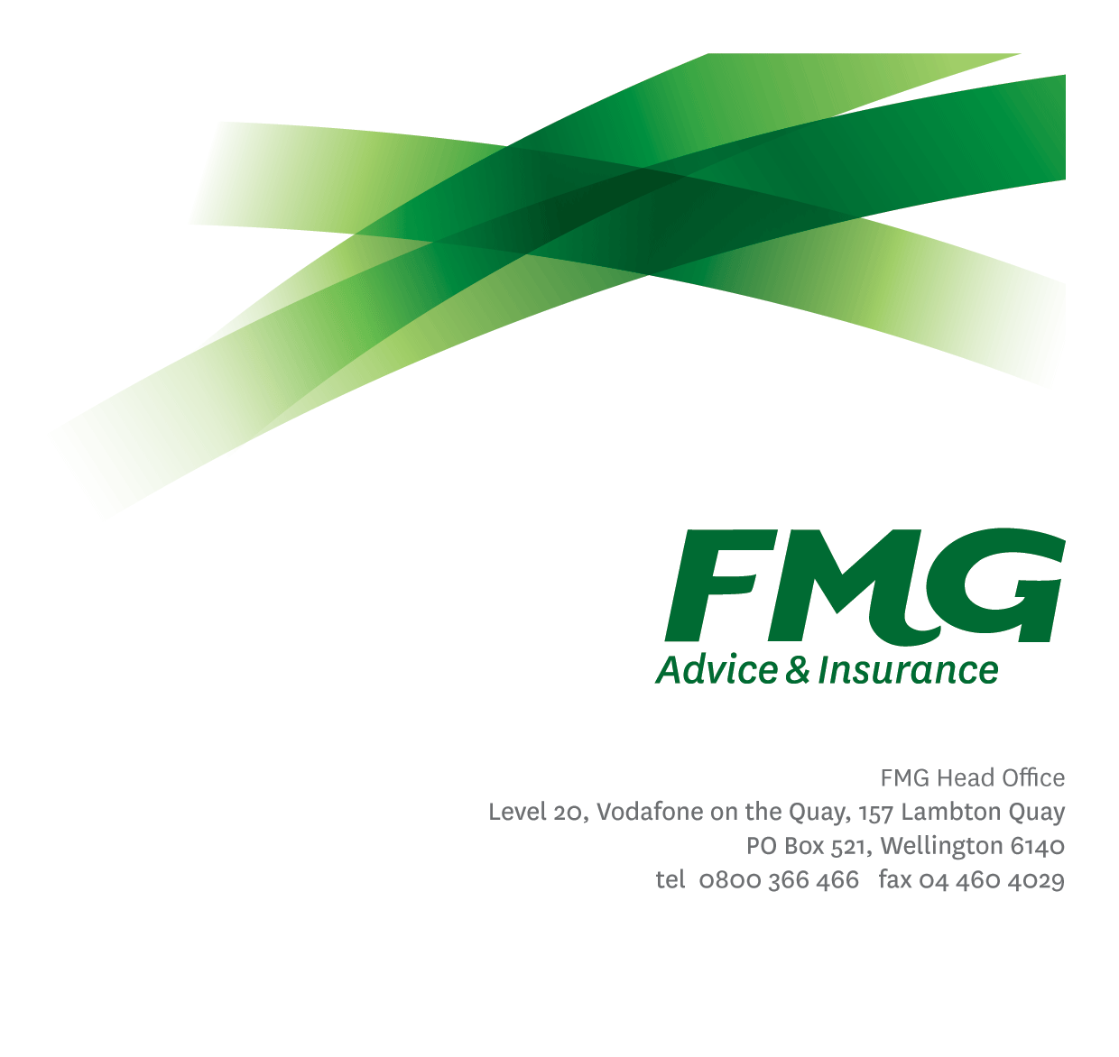
Product Architect
Position Description

Location: Palmerston North or Wellington or Christchurch
Reporting to: Head of Architecture
Business Unit: Digital and Data
Direct Reports: None
Date Last Reviewed: February 2026

About FMG
Formed by farmers for farmers over a century ago, FMG is New Zealand’s leading rural insurer providing risk advice and insurance solutions for farmers, growers, commercial businesses, the lifestyle sector and residential clients.

FMG is proudly 100% New Zealand owned and operated, and our focus is on helping our clients to achieve their goals. As a mutual organisation, FMG is all about giving rural New Zealanders a better deal, and part of this involves reinvesting all profits back into the business to keep premiums low and ensure the future sustainability of the Mutual

FMG’s Values
FMG’s brand represents promises about what clients can expect from the Mutual and each FMG employee across our One Team is responsible for delivering on these promises. Living FMG’s Values means we all deliver the best brand experience for our clients. FMG’s Values are:
- Do what's right - Whāia te ara tika | - Make it happen - Whakatutukitia
- We're in it together - Ko tātau tātau | - Proud of who we are - Whakahīhī i te whakapapa

Work Environment
FMG strives to provide an environment that promotes and fosters achievement, placing importance on career development and training to provide our people with the tools they need to succeed.
FMG’s Head Office is located in Wellington and accommodates FMG’s Executive Leadership Team (ELT), Sales, Advice and Service, Claims, Marketing and Propositions, People and Culture, Finance and Investments, Insurance Solutions, Digital and Data, Risk and Compliance and Strategy and Enablement teams.
FMG’s largest regional office is in located in Palmerston North accommodating FMG’s National Sales and Advice Centre, People and Culture, Digital and Data, Claims, Operations and Payments functions. In addition to offices in Wellington, Palmerston North and Christchurch, FMG has regional offices in 30 locations throughout provincial New Zealand Aotearoa.

Purpose of the role
The Product Architect provides architectural leadership to ensure FMG's digital, data and AI products align with enterprise strategies, client needs and enterprise architecture blueprint. This role guides product strategy, architecture decisions, and supports the creation of product roadmap while ensuring compliance with architecture guiderails.

Key Responsibilities

Area | Responsibilities
Product Architecture | - Define and maintain Product Reference Architecture for the product, aligned to the Enterprise Architecture Blueprint.  - Contribute to the development, maintenance and continuous improvement of the enterprise architecture blueprint.  - Translate business requirements into solution architecture that are aligned with enterprise architecture blueprint and product strategy.  - Conduct architecture security assessments across FMG’s digital ecosystem, ensuring compliance, risk mitigation, and alignment with enterprise security frameworks and threat modelling practices.  - Design solutions that enable accurate, accessible, and governed data, information and analytics lifecycles.  - Identify opportunities to integrate emerging technologies when shaping solution options; consider AI/automation opportunities as a primary design principle.  - Coach and mentor delivery team members on architecture thinking.
Strategic Delivery Leadership | - Ensure solution options are aligned to the ambitions of the Digital Strategy and Data, Information and Analytics strategy.  - Define and assess solution options during discovery to evaluate feasibility, align with business capabilities, and ensure delivery readiness.
Industry/Practice Awareness | - Stay informed on industry trends and architectural practices to ensure product design remains modern, scalable, and competitive.  - Ensure compliance with regulatory requirements and industry standards.
Relationship Management | - Build effective working relationships with all stakeholders:  - Collaborate with Product Managers, Pillar Leads and Mutual Leaders on product strategy and roadmaps and coordinate cross-product dependencies.  - Build and maintain strong working relationships with Product Owners and Delivery Managers to support solution options and delivery ensuring architectural guidance are embedded into product roadmaps/backlogs.  - Collaborate with Strategy and Innovation team to continuously scan, evaluate, and recommend adoption pathways for emerging technologies and translate learnings into updates to the Enterprise Architecture Blueprint.
Other duties | - Undertake tasks as directed by the Head of Architecture from time to time
Health & Safety | - Comply with safety and wellbeing policy and procedures, including accident and incident reporting and hazard management requirements.  - Works in a safe manner at all times and does not undertake activities without appropriate training

COMPETENCIES
*See competency framework for behaviours expected at each level | Expected Level
Client Driven (Internal & External)  A commitment to understanding the needs and best interests of both internal and external clients, to provide them with exceptional client service and help them to make informed decisions. | Advanced*
Accountability  Taking personal ownership of decisions, behaviour, and development, and being responsible for how these actions impact on the wider organisation and clients. | Intermediate*
Adaptability  Demonstrating a willingness to engage in a changing environment and being flexible and comfortable working with change. | Advanced*
Motivation and Drive  The determination to achieve goals and strive for excellence. | Intermediate*
Relationship Building  Developing and maintaining positive, professional relationships that are built on mutual trust and respect. | Advanced*
Collaboration and Teamwork  Making a positive contribution to the FMG team and collaborating effectively with others to achieve objectives. | Advanced*
Critical Analysis  The capability to identify key issues, trends, or important facts from information and to question and probe. | Advanced*
Problem Solving  The ability to understand information from a variety of sources and think quickly on one’s feet. The ability to effectively combine verbal and numeric data into a coherent whole. | Intermediate*
Influencing / Persuading  Using rational argument and reasoning to convince others. To not be afraid to take a stand and to sell a position while keeping the relationship intact. | Advanced*
Change Leadership  The drive to initiate opportunities to address FMG’s organisational needs and to communicate change in a way that gains buy-in and support from others | Intermediate*

KNOWLEDGE
Qualifications | - Relevant Tertiary Qualification required
Business Awareness | - Understands FMG's position in the insurance market and the competition.
Digital, Data and Information Knowledge | - Knowledge of SaaS-native architectures, Artificial Intelligence capabilities, and modern integration patterns across digital platforms.  - Knowledge of data and information architecture to design solutions that support governed, accurate, and accessible information lifecycle.  - Knowledge of AI concepts and their application in product design, including intelligent automation, advanced analytics, and AI agents.  - Knowledge of modeling languages (e.g., C4) and development methodologies (e.g., Agile, DevOps) to support adaptive product delivery.
Specialist Knowledge | - Knowledge and experience (6+ years) in Senior roles related to Product and/or Solution Architecture.  - Knowledge of Architecture Modelling tools.  - Understanding how an organisation delivers its services through people, process, technology and information.  - Familiarity with TOGAF, GEANZ and/or other Architecture frameworks

SKILLS
Written Communication Skills | Able to communicate ideas in a convincing manner through writing clearly and concisely.
Verbal Communications Skills | Communicates clearly to present information to persuade and influence others.
Listening Skills | Demonstrates active listening skills through eye contact, paraphrasing, appropriate body language, and checking understanding.
Leadership skills | Experience leading and delivering Product and Solution Architectures
Strategic decision-making skills | Proven experience in Strategic decision making
Risk Assessment Skills | Can put in place plans to mitigate risks and manage issues.
Inter-personal Skills | Build meaningful and reciprocal relationships at all levels of FMG and motivate others using genuine praise and friendliness.

Relationships
External | Internal | Committees/Groups
- Partners & Suppliers of Key Systems  - Research Analyst Groups | - Digital and Data Leadership Team  - Strategy and Enablement Leadership Team  - FMG Pillar Leads  - FMG Mutual Leaders  - All FMG Business and Product Owners  - Delivery Team Members | - Architecture Review and Governance (ARG) Group

Financial Authority Levels
- No authority to approve and/or commit expenditure

Human Resources Authority Levels
- Not applicable

Agreement
I agree to the outline of the role as contained in this document and recognise that the contents may need to be amended from time to time to reflect changing business requirements.

I as Job holder, allow my manager to gather information from third parties where necessary for the purposes of performance management.

Agreement will be via electronic signature as evidenced on the acceptance form.

