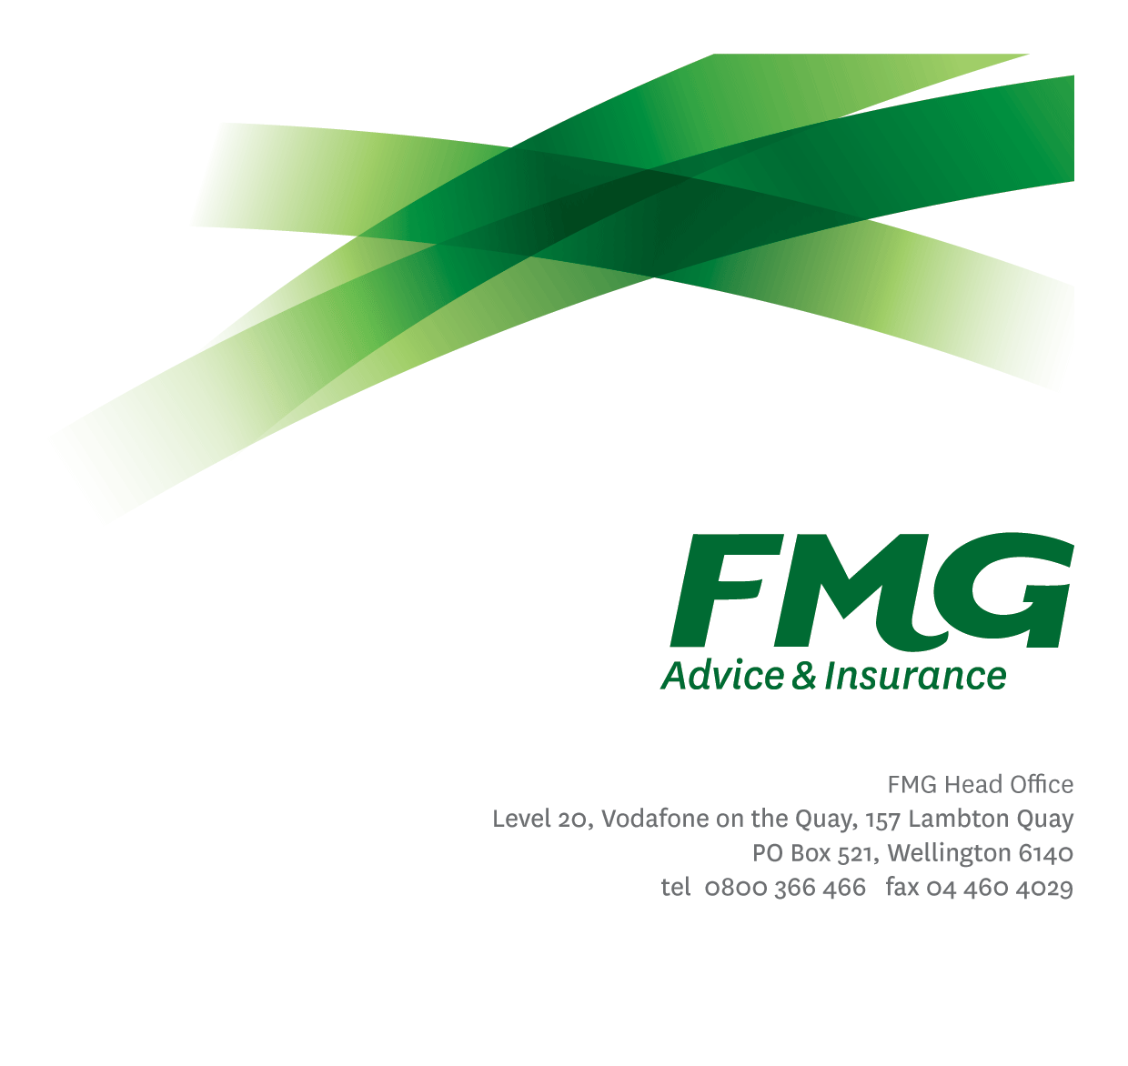
Liability Claims Specialist
Position Description

Location: As per Personal Terms
Reporting to: Manager, Liability & Resolution
Business Unit: Claims
Direct Reports: Nil
Date Last Reviewed: July 2024

About FMG
Formed by farmers for farmers over a century ago, today’s FMG is New Zealand’s leading rural insurer providing business and personal risk advice and insurance solutions for farmers, growers, commercial businesses, the lifestyle sector and domestic customers.
We’re proudly 100% New Zealand owned and operated and our focus is on helping our customers achieve their goals. Our commitment to a mutual ownership structure guarantees that members’ and customers’ interests are preserved through working in partnership and reinvesting all profits in the business.

FMG’s Values
The FMG brand represents promises about what customers can expect from us and each of us is responsible for delivering on these promises. Living our company values means we deliver the best brand experience for our customers. Our company values are:
- Do what's right - Whāia te ara tika | - Make it happen - Whakatutukitia
- We're in it together - Ko tātau tātau | - Proud of who we are - Whakahīhī i te whakapapa

Work Environment
We strive to provide an environment that promotes and fosters achievement. We place importance on career development and training to give our people the tools they need to succeed.
FMG’s Head Office is located in Wellington and accommodates FMG’s Executive Leadership Team (ELT), Client Propositions & Online Services, People & Culture and Communications, Financial Management, Product & Pricing and Underwriting, Reinsurance, Business Information and Analysis, Legal and Compliance.
FMG’s largest regional office is located in Palmerston North accommodating our National Sales & Advice Centre, Information Technology, Claims, Operations and Payments functions. In addition to the offices in Wellington, Palmerston North and Christchurch FMG has offices in 30 regional locations throughout New Zealand.

Purpose of the role
A Liability Claims Specialist’s role is to provide excellent customer service to FMG clients through the effective and efficient management of a claim’s portfolio whilst to the greatest extent possible administering the reinstatement of our customers’ financial position to the same level prior to the loss occurring.
While this role is primarily focused on Liability claims, there may also be the requirement to manage other similar/complex claims.
Other major components of the Liability Claims Specialist role are:
- Support the overall development of the Claims team in terms of liability and other claims through provision of coaching (including claims clinic) and process maps that outline the liability claims processes.
- Support the education of the overall FMG Business through written material, targeted training and presentations (some of which may be to external audiences)
- Support the Product and Underwriting teams as required in the development of wordings

Key Responsibilities

Area | Responsibilities
Claims Management | - Effective and efficient management of a claims portfolio whilst to the greatest extent possible administering the reinstatement of our customers’ financial position to the same level prior to the loss occurring.  - Support the Claims Adviser - Liability in the management of liability claims and outsourced claims (including Caitlin Marine).
Management of FMG Liability Lines of Business | - This includes Professional Indemnity, Directors and Officers, Trustees Liability, Fidelity / Crime, Internet, Technology, Employment Practices/Disputes, Associations (combined trustees/professional cover) and Legal Defence.
Problem Solving | - Uses initiative to gather, analyse and evaluate options and develop innovative working solutions.  - Uses a common sense approach to make sound, well-informed decisions which are mutually agreeable.
Risk Management | - Understands, supports and contributes to FMG’s Risk Management strategy.
Relationship Management | - Establishes and maintains professional relationships with internal stakeholders.  - Establishes and maintains professional relationships external stakeholders to provide FMG with business opportunities - in particular building networks within the insurance and legal sector
Customer Focus | - Takes responsibility and is accountable for delivering superior customer service with a Can Do Attitude, achieving ‘win win’ outcomes.  - Manages internal stakeholder, client, lawyers and third party expectations, satisfies their needs and delivers on promises through an empowered & confident decision making approach.
Claims Team | - Actively participates and contributes to the development and maintenance of the Claims Team performance culture, achieving goals; including the Claims Strategic Plan and Objectives.
Personal Proficiency | - Proactively acquires and develops skills, knowledge and techniques.  - Attends coaching sessions and personal development as agreed with management.
Compliance | - Ensures compliance with legislative and regulatory requirements and adheres to FMG policies through the implementation and monitoring of systems, processes and improvements
Wellbeing & Safety | - Ensures compliance with safety and wellbeing policy and procedures, including accident and incident reporting and investigation, hazard management, induction, training and supervision, employee participation and contractor management
FMG Values | - To promote the “FMG Way” through displaying the values of FMG which are do what’s right, make it happen, we’re in it together and proud of who we are

COMPETENCIES
*see competency framework for behaviours expected at each level | Expected Level
Customer Driven (Internal & External)  A commitment to understanding the needs and best interests of both internal and external customers, in order to provide them with outstanding customer service and help them to make informed decisions. | Advanced*
Accountability  Taking personal ownership of decisions, behaviour, and development, and being responsible for how these actions impact on the wider organisation and customers. | Intermediate*
Adaptability  Demonstrating a willingness to engage in a changing environment and being flexible and comfortable working with change. | Intermediate*
Motivation and Drive  The determination to achieve goals and strive for excellence. | Intermediate*
Relationship Building  Developing and maintaining positive, professional relationships that are built on mutual trust and respect. | Intermediate*
Team Work  Making a positive contribution to the FMG team and collaborating effectively with others to achieve objectives. | Intermediate*
Critical Analysis  The capability to identify key issues, trends, or important facts from information and to question and probe. | Intermediate*

KNOWLEDGE
Qualifications | Relevant Tertiary Qualification essential
Business Awareness | Understands the internal workings of FMG and how business works; understands FMG's position in the advice and insurance market and knows the competition.
Rural Knowledge | Understands the rural community and keep up to date with the economic, political, and environmental issues affecting our customers.
Legal Knowledge | Has legal knowledge e.g. indemnity, liability, the Privacy Act etc.  Exposure to Legal matters, or a Legal qualification. Also, the ability to understand and work alongside Legal providers effectively.
Product Knowledge | Is knowledgeable about FMG's insurance policies and packages, the differences between them, and the appropriateness of each in different situations.
Risk/Insurance Knowledge | Understands risk and how to apply FMG's policies to situations; is knowledgeable about compliance requirements; understands the insurance process and how claims are managed; knows industry partners and competitors.
Systems Knowledge | Knowledge of the following systems is required:  Genisys, Atrack, FMG Claims Calculator
Specialist Knowledge | Extensive experience in managing Liability Claims.

SKILLS
Written Communication Skills | Able to write clear, concise and persuasive proposals and reports.
Verbal Communications Skills | Communicates clearly in order to present information to persuade and influence others.
Listening Skills | Demonstrates active listening skills through eye contact, paraphrasing, appropriate body language and checking understanding.
Financial Skills | Able to calculate and understand financial information e.g. reserving requirements, fines, losses and legal cost, profit & loss, forecasts.
Risk Assessment Skills | Identifies, understands and mitigates the risks that may impact on FMG's strategy, initiatives and reputation.
Negotiation Skills | Ability to negotiate effectively across a variety of contexts; including different industries, products and services.

Relationship
External | Internal | Committees/Groups
- External Assessors  - Repairers  - Suppliers  - Brokers  - Other insurance providers | - Claims Team  - Service Centre  - Loss Adjusters  - Rural Managers  - Other FMG Staff | As directed

Financial Authority Levels
- No authority to commit or approve expenditure

Human Resources Authority Levels
- Not applicable

Agreement
I agree to the outline of the role as contained in this document and recognise that the contents may need to be amended from time to time to reflect changing business requirements.

I as Job holder, allow my Manager to gather information from third parties where necessary for the purposes of performance management.

Name: ___________________________

Signature: ________________________

Date: ____________________________

