Events & Sponsorship Specialist

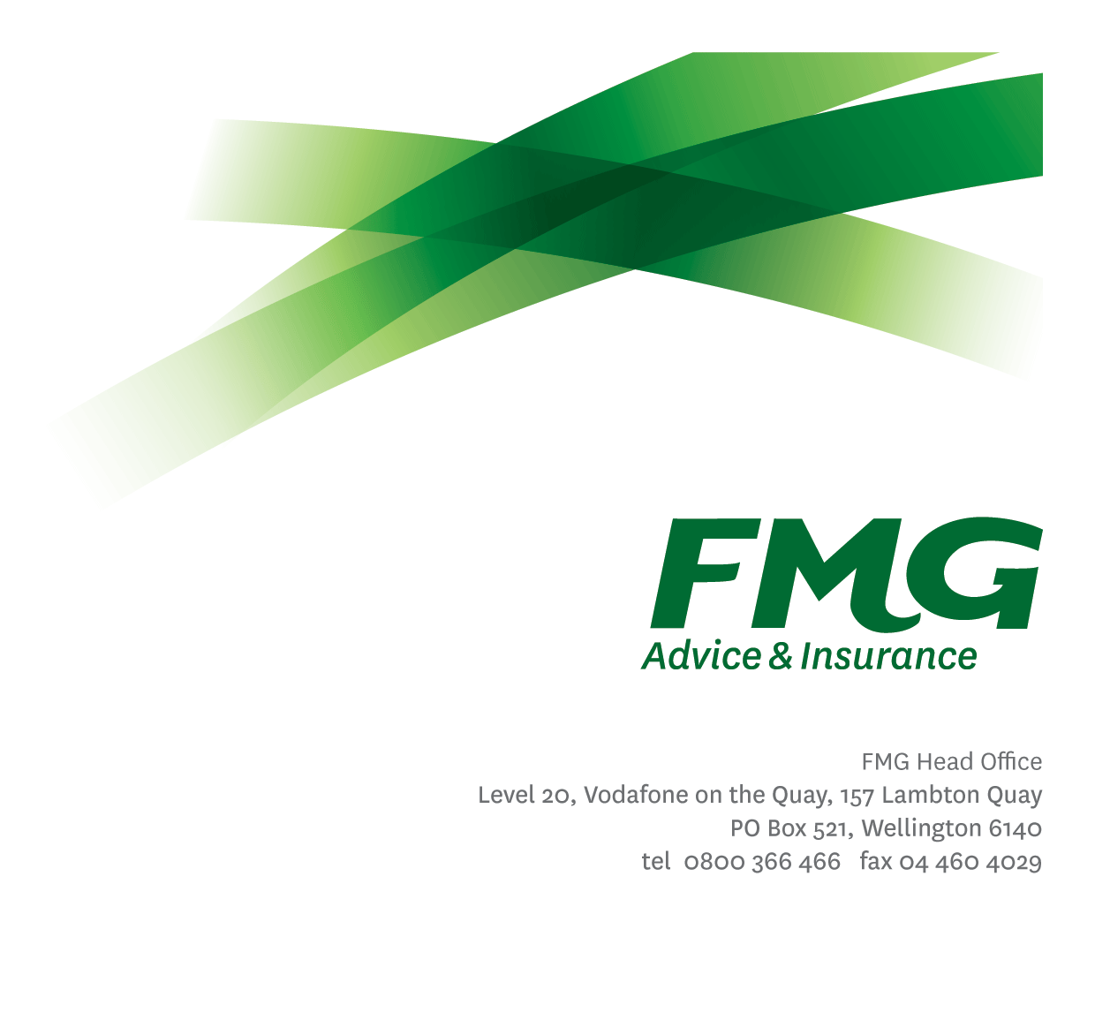

*Position Description*

*Location:* As per Personal Terms

*Reporting to:* Head of Events, Travel & Sponsorship

*Business Unit:* Marketing and Propositions

*Direct Reports:* Nil

*Date:* April 2024

### *About FMG*

***Formed by farmers for farmers over a century ago, today’s FMG is New Zealand’s leading rural insurer providing business and personal risk advice and insurance solutions for farmers, growers, commercial businesses, the lifestyle sector and domestic customers.***

***We’re proudly 100% New Zealand owned and operated, and our focus is on helping our customers achieve their goals.  Our commitment to a mutual ownership structure guarantees that members’ and customers’ interests are preserved through working in partnership and reinvesting all profits in the business.***

### *FMG’s Values*

The FMG brand represents promises about what clients can expect from us and each of us is responsible for delivering on these promises. Living our company values means we deliver the best brand experience for our customers. Our company values are:

|  |  |
| --- | --- |
| * Do what’s right - Whāia te ara tika | * Make it happen - Whakatutukitia |
| * We’re in it together - Ko tātau tātau | * Proud of who we are Whakahīhī i te whakapapa |

### *Work Environment*

We strive to provide an environment that promotes and fosters achievement. We place importance on career development and training to give our people the tools they need to succeed.

FMG’s Corporate Office is in Wellington and accommodates FMG’s Executive Leadership Team (ELT), Marketing and Propositions, People and Culture, Financial Management, Insurance Solutions, Reinsurance, Business Information and Analysis, Legal and Compliance.

FMG’s largest regional office is in Palmerston North accommodating our National Advice and Service Centre, Information Technology, Claims, Operations and Payments functions. In addition to the offices in Wellington, Palmerston North and Christchurch; FMG has offices in 30 regional locations throughout New Zealand/ Aotearoa.

### *Purpose of the role*

The Events & Sponsorship Specialist, along with the Events & Travel Team, is responsible for the leverage planning, delivery, and development of FMG’s regional and national event and sponsorship activity as well as supporting marketing activities within their designated regions and portfolio of events and sponsorships.  In addition, the role provides support to the Head of Events, Travel & Sponsorship who has overall responsibility for the event, travel and sponsorship portfolio. This role plays a key part in fostering internal and external relationships in relation to the portfolio and ensures that the form and function of an event fosters client relationships.

### *Key Responsibilities*

| Area | Responsibilities |
| --- | --- |
| Sponsorship & Event Planning | * Prepares and monitors sponsorship agreements * Confirms and coordinates sponsorship and event objectives with key stakeholders * Investigates and prepares recommendations for new portfolio development opportunities * In conjunction with the Area Managers, plans and strategises a forward looking 12-month regional event and sponsorship plan for the geographical areas allocated to their responsibility * Prepares and administers approved sponsorship and event budgets and ensures all invoices and expenses claims are coded and forwarded within agreed timeframes to FMG finance team * Analyses sponsorship and event effectiveness immediately following each event * Collaborates with Marketing and Proposition (MAP) and Sales, Advice & Service (SAS) functions for all events and sponsorships |
| Sponsorship & Event Management and Delivery | * Builds and maintains relationships with sponsorship portfolio key stakeholders * Oversees regional sponsorship and event activities in collaboration with regional sales team members * Oversees sponsorship and event activities organised with Strategic Alliance partners, with the guidance of FMG Alliance and Industry Partnerships team * Attends key events as required to provide event support and delivery * Ensures that all internal stakeholders are clear as to their roles and responsibilities both pre and post the event * Coordinates FMGs presence at key community, sponsorship, and events to ensure objectives are being achieved, including maximizing brand exposure, client hosting, and lead generation opportunities * Completes a post event debrief with key stakeholders and prepares an event closure and recommendation report from an agreed template |
| Client Management | * Actively connects with area teams and provides monthly sponsorship and event activity updates to Area Managers * Establish and maintain excellent relationships with key stakeholders * Establish regular feedback channels for events and sponsorships as well as own performance * Works and aligns with the other Events & Sponsorship Specialists and Event Coordinators. * Aligns with the Marketing and Communication team members |
| Team Participation | * Assists Events & Travel team colleagues with the organisation of corporate and internal events where required * Proactively assists and supports colleagues and regional sales team members * Shares information and provides feedback in a positive and collaborative manner * Collaborates with the wider Events & Travel team members to ensure processes and workflow are consistent as well as enhancing ideas and improvements |
| Safety & Wellbeing | * Complies with safety and wellbeing policy and procedures, including accident and incident reporting and hazard management requirements * Works in a safe manner at all times and does not undertake activities without appropriate training |

|  |  |
| --- | --- |
| **COMPETENCIES** | |
| *\*see competency framework for behaviours expected at each level* | *Expected Level* |
| **Customer Driven (Internal & External)**  A commitment to understanding the needs and best interests of both internal and external customers, in order to provide them with outstanding customer service and help them to make informed decisions. | Intermediate* |
| **Accountability**  Taking personal ownership of decisions, behaviour, and development, and being responsible for how these actions impact on the wider organisation and customers. | Intermediate* |
| **Adaptability**  Demonstrating a willingness to engage in a changing environment and being flexible and comfortable working with change. | Intermediate* |
| **Motivation and Drive**  The determination to achieve goals and strive for excellence. | Intermediate* |
| **Team Work**  Making a positive contribution to the FMG team and collaborating effectively with others to achieve objectives. | Intermediate* |
| **Critical Analysis**  The capability to identify key issues, trends, or important facts from information and to question and probe | Intermediate* |
| **Motivation and Drive**  The determination to achieve goals and strive for excellence. | Intermediate* |
| **Relationship Building**  Developing and maintaining positive, professional relationships that are built on mutual trust and respect. | Intermediate* |

|  |  |
| --- | --- |
| **KNOWLEDGE** | |
| **Qualification** | Minimum 3 – 5 years’ experience within sponsorship and events environment or relevant Tertiary Qualification essential. |
| **Relationship Management** | Ability to build and maintain effective and productive relationships both internally and externally |
| **Business Awareness** | Understands the internal workings of FMG and how business works; understands FMG's position in the advice and insurance market and knows the competition. |
| **Risk/Insurance Knowledge** | Understands risk and how to apply FMG's policies to situations; is knowledgeable about compliance requirements; understands the insurance process and how claims are managed; knows industry partners and competitors. |
| **Specialist Knowledge** | Understands and has a working knowledge of procedures surrounding event and sponsorship management, leverage and reporting. |

|  |  |
| --- | --- |
| **SKILLS** | |
| **Written Communication Skills** | Able to write clear, concise and persuasive proposals and reports. |
| **Verbal Communications Skills** | Effectively presents information to others, both informally and in meetings |
| **Listening Skills** | Demonstrates active listening skills through eye contact, paraphrasing, appropriate body language and checking understanding. |
| **Risk Assessment Skills** | Can put in place plans to mitigate risks and manage issues. |
| **Technology Skills** | Can expertly use relevant software and technology to its full capacity e.g. MS Word, Excel and PowerPoint. |
| **Time Management Skills** | Has a high degree of autonomy and can manage their time effectively to complete all required tasks. |
| **Driving Skills** | Driving is required in this role. |

### *Relationships*

|  |  |  |
| --- | --- | --- |
| External | Internal | Committees/Groups |
| * Strategic Alliance partners * FMG Clients * Sponsorship partners * Community groups * Key suppliers * Rural event organisers | * Events & Travel Team * Alliance & Industry Partnerships Team * Area Managers * SAS sales team members * Sales Operations Coordinators * MAP team members |  |

### *Financial Authority Levels*

### Up to $15,000.00

### *Human Resources Authority Levels*

* Not applicable

### *Agreement*

I agree to the outline of the role as contained in this document and recognise that the contents may need to be amended from time to time to reflect changing business requirements.

|  |  |
| --- | --- |
| Name: | _______________________________________ |
| Signature: | _______________________________________ |
| Date: | _______________________________________ |

I, as Job holder, allow my Manager to gather information from third parties where necessary for the purposes of performance management.