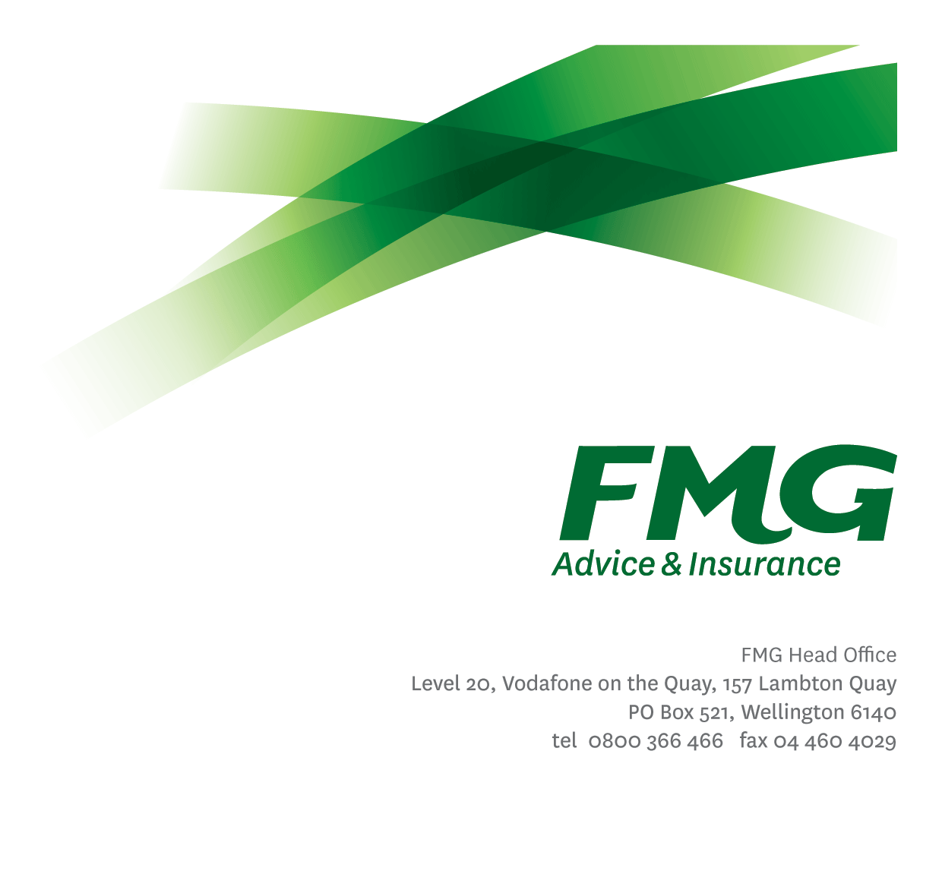Product Manager

*Position Description*

*Location:* As per personal terms

*Reporting to:* Head of Product

*Business Unit:* Product

*Direct Reports:* Nil

*Date Last Reviewed:* April 2024

### *About FMG*

***Formed by farmers for farmers over a century ago, FMG is New Zealand’s leading rural insurer providing risk advice and insurance solutions for farmers, growers, commercial businesses, the lifestyle sector and domestic clients.***

***We’re proudly 100% New Zealand owned and operated and our focus is on helping our clients to achieve their goals.  As a mutual organisation, we’re all about giving rural New Zealanders a better deal, and part of this involves reinvesting all profits back into the business to keep premiums low and ensure the future sustainability of the organisation.***

### *FMG’s Values*

The FMG brand represents promises about what customers can expect from us and each of us is responsible for delivering on these promises. Living our company values means we deliver the best brand experience for our customers. Our company values are:

|  |  |
| --- | --- |
| * Do what’s right | * Make it happen |
| * We’re in it together | * Proud of who we are |

### *Work Environment*

We strive to provide an environment that promotes and fosters achievement. We place importance on career development and training to give our people the tools they need to succeed.

FMG’s Corporate Office is in Wellington and accommodates FMG’s Executive Leadership Team (ELT), Marketing and Propositions, People and Culture, Financial Management, Insurance Solutions, Reinsurance, Business Information and Analysis, Legal and Compliance.

FMG’s largest regional office is in Palmerston North accommodating our National Advice and Service Centre, Information Technology, Claims, Operations and Payments functions. In addition to the offices in Wellington, Palmerston North and Christchurch; FMG has offices in 30 regional locations throughout New Zealand/ Aotearoa.

### *Purpose of the role*

The Product Manager will actively manage the performance of assigned projects, products or product discipline areas against agreed targets in relation to client outcomes, regulatory compliance, efficiency, profitability or innovation.

The role is also responsible for identifying and fulfilling opportunities, developing business cases; securing supply of resources from other business units; owning and driving successful outcomes and managing the delivery of product change impacts on other units including identifying and measuring success factors.

### *Key Responsibilities*

| Area | Responsibilities |
| --- | --- |
| Product Management | * Continuously review assigned product performance area against agreed targets. * Investigate areas of under-performance and develop initiatives in response, including preparation of recommendations for the Insurance Risk Committee * Provide input into agreed targets at product level. * Provide support to the wider business on product interpretation and product intent including technical product response support to the Client Resolution, Compliance and Risk teams. * Proactively put forward product ideas that:   + simplify products, processes and practices without compromising client outcomes or product performance   + amplify FMGs position without compromising client outcomes or product performance   + contribute to FMG products remaining innovative as well as meeting market demands and emerging risks. * Continually improve knowledge in agreed specialist areas e.g. case law, regulatory impacts or market opportunity into which assigned products can be sold * Support the definition and implementation of a product structure that makes FMG’s products and services easily available in the marketplace * Manage the implementation of approved product changes across the business within agreed timeframes. |
| Product Development | * Undertake research into new product initiatives and developments, considering features, risks, potential market and fit with the product strategy, the FMG organization strategy and alignment with the FMG product range. * Recommend whether FMG should pursue these product initiatives and developments. * Lead and manage the end-to-end implementation of the development of new products or product changes. * Lead and collaborate with the wider business on delivery of all product changes or initiatives. |
| Team Membership | * Support, marketing, online services, risk advice, communication, training, compliance, risk quality and all operational teams to ensure products and product intent is well understood and communicated accurately. * Proactively assist and supports colleagues and other stakeholders. * Collaboratively work with all areas of the business to understand and articulate product related issues and opportunities. * Collaboratively work with all areas of the business to ensure the desired outcome of product changes or initiatives are achieved. * Share information and resources and provide feedback in a positive and collaborative manner. |
| Other Duties | * Undertake tasks as directed by the Head of Product from time to time |
| Risk and Quality | * Ensure assigned products and overall work is compliant with legislation, regulations and FMG policies through the use of established systems. |
| Wellbeing & Safety | * Comply with safety and wellbeing policy and procedures, including accident and incident reporting and hazard management requirements. * Work in a safe manner at all times and do not undertake activities without appropriate training. |

|  |  |
| --- | --- |
| **COMPETENCIES** | |
| *\*see competency framework for behaviours expected at each level* | *Expected Level* |
| **Client Driven (Internal & External)**  A commitment to understanding the needs and best interests of both internal and external clients, in order to provide them with outstanding customer service and help them to make informed decisions. | Advanced* |
| **Accountability**  Taking personal ownership of decisions, behaviour, and development, and being responsible for how these actions impact on the wider organisation and clients. | Advanced* |
| **Adaptability**  Demonstrating a willingness to engage in a changing environment and being flexible and comfortable working with change. | Advanced* |
| **Motivation and Drive**  The determination to achieve goals and strive for excellence. | Intermediate* |
| **Relationship Building**  Developing and maintaining positive, professional relationships that are built on mutual trust and respect. | Advanced* |
| **Team Work**  Making a positive contribution to the FMG team and collaborating effectively with others to achieve objectives. | Intermediate* |
| **Critical Analysis**  The capability to identify key issues, trends, or important facts from information and to question and probe. | Advanced* |

|  |  |  |
| --- | --- | --- |
| **KNOWLEDGE** | | |
| **Qualifications** | Relevant Tertiary Qualification required | |
| **Experience** | | 10+ years Financial/Insurance Industry experience  Demonstrated product delivery management experience | |
| **Business Awareness** | Understands the internal workings of FMG and how business works; understands FMG's position in the advice and insurance market and knows the competition. | |
| **Market Knowledge** | Understands the insurance industry. Maintains an active knowledge of competitors’ products benefits, features and pricing. | |
| **Rural Knowledge** | Understands the rural community and keep up to date with the economic, political, and environmental issues affecting our customers. | |
| **Product Knowledge** | Is knowledgeable about FMG's insurance policies and packages, the differences between them, and the appropriateness of each in different situations. | |
| **Risk/Insurance Knowledge** | Understands risk and how to apply FMG's policies to situations; is knowledgeable about compliance requirements; understands the insurance process and how claims are managed; knows industry partners and competitors. | |
| **Specialist Knowledge** | Understands the roles of underwriting, sales, claims etc and is able to use their viewpoint in analysing product performance | |

|  |  |
| --- | --- |
| **SKILLS** | |
| **Written Communication Skills** | Able to write clear, concise and persuasive proposals and reports. |
| **Verbal Communications Skills** | Communicates clearly in order to present information to persuade and influence others. |
| **Listening Skills** | Demonstrates active listening skills through eye contact, paraphrasing, appropriate body language and checking understanding. |
| **Technology Skills** | Can expertly use relevant software and technology to its full capacity e.g. MS Word, Excel and PowerPoint. |
| **Project Management & Change Management Skills** | Can autonomously drive and manage projects to deliver agreed outcomes across the business within agreed timeframes. |

### *Relationships*

|  |  |  |
| --- | --- | --- |
| External | Internal | Committees/Groups |
| Nil | * Pricing * Client Strategy and Advice Services * Compliance * Legal, Compliance & Risk Quality * Underwriting * Reinsurance * Claims * Sales * Training * Marketing * Business Information Systems (BIS) * Online Services | * Operational Compliance Committee * Insurance Risk Committee * Executive Leadership Team |
|  |  |  |

### *Financial Authority Levels*

* No authority to approve or commit expenditure

### *Human Resources Authority Levels*

* Not applicable

### *Agreement*

### I agree to the outline of the role as contained in this document and recognise that the contents may need to be amended from time to time to reflect changing business requirements.

I as Job holder, allow my Manager to gather information from third parties where necessary for the purposes of performance management.

|  |  |
| --- | --- |
| Product Manager’s Name |  |
| Signature: |  |
| Date: |  |