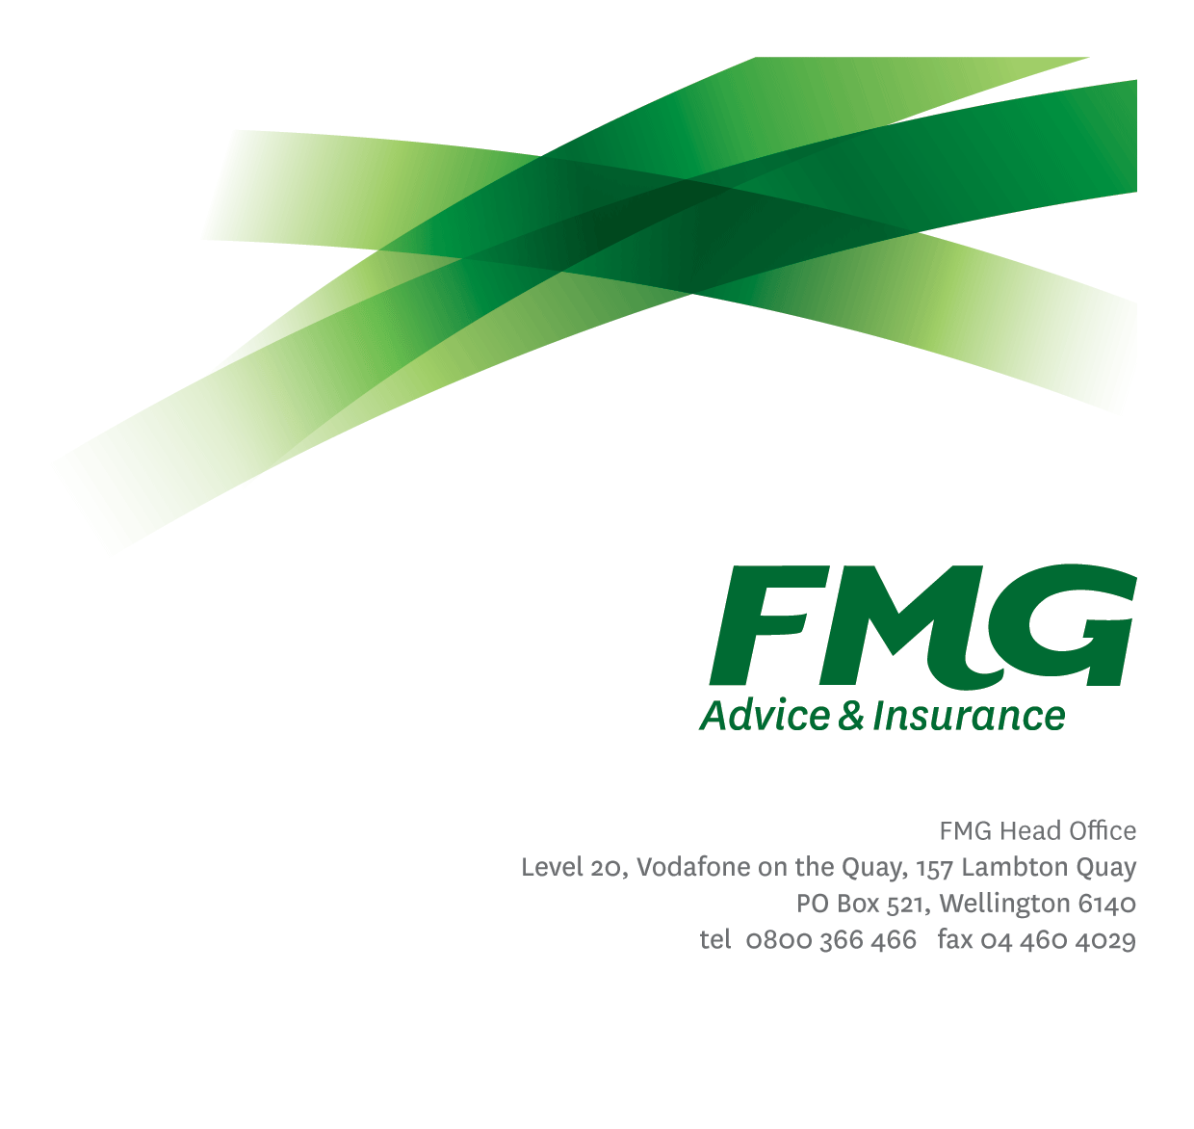
Head of Change
Position Description

Location: Palmerston North or Wellington
Reporting to: Chief Strategy and Enablement Officer
Business Unit: Strategy and Enablement
Direct Reports: None
Date Last Reviewed: February 2026

About FMG
Formed by farmers for farmers over a century ago, FMG is New Zealand’s leading rural insurer providing risk advice and insurance solutions for farmers, growers, commercial businesses, the lifestyle sector and residential clients.
We’re proudly 100% New Zealand owned and operated, and our focus is on helping our clients to achieve their goals. As a mutual organisation, we’re all about giving rural New Zealanders a better deal, and part of this involves reinvesting all profits back into the business to keep premiums low and ensure the future sustainability of the organisation.

FMG’s Values
The FMG brand represents promises about what clients can expect from us and each of us is responsible for delivering on these promises. Living our company values means we deliver the best brand experience for our clients. Our company values are:
- Do what's right - Whāia te ara tika | - Make it happen - Whakatutukitia
- We're in it together - Ko tātau tātau | - Proud of who we are - Whakahīhī i te whakapapa

Work Environment
We strive to provide an environment that promotes and fosters achievement. We place importance on career development and training to give our people the tools they need to succeed.
FMG’s Head Office is in Wellington and accommodates FMG’s Executive Leadership Team (ELT), Client Propositions & Online Services, People & Culture, Marketing, Communications, Financial Management, Product & Pricing and Underwriting, Reinsurance, Business Information and Analysis, Legal and Compliance.
FMG’s largest regional office is in Palmerston North accommodating our National Sales & Advice Centre, People and Culture, Information Technology, Claims, Operations and Payments functions. In addition to the offices in Wellington, Palmerston North and Christchurch FMG has offices in 30 regional locations throughout New Zealand.

Purpose of the Role
The Head of Change (HoC) develops and leads the strategy for embedding change leadership in FMG with the support of ELT, Mutual Leaders and Change Managers. They are a member of Enterprise Portfolio Management Committee (EPMC) are and responsible for helping to deliver the Strategy to Delivery framework, making change related recommendations and embedding the Change Community of Practice.
The Head of Change will lead the Change Community of Practice to enable governance and reporting, ensure consistency of change project delivery practice and encourage change capability building. They also facilitate the Employee Change Network, with the support of the Change Community of Practice, to act as a communication hub, encourage engagement, provide feedback, build change capability and embed change.
The Head of Change is responsible for the federated change management approach across the Mutual as well as setting and assuring the quality of change delivery practice.
As a member of the Strategy and Enablement Leadership Team, the Head of Change supports the delivery of change benefits identified in the Business Plan or approved through the Strategy and Delivery process. In support of this the Head of Change is responsible for working with key stakeholders to develop an organisation-wide view of the impact of planned change. They will also provide this as an input into decision making process around impact, timing and resourcing of key initiatives.
As a Mutual Leader, you will bring FMG’s Purpose, Vision and Strategy to life through accountability for delivery of FMG’s Business Plan in line with the Mutual’s overall strategic direction. You are tasked with running the Mutual, performing and transforming whilst continuing to ensure FMG remains relevant in a dynamic external environment and marketplace. They are accountable for protecting and growing the Mutual.

Key Responsibilities
 | Area | Responsibilities
Strategy and Direction |  | - Develop and deliver the Change strategy for the Mutual, including establish governance bodies, socialisation and implementation.  - Develop and deliver reporting on progress against implementation and capability building.  - Benchmark the Mutual’s change capability maturity regularly to demonstrate progress and focus continuous improvement.
 | Change Management Practice | - Provide intellectual leadership and clear direction for Change Managers, using change delivery frameworks(s) and reporting, so that together they can successfully deliver the people side of change for FMG.  - With reporting Mutual Leaders, undertake risk-based resource allocation of change management resource to change.  - Encourage collaboration between Change Managers, directly and through the Change Community of Practice, which enables them to work together to provide quality change delivery in line with FMG values.  - Ensure effective management of change collision
 | Change Capability | - With Learning and Development, develop a plan and delivery framework to build leader and employee change capability which aligns with Our Leadership Way, L&D programme and reflects FMGs changing needs.  - Work with Change Manager – Business Unit(s), to deliver Business Unit focussed leader and employee change capability.
Governance and Reporting |  | - Work with Change Managers and Mutual Leaders to ensure that the quantum and timing of change happening across the Mutual, and for clients, is clearly understood and managed effectively.  - Work with Change Managers, directly and through the Change Community of Practice, to develop and maintain collective view of employee and client change for EPMC and QBP.  - Assure the quality, sustainability and suitability of Business Unit reporting delivered by Change Manager – Business Unit(s).  - Support EPMC and QBP decision making with proposed epic assessment and employee and client change collision and impact reporting.
Change Delivery |  | - Develop and maintain the Change Delivery Frameworks with the Chief Strategy and Enablement Officer and Change Managers.  - Assure consistent application the Change Delivery Frameworks by Change Managers and they can demonstrate their use.  - Promote the Change Delivery frameworks and their value.  - Facilitate Change Managers to ensure consistent quality change practice across FMG.
 | Collaboration and Relationship Management | - Collaborate with the Strategy and Enablement team to design and deliver fit for purpose solutions which provide maximum organisational benefit.  - Contribute to business and Strategy and Enablement team meetings and actively share knowledge, learning and insights.  - Work with Mutual Leaders to set direction and priorities, discuss opportunities and plan resource allocation for Change Manager – Business Unit(s).  - Facilitate shared Change Manager – Business Unit(s) resource allocation, priorities and workload as needed.  - Share research, information, resources and provide feedback in a positive and collaborative manner.  - Establish and maintain change related governance groups to encourage collaboration and connection.  - Take proactive steps to build excellent relationships with key stakeholders both internal and external.
 | Wellbeing & Safety, Policy and Statutory Compliance | - Comply with wellbeing and safety policies and procedures, including accident and incident reporting and hazard management requirements.  - Work in a safe manner always and do not undertake activities without appropriate training.  - Comply with corporate policies, guidelines and procedures.  - Comply with all legislation governing employment.
 | Mutual Leader | As a Mutual Leader, you will be expected too –  - Turn strategy into action – this is done by translating organisational strategy and decisions into action, running the Mutual with an Owner’s Mindset and actively shape the culture required to achieve FMG’s strategic aspirations and objectives.  - Make good decisions - use critical thinking and appropriate decision-making frameworks to get to the heart of the opportunity, issue and/ or risk.  - Manage priorities – deliver on a broad range of initiatives simultaneously and remain focussed on the Mutual’s strategic priorities – which includes effectively delegating and maintaining oversight of work priorities.  - Lead change - lead change and role model the behaviours that contribute to a culture that embraces and enables change and  organisational agility.  - Enhance organisational outcomes – see organisational issues through a range of lenses and perspectives, recognising broader Mutual-wide implications and connections between issues. They drive a culture of continuous improvement encouraging others to identify opportunities to sustainably strengthen organisational outcomes and performance for clients, Members and employees.  - Enhance system-wide performance – contribute to their Leadership cohort, creating opportunities for Mutual-wide collaboration and knowledge-sharing with their peers and colleagues. They break down silos, think Mutual and system-wide and focus on aligned outcomes for FMG’s success.  - Communicate with purpose – communicate proactively, with clarity, consistency, and transparency, including when faced with ambiguity and/ or challenging circumstances.  - Build trust and influence – build strong internal and external relationships based on trust and mutual respect to positively influence and achieve strategic outcomes.  - Enhance people & team performance – build cohesive and high performing teams and networks to deliver on aligned and collective results. They create an inclusive environment where everyone can contribute and do their best  work and ensuring accountability for outcomes.  - Develop talent – identify, cultivate and develop leadership potential. They take an active approach to building diverse capabilities and are purposeful in succession planning, creating a pool of highly capable current and future leaders.

COMPETENCIES
*see competency framework for behaviours expected at each level |  |  | Expected Level
Customer Driven (Internal & External)  A commitment to understanding the needs and best interests of both internal and external customers, in order to provide them with outstanding customer service and help them to make informed decisions. |  |  | Advanced*
Accountability  Taking personal ownership of decisions, behaviour, and development, and being responsible for how these actions impact on the wider organisation and customers. |  |  | Advanced*
Adaptability  Demonstrating a willingness to engage in a changing environment and being flexible and comfortable working with change. |  |  | Advanced*
Motivation and Drive  The determination to achieve goals and strive for excellence. |  |  | Advanced*
Relationship Building  Developing and maintaining positive, professional relationships that are built on mutual trust and respect. |  |  | Advanced*
Teamwork  Making a positive contribution to the FMG team and collaborating effectively with others to achieve objectives. |  |  | Advanced*
Change Leadership  The drive to initiate opportunities to address FMG’s organisational needs and to communicate change in a way that gains buy-in and support from others |  |  | Advanced*
Influencing and Persuading  Use rational argument and reasoning to convince others. To not be afraid to take a stand and to sell a position while keeping the relationship intact. |  |  | Advanced*
Critical Analysis  The capability to identify key issues, trends, or important facts from information and to question and probe. |  |  | Advanced*
KNOWLEDGE
Qualification Required |  | Relevant Tertiary Qualification required. Prosci certification essential..
Business Awareness |  | Understands the internal workings of FMG and how business works; understands FMG's position in the advice and insurance market and knows the competition.
Product Knowledge |  | Is knowledgeable about FMG’s insurance products and the differences between them and the appropriateness of each in different situations.
Specialist Knowledge |  | At least seven (7) years proven experience in working with Change Management methodologies  Understanding and experience of the project lifecycle i.e., requirements, design, build, test, and transition.
SKILLS
Inter-personal Skills | Build meaningful and reciprocal relationships at all levels of FMG.
Written Communication Skills | Able to write clear, concise and persuasive proposals and reports.
Verbal Communications Skills | Communicates clearly in order to present information to persuade and influence others.
Listening Skills | Demonstrates active listening skills through eye contact, paraphrasing, appropriate body language and checking understanding.
Technology Skills | Can proficiently use relevant software and technology to its full capacity (e.g., Microsoft Office) and have a good understanding of how FMG’s systems are used to support its people and processes.
Risk Assessment Skills | Identifies, understands and mitigates the risks that may impact on FMG's strategy, initiatives and reputation.
Leadership skills | Experience at leading and managing change delivery teams and developing change delivery strategy and frameworks

Relationships
External | Internal | Committees/Groups
- External service providers.  - Relevant Change Management industry groups and forums. | - Chief Executive Officer  - Executive Leadership Team  - Head of Project Management Office  - Head of Enterprise Portfolio Office  - Project Managers  - Change Subject Matter Experts  - Change Champions and Leaders  - Head of Communications and Sustainability  - Manager, Learning & Development | - People & Culture Leadership Team  - EPMC  - Project Steering Groups

Financial Authority Levels
- May approve routine expenditure within budgetary limits
- May hire direct and indirect reports within approved FTE headcounts.
- May discipline direct and indirect reports in consultation with manager and Human Resources
- No authority to dismiss staff, unless delegated by the Chief Executive and in consultation with manager and People Advisory.

People Advisory Authority Levels
- May hire direct and indirect reports within approved FTE headcounts.
- May discipline direct and indirect reports in consultation with manager and People Advisory.
- No authority to dismiss staff, unless delegated by the Chief Executive and in consultation with manager and Chief People Officer.

Agreement
I agree to the outline of the role as contained in this document and recognise that the contents may need to be amended from time to time to reflect changing business requirements.

I as Job holder, allow my manager to gather information from third parties where necessary for the purposes of performance management.

Head of Enterprise Change Management Name:
Signature:
Date:

Chief Strategy and Enablement Officer Name:
Signature:
Date:

