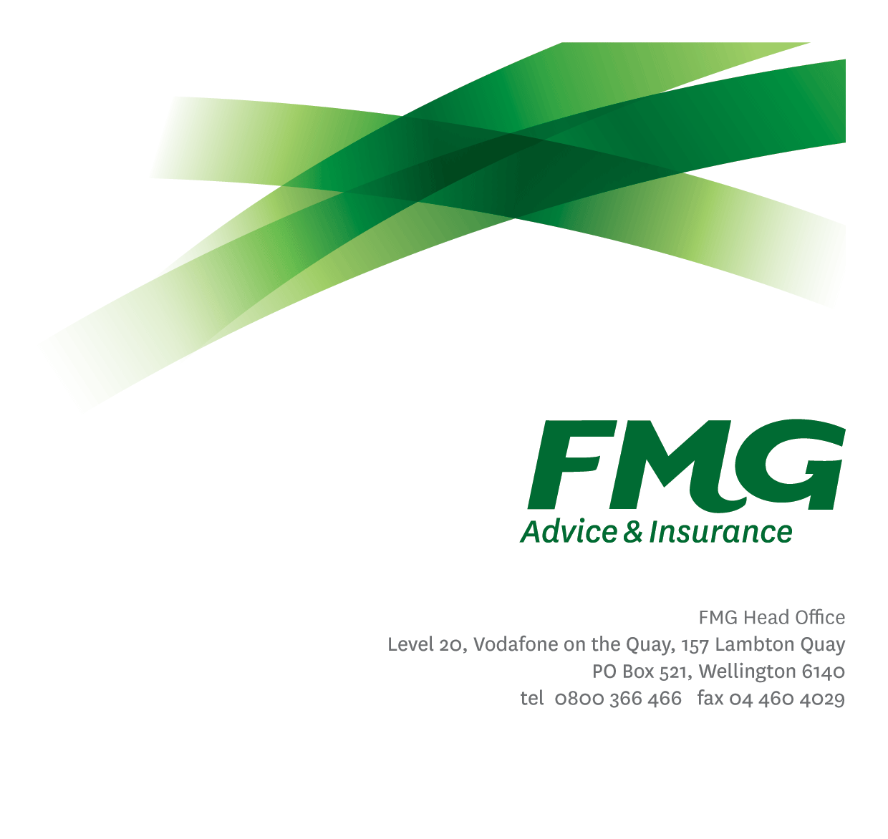Rural Consultant
Position Description

Location: As per Personal Terms
Reporting to: Agribusiness Centre Team Leader
Business Unit: Sales, Advice & Service
Direct Reports: 0
Date Last Reviewed: November 2015

About FMG
Formed by farmers for farmers over a century ago, FMG is New Zealand’s leading rural insurer providing risk advice and insurance solutions for farmers, growers, commercial businesses, the lifestyle sector and domestic clients.
We’re proudly 100% New Zealand owned and operated and our focus is on helping our clients to achieve their goals. As a mutual organisation, we’re all about giving rural New Zealanders a better deal, and part of this involves reinvesting all profits back into the business to keep premiums low and ensure the future sustainability of the organisation.

FMG’s Values
The FMG brand represents promises about what clients can expect from us and each of us is responsible for delivering on these promises. Living our company values means we deliver the best brand experience for our clients. Our company values are:
- Do what’s right | - Make it happen
- We’re in it together | - Proud of who we are

Work Environment
We strive to provide an environment that promotes and fosters achievement. We place importance on career development working as a team and having fun. Working out of busy, lively regional offices where our teams are committed to delivering outstanding customer service. We place importance on career development and training to give our people the tools they need to succeed.

Purpose of the role
The Rural Consultant is primarily accountable for the retention and management of clients within their portfolio. This is a pivotal role within the FMG client Advice & Insurance team, and is responsible for forming long-term, sustainable partnerships with FMG clients. Pre-programmed call events ensure the provision of proactive timely contact to discuss upcoming renewals, present risk management solutions and manage clients in such a way as to sustain or improve the loss ratio associated with the portfolio.

Key Responsibilities

Area | Responsibilities
Retention | - Talking to clients wishing to cancel and discussing options and benefits to retain business.  - Maintains regular contact with clients by phone contact.  - Holds in-depth discussions with clients about business related topics; provides advice and information and demonstrates a real commitment to the profitability and sustainability of their farming operations.  - Develops long-term relationships and is seen by the client as being trustful and accurate with a common sense approach.  - Exceeds client service satisfaction levels through the delivery of accurate and timely information and advice; recognized as an expert in risk management matters; and gets the job done in a timely manner with minimal disruption to the client.
Client Focus | - Seeks to improve FMG Net Promoter Score  - Provides superior service to all client and internal clients by demonstrating the FMG values.  - Achieves a targeted % client satisfaction score combined of excellent and/or very good, where the client recognizes FMG as providing strategically relevant advice in risk management  - Engagement with the client reflects a consultative approach where in-depth questioning and active listening is undertaken, and industry related information is discussed.  - Assisting to identify opportunities for process and service improvement.
Client Experience/Client Interaction | - Making outbound calls and taking ownership of providing clients with a complete range of services.  - Contacting clients to a portfolio plan and monthly target list.  - Being available to talk to clients outside of their renewal time to discuss their insurance needs.  - Providing support for client walk-ins into office.  - Preparing concise and accurate information for clients including quotes.  - Ensuring record of call and data entry in Guidewire system is accurate.
Referral Generation | - Generate leads for other parts of the business, including General Insurance, our Investment & Strategic Partners and Personal Risk Advisors
Networking | - Where required attends field days, risk management seminars and events in the local rural community to enhance FMG’s profile and personal profile  - Uses business and social networking occasions to identify business opportunities for FMG.
Business Growth and Profitability | - Achieves agreed Key Result Areas (KRAs)  - High claiming clients are provided with risk management plans to assist rehabilitation back to profitable and sustainable parameters for mutual benefit over the longer term.  - Within agreed timeframe standards, follows up with the client.  - Business written is of the highest quality and priced accordingly to minimize the risk to FMG’s long term profitability.  - Provides advice and information relevant to the client needs (e.g. product information, fact sheets, packs, etc).  - Identifies and clarifies the nature of the client’s risk needs and uses initiative to meet client’s entire insurance needs, in order to provide appropriate products, solutions and services to meet those needs.
Self Development | - Actively identifies all areas of development.  - Attends company approved training and development programs in insurance, risk management and agribusiness.  - Uses newly gained knowledge and skills on the job.
FMG Values | - Promotes the ‘FMG Way” through displaying the values of FMG which are: Do what’s right, Make it happen, We’re in it together, Proud of who we are.
Team Participation | - Effectively contributes to a collegial and efficient FMG team dynamic.  - Assisting and supporting other team members, including training and peer review work as required.  - Supporting the team by sharing information and resources and providing feedback in a positive manner.
Reporting | - All reports to meet agreed FMG service standards including but not limited to the quality of content, writing style, grammatical correctness, visual presentation and timeliness of delivery.
Risk Management | - Discusses with clients their approach to risk and examine their appetite and tolerance to risk. Puts risk in a positive context and discusses the ‘upside’ and opportunities that arise out of their risk positions they take. In broad terms identifies client’s financial ability to tolerate losses from adverse events and their willingness to fund losses themselves through equity or debt.  - Achieves a win/win risk environment with the client, where the client better manages risk including the transfer of appropriate portions to FMG through FMG’s insurance products.
Risk Quality | - Develops a thorough knowledge of all FMG products and services and rural industry topics through attending internal training sessions, external seminars and study programs.  - Business written is within delegated authority (DA) levels.  - Meets targeted Gross Claims Ratios.
Health and Safety | - Complies with safety and wellbeing policy and procedures, including accident and incident reporting and hazard management requirements.  - Works in a safe manner at all times and does not undertake activities without appropriate training.
Compliance | - Complies with company policies, guidelines and procedures.

COMPETENCIES
*see competency framework for behaviours expected at each level | Expected Level
Client Driven (Internal & External)  A commitment to understanding the needs and best interests of both internal and external clients, in order to provide them with outstanding client service and help them to make informed decisions. | Intermediate*
Accountability  Taking personal ownership of decisions, behaviour, and development, and being responsible for how these actions impact on the wider organisation and clients. | Intermediate*
Adaptability  Demonstrating a willingness to engage in a changing environment and being flexible and comfortable working with change. | Intermediate*
Motivation and Drive  The determination to achieve goals and strive for excellence. | Intermediate*
Relationship Building  Developing and maintaining positive, professional relationships that are built on mutual trust and respect. | Intermediate*
Team Work  Making a positive contribution to the FMG team and collaborating effectively with others to achieve objectives. | Intermediate*

KNOWLEDGE
Qualifications | Relevant Tertiary Qualification desirable
Business Awareness | Understands the internal workings of FMG and how business works; understands FMG's position in the advice and insurance market and knows the competition.
Rural Knowledge | Understands the rural community and keep up to date with the economic, political, and environmental issues affecting our clients.
Legal Knowledge | Has legal knowledge e.g. indemnity, liability, the Privacy Act etc.
Product Knowledge | Is knowledgeable about FMG's insurance policies and packages, the differences between them, and the appropriateness of each in different situations.
Risk/Insurance Knowledge | Understands risk and how to apply FMG's policies to situations; is knowledgeable about compliance requirements; understands the insurance process and how claims are managed; knows industry partners and competitors.
Experience | Previous experience working in a phone sales/customer service environment is desirable

SKILLS
Written Communication Skills | Able to write clear, concise and persuasive proposals and reports.
Verbal Communications Skills | Communicates clearly in order to present information to persuade and influence others.
Listening Skills | Demonstrates active listening skills through eye contact, paraphrasing, appropriate body language and checking understanding.
Financial Skills | Able to calculate premiums, and interpret budgets and forecasts.
Technology Skills | Can expertly use relevant software and technology to its full capacity e.g. MS Word, Excel and PowerPoint.
Risk Assessment Skills | Identifies, understands and mitigates the risks that may impact on FMG's strategy, initiatives and reputation.

Relationship
External | Internal | Committees/Groups
- Local rural business networks  - Agency representatives | - Advice & Insurance Leadership Team  - Rural Managers  - Mobile Rural Consultants  - Agribusiness Centre  - Regional Operations Coordinator  - Underwriting team  - Sales and Service Centre  - Assessors  - Personal Risk Advisors  - Claims  - Payment Services | - Industry Groups

Financial Authority Levels
- No authority to commit or approve expenditure

Human Resources Authority Levels
- Not applicable

Delegated Authority Levels
- Delegated authority levels for the individual role-holder will be advised following assessment, training and approval as per the requirements of the FMG Delegated Authority Policy.

Agreement
I agree to the outline of the role as contained in this document and recognise that the contents may need to be amended from time to time to reflect changing business requirements.

I as Job holder, allow my Manager to gather information from third parties where necessary for the purposes of performance management.

