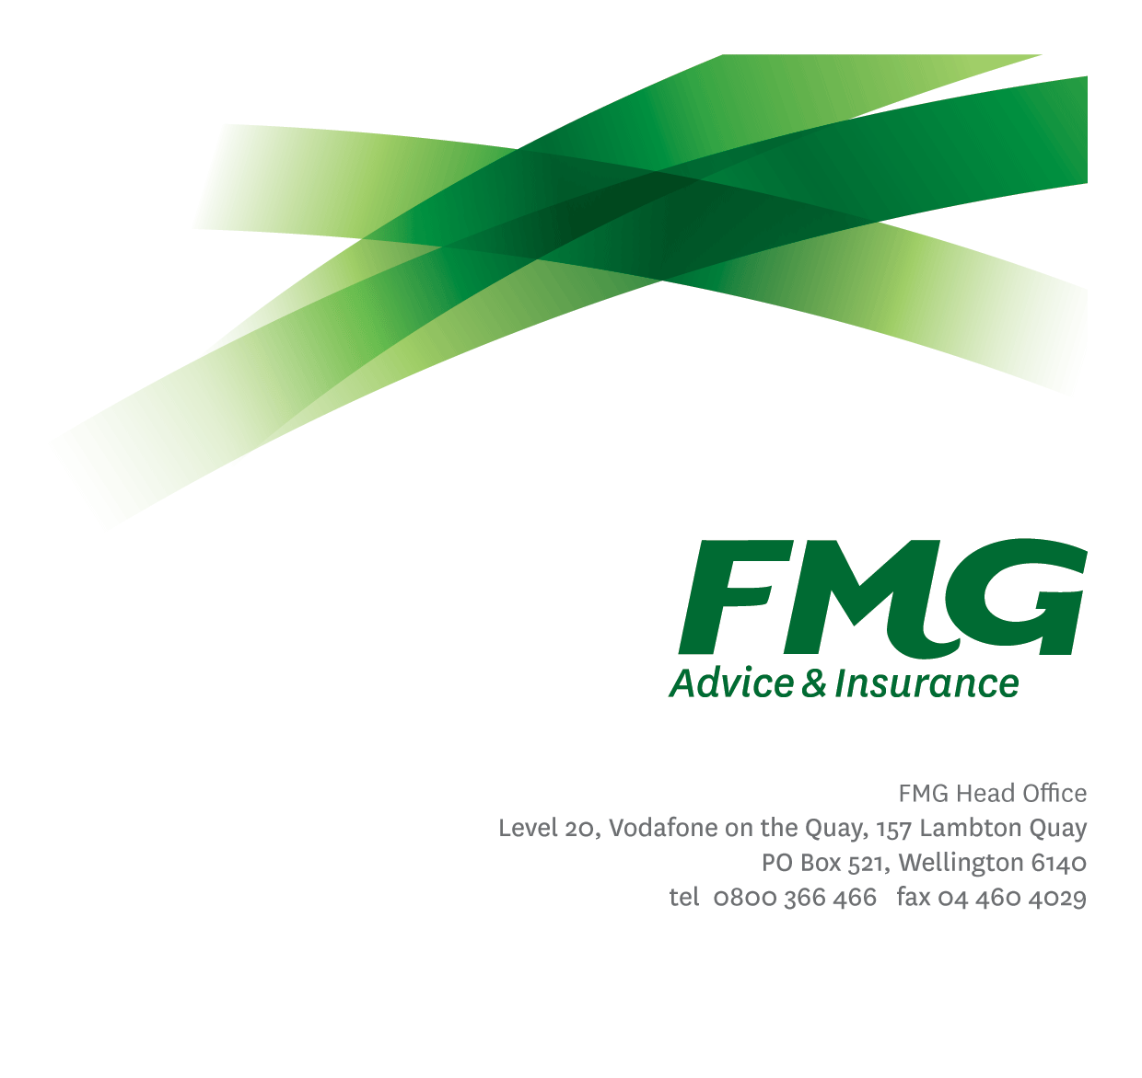
Communications Adviser
Position Description

Location: Wellington
Reporting to: Head of Communications and Sustainability
Business Unit: Marketing and Propositions
Direct Reports: Nil
Date: February 2026

About FMG
Formed by farmers for farmers over a century ago, FMG is New Zealand’s leading rural insurer providing risk advice and insurance solutions for farmers, growers, commercial businesses, the lifestyle sector and domestic clients.
We’re proudly 100% New Zealand owned and operated, and our focus is on helping our clients to achieve their goals. As a mutual organisation, we’re all about giving rural New Zealanders a better deal, and part of this involves reinvesting all profits back into the business to keep premiums low and ensure the future sustainability of the organisation.

FMG’s values
The FMG brand represents promises about what clients can expect from us and each of us is responsible for delivering on these promises. Living our company values means we deliver the best brand experience for our clients. Our company values are:
- Do what's right - Whāia te ara tika | - Make it happen - Whakatutukitia
- We're in it together - Ko tātau tātau | - Proud of who we are - Whakahīhī i te whakapapa

Work environment
We strive to provide an environment that promotes and fosters achievement. We place importance on career development and training to give our people the tools they need to succeed.
FMG’s Head Office is located in Wellington and accommodates FMG’s Executive Leadership Team (ELT), Client Propositions & Online Services, People & Culture and Communications, Financial Management, Product & Pricing and Underwriting, Reinsurance, Business Information and Analysis, Legal and Compliance.
FMG’s largest regional office is located in Palmerston North accommodating our National Sales & Advice Centre, Information Technology, Claims, Operations and Payments functions. In addition to the offices in Wellington, Palmerston North and Christchurch FMG has offices in 31 regional locations throughout New Zealand.

Purpose of the role
The Communications Adviser will be responsible for leading and delivering key internal and external communication initiatives and projects with the intent to enhance and maintain FMG’s reputation.

Internally, the role will help to build communication frameworks, support employees to become effective communicators and enhance FMG’s culture.

In support of FMGs strategic business goals the role will have oversight of social media and support all other external communication activity. It will also provide communication support, including social media delivery for FMG’s rural wellbeing programme Farmstrong.

The role will need to build purposeful relationships across the organisation, and meet the teams, Communication Standards to deliver on stakeholder expectations.

Key responsibilities

Area | Responsibilities
Application delivery | - Support, and where required lead key internal and external communication initiatives and projects  - Have an oversight of FMG’s Social Media content and channels  - Write for, and help manage FMG’s internal website - Insite
Communication management | - Build trusting relationships with employees to find and generate great stories that can be told inside and outside FMG  - Create content for, and have oversight of, FMG’s and Farmstrong’s social media platforms. Track and evaluate performance.  - Support the Internal Communications Specialists on the day-to-day running of FMG’s internal website, Insite  - Support the Corporate Communication Specialists with the development and delivery of external communication collateral such as FMG Post  - Propose new content ideas and delivery methods for both internal and external communication activity  - Involvement with Farmstrong where required
Performance monitoring | - Remain across key trends within the insurance and rural sectors  - Generate content to a high standard  - Display initiative with new ideas and on the delivery of tasks  - Build trusting relationships with stakeholder
FMG values | - Operate within FMG’s four values  - Adopt an owner’s mindset in all decisions and actions you take for FMG  - Meet FMG’s Key Behavior Indicators
Compliance | - Ensures compliance with legislative, regulations and FMG policies through the monitoring of systems, processes and improvements.
Customer satisfaction and service delivery | - Provides excellent client service by demonstrating FMG values.  - Ensures all communication is to a high standard.
Relationship management | - Maintaining effective working relationships  - Establishing effective working relationships with managers and employees within FMG
Health & safety | - Complies with safety and wellbeing policy and procedures, including accident and incident reporting and hazard management requirements  - Works in a safe manner at all times and does not undertake activities without appropriate training

COMPETENCIES
*see competency framework for behaviours expected at each level | Expected Level
Client Driven (Internal & External)  A commitment to understanding the needs and best interests of both internal and external customers, in order to provide them with outstanding service and help them to make informed decisions. | Intermediate*
Accountability  Taking personal ownership of decisions, behaviour, and development, and be responsible for how these actions impact on the wider organisation and customers. | Intermediate*
Adaptability  Demonstrating a willingness to engage in a changing environment and be flexible and comfortable working with change. | Intermediate*
Motivation and drive  The determination to achieve goals and strive for excellence. Show initiative in all that you work on. | Intermediate*
Relationship building  Develop and maintain positive, professional relationships that are built on mutual trust and respect. | Intermediate*
Team work  Making a positive contribution to the FMG team and collaborating effectively with others to achieve objectives. | Intermediate*

KNOWLEDGE
Qualifications | Relevant business qualification in marketing and or communications related areas is desirable.
Business awareness | Understands the internal workings of FMG and how business works; understands FMG's position in the advice and insurance market and knows the competition.
Product knowledge | Is knowledgeable about FMG's insurance policies and packages, the differences between them, and the appropriateness of each in different situations
Rural knowledge | Understands the rural community and keep up to date with the economic, political, and environmental issues affecting our clients.
Risk/Insurance knowledge | Understand risk and how to apply FMG's policies to situations; Is knowledgeable about compliance requirements; Understand the insurance process and how claims are managed; Know industry partners and competitors
Specialist knowledge | Is savvy and fully understands all social media channels. Has previous experience creating and managing content on various social media channels.

SKILLS
Written communication skills | Spell words correctly and use grammar appropriately in everyday written communication. A vitally important skill for a role like this which communicates externally on a regular basis. Ability to write succulently when supporting traditional communications functions.
Verbal communication skills | Effectively presents information to others, both informally and in meetings
Listening skills | Gives others full attention when listening i.e. stops what they are doing
Technology skills | Can expertly use relevant software and technology to its full capacity (e.g. MS Word, Excel, PowerPoint and Teams), including internal and external social media platforms.
Risk assessment skills | Identifies, understands and mitigates the risks that may impact on FMG's strategy, initiatives and reputation

Relationship
External | Internal | Committees/Groups
- BCGCrave (Marketing agency  - Social Media Agency  - Rural and mainstream media | - Head of Communications and Sustainability  - Communications Team  - Sustainability Specialist  - Chief Marketing Officer  - Marketing Team  - Sponsorships & Events Specialists  - Senior Leaders  - Farmstrong Project Coordinator | - As required

Financial Authority Levels
- NA

Human Resources Authority Levels
- Not applicable

Agreement
I agree to the outline of the role as contained in this document and recognise that the contents may need to be amended from time to time to reflect changing business requirements.

I as Job holder, allow my Manager to gather information from third parties where necessary for the purposes of performance management.

Communications Advisor’s Name:
Signature:
Date:

Head of Communications and Sustainability Name:
Signature:
Date:

