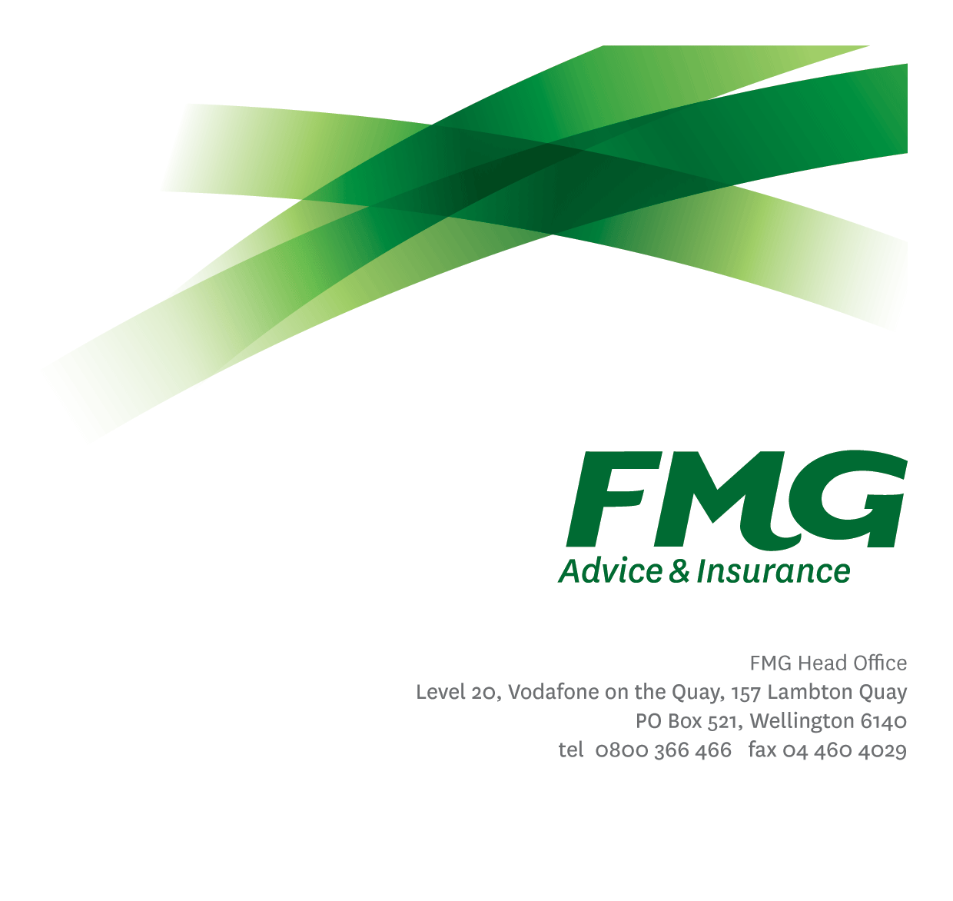
Strategy Analyst
Position Description

Location: Palmerston North, Wellington, or Christchurch
Reporting to: Head of Strategy and Innovation
Business Unit: Digital and Data
Direct Reports: Nil
Date Last Reviewed: February 2026

About FMG
Formed by farmers for farmers over a century ago, FMG is New Zealand’s leading rural insurer providing risk advice and insurance solutions for farmers, growers, commercial businesses, the lifestyle sector and residential clients.
FMG is proudly 100% New Zealand owned and operated, and our focus is on helping our clients to achieve their goals. As a mutual organisation, FMG is all about giving rural New Zealanders a better deal, and part of this involves reinvesting all profits back into the business to keep premiums low and ensure the future sustainability of the Mutual.

FMG’s Values
FMG’s brand represents promises about what clients can expect from the Mutual and each FMG employee across our One Team is responsible for delivering on these promises. Living FMG’s Values means we all deliver the best brand experience for our clients. FMG’s Values are:
- Do what's right - Whāia te ara tika | - Make it happen - Whakatutukitia
- We're in it together - Ko tātau tātau | - Proud of who we are - Whakahīhī i te whakapapa

Work Environment
FMG strives to provide an environment that promotes and fosters achievement, placing importance on career development and training to provide our people with the tools they need to succeed.
FMG’s Head Office is located in Wellington and accommodates FMG’s Executive Leadership Team (ELT), Sales, Advice and Service, Claims, Marketing and Propositions, People and Culture, Finance and Investments, Insurance Solutions, Digital and Data, Risk and Compliance and Strategy and Enablement teams.
FMG’s largest regional office is in located in Palmerston North accommodating FMG’s National Sales and Advice Centre, People and Culture, Digital and Data, Claims, Operations and Payments functions. In addition to offices in Wellington, Palmerston North and Christchurch, FMG has regional offices in 30 locations throughout provincial New Zealand Aotearoa.

Purpose of the role
The purpose of the Strategy Analyst role is to support the Head of Strategy & Innovation in the development, ongoing refresh, and effective delivery of FMG’s Digital and Data, Information, and Analytics strategies. The Strategy Analyst will also contribute analytical insight and support to the development of other organisational strategies and priority initiatives as required.
The Strategy Analyst supports the development of the Annual Digital and Data Business Plan, contributes to Digital and Data’s Strategic Performance Indicators, and works in partnership with stakeholders to identify and assess ongoing workforce planning needs to ensure Digital and Data’s successfully delivers business outcomes.

Key Responsibilities

Area | Responsibilities
Situational Leadership | - Communicate and share information with teams on a regular basis, both formally and informally.
Strategy Development | - Support the development, ongoing review, and refresh of the Digital and Data, Information, and Analytics strategies, ensuring alignment with FMG’s strategic ambitions and business priorities.  - Undertake research, analysis, and synthesis of internal and external information to inform strategy development, decision-making, and prioritisation.  - Contribute to the development and documentation of broader FMG’s strategies as required.
Strategy & Planning | - Work with the Head of Strategy and Innovation to develop the Annual Digital and Data Business Plan, bringing together strategic priorities, initiatives, dependencies, and investment inputs into a clear and coherent plan.  - Provide input into the development of business cases to ensure they are aligned with strategy and deliver business objectives and client needs.  - Work with Digital, Data, and People & Culture stakeholders to assess capability and workforce needs, supporting workforce planning aligned to strategic direction.
Analysis and Reporting | - Contribute to the definition, tracking, and reporting of Strategic Ambitions and associated metrics and capability uplifts contained within the Digital and Data, Information and Analytics Strategies, providing insight into progress, outcomes, and areas for focus.  - Contribute to the definition, tracking, and reporting of Digital and Data Strategic Performance Indicators, providing insight into progress, outcomes, and areas for focus.
Relationship Management | - Build effective working relationships with the stakeholders, with a specific focus on the following teams:  - Digital and Data Leadership Group  - Emerging Technology Analysts  - FMG Business Leaders
Other Duties | - Undertake tasks as directed by the Head of Strategy and Innovation from time-to-time.
Health & Safety | - Demonstrate commitment to workplace wellbeing and safety practices  - Promotes and supports initiatives that contribute to a healthy and safe working environment for employees, visitors and contractors  - Ensures compliance with wellbeing and safety policy and procedures, including accident and incident reporting and investigation, hazard management, induction, training and supervision, employee participation and contractor management

COMPETENCIES
*see competency framework for behaviours expected at each level | Expected Level
Client Driven (Internal & External)  A commitment to understanding the needs and best interests of both internal and external clients, to provide them with exceptional client service and help them to make informed decisions. | Advanced*
Accountability  Taking personal ownership of decisions, behaviour, and development, and being responsible for how these actions impact on the wider organisation and customers. | Advanced*
Adaptability  Demonstrating a willingness to engage in a changing environment and being flexible and comfortable working with change. | Intermediate*
Motivation and Drive  The determination to achieve goals and strive for excellence. | Advanced*
Relationship Building  Developing and maintaining positive, professional relationships that are built on mutual trust and respect. | Advanced*
Collaboration and Teamwork  Making a positive contribution to the FMG team and collaborating effectively with others to achieve objectives. | Advanced*
Problem Solving  The ability to understand information from a variety of sources and think quickly on one’s feet. The ability to effectively combine verbal and numeric data into a coherent whole. | Intermediate*
Critical Analysis  The capability to identify key issues, trends, or important facts from information and to question and probe. | Advanced*
Influencing / Persuading  Using rational argument and reasoning to convince others. To not be afraid to take a stand and to sell a position while keeping the relationship intact. | Intermediate*
Change Leadership  The drive to initiate opportunities to address FMG’s organisational needs and to communicate change in a way that gains buy-in and support from others. | Intermediate*
Strategic Thinking  The capacity to stand apart from the day-to-day and take a long-term, big picture view of the business. | Advanced*

KNOWLEDGE
Qualifications | Relevant Tertiary Qualification desirable
Business Awareness | Understands the internal workings of FMG and how business works; understands FMG's position in the advice and insurance market and knows the competition as well as industry trends.
Market Knowledge | Understands the rural and commercial community and keeps up to date with the economic, political, and environmental issues affecting FMG clients.
Legal Knowledge | Has relevant legal knowledge e.g. the Privacy Act etc.
Strategy Development | Has experience in strategy development and execution.
Specialist Knowledge | General understanding of technology principles, modalities (e.g., Software as a Service), and business value drivers.

SKILLS
Written Communication Skills | Able to write clear, concise and persuasive SOAPs, Business cases and reports.
Verbal Communications Skills | Communicates clearly in order to present information to persuade and influence others.
Listening Skills | Demonstrates active listening skills through eye contact, paraphrasing, appropriate body language and checking understanding.
Financial Skills | Able to calculate and understand financial information e.g. profit & loss, forecasts.
Technology Skills | Proficient in using a variety of planning and collaboration tools to manage product delivery and team coordination
Analytical and Evaluation  skills | Identifies, understands and mitigates the risks that may impact on FMG's strategy, initiatives and reputation.

Relationships
External | Internal | Committees/Groups
- System Providers  - Service Providers | - Digital Delivery Team  - Architecture Team  - Data, Information & Analytics Team  - Claims Team  - Sales, Advice & Service Team  - Other FMG Teams as required | - Working Groups  - Governance Forums (e.g., Information Data Governance Committee) as required.

Financial Authority Levels
- No authority to commit or approve expenditure

Human Resources Authority Levels
- Not Applicable

Agreement
I agree to the outline of the role as contained in this document and recognise that the contents may not be altered without mutual agreement but recognise that these duties may need to be amended from time to time to reflect changing business requirements.

I as Job holder, allow my Manager to gather information from third parties where necessary for the purposes of performance management.

Emerging Technology Analyst Name:
Signature:
Date:

Head of Strategy and Innovation Name:
Signature:
Date:

