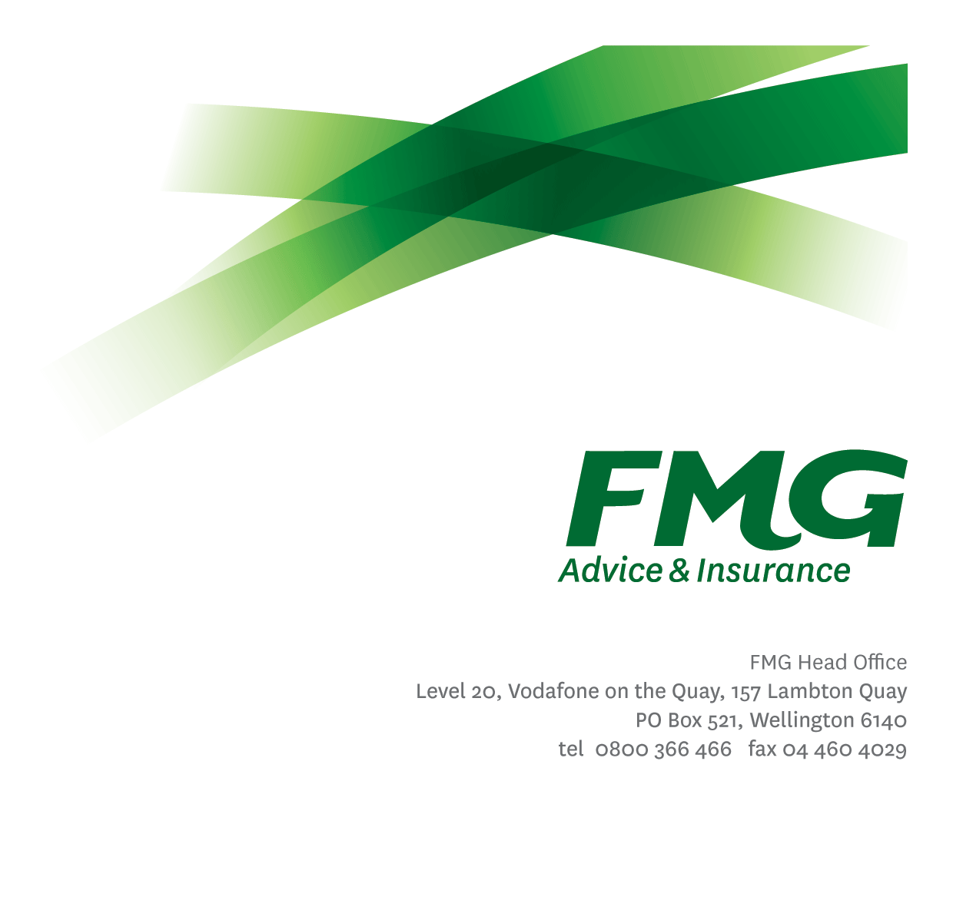Executive Assistant

*Position Description*

*Location:* Wellington

*Reporting to:* EA to the Chief Executive Officer

*Business Unit:* Executive

*Direct Reports:* Nil

*Date Last Reviewed:* August 2025

### *About FMG*

***Formed by farmers for farmers over a century ago, FMG is New Zealand’s leading rural insurer providing risk advice and insurance solutions for farmers, growers, commercial businesses, the lifestyle sector and domestic clients.***

***We’re proudly 100% New Zealand owned and operated and our focus is on helping our clients to achieve their goals.  As a mutual organisation, we’re all about giving rural New Zealanders a better deal, and part of this involves reinvesting all profits back into the business to keep premiums low and ensure the future sustainability of the organisation.***

### *FMG’s Values*

The FMG brand represents promises about what customers can expect from us and each of us is responsible for delivering on these promises. Living our company values means we deliver the best brand experience for our customers. Our company values are:

|  |  |
| --- | --- |
| * Do what’s right | * Make it happen |
| * We’re in it together | * Proud of who we are |

### *Work Environment*

We strive to provide an environment that promotes and fosters achievement. We place importance on career development and training to give our people the tools they need to succeed.

FMG’s Head Office is located in Wellington. Head Office accommodates FMG’s Leadership team, People & Culture, Marketing, Financial Management, Product & Underwriting teams.

FMG also has regional offices in Palmerston North, Christchurch and Branch Offices nationwide.

### *Purpose of the role*

To provide efficient, high quality, proactive administration support. The role may also provide administrative support to other areas of the business as directed by the EA to the CEO.

### *Key Responsibilities*

| Area | Responsibilities |
| --- | --- |
| Administrative Support | Assist in the achievement of FMGs strategic direction through the provision of confidential and efficient administrative support including but not limited to the following:   * Managing calendars and preparing written correspondence on behalf of managers * Supporting the EA to the CEO in developing the annual Executive calendar * Establishing and maintaining an efficient and effective electronic filing system * Developing agendas for meetings, coordinating attendees/presenters, timings and attendees. * Attendance and support at meetings, preparation of minutes, reports, presentations, photocopying, filing and other support * Regular coordination, preparation and review of reports as requested by managers * Booking travel and accommodation requirements as required * Preparation of correspondence, reports and presentations * Maintaining and following up on the reporting manager’s direct reports (e.g. training & development plans) * Collaborating with other business units to ensure administrative requirements are delivered in a timely fashion * Monitoring monthly expense reports and raising any incorrect coding and over spends with managers * Follow up coding of managers monthly visa expenses, and checking of direct report coding prior to manager signoff * Ensuring signoff and payment of invoices |
| Compliance | * Supporting the reporting manager to complete compliance certificates in a timely manner * Assisting with the implementation of support plans to remediate compliance certificate breaches * Assisting the reporting manager with compliance breaches discussions and action plans with team members before compliance certificates are signed * Monitoring when DA requirements are due and prompts the reporting manager to ensure DA requirements are completed on time * In consultation with the reporting manager, ensuring that changes and updates to compliance requirements are communicated at regular team meetings. * Complies with company policies, guidelines and procedures |
| Customer Service | * Ensuring the provision of excellent customer service to internal and external stakeholders |
| Team Membership | * Participating fully as a member of Executive Assistant Team, and wider FMG through the effective and efficient performing of other duties as may be required from time to time |
| Risk and Quality | * Ensuring overall compliance with legislation regulations and FMG policies through the use of established systems |
| Wellbeing and Safety | * Complies with safety and wellbeing policy and procedures, including accident and incident reporting and hazard management requirements * Works in a safe manner at all times and does not undertake activities without appropriate training |

|  |  |
| --- | --- |
| **COMPETENCIES** | |
| *\*see competency framework for behaviours expected at each level* | *Expected Level* |
| **Client Driven (Internal & External)**  A commitment to understanding the needs and best interests of both internal and external clients, in order to provide them with outstanding customer service and help them to make informed decisions. | Intermediate* |
| **Accountability**  Taking Executive ownership of decisions, behaviour, and development, and being responsible for how these actions impact on the wider organisation and customers. | Intermediate* |
| **Adaptability**  Demonstrating a willingness to engage in a changing environment and being flexible and comfortable working with change. | Intermediate* |
| **Motivation and Drive**  The determination to achieve goals and strive for excellence. | Intermediate* |
| **Relationship Building**  Developing and maintaining positive, professional relationships that are built on mutual trust and respect. | Intermediate* |
| **Team Work**  Making a positive contribution to the FMG team and collaborating effectively with others to achieve objectives. | Intermediate* |
| **Critical Analysis**  The capability to identify key issues, trends, or important facts from information and to question and probe. | Competent |

|  |  |
| --- | --- |
| **KNOWLEDGE** | |
| **Qualifications** | Relevant Tertiary Qualification or experience desirable. |
| **Business Awareness** | Understands the internal workings of FMG and how business works; understands FMG's position in the advice and insurance market and knows the competition. |
| **Risk/Insurance Knowledge** | Understands risk and how to apply FMG's policies to situations; is knowledgeable about compliance requirements; understands the insurance process and how claims are managed; knows industry partners and competitors. |
| **Legal Knowledge** | Has legal knowledge e.g. indemnity, liability, the Privacy Act etc. |

|  |  |
| --- | --- |
| **SKILLS** | |
| **Written Communication Skills** | Able to write clear and concise communications, and business reports. |
| **Listening Skills** | Demonstrates active listening skills through eye contact, paraphrasing, appropriate body language and checking understanding. |
| **Technology Skills** | Can expertly use relevant software and technology to its full capacity e.g. MS Word, Excel and PowerPoint. |
| **Risk Assessment Skills** | Identifies, understands and mitigates the risks that may impact on FMG's strategy, initiatives and reputation. |

### *Relationship*

|  |  |  |
| --- | --- | --- |
| External | Internal | Committees/Groups |
| * Business Partners * Business Contacts * FMG Customers | * [Relevant ELT Member] * Other FMG ELT Members * FMG Executive Assistants * [Relevant ELT wider Team] | * [Relevant ELT Member LT] |

### *Financial Authority Levels*

* As agreed and outlined in Appendix 1

### *People Advisory Authority Levels*

* Not applicable

### *Agreement*

I agree to the outline of the role as contained in this document and recognise that the contents may need to be amended from time to time to reflect changing business requirements.

I as job holder, allow my Manager to gather information from third parties where necessary for the purposes of performance management.

|  |  |
| --- | --- |
| Executive Assistant’s Name: |  |
| Signature: |  |
| Date: |  |