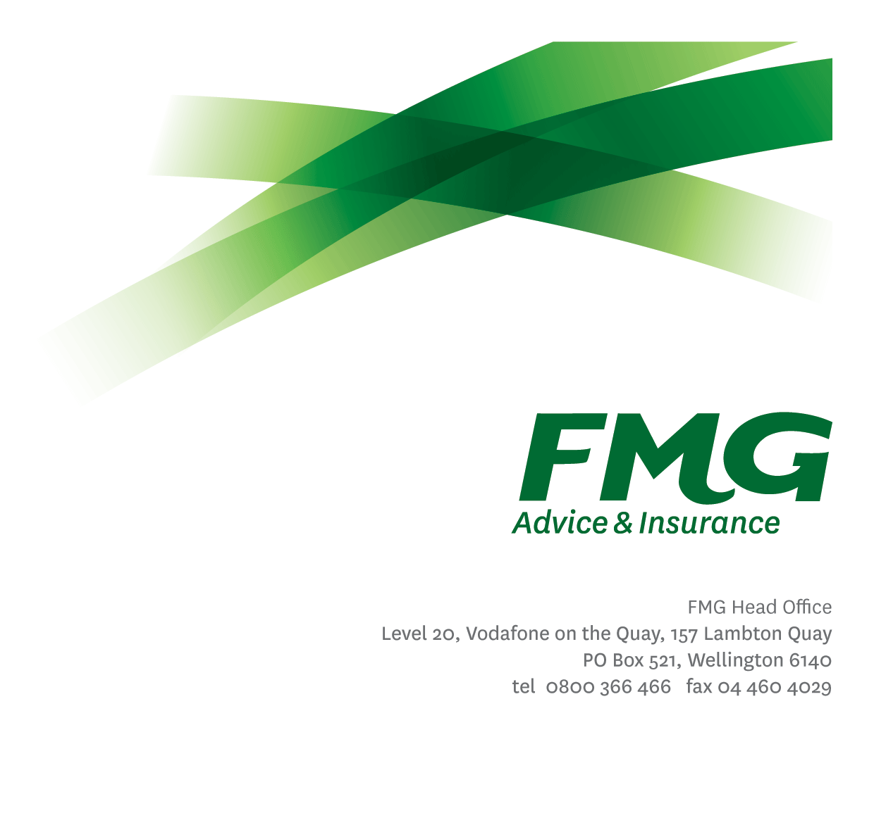Head of Compliance

*Position Description*

*Location:* Wellington

*Reporting to:* Chief Risk Officer

*Business Unit:* Risk

*Direct Reports:* Various

*Date Last Reviewed:* June 2025



### *About FMG*

***Formed by farmers for farmers over a century ago, FMG is New Zealand’s leading rural insurer providing risk advice and insurance solutions for farmers, growers, commercial businesses, the lifestyle sector and residential clients.***

***We’re proudly 100% New Zealand owned and operated, and our focus is on helping our clients to achieve their goals.  As a mutual organisation, we’re all about giving rural New Zealanders a better deal, and part of this involves reinvesting all profits back into the business to keep premiums low and ensure the future sustainability of the organisation.***



### *FMG’s Values*

The FMG brand represents promises about what clients can expect from us and each of us is responsible for delivering on these promises. Living our company values means we deliver the best brand experience for our clients. Our company values are:

|  |  |
| --- | --- |
| * Do what's right - Whāia te ara tika | * Make it happen - Whakatutukitia |
| * We're in it together - Ko tātau tātau | * Proud of who we are - Whakahīhī i te whakapapa |



### *Work Environment*

We strive to provide an environment that promotes and fosters achievement. We place importance on career development and training to give our people the tools they need to succeed.

FMG’s Head Office is located in Wellington and accommodates FMG’s Executive Leadership Team (ELT), Client Propositions & Online Services, People & Culture and Communications, Financial Management, Product & Pricing and Underwriting, Reinsurance, Business Information and Analysis, Legal and Compliance.

FMG’s largest regional office is located in Palmerston North accommodating our National Sales & Advice Centre, Information Technology, Claims, Operations and Payments functions. In addition to the offices in Wellington, Palmerston North and Christchurch FMG has offices in 30 regional locations throughout New Zealand.



### *Purpose of the role*

The Head of Compliance is responsible for compliance management at FMG and the development and execution of processes for the measuring and management of compliance in relation to legislative, regulatory and Industry code requirements and providing recommendations on improvements to internal controls and business processes.

As a Mutual Leader at FMG, you will bring FMG’s Purpose, Vision and Strategy to life through accountability for delivery of FMG’s Business Plan in line with the Mutual’s overall strategic direction. You are tasked with running the Mutual, performing and transforming whilst continuing to ensure FMG remains relevant in a dynamic external environment and marketplace. They are accountable for protecting and growing the Mutual.

### *Key Responsibilities*

| Area | Responsibilities |
| --- | --- |
| People Leadership | * Provide leadership to direct reports to support achievement of results. * Manage the on-going coaching and professional development of the team to ensure full competence in their roles. Provide feedback and coaching to the team to develop their skills and competencies. * Communicate and share information with the team on a regular basis, both formally and informally. * Ensure individual and team performance is managed and measured appropriately, identifies issues, or trends and removes performance barriers or escalates appropriately. * In conjunction with People & Culture, implement an internal talent management and capability process/plan and ensure succession plans for key positions are in place. |
| Compliance | * Responsible for the development, implementation, and on-going function of FMG’s Compliance framework ensuring we have the policies, processes, systems and controls to support a robust framework and culture at FMG, including the policies, processes and procedures required to support FMG’s compliance with its licence obligations under the Financial Markets Conduct Act. * Responsible for the development, implementation, and on-going function of the Delegated Authorities framework to ensure a robust framework is in place. * Ensure the effective management of the FMG Compliance Register. * Ensure the effective management of the FMG Breach Register, including working with internal stakeholders to remedy the consequences of any breach and address the root cause. * Develop testing plans to measure and report on the effectiveness of FMG’s internal controls used to satisfy compliance requirements. * Conduct testing of FMG’s internal controls in accordance with the testing plans and provide reporting of results. * To coordinate and contribute to the provision of reporting on Operational Risk and Compliance Committee outcomes for the Enterprise Risk and Compliance Committee. * To coordinate and contribute to the support of the Enterprise Risk and Compliance Committee, as required. * Contribute to the effective management of FMG’s Internal Audit program. * Provide recommendations on improvements to internal controls and business processes |
| Continuous Improvement | * Acts as a subject matter expert for any wider business change that impacts compliance or have implications on compliance. |
| Stakeholder Management | * Establishes and maintains stakeholder management and engagement at an operational level to ensure effective embedding of compliance frameworks and processes. * Maintains a high level of communication with all stakeholders, ensuring expectations are appropriately set and required communications are effective and reach the desired audiences. * Identifies, develops, and maintains an external network of relationships necessary to help deliver on FMG’s compliance requirements. * Proactively assists and supports other FMG colleagues and stakeholders |
| Personal Development | * Maintain own knowledge base of best practice and act as an expert resource in compliance across FMG. |
| Team Participation | * Contribute broadly to strategic and operational discussions and decisions as a member of the Risk Leadership Team. * Undertake additional duties as directed by the Chief Risk Officer. |
| Wellbeing & Safety | * Promote and support initiatives that contribute to a healthy and safe working environment for employees, visitors, and contractors. * Ensure compliance with Wellbeing & Safety policy and procedures, including accident and incident reporting and investigation, hazard management, induction, training and supervision, employee participation and contractor management. * Works in a safe manner at all times and does not undertake activities without appropriate training |

|  |  |
| --- | --- |
| **COMPETENCIES** | |
| *\*see competency framework for behaviours expected at each level* | *Expected Level* |
| **Customer Driven (Internal & External)**  A commitment to understanding the needs and best interests of both internal and external customers, to provide them with outstanding customer service and help them to make informed decisions. | Advanced* |
| **Accountability**  Taking personal ownership of decisions, behaviour, and development, and being responsible for how these actions impact on the wider organisation and clients. | Advanced* |
| **Adaptability**  Demonstrating a willingness to engage in a changing environment and being flexible and comfortable working with change. | Advanced* |
| **Motivation and Drive**  The determination to achieve goals and strive for excellence. | Advanced* |
| **Relationship Building**  Developing and maintaining positive, professional relationships that are built on mutual trust and respect. | Advanced* |
| **Teamwork**  Making a positive contribution to the FMG team and collaborating effectively with others to achieve objectives. | Advanced* |
| **Problem Solving**  The ability to understand information from a variety of sources and think quickly on one’s feet. The ability to effectively combine verbal and numeric data into a coherent whole. | Advanced* |
| **Critical Analysis**  The capability to identify key issues, trends, or important facts from information and to question and probe. | Advanced* |
| **Change Leadership**  The drive to initiate opportunities to address FMG’s organisational needs and to communicate change in a way that gains buy-in and support from others. | Advanced* |
| **Strategic Thinking**  The capacity to stand apart from the day-to-day and take a long-term, big picture view of the business. | Intermediate* |

|  |  |
| --- | --- |
| **KNOWLEDGE & EXPERIENCE** | |
| **Qualifications & Experience** | * Bachelor’s degree in law, business management or similar discipline * Minimum 10 years’ Experience in financial services, preferably in insurance * Specialist knowledge and experience working in a regulated environment. * Senior Compliance experience, including developing and implementing strategies. * Extensive legislative and compliance knowledge, including the Financial Markets Conduct Act and the Insurance (Prudential Supervision) Act (and the licensing regimes relevant to that legislation). |
| **Risk/ Insurance Knowledge** | * Extensive insurance industry knowledge and experience * Is knowledgeable about compliance requirements; understands the insurance process and how claims are managed; knows industry partners and competitors. |
| **Business Knowledge and Industry Awareness** | * Understands how businesses work and the commercial nature of doing business (including appreciation for how a mutual operates) * Understands FMG's position in the advice and insurance market and has knowledge of the competitive landscape. * Affinity with the rural community and keeps up to date with the economic, political, and environmental issues affecting our clients. |
| **Change Leadership** | * Ability to deal with ambiguity, be agile in response to business needs, manage competing priorities and coach other through change. |

|  |  |
| --- | --- |
| **SKILLS** | |
| **Verbal Communications Skills** | * Communicates clearly in order to present information to persuade and influence others. * Able to articulate information in a way that matches the skills and capabilities of the audience |
| **Listening Skills** | * Demonstrates active listening skills through eye contact, paraphrasing, appropriate body language and checking understanding. |
| **Written Communication Skills** | * Able to write clear, concise, and persuasive proposals and reports. |

### *Key Relationships*

|  |  |  |
| --- | --- | --- |
| External | Internal | Committees/Groups |
| * Auditors * Regulators RBNZ/ FMA | * Risk Leadership Team * General Counsel * Executive Leadership Team * Board Risk and Audit Committee | * Operational Risk and Compliance Committee (ORCC) * Enterprise Risk and Compliance Committee (ERCC) * Board Risk and Audit Committee (BRAC) * Conduct and Culture Committee (CCC) |

### *Financial Authority Levels*

* As per delegated authorities

### *People Advisory Authority Levels*

* Not applicable

### *Agreement*

I agree to the outline of the role as contained in this document and recognise that the contents may need to be amended from time to time to reflect changing business requirements.

I as Job holder, allow my Manager to gather information from third parties where necessary for the purposes of performance management.

|  |  |
| --- | --- |
| Head of Compliance’s Name: |  |
| Signature: |  |
| Date: |  |