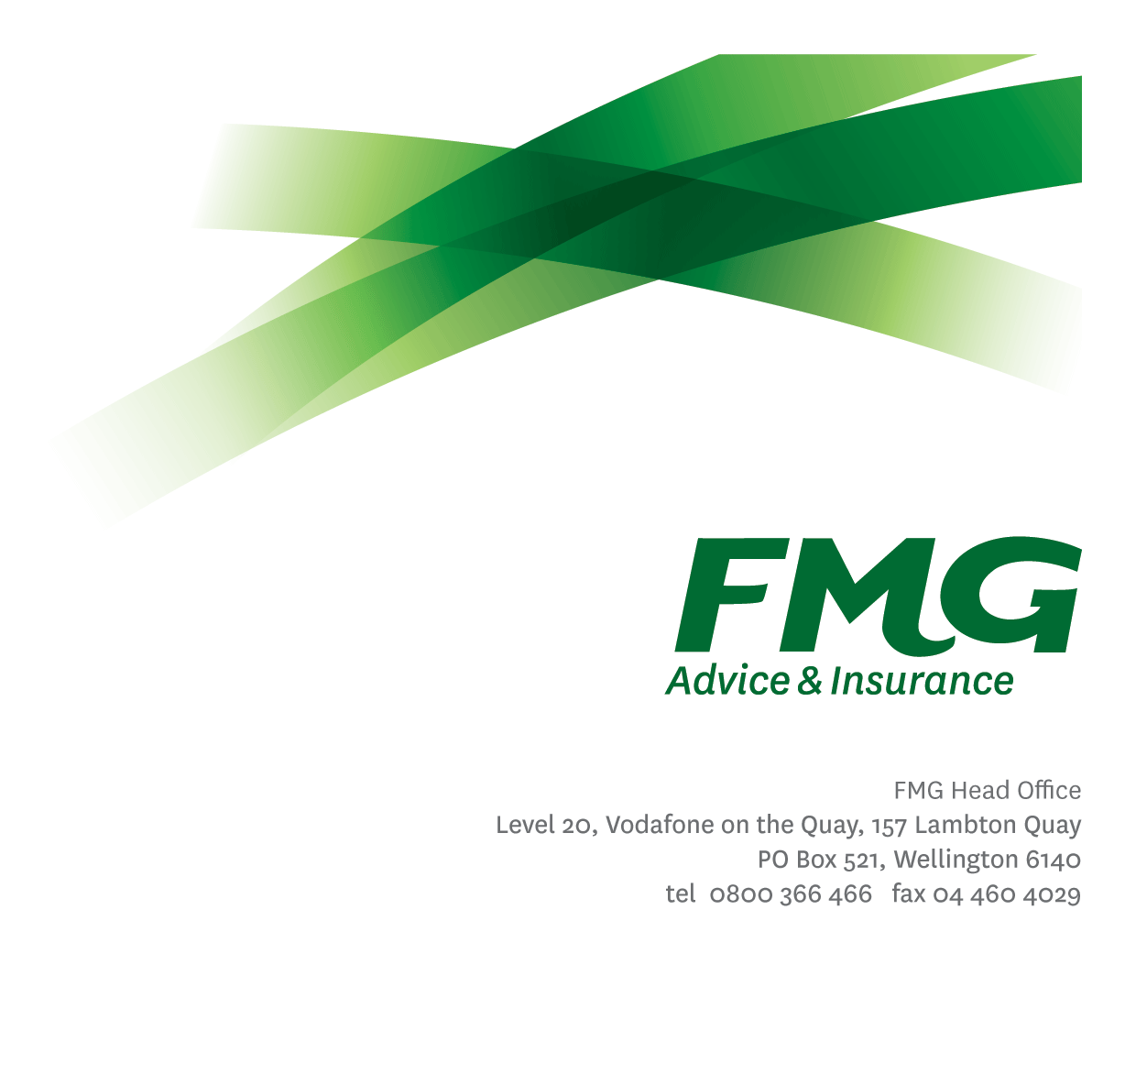Life & Health Best Practice Lead

*Position Description*

*Location:* Palmerston North, Feilding, Various

*Reporting to:* Life & Health Centre Manager

*Business Unit:* Sales, Advice & Service

*Direct Reports:* 0

*Date Last Reviewed:* January 2025

### *About FMG*

***Formed by farmers for farmers over a century ago, FMG is New Zealand’s leading rural insurer providing risk advice and insurance solutions for farmers, growers, commercial businesses, the lifestyle sector and domestic clients.***

***We’re proudly 100% New Zealand owned and operated and our focus is on helping our clients to achieve their goals.  As a mutual organisation, we’re all about giving rural New Zealanders a better deal, and part of this involves reinvesting all profits back into the business to keep premiums low and ensure the future sustainability of the organisation.***

### *FMG’s Values*

The FMG brand represents promises about what clients can expect from us and each of us is responsible for delivering on these promises. Living our values means we deliver the best brand experience for our clients. Our organisational values are:

|  |  |
| --- | --- |
| * Do what’s right - Whāia te ara tika | * Make it happen - Whakatutukitia |
| * We’re in it together - Ko tātau tātau | * Proud of who we are Whakahīhī i te whakapapa |

### *Work Environment*

We strive to provide an environment that promotes and fosters achievement. We place importance on career development and training to give our people the tools they need to succeed. Fostering a culture of Wellbeing and Safety is also a critical element.

FMG’s Head Office is located in Wellington and accommodates FMG’s Leadership Team, Marketing & Risk Services, Human Resources, Client Propositions, Financial Management, Underwriting and Risk Quality, Reinsurance, Business Information and Analysis, and Legal and Compliance.

FMG’s largest regional office is located in Palmerston North accommodating our National Service Centre, Insurance Consultants, Information Technology, Claims, Operations and Payment functions. Approximately 300 employees are located there. FMG’s largest office in the South Island is Christchurch. In addition to the offices in Wellington, Palmerston North and Christchurch – FMG has smaller offices in 30 regional locations throughout New Zealand.

### *Purpose of the role*

The Life & Health Best Practice Lead will be responsible for providing technical expertise, training, and support to the Life & Health Adviser team (inclusive of mobile and Centre based Advisers), ensuring the delivery of professional and quality service to all FMG clients.

The Life & Health Best Practice Lead will enhance team capability, ensure compliance, and promote best practice through technical coaching and mentoring. Additionally, they will use risk quality results to translate learnings into coaching or training requirements.

They will also work collaboratively with the Sales Development Manager - L&H, National Sales Manger – L&H, external provider partners (Fidelity, Southern Cross and AIA Insurance), the NASC team as well as L&D, and Risk Quality to ensure best practice and process changes are embedded and will be expected to build strong relationships across the SAS teams.

### *Key Responsibilities*

| Area | Responsibilities |
| --- | --- |
| Training on best practice | * Provide a ‘centre of excellence’ technical training service to support all Life & Health Advisers. * Provide regular one-on-one or group training to relevant members of the Life & Health team (including, but not limited to Life & Health Advisers and Life & Health Advisers (Mobile)) * Provide regular call coaching for the Centre Life & Health Advisers in collaboration with the Team Leader and the Centre Manager. * Develop the training plan for new field advisers and provide support on learning outside of the SDM role (e.g. procedures, provider accreditation, Level 5 etc.). * Provide group training to all advisers as required (e.g. Fidelity Life e-app adoption etc). * Confidently deliver Life & Health insurance training for advisers both in person (Manawatu) and virtually, covering a wide range of partner provider insurance products for new L&H Centre employees. This includes collaborating with external providers to arrange necessary training sessions and support. * Keep abreast of industry changes as relevant to the role. * Undertake tasks as directed by the Life & Health Centre Manager. |
| Facilitation and content development and delivery | * Collaborate with Subject Matter Experts across the Mutual and partner providers to translate technical insurance “speak” into easily understood coaching material for a range of employees from new starters to experienced and tenured. * Develop facilitation resources to support one on one and group learning. |
| Professional Development | * Maintains knowledge of FMG’s approach (including any changes) for all FMG’s segments and policies * Proactively maintain and enhance knowledge of all FMG Life & Health Insurance products and services and relevant industry topics through attending internal training sessions, external seminars, and study programs. * Proactively ensures a high level of technical acumen for themselves by proactively maintaining industry and technical training and knowledge. |
| Relationship Management | * Establishes and maintains professional relationships with internal and external stakeholders. |
| Compliance & Risk Quality | * Ensures compliance with legislative, regulations and FMG policies through the monitoring of systems, processes and improvements. * Understands, interprets and applies FMG product coverage, conditions, limitations and exceptions relevant to each client’s circumstances. * Write all business within the delegated authority levels. * Prepares concise and accurate information. * Ensures all records of call and data entry in PolicyCentre and other related software / databases are correct; with a focus on data quality is maintained. |
| Wellbeing & Safety | * Complies with safety and wellbeing policy and procedures, including accident and incident reporting and hazard management requirements * Works in a safe manner at all times and does not undertake activities without appropriate training |
| FMG Values | * Promote the “FMG Way” through displaying the values of FMG which are: Do what’s right, Make it happen, We’re in it together, Proud of who we are. |

|  |  |
| --- | --- |
| **COMPETENCIES** | |
| *\*see competency framework for behaviours expected at each level* | *Expected Level* |
| **Client Driven (Internal & External)**  A commitment to understanding the needs and best interests of both internal and external clients, in order to provide them with outstanding client service and help them to make informed decisions. | Advanced* |
| **Accountability**  Taking personal ownership of decisions, behaviour, and development, and being responsible for how these actions impact on the wider organisation and clients. | Intermediate* |
| **Adaptability**  Demonstrating a willingness to engage in a changing environment and being flexible and comfortable working with change. | Advanced* |
| **Motivation and Drive**  The determination to achieve goals and strive for excellence. | Intermediate* |
| **Relationship Building**  Developing and maintaining positive, professional relationships that are built on mutual trust and respect. | Advanced* |
| **Team Work**  Making a positive contribution to the FMG team and collaborating effectively with others to achieve objectives. | Intermediate* |
| **Critical Analysis**  The capability to identify key issues, trends, or important facts from information and to question and probe. | Intermediate* |

|  |  |
| --- | --- |
| **KNOWLEDGE** | |
| **Qualifications** | Relevant Tertiary Qualification preferrable  Experience in a leadership, coaching or senior role is essential  Proven experience training/coaching others is essential  Insurance experience and achieved or working towards NZ Certificate in Financial Services Level 5 or equivalent and associate ANZIIF qualification is desirable.  This is required to be obtained by 12 months of tenure.  Ability to create and facilitate learning material preferred. |
| **Business Awareness** | Understands the internal workings of FMG and how business works; understands FMG's position in the advice and insurance market and knows the competition. |
| **Legal Knowledge** | Has legal knowledge e.g. indemnity, liability, the Privacy Act etc. |
| **Product Knowledge** | Is knowledgeable about FMG's insurance policies and packages, the differences between them, and the appropriateness of each in different situations. |
| **Risk/Insurance Knowledge** | Understands risk and how to apply FMG's policies to situations; is knowledgeable about compliance requirements; understands the insurance process and how claims are managed; knows industry partners and competitors. |
| **Change Management** | Knowledge of change management principles, methodologies and tools; understands the change process and how people go through change |

|  |  |
| --- | --- |
| **SKILLS** | |
| **Written Communication Skills** | Proven ability in structuring, writing and maintaining technical documents.  Ability to communication ideas clearly, concisely, correctly for technical and non-technical readers. |
| **Verbal Communications Skills** | Communicates clearly in order to present information to persuade and influence others. |
| **Listening Skills** | Demonstrates active listening skills through eye contact, paraphrasing, appropriate body language and checking understanding. |
| **Technology Skills** | Can expertly use relevant software and technology to its full capacity e.g. MS Word, Excel and PowerPoint. |
| **Risk Assessment Skills** | Can put in place plans to mitigate risks and manage issues. |

### *Relationship*

|  |  |  |
| --- | --- | --- |
| External | Internal | Committees/Groups |
| * Clients * Partner Insurance Providers (Fidelity, AIA and Southern Cross) * External Service providers * Other Insurance Providers | * L&H Advisers * L&H Advisers (Mobile) * NASC Consultants * NASC Team Leaders * NASC Technical Leads * NASC Managers * Head of National Advice & Service Centre * Learning & Delivery Team * Risk Quality * SAS Operations * All FMG employees | * As directed |

### *Financial Authority Levels*

* No authority to commit or approve expenditure

### *Human Resources Authority Levels*

* Not applicable

### *Agreement*

I agree to the outline of the role as contained in this document and recognise that the contents may need to be amended from time to time to reflect changing business requirements.

I as Job holder, allow my Manager to gather information from third parties where necessary for the purposes of performance management.

|  |  |
| --- | --- |
| Name: |  |
| Signature: |  |
| Date: |  |