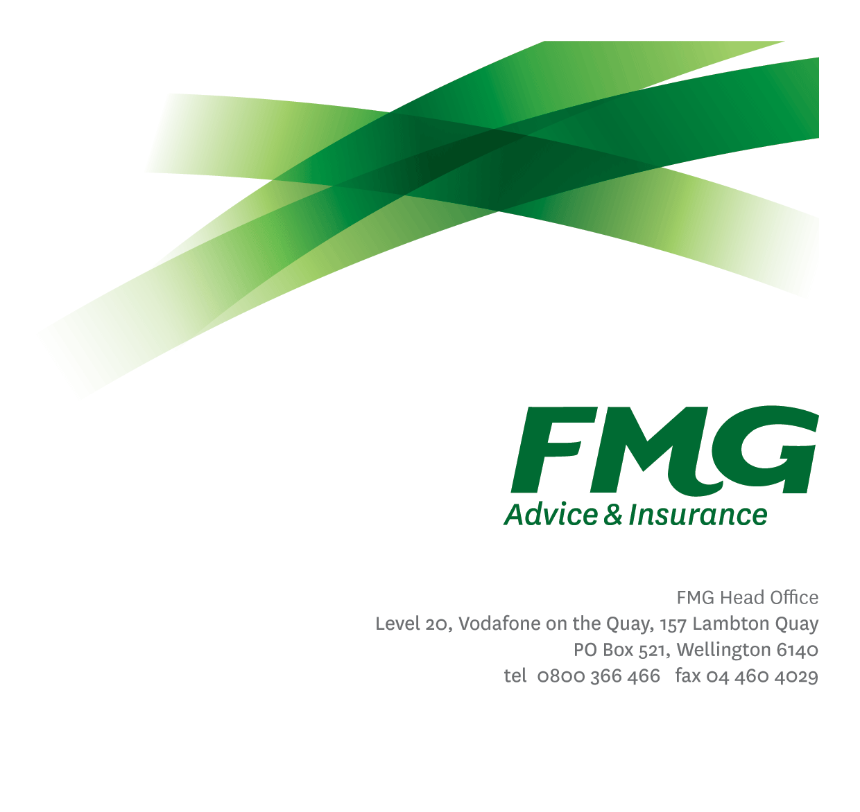
Client Insights Specialist
Position Description
Location: As per Personal Terms
Reporting to: Head of Client Propositions and Loss Prevention
Business Unit: Client Propositions and Loss Prevention
Direct Reports: Nil
Date Last Reviewed: Mar 2026

About FMG
Formed by farmers for farmers over a century ago, FMG is New Zealand’s leading rural insurer providing risk advice and insurance solutions for farmers, growers, commercial businesses, the lifestyle sector and residential clients.
We’re proudly 100% New Zealand owned and operated, and our focus is on helping our clients to achieve their goals. As a mutual organisation, we’re all about giving rural New Zealanders a better deal, and part of this involves reinvesting all profits back into the business to keep premiums low and ensure the future sustainability of the organisation.

FMG’s Values
The FMG brand represents promises about what customers can expect from us and each of us is responsible for delivering on these promises. Living our company values means we deliver the best brand experience for our customers. Our company values are:
- Do what's right - Whāia te ara tika | - Make it happen - Whakatutukitia
- We're in it together - Ko tātau tātau | - Proud of who we are - Whakahīhī i te whakapapa

Work Environment
We strive to provide an environment that promotes and fosters achievement. We place importance on career development and training to give our people the tools they need to succeed. Fostering a culture of Wellbeing and Safety is also a critical element.
FMG’s Head Office is located in Wellington and accommodates FMG’s Executive Leadership Team, Client Propositions, Marketing & Advice Services, Human Resources, Financial Management, Underwriting, Reinsurance, Business Information and Analysis, and Legal and Compliance.

FMG’s largest regional office is located in Palmerston North accommodating our National Sales & Service Centre, Insurance Consultants, Commercial Consultants, Information Technology, Claims, Operations and Payment functions. Approximately 300 employees are located there. FMG’s largest office in the South Island is Christchurch. In addition to the offices in Wellington, Palmerston North and Christchurch – FMG has smaller offices in 30 regional locations throughout New Zealand.

Purpose of the role
Responsible for developing relevant and timely data-driven insights that support better decision making in the development and delivery of client growth strategies and client experience initiatives, leveraging modern analytics tools and practices. The role also promotes the effective use of AI and advanced analytics to improve the speed, accuracy, and accessibility of insights as FMG continues to uplift its data and analytics capabilities.
This role will also be responsible for driving AI adoption to enhance the quality and speed of insights. To provide expert data collection and analysis to the Client Propositions and Loss Prevention team, reflecting the Voice of the Client. This role has a primary responsibility to provide actionable insights that enable the provision of exceptional client experiences, supporting Client Propositions and Loss Prevention strategies.

Key Responsibilities
 | Area | Responsibilities
Voice of the Client |  | - Responsible for the managing the execution of the annual research plan that best enables the provision of actionable insights to drive exceptional client experiences.
 | Data and Information Analysis | - Design and develop appropriate extracts and data sets, including data from external sources, for analysis, visualisation, and interpretation.  - Extract and organise data and information from FMG systems and external sources to enable further analysis.  - Present and discuss findings with stakeholders using data storytelling and visualisation techniques  - Apply appropriate analytical techniques to test hypotheses, identify drivers of client behaviour, and evaluate the effectiveness of client initiatives.  - Identify, prototype, and assess advanced analytics and AI use cases that improve insight quality, speed, or accessibility, working in partnership with Data & Digital.  - Support the transition of proven analytics and AI solutions from pilot to scalable business use, within agreed governance and ethical standards.
 | Insight and Data Communication and Visualisation | - Frame insights in the context of business questions, trade-offs, and implications to support effective decision-making by senior stakeholders.  - Translation of highly technical business intelligence into an easily understandable form for non-technical users.  - Provide constructive challenge to assumptions using evidence-based insights.  - Utilise data visualisation and story-telling techniques to communicate insights to a wide range of key stakeholders.  - Coordinate and liaise with stakeholders to ensure that analytics output meets their needs.  - Build and maintain effective working relationships with all stakeholders and ensure good working relationships are maintained with all FMG employees.
 | Decision Support & Strategic Enablement | - Provide insight-led recommendations to support prioritisation, investment, and design decisions across Client Propositions and Loss Prevention  - Partner with leaders to clarify decision questions and ensure insights are timely, relevant, and actionable  - Ensure insights are embedded into proposals, strategy documents, and governance forums where appropriate
 | Data Leadership | - Support the development and use of the client data strategy, standards, and methodologies.  - Ensure data and analytics processes adhere to FMG's Data Ethics principles and standards.  - Champion high standards of data integrity, ethical use, and analytical best practice across client insight activities.  - Contribute to the development of enterprise insight standards, tools, and practices as FMG’s analytics maturity evolves.  - Evaluate data needs of assigned projects, assure data integrity and suitability, and determine collection methods, metrics, definitions and evaluation methods.  - Provide expert advice on the integration of insights into other FMG business units, processes, and platforms, e.g., FMG Connect.
 | Relationship Management and User Engagement | - Build trusted advisory relationships with stakeholders, influencing thinking through clear, credible, and well-evidenced insights.  - Provides user support, mainly to internal clients, on a regular basis.  - Works with business partners to achieve the client experience strategy.
 | Risk and Quality | - Ensures overall compliance with legislation regulations and FMG policies through the use of established systems.
 | Team Membership and Other Duties | - Proactively assists and supports Client Propositions and Loss Prevention team colleagues and other stakeholders.  - Shares information and resources and provides feedback in a positive and collaborative manner.  - Is recognised as a valued team member of the team and completes tasks in an agreed timeframe and of an agreed quality, to the Head of Client Propositions and Loss Prevention.  - Undertake tasks as directed by the Head of Client Propositions and Loss Prevention as required.
 | Wellbeing & Safety | - Complies with safety and wellbeing policy and procedures, including accident and incident reporting and hazard management requirements  - Works in a safe manner at all times and does not undertake activities without appropriate training
 | COMPETENCIES
 | *see competency framework for behaviours expected at each level |  | Expected Level
 | Customer Driven (Internal & External)  A commitment to understanding the needs and best interests of both internal and external customers, in order to provide them with outstanding customer service and help them to make informed decisions. |  | Intermediate*
 | Critical Analysis  The capability to identify key issues, trends, or important facts from information and to question and probe. |  | Advanced*
 | Accountability  Taking personal ownership of decisions, behaviour, and development, and being responsible for how these actions impact on the wider organisation and customers. |  | Advanced*
 | Adaptability  Demonstrating a willingness to engage in a changing environment and being flexible and comfortable working with change. |  | Advanced*
 | Motivation and Drive  The determination to achieve goals and strive for excellence. |  | Advanced*
 | Relationship Building  Developing and maintaining positive, professional relationships that are built on mutual trust and respect. |  | Intermediate*
 | Team Work  Making a positive contribution to the FMG team and collaborating effectively with others to achieve objectives. |  | Advanced*

KNOWLEDGE
Qualifications | Relevant Tertiary Qualification required plus 3-5 years’ experience OR  At least 5 years’ experience in relevant roles with clear demonstration on having the required skills.
Business Awareness | Understands the environment in which FMG operates and how business works.
Specialist Knowledge | Knowledge of analytics principles and best practice.  Knowledge of and experience in using statistical modelling in a business context.

SKILLS
Technology Skills | Able to adapt to new tools and technologies as analytics and AI capabilities evolve. e.g. M365, SAS Visual Analytics.
Specialist Skills | Advanced analytical capability using appropriate statistical, analytical, and visualisation tools to solve complex business problems.  Experience working with modern analytics platforms, data visualisation tools, and/or cloud-based analytics environments.  Statistical modelling  Able to develop visualisations that communicate results of analytics and/or enable further exploration
Written Communication Skills | Able to write clear, concise, and persuasive proposals and reports.
Verbal Communications Skills | Communicates effectively to present information to others.
Listening Skills | Demonstrates active listening skills through eye contact, paraphrasing, appropriate body language and checking understanding.

Relationship
External | Internal | Committees/Groups
- Research Partners  - Subject Matter Experts | - Client Propositions and Loss Prevention  - Data and Digital  - Analyst community  - Marketing and Propositions  - Sales, Advice, and Service  - Insurance Solutions  - Claims and Assessing  - Finance | - Analytics Community of Practice

Financial Authority Levels
- No authority to commit or approve expenditure

People and Culture Authority Levels
- Not applicable

Agreement
I agree to the outline of the role as contained in this document and recognise that the contents may not be altered without mutual agreement but recognise that these duties may need to be amended from time to time to reflect changing business requirements.

I as Job holder, allow my Manager to gather information from third parties where necessary for the purposes of performance management.

Client Insight Specialist’s Name:
Signature:
Date:

