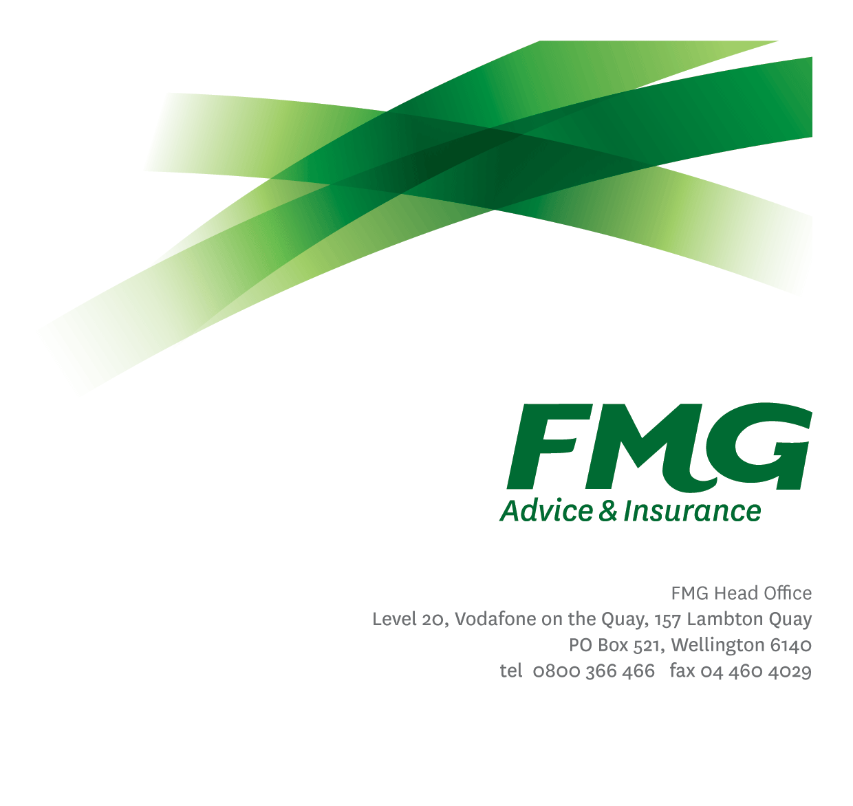
Senior Management Accountant
Position Description

Location: Wellington
Reporting to: Financial Controller
Business Unit: Finance and Investment
Direct Reports: Nil
Date Last Reviewed: April 2024

About FMG
Formed by farmers for farmers over a century ago, FMG is New Zealand’s leading rural insurer providing risk advice and insurance solutions for farmers, growers, commercial businesses, the lifestyle sector and domestic clients.
We’re proudly 100% New Zealand owned and operated and our focus is on helping our clients to achieve their goals. As a mutual organisation, we’re all about giving rural New Zealanders a better deal, and part of this involves reinvesting all profits back into the business to keep premiums low and ensure the future sustainability of the organisation.

FMG’s Values
The FMG brand represents promises about what customers can expect from us and each of us is responsible for delivering on these promises. Living our company values means we deliver the best brand experience for our clients. Our company values are:
- Do what’s right | - Make it happen
- We’re in it together | - Proud of who we are

Work Environment
We strive to provide an environment that promotes and fosters achievement. We place importance on career development and training to give our people the tools they need to succeed.

Purpose of the role
To provide financial expertise, advice and support to the management accounting area and financial support to organizational efficiency and cost reduction initiatives enabling critical business decisions to be made and strategies adopted for organisational growth and wellbeing.

Key Responsibilities
Area | Responsibilities
Management Accountant | - Processes accruals and adjustments as required.  - Leads the month-end close process, ensuring revenue and expenses are recognised in the correct accounting period.  - Reviews and analyses monthly results against budget.  - Provides financial expertise and support to budget holders during the budget and forecast processes.  - Provides meaningful insights and advice on the performance of agreed budgets.  - Regularly reviews the budget and forecast models within the Finance system, and the associated processes, to ensure they operate effectively.
Financial Analysis | - Providing financial analysis and support for organizational efficiency and cost reductions initiatives.  - Working alongside business units to define and report on financial benefit realization  - A strong advocate for these initiatives and their long terms importance to the sustainability of the organization.
Reporting | Provides comprehensive and appropriate information on the achievement of financial and operational goals by monitoring, evaluating and reporting on the operational financial performance of FMG through:  - Review and analysis of operational financial results.  - Variance analysis against budgets/targets.  - Financial performance commentary for FMG Managers, Executive team and the Board of Directors.  - Reviews the relevance of financial management reporting and management’s information requirements.  - Compliance with relevant legislation.  - Responsible for the running of monthly XLOne reports for business owners, showing performance against budget.
Business Partnering Support | - Provide support to the Finance Business Partners  - Partners with select business units primarily in a financial advisory capacity, providing insights to support decision making.  - Support business owners with the development of business cases as required.  - Identifies financial and non-financial trends and can translate this in a meaningful way for business owners.  - Keeping abreast of changes within those areas directly supported.
Project Accounting | - Provides support to the designated Project Accountant where required.  - Where required, liaising with Project Managers and the Programme Committee and provides technical accounting expertise to major programmes of work.
Process Improvement | - Regularly reviews current business processes and policies to ensure they are operating as effectively as possible and in line with best practice.  - Preparing and maintaining thorough documentation for end-to-end finance processes.
Team Focus | - Contributes to the effective functioning of the Financial Management team through assisting other team members with any work required.  - Share information and resources and provide feedback in a positive and collaborative manner.  - Undertakes tasks as required by the Financial Controller or Chief Financial Officer.
FMG Values | - Promotes the “FMG Way” through displaying the values of FMG which are: do what’s right; we’re in it together; proud of who we are; and make it happen.
Wellbeing and Safety | - Complies with safety and wellbeing policy and procedures, including accident and incident reporting and hazard management requirements.  - Works in a safe manner at all times and does not undertake activities without appropriate training.
COMPETENCIES
*see competency framework for behaviours expected at each level |  |  | Expected Level
Client Driven (Internal & External)  A commitment to understanding the needs and best interests of both internal and external clients, in order to provide them with outstanding service and help them to make informed decisions. |  |  | Intermediate*
Accountability  Taking personal ownership of decisions, behaviour, and development, and being responsible for how these actions impact on the wider organisation and clients. |  |  | Advanced*
Adaptability  Demonstrating a willingness to engage in a changing environment and being flexible and comfortable working with change. |  |  | Advanced*
Motivation and Drive  The determination to achieve goals and strive for excellence. |  |  | Advanced*
Relationship Building  Developing and maintaining positive, professional relationships that are built on mutual trust and respect. |  |  | Advanced*
Team Work  Making a positive contribution to the FMG team and collaborating effectively with others to achieve objectives. |  |  | Advanced*
Problem Solving  The ability to understand information from a variety of sources and think quickly on one’s feet. The ability to effectively combine verbal and numeric data into a coherent whole. |  |  | Intermediate*
KNOWLEDGEQ
Qualifications |  | Relevant tertiary qualification or equivalent
Systems Knowledge |  | Knowledge of the following systems is preferred: TechnologyOne, BIZi Portal, SAS Visual Analytics
Business Awareness |  | Understands the internal workings of FMG and how business works; understands FMG's position in the advice and insurance market and knows the competition.
Experience |  | Three to four years insurance accounting experience with a good understanding of insurance accounting.
Rural Knowledge |  | Understands the rural community and keep up to date with the economic, political, and environmental issues affecting our clients.

SKILLS
Financial Skills | Able to calculate and understand financial information e.g. profit & loss, forecasts, conducts cost benefit analyses and general financial planning.
Technology Skills | Can expertly use relevant software and technology to its full capacity e.g. MS Word, Excel and PowerPoint.
Listening Skills | Demonstrates active listening skills through eye contact, paraphrasing, appropriate body language and checking understanding.
Verbal Communication Skills | Communicates clearly in order to present information to persuade and influence others.
Written Communication Skills | Able to write clear and concise proposals and reports.

Relationships
External | Internal | Committees/Groups
- External Auditors  - External Suppliers  - Bank Personnel | - Financial Management team  - Internal Audit  - People and Culture team  - All FMG Managers  - Executive team | - Project Steering Groups  - Internal Committees if required i.e. Personal Insurance Committee

Financial Authority Levels
- No authority to approve or commit expenditure

Human Resources Authority Levels
- Not applicable

Agreement
I agree to the outline of the role as contained in this document and recognise that the contents may need to be amended from time to time to reflect changing business requirements.

I as Job holder, allow my Manager to gather information from third parties where necessary for the purposes of performance management.

Senior Management Accountant’s Name:
Signature:
Date:

