Product Specialist

*Position Description*

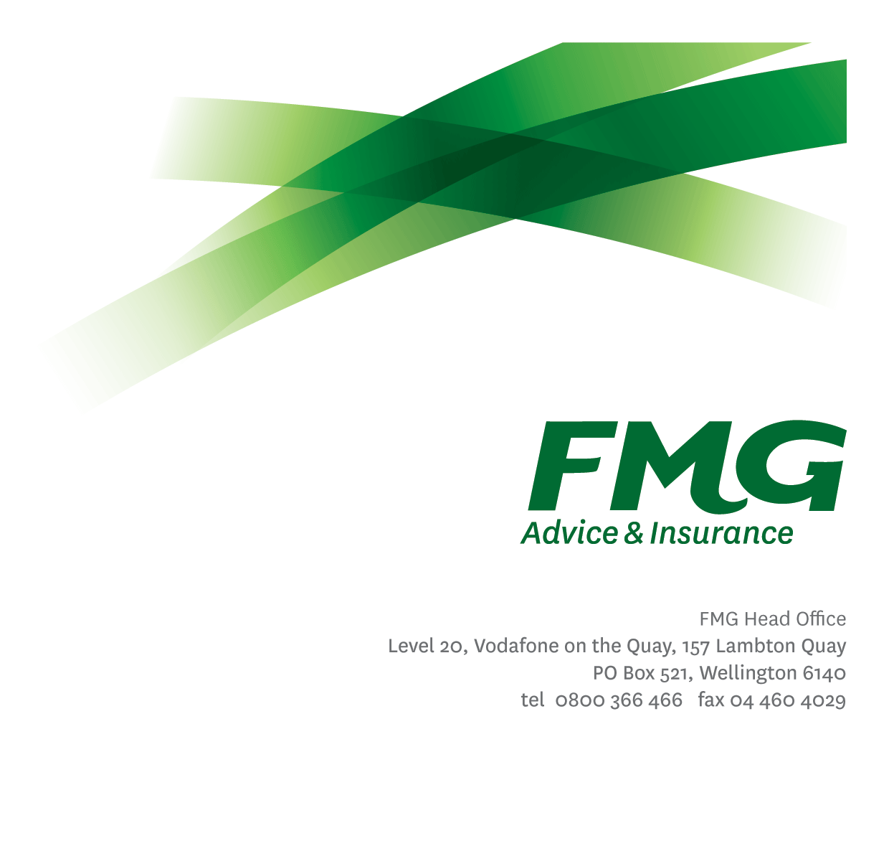

*Location:* As per Personal Terms



*Reporting to:* Senior Product Manager

*Business Unit:* Insurance Solutions

*Direct Reports:* Nil

*Date Last Reviewed:* May 2025

***About FMG***

***Formed by farmers for farmers over a century ago, FMG is New Zealand’s leading rural insurer providing risk advice and insurance solutions for farmers, growers, commercial businesses, the lifestyle sector and domestic clients.***

***We’re proudly 100% New Zealand owned and operated and our focus is on helping our clients to achieve their goals.  As a mutual organisation, we’re all about giving rural New Zealanders a better deal, and part of this involves reinvesting all profits back into the business to keep premiums low and ensure the future sustainability of the organisation.***

***FMG’s Values***

The FMG brand represents promises about what customers can expect from us and each of us is responsible for delivering these promises. Living our company values means we deliver the best brand experience for our customers. Our company values are:

|  |  |
| --- | --- |
| **Do what's right - Whāia te ara tika** | **Make it happen - Whakatutukitia** |
| **We're in it together - Ko tātau tātau** | **Proud of who we are - Whakahīhī i te whakapapa** |

***Work Environment***

We strive to provide an environment that promotes and fosters achievement. We place importance on career development and training to give our people the tools they need to succeed.

FMG’s Head Office is in Wellington and accommodates FMG’s Executive Leadership Team (ELT) and other teams including Risk, Client Strategy, People & Culture, Communications, Financial Management, Product & Pricing and Underwriting, Reinsurance and Business Information Services.

FMG’s largest regional office is in Palmerston North accommodating our National Sales & Advice Centre, Business Information Services, Claims, Operations and Payments functions. In addition to the offices in Wellington, Palmerston North and Christchurch FMG has offices in 28 regional locations throughout New Zealand.

***Purpose of the role***

This role will lead and support the management and development of internal and external product information as required. This includes the analysis of FMG’s product offerings against competitor offerings and communicating the findings to internal stakeholders.

With growing experience and judgement, this role will lead some product reviews and projects and support specific aspects of the product development process.

***Key Responsibilities***

| Area | | Responsibilities | |
| --- | --- | --- | --- |
| Product Analysis | | * Actively monitors, gathers, stores and communicates insurance market and competitor product information. * Analyses and implements product enhancements and new product development as required. * Analyses product, market, sales, claims and other information as an input to the product development and improvement process. * Monitors product performance against agreed performance targets (including product metrics, claims and sales). Investigates causes of any under performance against those targets. * Is proactive in putting forward ideas that will contribute to ensuring that FMG products remain innovate and meet market demand and emerging risks. * Examines the impact of product decisions on the client base. * Analyse client databases to identify trends and opportunities in new business, retention, and needs met. | |
| Product Support | | * Supports the review and update of internal and external product information including resources such as Insite, Marketing Collateral, Product Summaries, Key Feature Documents and the FMG external website. * Investigates employee and client product queries as required. | |
| Team Membership | | * Lead small-medium initiatives on behalf of Senior Product Manager or Head of Product * Positively and proactively supports colleagues and other stakeholders. * Shares information and resources and provides feedback in a positive and collaborative manner. | |
| Process Improvement | | * Identify and articulate required changes to systems and processes to support simplification or amplification of the FMG product offering or specific changes to products. | |
| Self-Development | | * Actively identifies all areas for development. * Attends company approved training and development programs in insurance, risk management and agribusiness. * Uses newly gained knowledge and skills on the job. | |
| FMG Values | | * Promotes the “FMG Way” through displaying the values of FMG which are: Do what’s right, Make it happen, We’re in it together, Proud of who we are. | |
| Other Duties | | * Support and participate in business, system or data quality projects as required to improve the overall performance of the Mutual or the client experience. * Complete tasks in agreed timeframes and provides reporting, as required, to the satisfaction of the Head of Product | |
| Risk and Quality | | * Ensure assigned products and overall work is compliant with legislation, regulations and FMG policies through the use of established systems. | |
| Wellbeing & Safety | | * Comply with safety and wellbeing policy and procedures, including accident and incident reporting and hazard management requirements. * Work in a safe manner at all times and do not undertake activities without appropriate training. | |

|  |  |
| --- | --- |
| **COMPETENCIES** | |
| *\*see competency framework for behaviours expected at each level* | *Expected Level* |
| **Customer Driven (Internal & External)**  A commitment to understanding the needs and best interests of both internal and external customers, in order to provide them with outstanding customer service and help them to make informed decisions. | Intermediate* |
| **Accountability**  Taking personal ownership of decisions, behaviour, and development, and being responsible for how these actions impact on the wider organisation and customers. | Intermediate* |
| **Adaptability**  Demonstrating a willingness to engage in a changing environment and being flexible and comfortable working with change. | Intermediate* |
| **Motivation and Drive**  The determination to achieve goals and strive for excellence. | Intermediate* |
| **Relationship Building**  Developing and maintaining positive, professional relationships that are built on mutual trust and respect. | Intermediate* |
| **Team Work**  Making a positive contribution to the FMG team and collaborating effectively with others to achieve objectives. | Intermediate* |
| **Critical Analysis**  The capability to identify key issues, trends, or important facts from information and to question and probe. | Advanced* |

|  |  |  |  |
| --- | --- | --- | --- |
| **KNOWLEDGE** | | | |
| **Qualifications** | | Relevant Tertiary Qualification preferable | |
| **Experience** | | 5 years Financial/ Insurance Industry experience | |
| **Business Awareness** | | Understands the internal workings of FMG and how business works; understands FMG's position in the advice and insurance market and knows the competition. | |
| **Rural Knowledge** | | Understands the rural community and keep up to date with the economic, political, and environmental issues affecting our customers. | |
| **Product Knowledge** | | Is knowledgeable about FMG's insurance policies and packages, the differences between them, and the appropriateness of each in different situations. | |
| **Risk/Insurance Knowledge** | | Understands risk and how to apply FMG's policies to situations; is knowledgeable about compliance requirements; understands the insurance process and how claims are managed; knows industry partners and competitors. | |
| **Specialist Knowledge** | | Understands the roles of underwriting, sales, claims etc and is able to use their viewpoint in analysing product performance | |

|  |  |
| --- | --- |
| **SKILLS** | |
| Written Communication Skills | Able to write clear, concise and persuasive proposals and reports. |
| Verbal Communication Skills | Communicates clearly in order to present information to persuade and influence others. |
| Technology Skills | Can expertly use relevant software and technology to its full capacity e.g. MS Word, Excel, PowerPoint. |
| Listening Skills | Demonstrates active listening skills through eye contact, paraphrasing, appropriate body language and checking understanding. |

***Relationships***

|  |  |  |
| --- | --- | --- |
| External | Internal | Committee/Groups |
|  | * Underwriting * Claims * BIS / BIAS * Sales, Advice & Service * Training * Marketing * Client Advice and Strategy/Propositions Team * Reinsurance | * As required |

***Financial Authority Levels***

1. No authority to approve or commit expenditure

***Human Resources Authority Levels***

1. Not applicable

***Agreement***

I agree to the outline of the role as contained in this document and recognise that the contents may need to be amended from time to time to reflect changing business requirements.

I as Job holder, allow my Manager to gather information from third parties where necessary for the purposes of performance management.

|  |  |
| --- | --- |
| Product Specialist’s Name |  |
| Signature: |  |
| Date: |  |