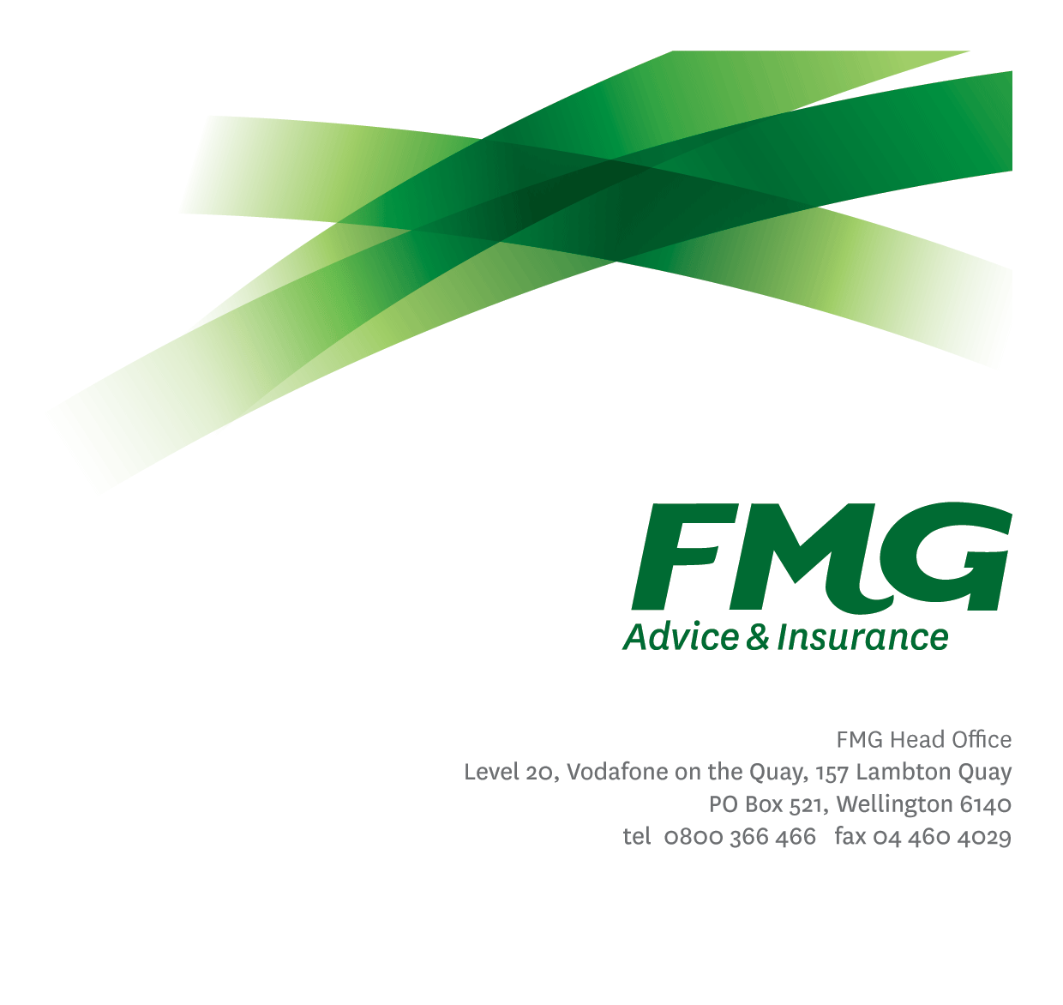
Supply Chain Manager - Claims
Position Description

Location: as per Personal Terms
Reporting to: Head of Property & Procurement
Business Unit: Finance & Investment
Direct Reports: Nil
Date Last Reviewed: Feb 2026

About FMG
Formed by farmers for farmers over a century ago, FMG is New Zealand’s leading rural insurer providing risk advice and insurance solutions for farmers, growers, commercial businesses, the lifestyle sector and domestic clients.
We’re proudly 100% New Zealand owned and operated and our focus is on helping our clients to achieve their goals. As a mutual organisation, we’re all about giving rural New Zealanders a better deal, and part of this involves reinvesting all profits back into the business to keep premiums low and ensure the future sustainability of the organisation.

FMG’s Values
The FMG brand represents promises about what customers can expect from us and each of us is responsible for delivering on these promises. Living our company values means we deliver the best brand experience for our customers. Our company values are:
- Do what's right - Whāia te ara tika | - Make it happen - Whakatutukitia
- We're in it together - Ko tātau tātau | - Proud of who we are - Whakahīhī i te whakapapa

Work Environment
We strive to provide an environment that promotes and fosters achievement. We place importance on career development and training to give our people the tools they need to succeed.
FMG’s Head Office is in Wellington and accommodates FMG’s Executive Leadership Team (ELT), Sales, Advice & Services, Claims, Marketing & Propositions, People & Culture, Finance & Investment, Insurance Solutions, Business Information Systems, Risk & Compliance and Strategy & Enablement.
FMG’s largest regional office is in Palmerston North accommodating our National Sales & Advice Centre, People and Culture, Information Technology, Claims, Operations and Payments functions. In addition to the offices in Wellington, Palmerston North and Christchurch FMG has offices in 30 regional locations throughout New Zealand.

Purpose of the Role
This role is responsible for helping manage the average claims cost by identifying areas of opportunity to partner with suppliers to deliver value for our Client’s and the Mutual. The role will primarily identify, implement and manage opportunities and performance of material damage suppliers. To achieve this the role will work closely with both the wider Procurement team as well as the Claims team.

Key Responsibilities
Area | Responsibilities
Network growth | - Identify areas of opportunity (spend or efficiency) within the claims supply chain through data analysis and in collaboration with the Claims team  - Work with the Procurement team to run sourcing exercises and implement contractual relationships with new suppliers
Supplier Relationship & Performance Management | - Act as the key point of contact for material damage suppliers.  - Proactively manage on-going reviews of all material damage suppliers based on agreed Service Level Agreements (SLAs) to ensure they deliver efficient, effective and client focused service outcomes at cost effective pricing.  - Administer and report on supplier key performance indicators as agreed.  - Act as an escalation point for issues which may arise within the use of preferred suppliers.  - Work alongside the Procurement team to ensure appropriate legal compliance is adhered to and contractual obligations are met. This includes in respect of Health & Safety requirements and obligations.  - Work alongside the Procurement team to ensure that a procurement register is maintained.  - Conduct supplier audits as/when required.
Market Knowledge and Sourcing | - Understands and proactively builds the technical knowledge and expertise necessary to understand the current and emerging industry changes and investigates, recommends and implements (as necessary / able).  - Supports the Head of Property & Procurement in developing sourcing strategies for the claims supply chain to deliver value from the market.
Compliance | - Collaborates with Procurement and the Legal Counsel to ensure appropriate legal compliance is adhered to, contractual obligations are met and business outcomes achieved.  - Monitor and review policy compliance and take necessary steps to prevent non-compliance.  - Ensure overall compliance with legislation regulations and FMG policies through the use of established systems.  - Conduct supplier audits as/when required.
Risk Management | - Assist the Head of Property & Procurement to identify and manage risk or perceived potential risks and take necessary action to protect FMG interests.
Wellbeing & Safety | - Demonstrate a commitment to workplace safety and wellbeing practices.  - Promote and support initiatives that contribute to a healthy and safe working environment for employees, visitors and contractors.  - Ensure compliance with safety and wellbeing policy and procedures, including accident and incident reporting and investigation, hazard management, induction, training and supervision, employee participation and supplier management.
Team Membership | - Participate fully as a member of FMG through the effective and efficient performing of other duties as may be required from time to time.
Project Work | - Complete projects and other work as assigned by the Head of Property & Procurement.

COMPETENCIES
*see competency framework for behaviours expected at each level | Expected Level
Customer Driven (Internal & External)  A commitment to understanding the needs and best interests of both internal and external customers, in order to provide them with outstanding customer service and help them to make informed decisions. | Intermediate*
Accountability  Taking personal ownership of decisions, behaviour, and development, and being responsible for how these actions impact on the wider organisation and customers. | Intermediate*
Adaptability  Demonstrating a willingness to engage in a changing environment and being flexible and comfortable working with change. | Intermediate*
Motivation and Drive  The determination to achieve goals and strive for excellence. | Intermediate*
Relationship Building  Developing and maintaining positive, professional relationships that are built on mutual trust and respect. | Intermediate*
Team Work  Making a positive contribution to the FMG team and collaborating effectively with others to achieve objectives. | Intermediate*

KNOWLEDGE
Experience | At least 5+ years working in a Claims environment.  Experience working in supply chain management, supplier management, procurement or a similar function  Tertiary Qualification Preferred
Business Awareness | Understands the internal workings of FMG and how business works; understands FMG's position in the advice and insurance market and knows the competition.
Legal Knowledge | Has legal knowledge e.g. indemnity, liability, dispute resolution etc.
Risk/Insurance Knowledge | Understands risk and how to apply FMG's policies to situations; is knowledgeable about compliance requirements; understands the insurance process and how claims are managed; knows industry partners and competitors.

SKILLS
Written Communication Skills | Able to write clear, concise and persuasive proposals and reports.
Verbal Communications Skills | Communicates clearly in order to present information to persuade and influence others.
Listening Skills | Demonstrates active listening skills through eye contact, paraphrasing, appropriate body language and checking understanding.
Technology Skills | Can expertly use relevant software and technology to its full capacity e.g. MS Word, Excel and PowerPoint.
Risk Assessment Skills | Identifies, understands and mitigates the risks that may impact on FMG's strategy, initiatives and reputation.

Relationships
External | Internal | Committees/Groups
- Prospective and current Suppliers | - Procurement Specialist  - Supplier Relationship Manager – Claims Motor  - Claims Team | - As required

Financial Authority Levels
- No authority to commit or approve expenditure

Human Resources Authority Levels
- Not applicable

Agreement
I agree to the outline of the role as contained in this document and recognise that the contents may need to be amended from time to time to reflect changing business requirements.

I as Job holder, allow my Manager to gather information from third parties where necessary for the purposes of performance management.

Name: _______________________

Signature: ____________________

Date: ________________________

