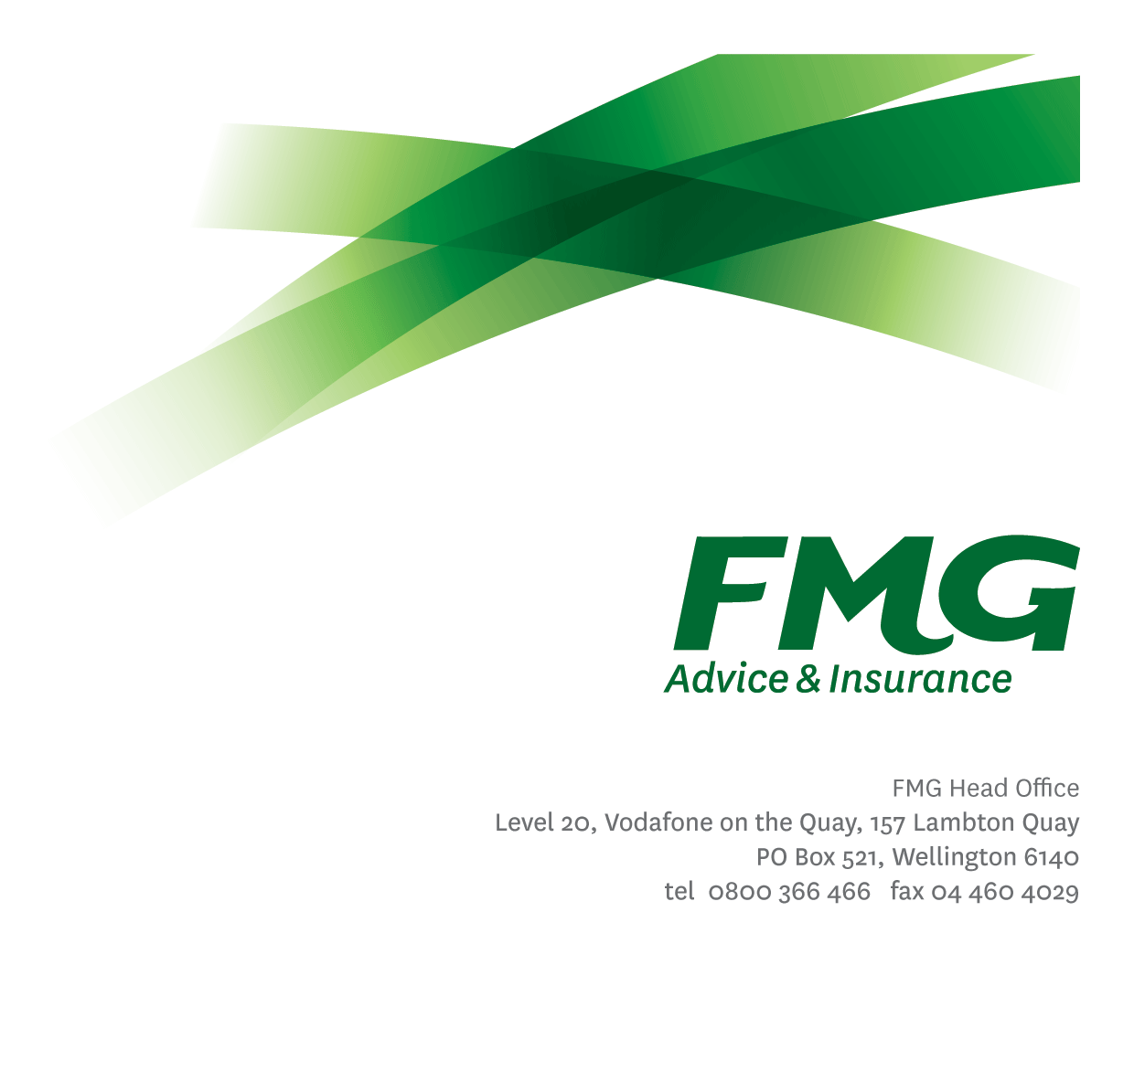Senior Compliance Specialist

*Position Description*

*Location:* Wellington

*Reporting to:* Head of Compliance

*Business Unit:* Risk

*Direct Reports:* 0

*Date Last Reviewed:* February 2025



### *About FMG*

***Formed by farmers for farmers over a century ago, FMG is New Zealand’s leading rural insurer providing risk advice and insurance solutions for farmers, growers, commercial businesses, the lifestyle sector and residential clients.***

***We’re proudly 100% New Zealand owned and operated, and our focus is on helping our clients to achieve their goals.  As a mutual organisation, we’re all about giving rural New Zealanders a better deal, and part of this involves reinvesting all profits back into the business to keep premiums low and ensure the future sustainability of the organisation.***



### *FMG’s Values*

The FMG brand represents promises about what clients can expect from us and each of us is responsible for delivering on these promises. Living our company values means we deliver the best brand experience for our clients. Our company values are:

|  |  |
| --- | --- |
| * Do what's right - Whāia te ara tika | * Make it happen - Whakatutukitia |
| * We're in it together - Ko tātau tātau | * Proud of who we are - Whakahīhī i te whakapapa |



### *Work Environment*

We strive to provide an environment that promotes and fosters achievement. We place importance on career development and training to give our people the tools they need to succeed.

FMG’s Head Office is located in Wellington and accommodates FMG’s Executive Leadership Team (ELT), Client Propositions & Online Services, People & Culture and Communications, Financial Management, Product & Pricing and Underwriting, Reinsurance, Business Information and Analysis, Legal and Compliance.

FMG’s largest regional office is located in Palmerston North accommodating our National Sales & Advice Centre, Information Technology, Claims, Operations and Payments functions. In addition to the offices in Wellington, Palmerston North and Christchurch FMG has offices in 30 regional locations throughout New Zealand.



### *Purpose of the role*

The Senior Compliance Specialist is responsible for contributing to effective compliance management at FMG. They will support FMG’s 2nd Line Compliance function and FMG’s 1st Line Teams in developing and executing processes for the measuring and management of compliance risk in relation to legislative, regulatory and industry code requirements and providing recommendations on improvements to internal controls and business processes.

### *Key Responsibilities*

| Area | Responsibilities |
| --- | --- |
| Compliance | * Responsible for supporting the development, implementation, and on-going function of FMG’s Compliance framework, ensuring we have the policies, processes and procedures to underpin the framework and foster a robust culture of compliance at FMG. * Support the effective management of the FMG Compliance Register. * Support the effective management of compliance incidents and issues, including working with 1st Line stakeholders to remedy the consequences of any incidents and address the root cause. * Support the development of compliance assurance plans to measure and report on the effectiveness of FMG’s internal controls used to satisfy compliance requirements. * Conduct testing of FMG’s internal controls in accordance with the testing plans and provide reporting of results. * Contribute to the provision of reporting to the Enterprise Risk and Compliance Committee. * Coordinate and contribute to the support of the Enterprise Risk and Compliance Committee, as required. * Contribute to the effective management of FMG’s Internal Audit program. * Provide recommendations on improvements to internal controls and business processes. |
| Continuous Improvement | * Act as a subject matter expert for any wider business change that impacts compliance or has implications for compliance. * Contribute to the identification of ways that the compliance framework can be improved, and executing on improvements identified. |
| Stakeholder Management | * Support the 2nd Line Compliance Team in effective stakeholder management and engagement at an operational level to ensure effective embedding of compliance frameworks and processes. * Maintains an effective level of communication with all stakeholders, ensuring expectations are appropriately set and required communications are effective and reach the desired audiences. * Proactively assists and supports other FMG colleagues and stakeholders. |
| Personal Development | * Maintain own knowledge base of best practice and act as a subject matter expert in compliance practices across FMG. |
| Team Participation | * Support the Compliance Specialists in execution of day-to-day responsibilities, being a first instance escalation point where necessary. * Day to day oversight of the execution of the 2nd Line Compliance Team business plan. * Undertake additional duties as directed by the Head of Compliance. |
| Wellbeing & Safety | * Promote and support initiatives that contribute to a healthy and safe working environment for employees, visitors, and contractors. * Ensure compliance with Wellbeing & Safety policy and procedures, including accident and incident reporting and investigation, hazard management, induction, training and supervision, employee participation and contractor management. * Works in a safe manner at all times and does not undertake activities without appropriate training |

|  |  |
| --- | --- |
| **COMPETENCIES** | |
| *\*see competency framework for behaviours expected at each level* | *Expected Level* |
| **Customer Driven (Internal & External)**  A commitment to understanding the needs and best interests of both internal and external customers, to provide them with outstanding customer service and help them to make informed decisions. | Intermediate* |
| **Accountability**  Taking personal ownership of decisions, behaviour, and development, and being responsible for how these actions impact on the wider organisation and clients. | Advanced* |
| **Adaptability**  Demonstrating a willingness to engage in a changing environment and being flexible and comfortable working with change. | Intermediate* |
| **Motivation and Drive**  The determination to achieve goals and strive for excellence. | Advanced* |
| **Relationship Building**  Developing and maintaining positive, professional relationships that are built on mutual trust and respect. | Intermediate* |
| **Teamwork**  Making a positive contribution to the FMG team and collaborating effectively with others to achieve objectives. | Advanced* |
| **Problem Solving**  The ability to understand information from a variety of sources and think quickly on one’s feet. The ability to effectively combine verbal and numeric data into a coherent whole. | Advanced* |
| **Critical Analysis**  The capability to identify key issues, trends, or important facts from information and to question and probe. | Intermediate* |
| **Change Leadership**  The drive to initiate opportunities to address FMG’s organisational needs and to communicate change in a way that gains buy-in and support from others. | Intermediate* |
| **Strategic Thinking**  The capacity to stand apart from the day-to-day and take a long-term, big picture view of the business. | Competent* |

|  |  |
| --- | --- |
| **KNOWLEDGE & EXPERIENCE** | |
| **Qualifications & Experience** | * Preferably a Bachelor’s degree in law, business management or similar discipline * Minimum 5 years’ Experience in financial services, preferably in insurance * Risk and/or compliance experience, including working within risk and/or compliance frameworks and risk and compliance systems * Experience with the Three Lines of Defence model for risk management * Basic legislative and compliance knowledge, including the Financial Markets Conduct Act and the Insurance (Prudential Supervision) Act (and the licensing regimes relevant to that legislation) * Basic understanding of regulatory expectations (RBNZ and FMA) |
| **Risk/Insurance Knowledge** | * Financial industry knowledge and experience * Basic knowledge of compliance requirements; understands the insurance process and how claims are managed; knows industry partners and competitors. |
| **Business Knowledge and Industry Awareness** | * Basic understanding of FMG's position in the advice and insurance market and has knowledge of the competitive landscape. * Affinity with the rural community and keeps up to date with the economic, political, and environmental issues affecting our clients. |
| **Change Leadership** | * Ability to deal with a degree of ambiguity, be agile in response to business needs, manage competing priorities and a willingness to support others through change where required. |

|  |  |
| --- | --- |
| **SKILLS** | |
| **Verbal Communications Skills** | * Communicates clearly in order to present information to persuade and influence others. * Able to articulate information in a way that matches the skills and capabilities of the audience |
| **Listening Skills** | * Demonstrates active listening skills through eye contact, paraphrasing, appropriate body language and checking understanding. |
| **Written Communication Skills** | * Able to write clear, concise, and persuasive proposals and reports. |

### *Key Relationships*

|  |  |  |
| --- | --- | --- |
| External | Internal | Committees/Groups |
| * Auditors | * 2nd Line Risk & Compliance Team * Legal Team * 1st Line stakeholders | * Enterprise Risk and Compliance Committee |

### *Financial Authority Levels*

* As per delegated authorities

### *People Advisory Authority Levels*

* Not applicable

### *Agreement*

I agree to the outline of the role as contained in this document and recognise that the contents may need to be amended from time to time to reflect changing business requirements.

I as Job holder, allow my Manager to gather information from third parties where necessary for the purposes of performance management.

|  |  |
| --- | --- |
| Senior Compliance Specialist’s Name: |  |
| Signature: |  |
| Date: |  |