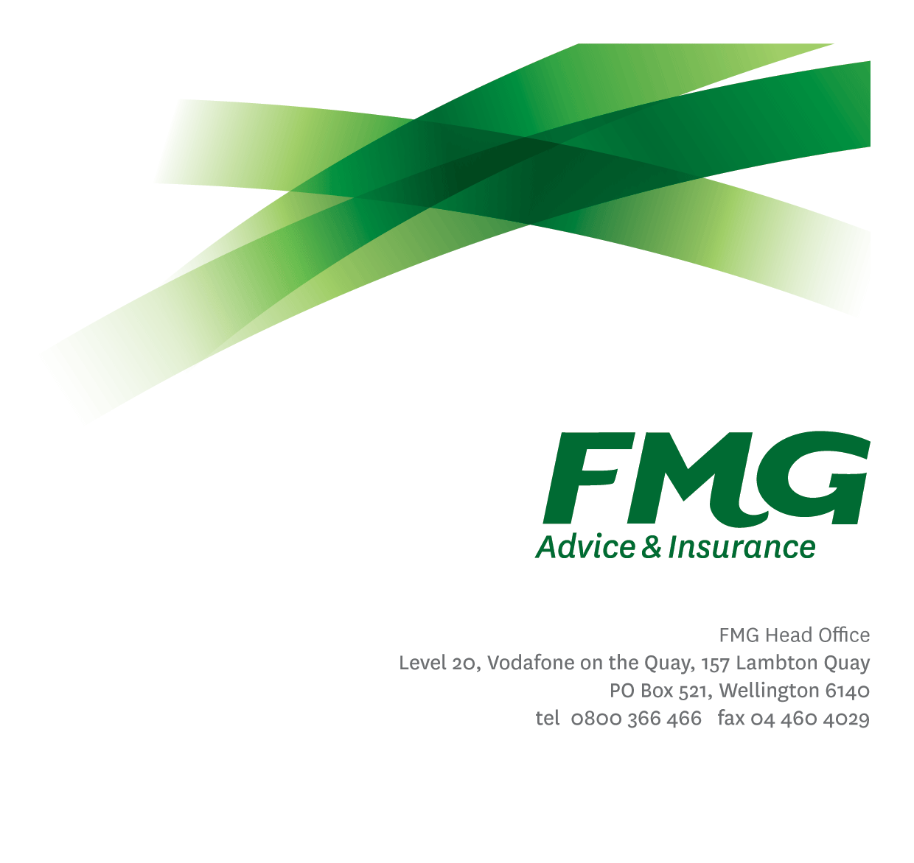
Product Owner
Position Description
Location: As per Personal Term
Reporting to: Relevant Mutual Leader (as per variation)
Business Unit: Aligned with Mutual Leader
Direct Reports: Nil
Date Last Reviewed: March 2025

About FMG
Formed by farmers for farmers over a century ago, FMG is New Zealand’s leading rural insurer providing risk advice and insurance solutions for farmers, growers, commercial businesses, the lifestyle sector and residential clients.
FMG is proudly 100% New Zealand owned and operated, and our focus is on helping our clients to achieve their goals. As a mutual organisation, FMG is all about giving rural New Zealanders a better deal, and part of this involves reinvesting all profits back into the business to keep premiums low and ensure the future sustainability of the Mutual.

FMG’s Values
FMG’s brand represents promises about what clients can expect from the Mutual and each FMG employee across our One Team is responsible for delivering on these promises. Living FMG’s Values means we all deliver the best brand experience for our clients. FMG’s Values are:
- Do what's right - Whāia te ara tika | - Make it happen - Whakatutukitia
- We're in it together - Ko tātau tātau | - Proud of who we are - Whakahīhī i te whakapapa

Work Environment
FMG strives to provide an environment that promotes and fosters achievement, placing importance on career development and training to provide our people with the tools they need to succeed.
FMG’s Head Office is located in Wellington and accommodates FMG’s Executive Leadership Team (ELT), Sales, Advice and Service, Claims, Marketing and Propositions, People and Culture, Finance and Investments, Insurance Solutions, Digital and Data, Risk and Compliance and Strategy and Enablement teams.
FMG’s largest regional office is in located in Palmerston North accommodating FMG’s National Sales and Advice Centre, People and Culture, Digital and Data, Claims, Operations and Payments functions. In addition to offices in Wellington, Palmerston North and Christchurch, FMG has regional offices in 30 locations throughout provincial New Zealand Aotearoa.

Purpose of the role
The Product Owner is responsible for the product vision outlined in the Addendum and is responsible for maximising the value created across all streams of work. The Product Owner ensures alignment and consistency in implementing changes across both the technical and people readiness teams.

Key Responsibilities

Please note –responsibilities will be confirmed by the People Leader/Manager.

Area | Responsibilities
Agile Product Management | - Maximises the value of the Product by identifying, creating, and prioritising those features that deliver the most value for the product’s users.  - Ensure all aspects of the product development and improvement are considered, prioritised and executed. This includes technical considerations, updates, patches, and product risks.  - Leads the product release planning and sets expectations for delivery of new functionality.  - Provides clear direction and support to development teams in line with business priorities and team capacity. Manages and monitors team activity and output.
Product Vision | - Develops and communicates the Product Vision with key stakeholders, in line with business needs and stakeholder input. Maintains regular contact with key stakeholders and adjusts visions when necessary.  - Develops, communicates and delivers on the product road map to ensure a common understanding among all stakeholders on the direction of the product at any given time.
Product Backlog Management | - Ensures the product backlog is managed effectively, taking into account value, business and technical risks, learning opportunities and dependencies. Ensures backlog refinement is completed regularly and is up to date.  - Ensures strategic needs of FMG are well considered and well understood by the Product Governance group.  - Research ongoing needs and uses findings to inform decisions on improvements needed.
Stakeholder Management | - Builds and maintains relationships with key stakeholders, understanding their needs and how it relates to the Product programme of work.  - Encourages stakeholder engagements using agile processes and direct stakeholder development team communication.  - Ensure stakeholders understand business needs, capacity to deliver and priorities in order to manage expectations
Business Change Planning | - Identify change planning strategies and activities that will be undertaken to support individual product/s  - Coordinate any execution of the identified change planning strategies, and review any key deliverables as required  - Provide expertise and guidance around the analysis, development and execution of training for assigned product  - Identify, execute and coordinate change planning activities to achieve benefits and support impacted employees
Professional Development | - Actively identifies all areas for personal development.  - Attends company approved training and development programs as required
Compliance | - Ensures compliance with legislative, regulations and FMG policies through the monitoring of systems, processes, and improvements.  - Complying with corporate policies, procedures, and guidelines.
Team Membership & Relationship Management | - Effectively contributes to a collegial and efficient FMG team dynamic.  - Proactively builds, monitors, and manages a wide-ranging network of relationships related to the role both internal and external.  - Undertaking additional duties and provide assistance as allocated by management.
FMG Values | - Promotes the “FMG Way” through displaying the values of FMG which are: Do what’s right, Make it happen, We’re in it together, Proud of who we are.
Safety & Wellbeing | - Demonstrates commitment to workplace safety and wellbeing practices  - Promotes and supports initiatives that contribute to a healthy and safe working environment for employees, visitors and contractors  - Ensures compliance with safety and wellbeing policy and procedures, including accident and incident reporting and investigation, hazard management, induction, training and supervision, employee participation and contractor management

COMPETENCIES
*see competency framework for behaviours expected at each level | Expected Level
Customer Driven (Internal & External)  A commitment to understanding the needs and best interests of both internal and external customers, in order to provide them with outstanding customer service and help them to make informed decisions. | Advanced*
Accountability  Taking personal ownership of decisions, behaviour, and development, and being responsible for how these actions impact on the wider organisation and customers. | Advanced*
Adaptability  Demonstrating a willingness to engage in a changing environment and being flexible and comfortable working with change. | Advanced*
Motivation and Drive  The determination to achieve goals and strive for excellence. | Advanced*
Relationship Building  Developing and maintaining positive, professional relationships that are built on mutual trust and respect. | Advanced*
Teamwork  Making a positive contribution to the FMG team and collaborating effectively with others to achieve objectives. | Advanced*
Critical Analysis  The capability to identify key issues, trends, or important facts from information and to question and probe. | Advanced*
Problem Solving  The ability to understand information from a variety of sources, to effectively combine verbal and numeric data into a coherent whole and to be able to apply problem solving techniques to solve difficult or complex problems. | Advanced*
Change Leadership  The drive to initiate opportunities to address FMG’s organisational needs and to communicate change in a way that gains buy-in and support from others | Advanced*
Strategic Thinking  The capacity to stand apart from the day-to-day and take a long-term, big picture view of the business. | Advanced *
Influencing / Persuading  Using rational argument and reasoning to convince others. To not be afraid to take a stand and to sell a position while keeping the relationship intact. | Advanced*

KNOWLEDGE
Qualifications | Relevant Tertiary Qualification required
Business Awareness | Has an in-depth understanding of the internal workings of FMG, business operations and the strategic vision to support the operational effectiveness of the Advice and Insurance function
Rural Knowledge | Has an understanding of the rural community and keeps up to date with the economic, political, and environmental issues affecting FMG clients
Specialist Knowledge | Understands people, system, structure and process challenges and future business requirements to support putting plans in place which aim to better the position of the business.
Change Leadership | Ability to deal with ambiguity, be agile in response to business needs, manage competing priorities and coach other through change.

SKILLS
Communication | Advanced ability to communicate clearly to clarify the needs of stakeholders and tailor communication style to different audiences
Problem Solving | Ability to apply proactive and collaborative approach to problem solving, partnering alongside others in the business to understand need and identify solutions and alternatives to ensure best outcomes for internal and external stakeholders
Analytical | Sharp analytical skills to be able to interpret, and evaluate information to provide sound recommendations and advice
Influencing | Can persuade and influence others to achieve change and business improvement business objectives.
Embedding Change | Ability to apply FMG business change framework to reinforce/embed change and to lead and help leaders manage any resistance to change to ensure the achievement of business objectives,
Financial Skills | Ability to apply financial calculations and principles to ensure effective management of budgets and informed decision making
Stakeholder Management | Advanced ability to effectively and proactively engage with stakeholders to meet business objectives and work collaboratively with other business groups.

Relationship
External | Internal | Committees/Groups
- IT vendors (software, infrastructure, etc)  - Industry representatives  - Wider stakeholders | - Development team  - Technical owners and experts  - Other Product Owners  - Head of Technical Product Management Manager’s | - Members of the Product Ownership Group

Financial Authority Levels
- N/A

Delegated Authority Levels
Delegated authority levels for the individual role-holder will be advised following assessment, training and approval as per the requirements of the FMG Delegated Authority Policy.

Agreement
I agree to the outline of the role as contained in this document and recognise that the contents may need to be amended from time to time to reflect changing business requirements.

I as Job holder, allow my Manager to gather information from third parties where necessary for the purposes of performance management.

Product Owner’s Name:
Signature:
Date:

Addendum

Product Owner – Policy Management | The Product Owner – Policy Management owns the product vision for Product within PolicyCenter and is responsible for maximising the value created in the product across all streams of work. The Product Owner – Policy Management ensures a consistent approach to changes in both the technical and people readiness teams.  In situations where there are multiple streams of work, the Product Owner – Policy Management needs to be aware of inter-dependencies between the different streams of work. They facilitate the resolution of conflicts between the different streams through the prioritisation and team assignment processes.
Product Owner – Pricing & Underwriting | The Product Owner – Pricing & Underwriting owns the product vision for Product within Guidewire and is responsible for maximising the value created in the product across all streams of work. The Product Owner – Pricing & Underwriting ensures a consistent approach to changes in both the technical and people readiness teams.  In situations where there are multiple streams of work, the Product Owner – Pricing & Underwriting needs to be aware of inter-dependencies between the different streams of work. They facilitate the resolution of conflicts between the different streams through the prioritisation and team assignment processes.
Product Owner – Claim Centre | The Product Owner – Claims Centre owns the product vision for Product within Claims Centre and is responsible for maximising the value created in the product across all streams of work. The Product Owner – Claims Centre ensures a consistent approach to changes in both the technical and people readiness teams.  In situations where there are multiple streams of work, the Product Owner – Claims Centre needs to be aware of inter-dependencies between the different streams of work. They facilitate the resolution of conflicts between the different streams through the prioritisation and team assignment processes.
Product Owner – Billing | The Product Owner - Billing owns the product vision for billing within Guidewire and is responsible for maximising the value created in the product across all streams of work. The Product Owner - Billing ensures a consistent approach to changes in both the technical and people readiness teams.  In situations where there are multiple streams of work, the Product Owner - Billing needs to be aware of inter-dependencies between the different streams of work. They facilitate the resolution of conflicts between the different streams through the prioritisation and team assignment processes.
Product Owner – Client Relationship Management (CRM) | The Product Owner – Client Relationship Management (CRM) owns the product vision for Product within CRM and is responsible for maximising the value created in the product across all streams of work. The Product Owner – Policy Management ensures a consistent approach to changes in both the technical and people readiness teams.  In situations where there are multiple streams of work, the Product Owner – Client Relationship Management needs to be aware of inter-dependencies between the different streams of work. They facilitate the resolution of conflicts between the different streams through the prioritisation and team assignment processes.
Product Owner – Data Services | The Product Owner – Data Services owns the product vision for FMG’s shared Data Services and is responsible for maximising the value created across all streams of work. The Product Owner – Data Services ensures a consistent enterprise approach to data service changes and enhancements, working with delivery teams and stakeholders to manage inter-dependencies and priorities  In situations where there are multiple streams of work, the Product Owner – Data Services needs to be aware of inter-dependencies between the different streams of work. They facilitate the resolution of conflicts between the different streams through the prioritisation and team assignment processes.

