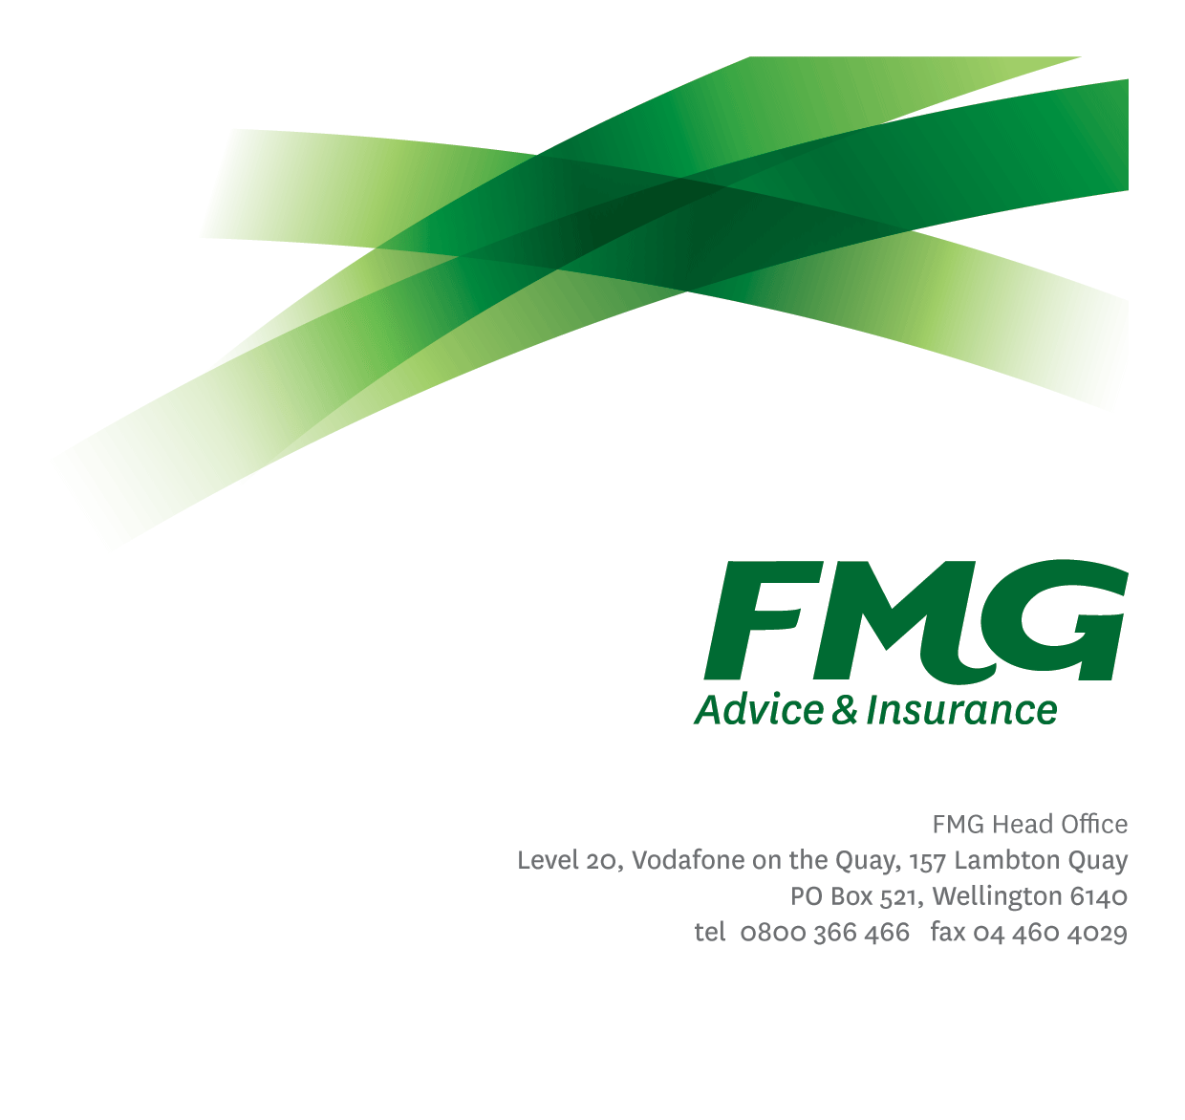
Commercial Manager
Position Description

Location: As per Personal Terms
Reporting to: Area Manager
Business Unit: Sales, Advice & Service
Direct Reports: Nil
Date Last Reviewed: March 2013

About FMG
Formed by farmers for farmers over a century ago, FMG is New Zealand’s leading rural insurer providing risk advice and insurance solutions for farmers, growers, commercial businesses, the lifestyle sector and domestic clients.
We’re proudly 100% New Zealand owned and operated and our focus is on helping our clients to achieve their goals. As a mutual organisation, we’re all about giving rural New Zealanders a better deal, and part of this involves reinvesting all profits back into the business to keep premiums low and ensure the future sustainability of the organisation.

FMG’s Values
The FMG brand represents promises about what customers can expect from us and each of us is responsible for delivering on these promises. Living our company values means we deliver the best brand experience for our customers. Our company values are:
- Do what’s right | - Make it happen
- We’re in it together | - Proud of who we are

Work Environment
We strive to provide an environment that promotes and fosters achievement. We place importance on career development and training to give our people the tools they need to succeed.
As part of our customer services and risk solution network the Commercial Managers are the face of FMG in the provincial small to medium business community, actively providing insurance advice, making sales and developing business. Working independently in their specific territories, the Commercial Managers also have close relationships with local Rural Managers, Rural Consultants, Inbound/Outbound/Commercial Consultants and the Underwriting teams to guarantee constant flow of information and knowledge sharing. Spending the majority of their time in their geographic area Commercial Managers really understand and appreciate the provincial commercial insurance market FMG works in.

Purpose of the role
To consult with small to medium sized provincial business customers to identify, assess, manage and provide solutions for commercial business risks that will maximise the ongoing profitability and sustainability of the customers operations, and continue to grow FMG’s market share.
The Commercial Manager forms long term sustainable partnerships with FMG customers helping them to manage their commercial risks.

Key Responsibilities

Area | Responsibilities
Sales & Acquisition | - Acquisition of profitable ‘new to FMG’ business, through the application of our risk management proposition.  - Follows up with existing and prospective customers and seeks to exceed targeted conversion rates of risk management and insurance business written.  - Attends and supports FMG risk management seminars, local field days and events, seeking and following up on customer and prospective customer enquiries.  - Generate leads for other parts of the business, including our Investment & Strategic Partners and Life Risk Advisors
Professional Relationship Management | - Identifies and evaluates third party organisations that would provide profitable business openings for FMG.  - Establishes and maintains professional relationships with these third party organizations to provide FMG with business gains and referrals.  - Holds regular meetings with third parties to establish business oriented opportunities that included cross-selling and referrals.  - Re-evaluates the value of the third party relationship in terms of quality of business referrals.
Networking | - Regularly attend field days, risk management seminars and events in the local rural community to enhance FMG’s profile and personal profile  - Uses business and social networking occasions to identify business opportunities for FMG.
Business Growth and Profitability | - Achieves agreed Key Result Areas (KRAs)  - High claiming clients are provided with detailed risk management plans to assist rehabilitation back to profitable and sustainable parameters for mutual benefit over the longer term.  - On farm and business to business meetings will be core to the service proposition through mobility  - Provides new and existing commercial customers, access to our risk management service, to differentiate our FMG offering in the market place. Presents a written report (either summary or detailed) to the customer outlining, detailing risk management recommendations and general insurance solutions, relevant to previous customer profiling and discussions.  - Within agreed timeframe standards, follows up with the customer.  - Business written is of the highest quality and priced accordingly to minimize the risk to FMG’s long term profitability.  - Provides advice and information relevant to the client needs (e.g. product information, fact sheets, packs, etc).  - Strategic joint prospecting campaigns with other team members to acquire new business.
Retention | - Maintains regular contact with High Value Commercial customers either by phone contact or site visits.  - Holds in-depth discussions with customers about business related topics; provides advice and information and demonstrates a real commitment to the profitability and sustainability of their operation.  - Develops long-term relationships and is seen by the customer as being trustworthy and accurate with a common sense approach.  - Exceeds customer service satisfaction levels through the delivery of accurate and timely information and advice; recognized as an expert in risk management matters; and gets the job done in a timely manner with minimal disruption to the customer.
Customer Focus | - Seeks to improve FMG Net Promoter Score  - Provides superior service to all customer and internal customers by demonstrating the FMG values.  - Achieves a targeted % customer satisfaction score combined of excellent and/or very good, where the customer recognizes FMG as providing strategically relevant advice in risk management  - Engagement with the customer reflects a consultative approach where in-depth questioning and active listening is undertaken, and industry related information is discussed.  - Assisting to identify opportunities for process and service improvement.
Self Development | - Actively identifies all areas for development.  - Attends company approved training and development programs in insurance, risk management and agribusiness.  - Maintains Senior Associate CIP membership level status.  - Uses newly gained knowledge and skills on the job.
FMG Values | - Promotes the ‘FMG Way” through displaying the values of FMG which are: Do what’s right, Make it happen, We’re in it together, Proud of who we are.
Team Participation | - Effectively contributes to a collegial and efficient FMG team dynamic.  - Assisting and supporting other team members, including training and peer review work as required,  - Supporting the team by sharing information and resources and providing feedback in a positive manner.
Reporting | - Presents a written report (either summary or detailed) to the customer outlining, detailing risk management recommendations and general insurance solutions, relevant to previous customer profiling and discussions.  - All reports to meet agreed FMG service standards including but not limited to the quality of content, writing style, grammatical correctness, visual presentation and timeliness of delivery.
Risk Management | - Assesses and determines a customer’s risk profile through undertaking strategic conversations with the customer about how and why they farm, including farm, financial, business and personal goals. Can reconcile these strategic goals with the farm and business risks and opportunities faced.  - Discusses with customers their approach to risk and examine their appetite and tolerance to risk. Puts risk in a positive context and discusses the ‘upside’ and opportunities that arise out of their risk positions they take. In broad terms identifies customer’s financial ability to tolerate losses from adverse events and their willingness to fund losses themselves through equity or debt.  - Achieves a win/win risk environment with the customer, where the customer better managers risk including the transfer of appropriate portions to FMG through FMG’s insurance products.  - Carries out a risk assessment, in accordance with FMG standards including making reasoned judgments about the probability and consequence of risks arising.  - Compiles and presents a professionally written Risk Report.
Risk Quality | - Develops a thorough knowledge of all FMG products and services and rural industry topics through attending internal training sessions, external seminars and study programs.  - Business written is within delegated authority (DA) levels.  - Meets targeted Gross Claims Ratios.
Health and Safety | - Complies with safety and wellbeing policy and procedures, including accident and incident reporting and hazard management requirements.  - Works in a safe manner at all times and does not undertake activities without appropriate training.
Compliance | - Complies with company policies, guidelines and procedures.

COMPETENCIES
*see competency framework for behaviours expected at each level | Expected Level
Advice & Sales Acumen  Using appropriate interpersonal styles and communication methods to gain client acceptance of advice, which incorporates a product, service or idea. | Intermediate*
Customer Driven (Internal & External)  A commitment to understanding the needs and best interests of both internal and external customers, in order to provide them with outstanding customer service and help them to make informed decisions. | Advanced*
Accountability  Taking personal ownership of decisions, behaviour, and development, and being responsible for how these actions impact on the wider organisation and customers. | Intermediate*
Adaptability  Demonstrating a willingness to engage in a changing environment and being flexible and comfortable working with change. | Intermediate*
Motivation and Drive  The determination to achieve goals and strive for excellence. | Intermediate*
Relationship Building  Developing and maintaining positive, professional relationships that are built on mutual trust and respect. | Advanced*
Team Work  Making a positive contribution to the FMG team and collaborating effectively with others to achieve objectives. | Intermediate*
Problem Solving  The ability to understand information from a variety of sources and think quickly on one’s feet. The ability to effectively combine verbal and numeric data into a coherent whole. | Intermediate*
Critical Analysis  The capability to identify key issues, trends, or important facts from information and to question and probe. | Intermediate*
Influencing/Persuading  Using rational argument and reasoning to convince others. To not be afraid to take a stand and to sell a position while keeping the relationship intact. | Intermediate*

KNOWLEDGE
Qualifications | Relevant Tertiary Qualification required
Business Awareness | Understands the internal workings of FMG and how business works; understands FMG's position in the advice and insurance market and knows the competition.
Rural Knowledge | Understands the rural community and keep up to date with the economic, political, and environmental issues affecting our customers.
Legal Knowledge | Has legal knowledge e.g. indemnity, liability, the Privacy Act etc.
Product Knowledge | Is knowledgeable about FMG's insurance policies and packages, the differences between them, and the appropriateness of each in different situations.
Systems Knowledge | Knowledge of the following systems is required:  Oracle, Sales Reporting Portal (SAS), Quick Quotes, Gateway.
Risk/Insurance Knowledge | Understands risk and how to apply FMG's policies to situations; is knowledgeable about compliance requirements; understands the insurance process and how claims are managed; knows industry partners and competitors.

SKILLS
Written Communication Skills | Able to write clear, concise and persuasive proposals and reports.
Verbal Communications Skills | Communicates clearly in order to present information to persuade and influence others.
Listening Skills | Demonstrates active listening skills through eye contact, paraphrasing, appropriate body language and checking understanding.
Financial Skills | Able to calculate and understand financial information e.g. profit & loss, forecasts.
Technology Skills | Proficient in networking and programming, and has broad systems knowledge.
Risk Assessment Skills | Identifies, understands and mitigates the risks that may impact on FMG's strategy, initiatives and reputation.
Driving Skills | Has full driver’s license.

Relationship
External | Internal | Committees/Groups
- Assessors  - Local rural / provincial business networks  - Agency representatives | - Regional Sales Manager  - Regional Marketing Coordinators  - Underwriting team  - National Sales & Service Centre Consultants  - Business Development Managers | - Life Risk Advisors  - Other Commercial and Rural Managers  - Claims team  - Assessors

Financial Authority Levels
- No authority to approve or commit expenditure

Human Resources Authority Levels
- Not applicable

Delegated Authority Levels
- Delegated authority levels for the individual role-holder will be advised following assessment, training and approval as per the requirements of the FMG Delegated Authority Policy.

Agreement
I agree to the outline of the role as contained in this document and recognise that the contents may need to be amended from time to time to reflect changing business requirements.

I as Job holder, allow my Manager to gather information from third parties where necessary for the purposes of performance management.

Commercial Manager’s Name:
Signature:
Date:

