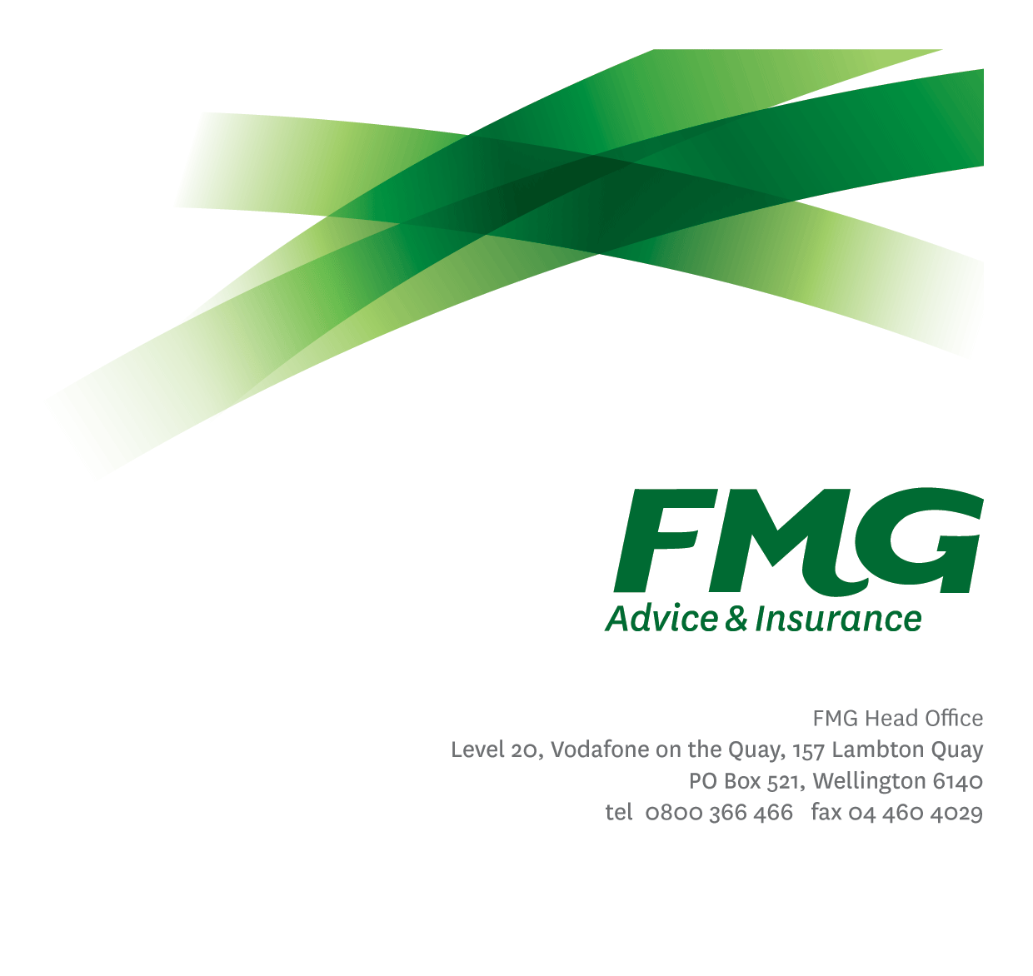
Emerging Technology Analyst
Position Description

Location: Palmerston North, Wellington, or Christchurch
Reporting to: Head of Strategy and Innovation
Business Unit: Digital and Data
Direct Reports: Nil
Date Last Reviewed: February 2026

About FMG
Formed by farmers for farmers over a century ago, FMG is New Zealand’s leading rural insurer providing risk advice and insurance solutions for farmers, growers, commercial businesses, the lifestyle sector and residential clients.
FMG is proudly 100% New Zealand owned and operated, and our focus is on helping our clients to achieve their goals. As a mutual organisation, FMG is all about giving rural New Zealanders a better deal, and part of this involves reinvesting all profits back into the business to keep premiums low and ensure the future sustainability of the Mutual.

FMG’s Values
FMG’s brand represents promises about what clients can expect from the Mutual and each FMG employee across our One Team is responsible for delivering on these promises. Living FMG’s Values means we all deliver the best brand experience for our clients. FMG’s Values are:
- Do what's right - Whāia te ara tika | - Make it happen - Whakatutukitia
- We're in it together - Ko tātau tātau | - Proud of who we are - Whakahīhī i te whakapapa

Work Environment
We strive to provide an environment that promotes and fosters achievement. We place importance on career development and training to give our people the tools they need to succeed.
FMG’s Head Office is in Wellington and accommodates FMG’s Executive Leadership Team (ELT), Sales, Advice & Services, Claims, Marketing & Propositions, People & Culture, Finance & Investment, Insurance Solutions, Digital and Data, Risk & Compliance and Strategy & Enablement.
FMG’s largest regional office is in Palmerston North accommodating our National Sales & Advice Centre, People and Culture, Information Technology, Claims, Operations and Payments functions. In addition to the offices in Wellington, Palmerston North and Christchurch FMG has offices in 30 regional locations throughout New Zealand.

Purpose of the role
FMG strives to provide an environment that promotes and fosters achievement, placing importance on career development and training to provide our people with the tools they need to succeed.
FMG’s Head Office is located in Wellington and accommodates FMG’s Executive Leadership Team (ELT), Sales, Advice and Service, Claims, Marketing and Propositions, People and Culture, Finance and Investments, Insurance Solutions, Digital and Data, Risk and Compliance and Strategy and Enablement teams.
FMG’s largest regional office is in located in Palmerston North accommodating FMG’s National Sales and Advice Centre, People and Culture, Digital and Data, Claims, Operations and Payments functions. In addition to offices in Wellington, Palmerston North and Christchurch, FMG has regional offices in 30 locations throughout provincial New Zealand Aotearoa.

Key Responsibilities

Area | Responsibilities
Industry/Technology Awareness | - Maintain strong awareness of emerging technology trends, including key vendors, significant investment pattens, and industry adoption signals.  - Continuously scan and synthesise insights from research firms, industry forums, startups, and thought leaders to understand how emerging technologies are evolving and creating business value.  - Translate Emerging Technology signals into opportunities which could create business value for FMG.  - Maintain a technology radar and emerging capability heatmap.
Analysis and Reporting | - Identify and prioritise emerging technologies by assessing strategic fit, momentum, client impact, and contribution to FMG’s Strategic Ambitions.  - Evaluate the value of emerging technologies through analysis of potential use cases/business applications.  - Work with vendors and internal stakeholders to provide an initial assessment of business value and risk by reviewing technology maturity, vendor landscape, integration requirements, data/privacy/security considerations, regulatory implications, and operational readiness.  - Contribute to decision-making by producing clear documentation that synthesises research, analysis, and stakeholder input into a coherent narrative with key findings and implications.  - Document recommendations and propose next steps using FMG’s preferred artefacts (e.g., Statements on a Page, Business Cases etc.)
Innovation | - Translate technology signals into clearly defined use cases.  - Validate business value by designing and running pilots or proofs of concept to test assumptions and ideas.  - Produce clear documentation of pilot and proof-of-concept outcomes, including findings, value realised, risks identified, and recommended actions.
Strategy | - Support strategic decisions by providing clear insights on emerging technologies, helping leaders understand options, opportunities, and risks.  - Help progress FMG’s strategic ambitions by identifying and recommending technologies that support future capabilities and business priorities.  - Contribute to the development of the Digital and Data business plan  - Provide input into enterprise architecture blueprint, technology roadmaps and capability uplift strategies.
Relationship Management | - Represent the Mutual in relevant industry events, forums, or innovation networks.  - Engage with stakeholders (partners, architecture, product, security and operations) to shape innovative opportunities.  - Build effective working relationships with the stakeholders, with a specific focus on the following teams:  - Digital and Data Architecture and Delivery Teams  - Product Owners  - FMG Business Leaders
Other Duties | - Undertake tasks as directed by the Head of Strategy and Innovation from time-to-time.
Health & Safety | - Demonstrate commitment to workplace wellbeing and safety practices  - Promotes and supports initiatives that contribute to a healthy and safe working environment for employees, visitors and contractors  - Ensures compliance with wellbeing and safety policy and procedures, including accident and incident reporting and investigation, hazard management, induction, training and supervision, employee participation and contractor management

COMPETENCIES
*see competency framework for behaviours expected at each level | Expected Level
Client Driven (Internal & External)  A commitment to understanding the needs and best interests of both internal and external clients, to provide them with exceptional client service and help them to make informed decisions. | Intermediate*
Accountability  Taking personal ownership of decisions, behaviour, and development, and being responsible for how these actions impact on the wider organisation and customers. | Intermediate*
Adaptability  Demonstrating a willingness to engage in a changing environment and being flexible and comfortable working with change. | Intermediate*
Motivation and Drive  The determination to achieve goals and strive for excellence. | Intermediate*
Relationship Building  Developing and maintaining positive, professional relationships that are built on mutual trust and respect. | Advanced*
Collaboration and Teamwork  Making a positive contribution to the FMG team and collaborating effectively with others to achieve objectives. | Advanced*
Problem Solving  The ability to understand information from a variety of sources and think quickly on one’s feet. The ability to effectively combine verbal and numeric data into a coherent whole. | Intermediate*
Critical Analysis  The capability to identify key issues, trends, or important facts from information and to question and probe. | Advanced*
Influencing / Persuading  Using rational argument and reasoning to convince others. To not be afraid to take a stand and to sell a position while keeping the relationship intact. | Intermediate*
Change Leadership  The drive to initiate opportunities to address FMG’s organisational needs and to communicate change in a way that gains buy-in and support from others. | Intermediate*
Strategic Thinking  The capacity to stand apart from the day-to-day and take a long-term, big picture view of the business. | Intermediate*

KNOWLEDGE
Qualifications | Relevant Tertiary Qualification desirable
Business Awareness | Understands the internal workings of FMG and how business works; understands FMG's position in the advice and insurance market and knows the competition.
Legal Knowledge | Has relevant legal knowledge e.g. the Privacy Act etc.
Systems Knowledge | Possess a well-rounded understanding of FMGs technology stack and how various platforms and tools interconnect to support product delivery
Specialist Knowledge | General understanding of technology principles, modalities (e.g., Software as a Service), and business value drivers.

SKILLS
Written Communication Skills | Able to write clear, concise and persuasive SOAPs, Business cases and reports.
Verbal Communications Skills | Communicates clearly in order to present information to persuade and influence others.
Listening Skills | Demonstrates active listening skills through eye contact, paraphrasing, appropriate body language and checking understanding.
Technology Skills | Proficient in using a variety of planning and collaboration tools to manage product delivery and team coordination
Analytical and Evaluation  skills | Identifies, understands and mitigates the risks that may impact on FMG's strategy, initiatives and reputation.

Relationships
External | Internal | Committees/Groups
- System Providers  - Service Providers  - Research Organisations | - Digital Delivery Team  - Architecture Team  - Data, Information & Analytics Team  - Claims Team  - Sales, Advice & Service Team  - Other FMG Teams as required | - Working Groups  - Governance Forums (e.g., Information Data Governance Committee) as required.

Financial Authority Levels
- No authority to commit or approve expenditure

Human Resources Authority Levels
- Not Applicable

Agreement
I agree to the outline of the role as contained in this document and recognise that the contents may not be altered without mutual agreement but recognise that these duties may need to be amended from time to time to reflect changing business requirements.

I as Job holder, allow my Manager to gather information from third parties where necessary for the purposes of performance management.

Emerging Technology Analyst Name:
Signature:
Date:

Head of Strategy and Innovation Name:
Signature:
Date:

