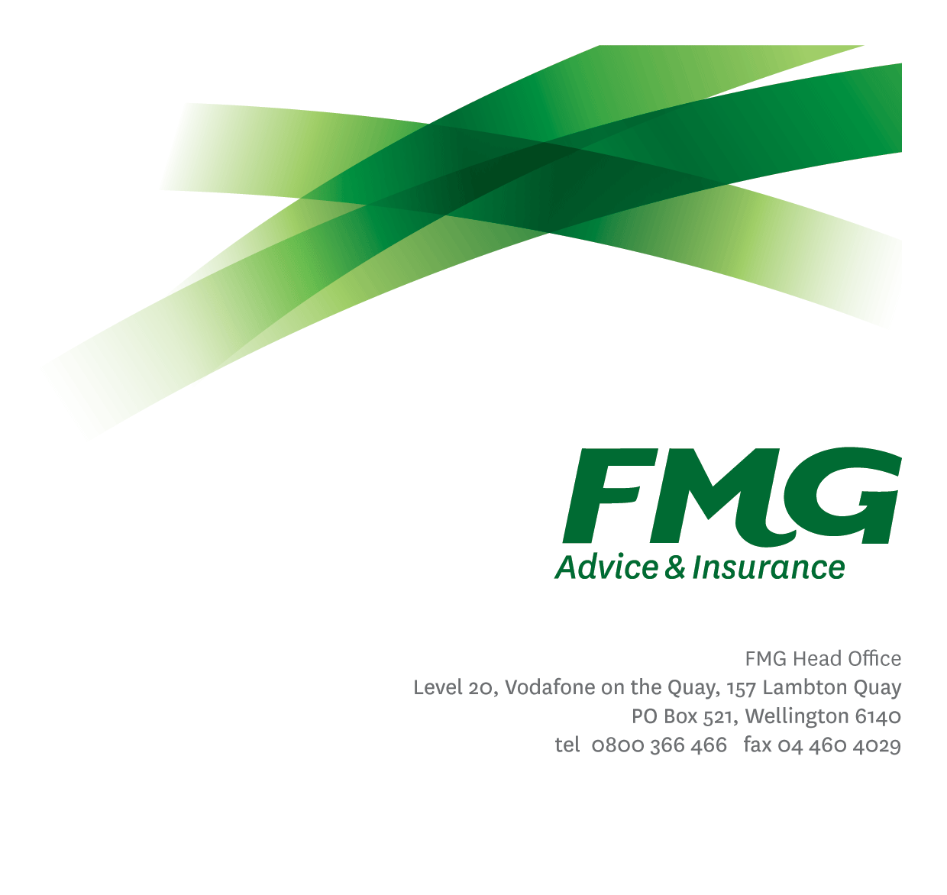Data Engineer
Position Description

Location: Wellington/Palmerston North
Reporting to: Delivery Manager – Data Engineering
Business Unit: Digital & Data
Direct Reports: N/A
Date Last Reviewed: February 2026

About FMG
Formed by farmers for farmers over a century ago, FMG is New Zealand’s leading rural insurer providing risk advice and insurance solutions for farmers, growers, commercial businesses, the lifestyle sector and residential clients.
FMG is proudly 100% New Zealand owned and operated, and our focus is on helping our clients to achieve their goals. As a mutual organisation, FMG is all about giving rural New Zealanders a better deal, and part of this involves reinvesting all profits back into the business to keep premiums low and ensure the future sustainability of the Mutual.

FMG’s Values
FMG’s brand represents promises about what clients can expect from the Mutual and each FMG employee across our One Team is responsible for delivering on these promises. Living FMG’s Values means we all deliver the best brand experience for our clients. FMG’s Values are:
- Do what's right - Whāia te ara tika | - Make it happen - Whakatutukitia
- We're in it together - Ko tātau tātau | - Proud of who we are - Whakahīhī i te whakapapa

Work Environment
FMG strives to provide an environment that promotes and fosters achievement, placing importance on career development and training to provide our people with the tools they need to succeed.
FMG’s Head Office is located in Wellington and accommodates FMG’s Executive Leadership Team (ELT), Sales, Advice and Service, Claims, Marketing and Propositions, People and Culture, Finance and Investments, Insurance Solutions, Digital and Data, Risk and Compliance and Strategy and Enablement teams.
FMG’s largest regional office is in located in Palmerston North accommodating FMG’s National Sales and Advice Centre, People and Culture, Digital and Data, Claims, Operations and Payments functions. In addition to offices in Wellington, Palmerston North and Christchurch, FMG has regional offices in 30 locations throughout provincial New Zealand Aotearoa.

Purpose of the role
The Data Engineer is responsible for building, maintaining, and supporting reliable data pipelines, data assets, and technical data components that enable analytics, reporting, and operational intelligence across FMG.
Working under the guidance of the Delivery Manager – Data Engineering and in collaboration with analytics, platform, and governance colleagues, the role focuses on delivering high-quality data engineering outcomes that ensure data is trusted, reusable, and fit for purpose. The role contributes to strong data foundations that support both current operational needs and future analytics and AI-enabled use cases.
This role is an individual contributor, focused on technical delivery, quality, and continuous improvement rather than people or delivery management.

Key Responsibilities

Area | Responsibilities
Data Engineering Delivery | - Design, develop, and maintain data pipelines, transformations, and data assets that support analytics, reporting, and operational intelligence needs.  - Develop appropriate data extracts and integration patterns, including data from external sources, to support analytical and operational use cases.  - Analyse source systems and data structures to determine appropriate data transformations and modelling approaches that meet information requirements.  - Contribute to the development and improvement of data structures and patterns that enable consistent, efficient use of data across the organisation.
Data Platform & Asset Support | - Support the reliability, performance, and usability of data assets and supporting services.  - Contribute to the creation and maintenance of data engineering documentation and technical artefacts to support sustainable delivery and supportability.  - Work with platform and delivery colleagues to identify and address issues, reduce technical debt, and improve data engineering practices over time.
Modelling & Data Structure Support | - Contribute to the development and maintenance of data models and structures that support analysis of key aspects of FMG’s business.  - Support consistent use of definitions, metadata, and data structures aligned to agreed standards and patterns.
Collaboration & Enablement | - Work collaboratively with analytics practitioners to ensure data engineering solutions effectively support insight and reporting needs.  - Engage with business and technical stakeholders to clarify data requirements and support delivery of fit-for-purpose data solutions.  - Maintain effective working relationships with internal teams and external partners where required.
Ways of Working & Quality | - Deliver data engineering work in alignment with agreed priorities, standards, and ways of working.  - Ensure data engineering outputs meet quality, governance, security, and documentation expectations.  - Identify and proactively flag data engineering risks (including data quality issues, assumptions, limitations, performance concerns, or operational impacts), and work with appropriate stakeholders to address or escalate these in line with agreed practices.  - Work in alignment with FMG’s data and information governance standards and engage with the Data & Information Governance function to seek guidance or escalate data quality, privacy, or appropriate-use considerations where required.  - Apply data engineering best practice and sound professional judgement to ensure data assets are reliable, appropriate, and fit for purpose.
Team Contribution | - Actively contribute to the data engineering team through collaboration, knowledge sharing, and peer support.  - Support capability uplift by assisting colleagues with technical queries and contributing to continuous improvement of data engineering practices.
Service Mindset | - Demonstrate a strong service mindset by delivering reliable data foundations that enable positive client and employee experiences.  - Ensure work is completed to a high standard, with a focus on stability, responsiveness, and clear communication.  - Consider the downstream impact of data engineering decisions on analytics delivery and business operations.
Other Duties | - Undertake other tasks as directed by the Delivery Manager – Data Engineering from time to time
Health & Safety | - Comply with FMG’s safety and wellbeing policies and procedures, including hazard management and incident reporting.  - Work in a safe manner at all times and do not undertake activities without appropriate training.

COMPETENCIES
*see competency framework for behaviours expected at each level | Expected Level
Customer Driven (Internal & External)  A commitment to understanding the needs and best interests of both internal and external customers, in order to provide them with outstanding customer service and help them to make informed decisions. | Competent*
Accountability  Taking personal ownership of decisions, behaviour, and development, and being responsible for how these actions impact on the wider organisation and customers. | Intermediate*
Adaptability  Demonstrating a willingness to engage in a changing environment and being flexible and comfortable working with change. | Competent*
Motivation and Drive  The determination to achieve goals and strive for excellence. | Intermediate*
Relationship Building  Developing and maintaining positive, professional relationships that are built on mutual trust and respect. | Competent*
Team Work  Making a positive contribution to the FMG team and collaborating effectively with others to achieve objectives. | Competent*
Critical Analysis  The capability to identify key issues, trends, or important facts from information and to question and probe. | Intermediate*

KNOWLEDGE
Qualifications | Relevant tertiary qualification in a technical, engineering, data, or related discipline, or equivalent practical experience.
Business Awareness | Understanding of FMG’s business environment and how data engineering supports analytics, reporting, operational decision-making, and client outcomes.
Specialist Knowledge | - Data quality considerations, data modelling concepts, and lifecycle management of data assets.  - Responsible and appropriate handling of data, aligned to governance, privacy, and security expectations.  - Understanding of how strong data foundations enable advanced analytics and AI-enabled use cases, without ownership of those use cases.

SKILLS
Communication Skills | - Able to communicate technical concepts clearly to both technical and non-technical stakeholders.  - Able to produce clear, concise technical documentation.
Technical Skills | - Strong understanding of data engineering concepts, including data integration, transformation, and working with structured and semi-structured data.  - Ability to work across multiple data sources and data environments.
Problem Solving | Applies structured thinking to diagnose data issues, resolve defects, and support reliable delivery of data assets.
Relationship Building | Builds effective working relationships with stakeholders and colleagues based on trust and professionalism.

Relationship
External | Internal | Committees/Groups
- Technical vendors, suppliers, and delivery partners (as required) | - Data engineering colleagues  - Analytics practitioners and report developers  - Data & Information Governance and data platform teams  - Business and technical stakeholders as required | - Project teams and working groups (as required)

Financial Authority Levels

This role does not have independent authority to approve or commit expenditure.

All financial commitments must be made in accordance with FMG’s Delegation of Financial Authority (DFA) and within approved budgets.

Human Resources Authority Levels
- Nil

Agreement
I agree to the outline of the role as contained in this document and recognise that the contents may need to be amended from time to time to reflect changing business requirements.

I as Job holder, allow my Manager to gather information from third parties where necessary for the purposes of performance management.

Data Engineers’ Name:
Signature:
Date:

Delivery Manager – Data Engineerings’ Name:
Signature:
Date:

