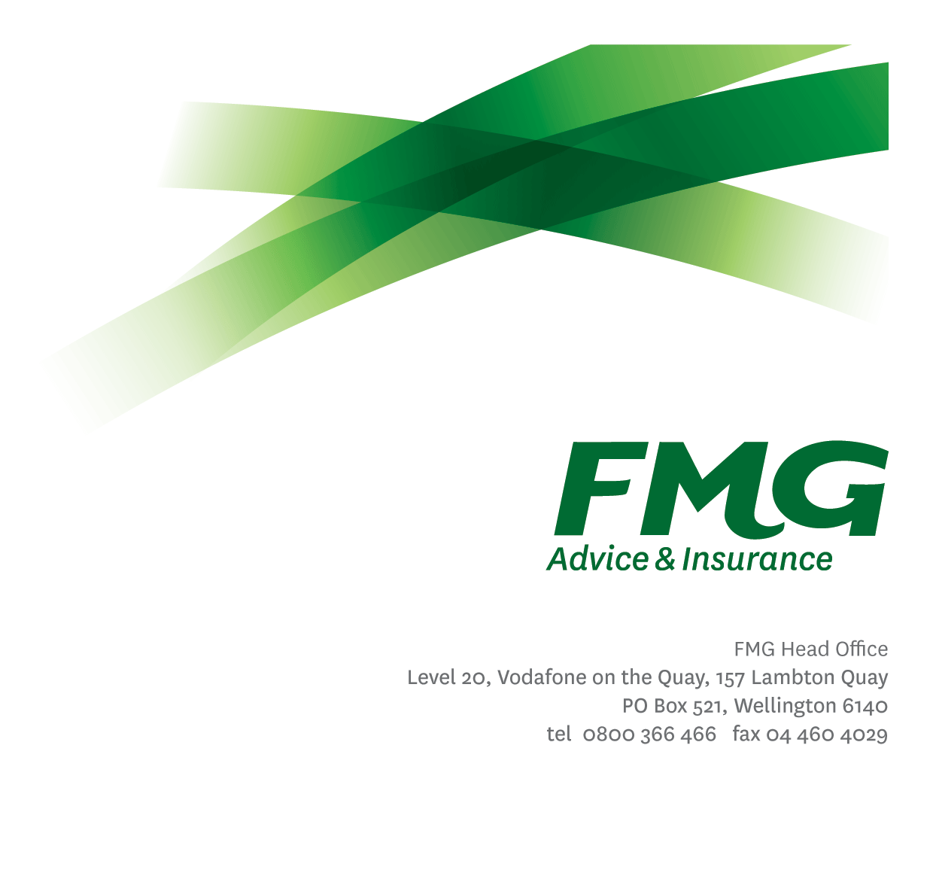Client Experience Manager

*Position Description*

*Location:* Wellington (minimum two days a week)

*Reporting to:* Head of Client Strategy & Advice Services

*Business Unit:* Client Propositions

*Direct Reports:* 5

*Date Last Reviewed:* July 2024

### *About FMG*

***Formed by farmers for farmers over a century ago, FMG is New Zealand’s leading rural insurer providing advice services and insurance solutions for farmers, growers, commercial businesses, the lifestyle sector and domestic clients.***

***We’re proudly 100% New Zealand owned and operated and our focus is on helping our clients to achieve their goals.  As a mutual organisation, we’re all about giving rural New Zealanders a better deal, and part of this involves reinvesting all profits back into the business to keep premiums low and ensure the future sustainability of the organisation.***

### *FMG’s Values*

The FMG brand represents promises about what clients can expect from us and each of us is responsible for delivering on these promises. Living our company values means we deliver the best brand experience for our clients. Our company values are:

|  |  |
| --- | --- |
| * Do what's right - Whāia te ara tika | * Make it happen - Whakatutukitia |
| * We're in it together - Ko tātau tātau | * Proud of who we are - Whakahīhī i te whakapapa |



### *Work Environment*

We strive to provide an environment that promotes and fosters achievement. We place importance on career development and training to give our people the tools they need to succeed.

FMG’s Head Office is located in Wellington and accommodates FMG’s Executive Leadership Team (ELT), Client Propositions & Online Services, People & Culture and Communications, Financial Management, Product & Pricing and Underwriting, Reinsurance, Business Information and Analysis, Legal and Compliance.

FMG’s largest regional office is located in Palmerston North accommodating our National Sales & Advice Centre, Information Technology, Claims, Operations and Payments functions. In addition to the offices in Wellington, Palmerston North and Christchurch FMG has offices in 30 regional locations throughout New Zealand.

### *Purpose of the role*

In this role you will bring a Mutual-wide perspective of the client experience FMG provides, to help contribute to the strategic goals in the short, medium and long term. This role requires you to manage a team that covers research, client insights, and advice to provide holistic initiatives to contribute towards a positive client experience.

You will implement initiatives and work alongside the Client Propositions Manager – Strategy and Engagement to mobilise different teams. You will use data to support client experience initiatives and ensure that advice forms a core part of these initiatives. Advice is spread across several business units and this role will lead these activities and provide specialist support to the Head of Client Strategy & Advice Services.

Being a strong networker is a must both internally to drive collaboration and externally to gain intel within the industry.

### *Key Responsibilities*

| Area | Responsibilities |
| --- | --- |

|  |  |
| --- | --- |
| Lead Client Experience | * Lead FMG’s overall client experience programme and work with other parts of the business to ensure a one-team approach. * Measure and map the Mutual’s current client experience levels, and ensure the research programme is aligned to the client experience outcomes the Mutual is targeting. * Establish and maintain key stakeholder relationships to improve client experience across the Mutual. Lead stakeholder engagement networks. * Ensure actionable insights and initiatives are developed to create positive client experience outcomes, and obtain buy-in from the wider Mutual for these initiatives. * Assist with planning, organising and monitoring of relevant marketing initiatives and customer events to explore new business sources, enhance brand awareness and establish customer relationships. |

|  |  |
| --- | --- |
| Advice Services Coordination | * Work closely with the Head of Client Strategy on the advice strategy and purpose of advice. * Establish and maintain key metrics to measure the success of Advice Services. * Ensure Advice initiatives with other business units are well planned for and resourced. * Work closely with other business units and Advice Service partners to achieve agreed Advice initiatives. |

|  |  |
| --- | --- |
| 3rd Party Advice Services Provider Management | * Support third party Advice Service supplier management, including service level agreements and streamlining access to their products and services. * Manage third party Advice Service providers to ensure services and products provided are market leading and consistent with FMG brand requirements. * Identify, plan and execute new providers for Advice Services. |
| People Leadership | * Provide clear leadership to direct reports to support achievement of results and ensuring that individual and team performance is managed and measured appropriately * Manage the on-going coaching and professional development of the team to ensure full competence in their roles * Communicate and share information with the team on a regular basis, both formally and informally * Drive a culture which is underpinned by individual accountability, client/business focus and collaboration. * Actively looks for and identifies areas for improvement within the team’s business processes. * Identifies, understands and mitigates the risks that may impact on FMG's strategy, initiatives and reputation. * Report regularly to the wider Client Strategy & Advice Services team and wider stakeholders to identify opportunities and to celebrate successes. |
| Team Membership & Personal Development | * Proactively assists and supports Client Strategy & Advice Services team colleagues and other stakeholders. * Shares information and resources and provides feedback in a positive and collaborative manner. * Role-model the FMG capability development principles; Take ownership for your personal development, seek guidance from your people leader and colleagues, seize and create opportunities in your work and identify areas that FMG should invest which will build your capability and that of others. |
| Business Requirements | * Document the team’s approved requests for development and improvement that enhance FMG’s proposition and/or client experience. |

|  |  |
| --- | --- |
| Team Membership | * Proactively assist the Client Strategy & Advice Services team colleagues and other stakeholders. * Share information and resources and provide feedback in a positive and collaborative manner. |
| Self-Development | * Maintain own knowledge base of best practice and act as an expert resource |
| FMG Values | * Promotes the “FMG Way” through displaying the values of FMG which are: Do what’s right, Make it happen, We’re in it together, Proud of who we are. |
| Other Duties | * Undertakes tasks as directed by the Head of Client Strategy & Advice Services from time to time. |
| Compliance | * Ensure assigned products and overall work is compliant with legislation, regulations and FMG policies through the use of established systems. |
| Wellbeing & Safety | * Comply with the Safety & Wellbeing policy and procedures, including accident and incident reporting and hazard management requirements * Work in a safe manner at all times and do not undertake activities without appropriate training |

|  |  |
| --- | --- |
| **COMPETENCIES** | |
| *\*see competency framework for behaviours expected at each level* | Expected Level |
| **Client Driven (Internal & External)**  A commitment to understanding the needs and best interests of both internal and external clients, in order to provide them with outstanding client service and help them to make informed decisions. | Advanced* |
| **Accountability**  Taking personal ownership of decisions, behaviour, and development, and being responsible for how these actions impact on the wider organisation and customers. | Advanced* |
| **Adaptability**  Demonstrating a willingness to engage in a changing environment and being flexible and comfortable working with change. | Advanced* |
| **Motivation and Drive**  The determination to achieve goals and strive for excellence. | Intermediate* |
| **Relationship Building**  Developing and maintaining positive, professional relationships that are built on mutual trust and respect. | Intermediate* |
| **Team Work**  Making a positive contribution to the FMG team and collaborating effectively with others to achieve objectives. | Advanced* |
| **Motivating and Developing Others**  A commitment to getting the best out of people and motivating them to reach their full potential. | Intermediate* |
| **Critical Analysis**  The capability to identify key issues, trends, or important facts from information and to question and probe. | Advanced * |
| **Influencing/Persuading**  Using rational argument and reasoning to convince others. To not be afraid to take a stand and to sell a position while keeping the relationship intact. | Intermediate* |
| **Problem Solving**  The ability to understand information from a variety of sources and think quickly on one’s feet. The ability to effectively combine verbal and numeric data into a coherent whole. | Advanced* |
| **Change Leadership**  The drive to initiate opportunities to address FMG’s organisational needs and to communicate change in a way that gains buy-in and support from others. | Intermediate * |

|  |  |
| --- | --- |
| **KNOWLEDGE** | |
| **Qualifications** | Relevant tertiary qualification required |
| **Experience** | 5 years’ Financial/Insurance Industry experience  5 years’ experience working within rural NZ, with a strong knowledge of farming and growing operations |
| **Business Awareness** | Understands the internal workings of FMG and how business works; understands FMG's position in the advice and insurance market and knows the competition. |
| **Rural Knowledge** | Deep understanding of the rural community and keep up to date with the economic, political, and environmental issues affecting our customers. |
| **Knowledge of Insurance Risks** | Understands insurance risks and how to apply FMG's policies to situations; is knowledgeable about compliance requirements; understands the insurance process and how claims are managed; knows industry partners and competitors. |
| **Legal Knowledge** | Has legal knowledge, such as, indemnity, liability, the Privacy Act and the Financial Advisers Act. |

|  |  |
| --- | --- |
| **SKILLS** | |
| **Written Communication Skills** | Able to write clear, concise and persuasive proposals and reports. |
| **Verbal Communications Skills** | Communicates clearly in order to present information to persuade and influence others. |
| **Listening Skills** | Demonstrates active listening skills through eye contact, paraphrasing, appropriate body language and checking understanding. |
| **Financial Skills** | Able to calculate and understand financial information e.g. profit & loss, forecasts. |
| **Technology Skills** | Can expertly use relevant software and technology to its full capacity e.g. MS Word, Excel and PowerPoint. |
| **Risk Assessment Skills** | Identifies, understands and mitigates the risks that may impact on FMG's strategy, initiatives and reputation. |

### *Relationships*

|  |  |  |
| --- | --- | --- |
| External | Internal | Committees/Groups |
| * Industry Groups and Associations aligned to advice services: FENZ, Police, Irrigation NZ, WorkSafe, ACC, others as required. * Research partners * FMG business partners | * Client Experience team * Head of Client Strategy & Advice Services * Client Proposition Managers * Marketing and Proposition team * Sales and Service team * Learning and development team * Business Information Services team * Claims team * Insurance Solutions team | * Relevant project groups and committees |

### *Financial Authority Levels*

### May approve routine expenditure within budgetary limits

### *People Advisory Authority Levels*

* May hire direct and indirect reports within approved FTE headcounts.
* May discipline direct and indirect reports in consultation with manager and People Advisory.
* No authority to dismiss staff, unless delegated by the Chief Executive and in consultation with manager and Chief People Officer.

### *Delegated Authority Levels*

### Delegated authority levels for the individual role-holder will be advised following assessment, training and approval as per the requirements of the FMG Delegated Authority Policy.

***Agreement***

I agree to the outline of the role as contained in this document and recognise that the contents may need to be amended from time to time to reflect changing business requirements.

I as Job holder, allow my Manager to gather information from third parties where necessary for the purposes of performance management.

|  |  |
| --- | --- |
| Client Experience Manager’s Name |  |
| Signature: |  |
| Date: |  |