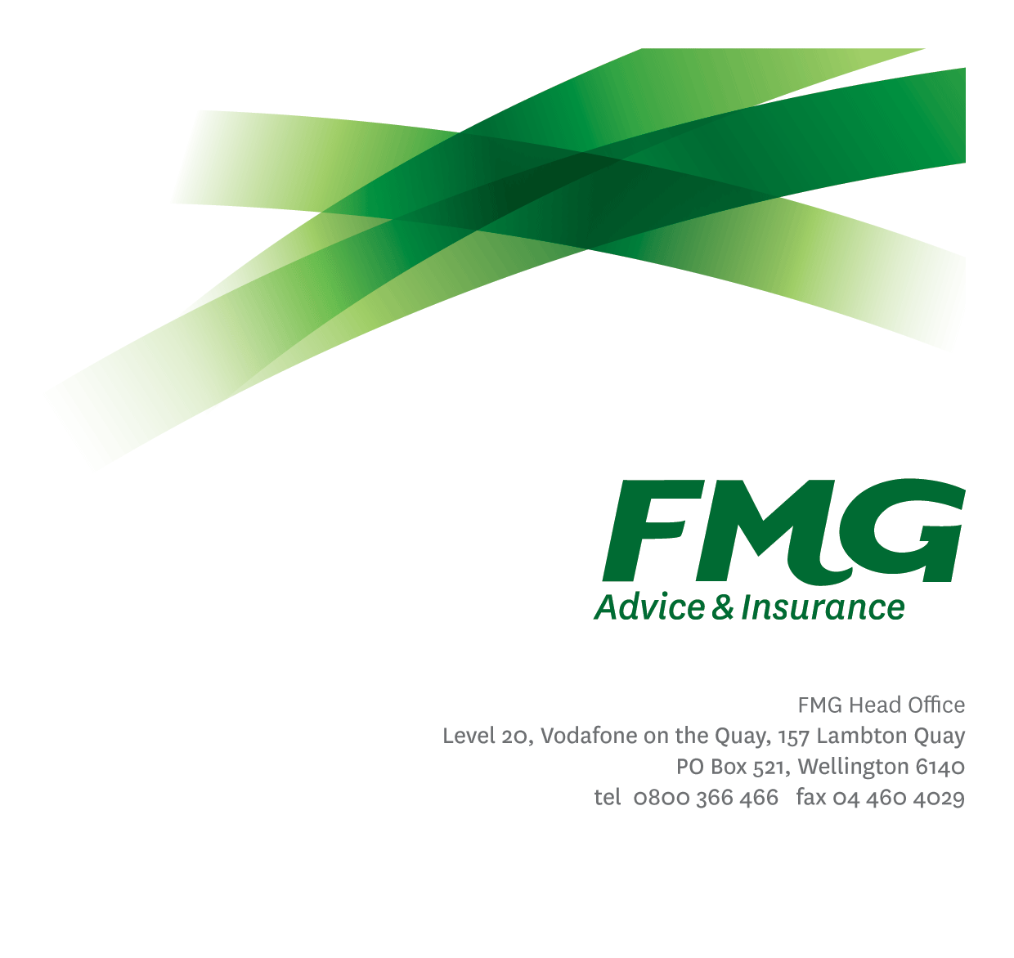Senior Analytics and Insights Specialist
Position Description

Location: Wellington/Palmerston North
Reporting to: Delivery Manager – Advanced Analytics
Business Unit: Digital & Data
Direct Reports: N/A
Date Last Reviewed: February 2026

About FMG
Formed by farmers for farmers over a century ago, FMG is New Zealand’s leading rural insurer providing risk advice and insurance solutions for farmers, growers, commercial businesses, the lifestyle sector and residential clients.
FMG is proudly 100% New Zealand owned and operated, and our focus is on helping our clients to achieve their goals. As a mutual organisation, FMG is all about giving rural New Zealanders a better deal, and part of this involves reinvesting all profits back into the business to keep premiums low and ensure the future sustainability of the Mutual.

FMG’s Values
FMG’s brand represents promises about what clients can expect from the Mutual and each FMG employee across our One Team is responsible for delivering on these promises. Living FMG’s Values means we all deliver the best brand experience for our clients. FMG’s Values are:
- Do what's right - Whāia te ara tika | - Make it happen - Whakatutukitia
- We're in it together - Ko tātau tātau | - Proud of who we are - Whakahīhī i te whakapapa

Work Environment
FMG strives to provide an environment that promotes and fosters achievement, placing importance on career development and training to provide our people with the tools they need to succeed.
FMG’s Head Office is located in Wellington and accommodates FMG’s Executive Leadership Team (ELT), Sales, Advice and Service, Claims, Marketing and Propositions, People and Culture, Finance and Investments, Insurance Solutions, Digital and Data, Risk and Compliance and Strategy and Enablement teams.
FMG’s largest regional office is in located in Palmerston North accommodating FMG’s National Sales and Advice Centre, People and Culture, Digital and Data, Claims, Operations and Payments functions. In addition to offices in Wellington, Palmerston North and Christchurch, FMG has regional offices in 30 locations throughout provincial New Zealand Aotearoa.

Purpose of the role
The Senior Analytics & Insights Specialist is responsible for delivering advanced analytics, insights, and expert analytical advice that support complex and strategic decision-making across FMG.
Working closely with senior leaders, business stakeholders, and analytics colleagues, the role applies deep analytical expertise to identify opportunities, develop sophisticated insights, and influence decisions that improve business performance and outcomes. The role contributes to FMG’s ability to compete and succeed through the effective and responsible use of analytics, advanced modelling, and data-driven insights.
This role is a senior individual contributor, providing specialist depth, analytical thought leadership, and expert capability rather than people or delivery management responsibility.

Key Responsibilities

Area | Responsibilities
Advanced Analytics & Insights Delivery | - Deliver advanced analytics and insights that address complex business questions and strategic decision-making needs.  - Apply sophisticated analytical techniques, including statistical, predictive, and where appropriate AI-enabled approaches, to generate insights that deliver clear business value.  - Develop and refine analytical models and approaches that improve understanding of key drivers such as customer behaviour, risk, performance, and market characteristics.
Specialist Advice & Influence | - Proactively identify opportunities where advanced analytics can add value and improve business performance.  - Provide expert analytical advice to senior leaders and decision‑makers, influencing how analytics and insights are applied across the organisation.  - Recommend appropriate analytical approaches and solutions based on business context, data availability, and intended outcomes.
Stakeholder Engagement | - Build strong, trusted relationships with senior leaders, operational managers, and analytics stakeholders.  - Work collaboratively with business areas to embed insights into decision-making and, where appropriate, into operational processes.  - Work closely with the Product Owner – Data Services to inform data service priorities by contributing advanced analytics expertise, insight, and recommendations that support value-based decision-making.  - Present complex analytical findings in a clear, compelling way that supports understanding and action.  - Work collaboratively with the Data & Information Governance function to ensure advanced analytics and insights are developed and applied in a responsible, ethical, and appropriate manner.
Analytics Development & Methods | - Design and develop analytical data sets, models, and visualisations required to support advanced analysis and insight delivery.  - Contribute to the evolution of analytics methods, tools, and approaches used across the analytics team.  - Support the responsible use of advanced analytics and AI‑enabled insights in line with agreed standards, governance, and ethical expectations.
Ways of Working & Quality | - Deliver analytics work in alignment with agreed priorities, standards, and ways of working.  - Ensure analytics outputs meet quality, governance, and documentation expectations.  - Identify and proactively flag analytical risks (including data quality issues, assumptions, limitations, or model risks), and work with appropriate stakeholders to address or escalate these in line with agreed practices.  - Apply analytics best practice and sound professional judgement to ensure insights are trustworthy, appropriate, and fit for purpose.
Team Contribution & Capability Uplift | - Actively contribute to the analytics team through collaboration, peer support, and knowledge sharing.  - Support capability uplift by sharing specialist knowledge, mentoring colleagues where appropriate, and contributing to the maturity of analytics practice across FMG.
Service Mindset | - Demonstrate a strong service mindset by delivering analytics and insights that are timely, relevant, and aligned to business needs.  - Ensure work is completed to a high standard and communicated clearly, with awareness of downstream business impact.
Other Duties | - Undertake other tasks as directed by the Delivery Manager – Advanced Analytics from time to time
Health & Safety | - Comply with FMG’s safety and wellbeing policies and procedures, including hazard management and incident reporting.  - Work in a safe manner at all times and do not undertake activities without appropriate training.

COMPETENCIES
*see competency framework for behaviours expected at each level | Expected Level
Customer Driven (Internal & External)  A commitment to understanding the needs and best interests of both internal and external customers, in order to provide them with outstanding customer service and help them to make informed decisions. | Intermediate*
Accountability  Taking personal ownership of decisions, behaviour, and development, and being responsible for how these actions impact on the wider organisation and customers. | Intermediate*
Adaptability  Demonstrating a willingness to engage in a changing environment and being flexible and comfortable working with change. | Intermediate*
Motivation and Drive  The determination to achieve goals and strive for excellence. | Intermediate*
Relationship Building  Developing and maintaining positive, professional relationships that are built on mutual trust and respect. | Intermediate*
Team Work  Making a positive contribution to the FMG team and collaborating effectively with others to achieve objectives. | Intermediate*
Problem Solving  The ability to understand information from a variety of sources, to effectively combine verbal and numeric data into a coherent whole and to be able to apply problem solving techniques to solve difficult or complex problems. | Advanced*
Critical Analysis  The capability to identify key issues, trends, or important facts from information and to question and probe. | Advanced*

KNOWLEDGE
Qualifications | Relevant tertiary qualification in analytics, statistics, data science, or a related discipline, or equivalent practical experience.
Business Awareness | - Strong understanding of FMG’s business model, strategy, and operating environment, including how analytics and insights support decision-making, performance, risk management, and client outcomes.  - Ability to apply analytics and insights in a way that reflects business priorities, constraints, and trade-offs.
Specialist Knowledge | - Expert knowledge of analytics principles and best practice.  - Advanced experience in statistical analysis, predictive modelling, and analytical techniques in a business context.  - Understanding of responsible and ethical use of data, analytics, and AI-enabled techniques, including limitations and risks.

SKILLS
Analytical & Problem-Solving Skills | Advanced ability to analyse complex data, identify patterns and trends, and derive meaningful insights
Communication & Influence | - Ability to clearly communicate complex analytical concepts and findings to senior and non-technical audiences.  - Ability to influence decisions through evidence-based insights and recommendations.
Technical Skills | - Experience using modern analytics and data platforms, tools, and visualisation capabilities (platform-agnostic).  - Ability to work across multiple data sources and analytical environments.
Relationship Building | Builds and maintains effective working relationships based on trust, credibility, and professionalism.

Relationship
External | Internal | Committees/Groups
- Analytics and data partners (as required) | - Product Owner – Data Services  - Senior leaders and operational managers  - Analytics and data engineering colleagues  - Data & Information Governance and platform teams  - Analytics stakeholders across the Mutual | - Analytics or data working groups (as required)

Financial Authority Levels

This role does not have independent authority to approve or commit expenditure.

All financial commitments must be made in accordance with FMG’s Delegation of Financial Authority (DFA) and within approved budgets.

Human Resources Authority Levels
- Nil

Agreement
I agree to the outline of the role as contained in this document and recognise that the contents may need to be amended from time to time to reflect changing business requirements.

I as Job holder, allow my Manager to gather information from third parties where necessary for the purposes of performance management.

Senior Analytics & Insights Specialists’ Name:
Signature:
Date:

Delivery Manager – Advanced Analytics’ Name:
Signature:
Date:

