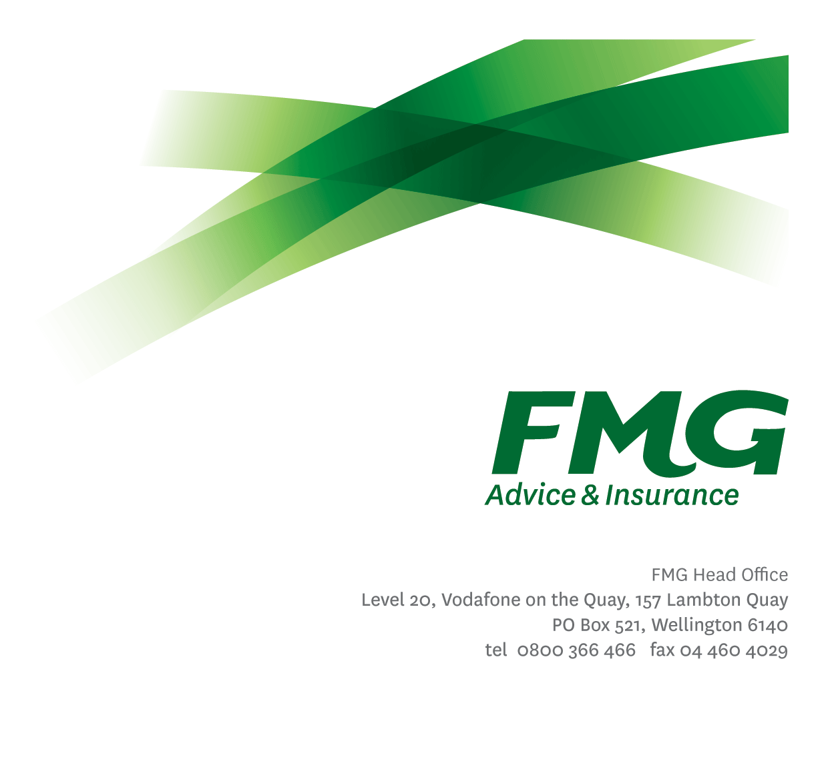Claims Change Specialist

*Position Description*



*Location:* Palmerston North or Christchurch

*Reporting to:* Manager, Claims Capability

*Business Unit:* Claims

*Direct Reports:* Nil

*Date Last Reviewed:* April 2025



### *About FMG*

***Formed by farmers for farmers over a century ago, FMG is New Zealand’s leading rural insurer providing risk advice and insurance solutions for farmers, growers, commercial businesses, the lifestyle sector and domestic clients.***

***We’re proudly 100% New Zealand owned and operated and our focus is on helping our clients to achieve their goals.  As a mutual organisation, we’re all about giving rural New Zealanders a better deal, and part of this involves reinvesting all profits back into the business to keep premiums low and ensure the future sustainability of the organisation.***



### *FMG’s Values*

The FMG brand represents promises about what customers can expect from us and each of us is responsible for delivering on these promises. Living our company values means we deliver the best brand experience for our customers. Our company values are:

|  |  |
| --- | --- |
| * Do what's right - Whāia te ara tika | * Make it happen - Whakatutukitia |
| * We're in it together - Ko tātau tātau | * Proud of who we are - Whakahīhī i te whakapapa |



### *Work Environment*

We strive to provide an environment that promotes and fosters achievement. We place importance on career development and training to give our people the tools they need to succeed.

FMG’s Head Office is located in Wellington and accommodates FMG’s Executive Leadership Team (ELT), Marketing & Propositions, People & Culture, Financial Management, Insurance Solutions, Business Information and Analysis, Legal and Risk.

FMG’s largest regional office is located in Palmerston North accommodating our National Sales & Advice Centre, Information Technology, Claims, Operations and Payments functions. In addition to the offices in Wellington, Palmerston North and Christchurch FMG has offices in 30 regional locations throughout New Zealand.

### *Purpose of the role*



The purpose of the Claims Change Specialist role is to effectively prepare for and support the delivery of project and tactical changes that impact the Claims team, ensuring the successful adoption and embedment of these changes.



### *Key Responsibilities*

| Area | Responsibilities |
| --- | --- |
| Business Change Planning | * Accountable for managing the Claims Change Plan which details initiatives, timing and impacts. * Identify change management strategies and activities that will be undertaken to support individual initiatives. * Coordinate the execution of the identified change management strategies, and review any key deliverables as required * Provide support across the Claims team to ensure the team can successfully deliver the people side of change for projects and change initiatives. * Provide expertise and guidance around the analysis, development and execution of training for assigned initiatives. * Be an advocate for Change Management and promote the value it provides for not only Claims, but throughout FMG. * Establish and maintain effective connections with the Change Team to ensure that FMG Change Best Practices are well understood and that they understand (as required) changes occurring within the Claims department. |
| Business Process Design | * Coordinate any design/redesign of Claims business processes to ensure alignment with assigned initiatives. |
| Impact Analysis | * Understand the proposed ‘future state’ for Claims arising from assigned initiatives and define the changes from the current state. * Identify and deliver detailed documentation of the impacts on all stakeholders, including other business units, resulting from the changes to current state. * Identify risks and develop risk mitigation plans to manage any resistance to change. |
| Communication and Stakeholder Engagement | * Coordinate and assist with the development and maintenance of Change Management communications schedules for assigned initiatives. * Assist with the preparation and delivery/distribution of communication materials for initiatives as required. |
| Organisation Design | * Assist with the identification and documentation of organisation design activities for relevant Claims initiatives. * Support organisation design activities as required. |
| Training | * Assist the Claims Capability Team or the Learning & Development Team with developing training plans and materials to support change. |
| Transition Planning | * Coordinate with relevant managers and team leaders to develop the plan for transition of projects and change initiatives into run-state to ensure ongoing embedment of the change. |
| Relationship Management | * Establish effective working relationships with all the key stakeholders of any initiative or projects including the Sponsor, Owner, and staff within Claims and other business units of FMG. |
| Personal Development | * Proactively acquires and develops skills, knowledge and techniques relating to planning and managing Change Management. |
| Other Duties | * Other tasks may be delegated as and when required. |
| FMG Values | * To promote the “FMG Way” through displaying the values of FMG which are do what’s right, make it happen, we’re in it together and proud of who we are |
| Wellbeing & Safety | * Complies with safety and wellbeing policy and procedures, including accident and incident reporting and hazard management requirements * Works in a safe manner at all times and does not undertake activities without appropriate training |

|  |  |
| --- | --- |
| **COMPETENCIES** | |
| *\*see competency framework for behaviours expected at each level* | *Expected Level* |
| **Customer Driven (Internal & External)**  A commitment to understanding the needs and best interests of both internal and external customers, in order to provide them with outstanding customer service and help them to make informed decisions. | Advanced* |
| **Accountability**  Taking personal ownership of decisions, behaviour, and development, and being responsible for how these actions impact on the wider organisation and customers. | Intermediate* |
| **Adaptability**  Demonstrating a willingness to engage in a changing environment and being flexible and comfortable working with change. | Advanced* |
| **Motivation and Drive**  The determination to achieve goals and strive for excellence. | Intermediate* |
| **Relationship Building**  Developing and maintaining positive, professional relationships that are built on mutual trust and respect. | Advanced* |
| **Team Work**  Making a positive contribution to the FMG team and collaborating effectively with others to achieve objectives. | Advanced* |
| **Change Leadership**  The drive to initiate opportunities to address FMG’s organisational needs and to communicate change in a way that gains buy-in and support from others. | Advanced* |
| **Critical Analysis**  The capability to identify impacts, key issues, trends, or important facts from information provided and to question and probe. | Intermediate* |

|  |  |
| --- | --- |
| **KNOWLEDGE** | |
| **Qualification Required** | Relevant Tertiary Qualification desirable  Prosci certification essential |
| **Business Awareness** | Understands the internal workings of FMG and how the Claims team works. |
| **Product Knowledge** | Is knowledgeable about FMG’s insurance products and the differences between them and the appropriateness of each in different situations. |
| **Specialist Knowledge** | Knowledge and experience in working with Change Management methodologies (such as Prosci) |

|  |  |
| --- | --- |
| **SKILLS** | |
| **Written Communication Skills** | Able to write clear, concise and persuasive proposals and reports. |
| **Verbal Communication Skills** | Communicates clearly in order to present information to persuade and influence others. |
| **Listening Skills** | Demonstrates active listening skills through eye contact, paraphrasing, appropriate body language and checking understanding. |
| **Technology Skills** | Can expertly use relevant software and technology to its full capacity e.g. MS Word, Excel and PowerPoint. |
| **Risk Assessment Skills** | Can put in place plans to mitigate risks and manage issues. |

### *Relationships*

|  |  |  |
| --- | --- | --- |
| **External** | Internal | Committees/Groups |
| * External service providers | * All FMG staff * Claims Leadership Team * Change Team * Learning and Development Team * Subject Matter Experts | * Project Steering Group * Project Working Groups * Change Leader Groups * Change Champion Groups |



### *Financial Authority Levels*

* No authority to commit or approve expenditure

### *Human Resources Authority Levels*

* Not applicable



### *Agreement*

I agree to the outline of the role as contained in this document and recognise that the contents may need to be amended from time to time to reflect changing business requirements.

I as Job holder, allow my Manager to gather information from third parties where necessary for the purposes of performance management.

|  |  |
| --- | --- |
| Claims Change Specialist’s Name: |  |
| Signature: |  |
| Date: |  |