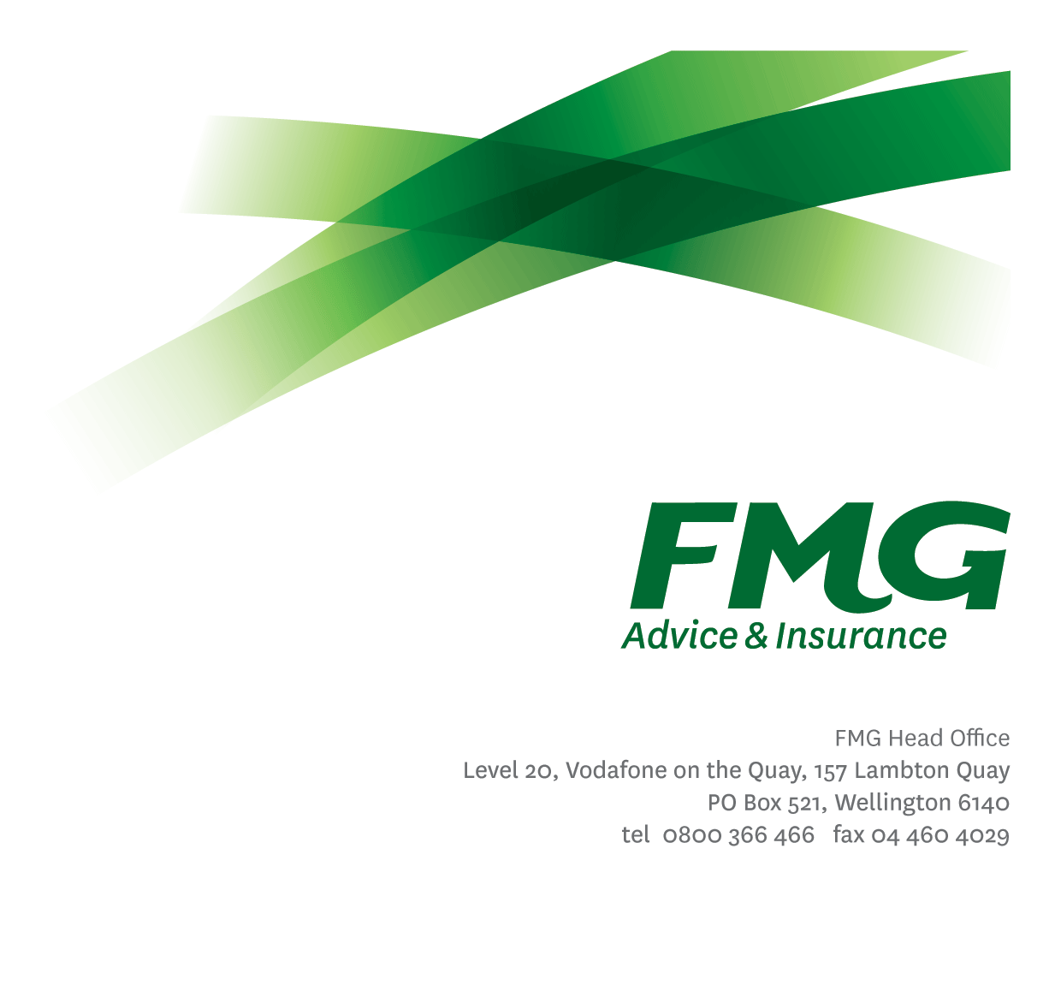Workforce Analyst

*Position Description*

*Location:* As per Personal Terms

*Reporting to:* Workforce Planning Manager

*Business Unit:* Sales, Advice & Service

*Direct Reports:* 0

*Date Last Reviewed:* July 2024

### *About FMG*

***Formed by farmers for farmers over a century ago, FMG is New Zealand’s leading rural insurer providing risk advice and insurance solutions for farmers, growers, commercial businesses, the lifestyle sector and domestic clients.***

***We’re proudly 100% New Zealand owned and operated and our focus is on helping our clients to achieve their goals.  As a mutual organisation, we’re all about giving rural New Zealanders a better deal, and part of this involves reinvesting all profits back into the business to keep premiums low and ensure the future sustainability of the organisation.***

### *FMG’s Values*

The FMG brand represents promises about what clients can expect from us and each of us is responsible for delivering on these promises. Living our company values means we deliver the best brand experience for our clients. Our company values are:

|  |  |
| --- | --- |
| * Do what's right - Whāia te ara tika | * Make it happen - Whakatutukitia |
| * We're in it together - Ko tātau tātau | * Proud of who we are - Whakahīhī i te whakapapa |



### *Work Environment*

We strive to provide an environment that promotes and fosters achievement. We place importance on career development and training to give our people the tools they need to succeed.

FMG’s Corporate Office is in Wellington and accommodates FMG’s Executive Leadership Team (ELT), Client Propositions & Online Services, People & Culture and Communications, Financial Management, Product & Pricing and Underwriting, Reinsurance, Business Information and Analysis, Legal and Compliance.

FMG’s largest regional office is in Palmerston North accommodating our National Sales & Advice Centre, Information Technology, Claims, Operations and Payments functions. In addition to the offices in Wellington, Palmerston North and Christchurch FMG has offices in 30 regional locations throughout New Zealand.



### *Purpose of the role*

The Workforce Analyst is jointly responsible for the resource management of NASC, enabling FMG to achieve efficiency and service level performance for all phone-based, client facing channels with the overall aim of optimising staffing levels to mitigate cost, maximise performance to deliver on demand and improve client satisfaction and experience

### *Key Responsibilities*

| Area | Responsibilities |
| --- | --- |
| Real-Time Queue Management | * Analyse real-time call trends and adjust FTE to ensure service levels are met. * Manage intra-day performance to ensure on the day resource is managed with optimal efficiency against forecasts. * Drive schedule adherence, compliance, activity and reports on exceptions and trends. * Manage daily shrinkage, utilizing Workforce Management tools to maintain information on team activity and statistics, including schedule maintenance, meetings, absence, and other shrinkage activities. * Enter and report on Consultant schedule and exception/out of adherence activity. * Record daily trending, Consultant absence, outages, and other performance insights. * Provide regular updates to Team Leaders & and Centre Managers detailing performance. * Lead daily insight meetings providing Team Leaders with daily performance reports and optimal time to conduct unplanned activities with a focus on improving from the prior day. * Ensure Consultant skills and priorities are accurate and reflective of Client demand. |
| Scheduling & Forecasting | * Develop staffing rosters that ensure Center team are scheduled for maximum efficiency to meet organization’s demand. * Alongside the Workforce Planning Manager, creating, reviewing, publishing, and optimizing of rolling schedules. * Balance annual leave, training, and other shrinkages against staffing requirements for the scheduled period being planned for * Alongside the Workforce Planning Manager, produce weekly/daily/intra-day forecasts for both voice and non-voice channels. * Alongside the Workforce Planning Manager, ensure effective scheduling of all shrinkage, i.e. 1-1’s, Meetings, training etc. * Analysing and providing solutions to support the business to address non-productive time. * General support tasks as assigned on an ad-hoc basis |
| Reporting | * Provides reporting as required and agreed from time to time |
| Personal Proficiency | * Proactively acquire and develop appropriate skills, knowledge and techniques in relation to fulfilling the core functions of the role. |
| Team Membership | * Report regularly to the NASC Leadership Team and wider stakeholders as required. |
| Compliance | * Ensure overall compliance with legislation regulations and FMG policies using established systems. |
| FMG Values | * Promote the “FMG Way” through displaying the values of FMG which are: Do what’s right, Make it happen, We’re in it together, Proud of who we are. |
| Wellbeing & Safety | * Demonstrate leadership and commitment to workplace wellbeing and safety practices. * Promote and support initiatives that contribute to a healthy and safe working environment for employees, visitors, and contractors. * Ensure compliance with safety and wellbeing policy and procedures, including accident and incident reporting and investigation, hazard management, induction, training and supervision, employee participation and contractor management. |

|  |  |
| --- | --- |
| **COMPETENCIES** | |
| *\*see competency framework for behaviours expected at each level* | *Expected Level* |
| **Customer Driven (Internal & External)**  A commitment to understanding the needs and best interests of both internal and external customers, in order to provide them with outstanding customer service and help them to make informed decisions. | Intermediate* |
| **Accountability**  Taking personal ownership of decisions, behaviour, and development, and being responsible for how these actions impact on the wider organisation and customers. | Intermediate* |
| **Adaptability**  Demonstrating a willingness to engage in a changing environment and being flexible and comfortable working with change. | Intermediate* |
| **Motivation and Drive**  The determination to achieve goals and strive for excellence. | Intermediate* |
| **Relationship Building**  Developing and maintaining positive, professional relationships that are built on mutual trust and respect. | Intermediate* |
| **Teamwork**  Making a positive contribution to the FMG team and collaborating effectively with others to achieve objectives. | Intermediate* |
| **Critical Analysis**  The capability to identify key issues, trends, or important facts from information and to question and probe. | Intermediate* |

|  |  |
| --- | --- |
| **KNOWLEDGE** | |
| **Qualifications** |  |
| **Business Awareness** | Deep understanding of the general insurance industry and practices.  Understands FMG's position in the advice and insurance market and knows the competition. |
| **Rural Knowledge** | Understands the rural community and keep up to date with the economic, political, and environmental issues affecting our customers. |
| **Legal Knowledge** | Has legal knowledge e.g. indemnity, liability, the Privacy Act etc. |

|  |  |
| --- | --- |
| **EXPERIENCE** | |
| **Work Experience** | 18 months experience in a Contact Centre environment, ideally in a Senior Consultant role  Demonstrated experience delivering excellent Client Experiences  *Experience with real time supervision of staff within a contact centre environment*  *Previous experience in Real Time Contact Centre Queue Management*  *12 months minimum within an Insurance role* |

|  |  |
| --- | --- |
| **SKILLS** | |
| **Written Communication Skills** | Able to write clear, concise and persuasive proposals and reports. |
| **Verbal Communications Skills** | Communicates clearly in order to present information to persuade and influence others. |
| **Listening Skills** | Demonstrates active listening skills through eye contact, paraphrasing, appropriate body language and checking understanding. |
| **Technology Skills** | Broad systems knowledge including experience in workforce management tools. Can expertly use relevant software and technology to its full capacity. |
| **Project Management Skills** | Can manage projects to deliver agreed outcomes across the business within agreed timeframes. |
| **Risk Assessment Skills** | Can put in place plans to mitigate risks and manage issues. |

### *Relationship*

|  |  |  |
| --- | --- | --- |
| External | Internal | Committees/Groups |
|  | * SAS NASC/Claims/Payment Services Team Leaders/Managers * Best Practice Leads * Learning & Development Team * Genesys Cloud Technical Consultant * NASC / Claims / Payment Services Consutants |  |

### *Financial Authority Levels*

* No authority to approve or commit expenditure

### *People Advisory Authority Levels*

* Not applicable

### *Agreement*

I agree to the outline of the role as contained in this document and recognise that the contents may need to be amended from time to time to reflect changing business requirements.

I as Job holder, allow my Manager to gather information from third parties where necessary for the purposes of performance management.

Name: ______________________

Signature: ____________________

Date: ________________________