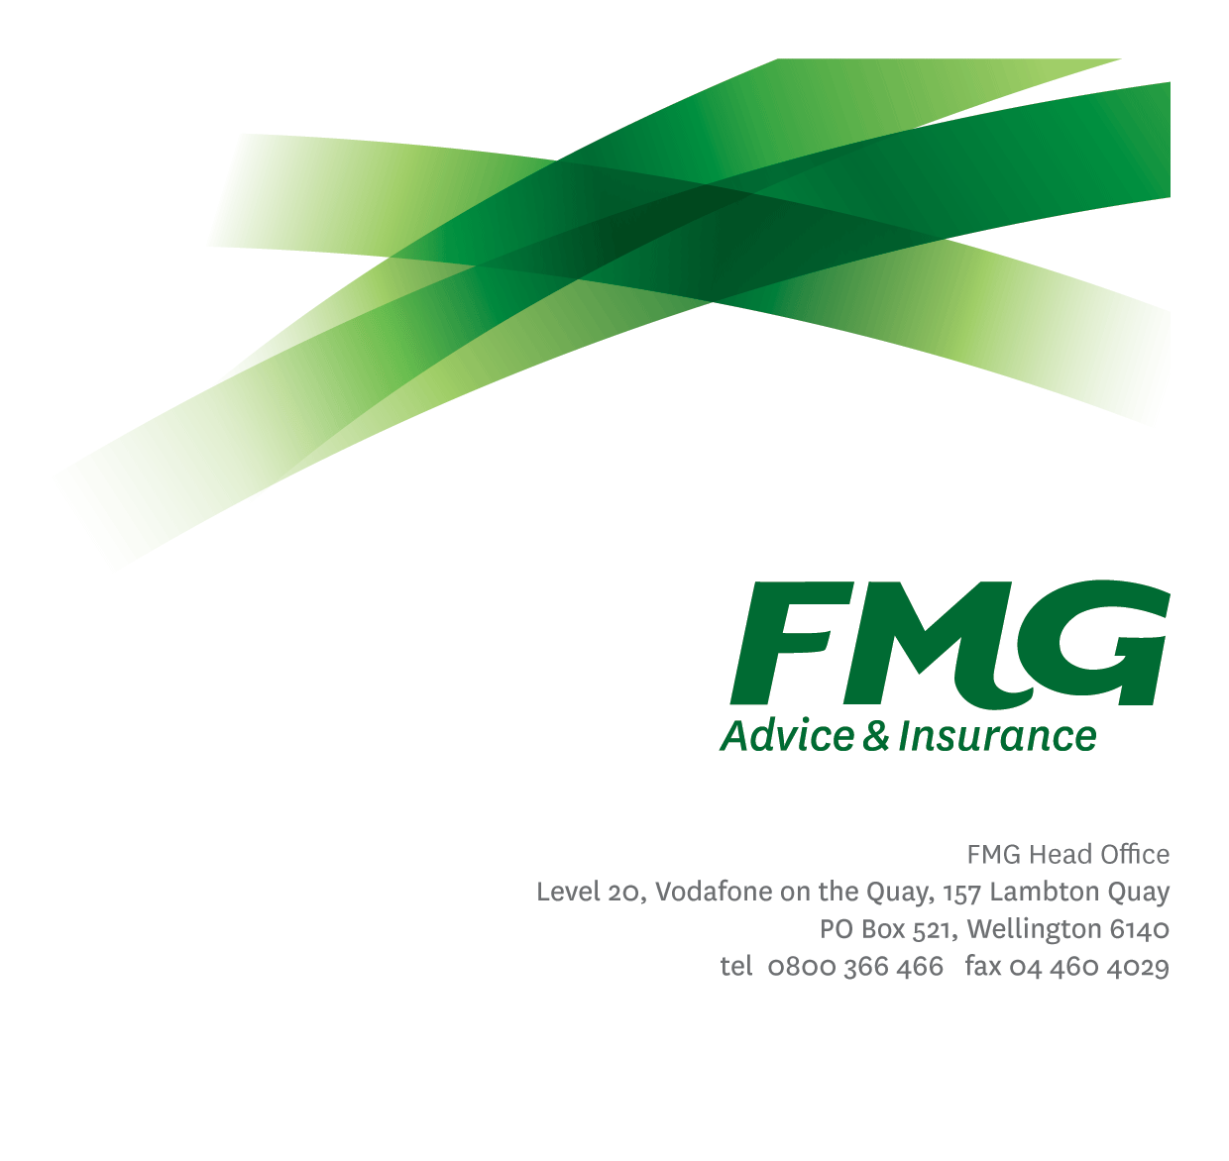Senior Data Analyst
Position Description

Location: Wellington/Palmerston North
Reporting to: Delivery Manager – Advanced Analytics
Business Unit: Digital & Data
Direct Reports: N/A
Date Last Reviewed: February 2026

About FMG
Formed by farmers for farmers over a century ago, FMG is New Zealand’s leading rural insurer providing risk advice and insurance solutions for farmers, growers, commercial businesses, the lifestyle sector and residential clients.
FMG is proudly 100% New Zealand owned and operated, and our focus is on helping our clients to achieve their goals. As a mutual organisation, FMG is all about giving rural New Zealanders a better deal, and part of this involves reinvesting all profits back into the business to keep premiums low and ensure the future sustainability of the Mutual.

FMG’s Values
FMG’s brand represents promises about what clients can expect from the Mutual and each FMG employee across our One Team is responsible for delivering on these promises. Living FMG’s Values means we all deliver the best brand experience for our clients. FMG’s Values are:
- Do what's right - Whāia te ara tika | - Make it happen - Whakatutukitia
- We're in it together - Ko tātau tātau | - Proud of who we are - Whakahīhī i te whakapapa

Work Environment
FMG strives to provide an environment that promotes and fosters achievement, placing importance on career development and training to provide our people with the tools they need to succeed.
FMG’s Head Office is located in Wellington and accommodates FMG’s Executive Leadership Team (ELT), Sales, Advice and Service, Claims, Marketing and Propositions, People and Culture, Finance and Investments, Insurance Solutions, Digital and Data, Risk and Compliance and Strategy and Enablement teams.
FMG’s largest regional office is in located in Palmerston North accommodating FMG’s National Sales and Advice Centre, People and Culture, Digital and Data, Claims, Operations and Payments functions. In addition to offices in Wellington, Palmerston North and Christchurch, FMG has regional offices in 30 locations throughout provincial New Zealand Aotearoa.

Purpose of the role
The Senior Data Analyst is responsible for delivering high-quality analytics and insights that support informed decision-making across FMG.
Working closely with business stakeholders and analytics colleagues, the role applies strong analytical capability to identify opportunities, develop insights, and communicate findings in ways that influence decisions and improve outcomes. The role operates within agreed analytics priorities and delivery sequencing, contributing to a consistent, reliable analytics service aligned to FMG’s Data, Information and Analytics (DIA) Strategy.
This role is a senior individual contributor, providing depth of analytical expertise, supporting complex analysis, and contributing to the ongoing maturity of FMG’s analytics capability.

Key Responsibilities

Area | Responsibilities
Analytics Insights Delivery | - Deliver high-quality analysis and insights that address business questions and support the design and use of operational reporting within core business platforms where appropriate.  - Apply appropriate analytical techniques, including descriptive, diagnostic, and where relevant predictive analysis.  - Apply advanced analytics techniques, including AI-enabled approaches where appropriate, to generate insights that deliver clear business value, in alignment with governance and agreed standards.  - Develop and maintain analytics outputs that are accurate, reliable, and fit for purpose.
Stakeholder Engagement | - Work proactively with business stakeholders to understand information needs and translate them into analytical approaches.  - Present and discuss insights with stakeholders, clearly explaining assumptions, limitations, and implications.  - Act as a trusted analytics partner, supporting stakeholders to interpret and use insights effectively.  - Support and collaborate with analysts working within business units by providing analytical guidance, sharing best practices, and contributing to consistent approaches to analytics and insight delivery across FMG.  - Contribute analytical insight and demand perspectives to support discussions with the Product Owner – Data Services on opportunities to improve, standardise, or enhance analytics and data services.
Data Analysis & Modelling | - Design and develop data sets, analytical models, and transformations required to support analysis and insight delivery.  - Contribute to statistical and analytical modelling where appropriate, ensuring methods are robust, transparent, and well-understood.  - Work with data engineering and platform teams to ensure data required for analysis is available, reliable, and well understood.
Visualisation & Communication | - Develop visualisations and analytical outputs that clearly communicate insights to technical and non-technical audiences.  - Translate complex analytical findings into clear, actionable messages that support effective decision-making.
Ways of Working & Quality | - Deliver analytics work in alignment with agreed priorities, standards, and ways of working.  - Ensure analytics outputs meet quality, governance, and documentation expectations.  - Contribute to continuous improvement of analytics practices, tools, and methods across the team.  - Identify and proactively flag data, analytical, or reporting risks (including data quality issues, assumptions, or limitations), and work with appropriate stakeholders to address or escalate these in line with agreed practices.  - Work in alignment with FMG’s data and information governance standards and engage with the Data & Information Governance function to seek guidance or escalate data quality, privacy, or appropriate-use considerations where required.
Team Contribution | - Actively contribute to the analytics team through collaboration, peer support, and knowledge sharing.  - Contribute to the broader analytics community by sharing knowledge, standards, and approaches, helping to uplift analytical capability across central and business-aligned analytics roles.
Service Mindset | - Demonstrate a strong service mindset by delivering analytics that are timely, reliable, and aligned to business needs.  - Ensure work is completed to a high standard and communicated clearly, with consideration of downstream business impact.  - Apply sound analytical judgement and professional standards to ensure analytics and insights are trustworthy, appropriate, and fit for purpose.
Other Duties | - Undertake other tasks as directed by the Delivery Manager – Advanced Analytics from time to time
Health & Safety | - Comply with FMG’s safety and wellbeing policies and procedures, including hazard management and incident reporting.  - Work in a safe manner at all times and do not undertake activities without appropriate training.

COMPETENCIES
*see competency framework for behaviours expected at each level | Expected Level
Customer Driven (Internal & External)  A commitment to understanding the needs and best interests of both internal and external customers, in order to provide them with outstanding customer service and help them to make informed decisions. | Intermediate*
Accountability  Taking personal ownership of decisions, behaviour, and development, and being responsible for how these actions impact on the wider organisation and customers. | Intermediate*
Adaptability  Demonstrating a willingness to engage in a changing environment and being flexible and comfortable working with change. | Intermediate*
Motivation and Drive  The determination to achieve goals and strive for excellence. | Intermediate*
Relationship Building  Developing and maintaining positive, professional relationships that are built on mutual trust and respect. | Intermediate*
Team Work  Making a positive contribution to the FMG team and collaborating effectively with others to achieve objectives. | Intermediate*
Critical Analysis  The capability to identify key issues, trends, or important facts from information and to question and probe. | Intermediate*

KNOWLEDGE
Qualifications | Relevant tertiary qualification in a quantitative, analytical, or related discipline, or equivalent practical experience.
Business Awareness | Understanding of FMG’s business environment and how analytics supports operational performance and decision-making.
Specialist Knowledge | - Analytics principles and best practice in a business context.  - Statistical and analytical modelling techniques appropriate to business problems.  - Use of advanced analytics and AI-enabled techniques where appropriate, with an understanding of their limitations and risks.  - Data structures, data quality considerations, and analytical data preparation.  - Responsible and appropriate use of data, including governance and quality considerations.  - Understanding of analytics best practice, including data quality management, appropriate use of data, and responsible interpretation and communication of insights

SKILLS
Analytical Skills | Strong ability to analyse complex data, identify patterns and trends, and draw meaningful conclusions.
Communication Skills | - Ability to clearly communicate analytical findings and insights, both verbally and in writing.  - Skilled at translating complex analysis into clear, understandable messages for different audiences.
Technical Skills | - Experience using modern analytics and data platforms, tools, and visualisation capabilities (platform-agnostic).  - Ability to work across multiple data sources and analytical environments.
Problem Solving | Applies structured, critical thinking to solve complex analytical problems.
Relationship Building | Builds effective working relationships with stakeholders and colleagues based on trust and professionalism.

Relationship
External | Internal | Committees/Groups
- Analytics and data partners (as required) | - Analytics and data engineering colleagues  - Business stakeholders and decision‑makers  - Data & Information Governance and data platform teams  - Analysts working within business units | - Analytics or data working groups (as required)

Financial Authority Levels

This role does not have independent authority to approve or commit expenditure.

All financial commitments must be made in accordance with FMG’s Delegation of Financial Authority (DFA) and within approved budgets.

Human Resources Authority Levels
- Nil

Agreement
I agree to the outline of the role as contained in this document and recognise that the contents may need to be amended from time to time to reflect changing business requirements.

I as Job holder, allow my Manager to gather information from third parties where necessary for the purposes of performance management.

Senior Data Analysts’ Name:
Signature:
Date:

Delivery Manager – Advanced Analytics’ Name:
Signature:
Date:

