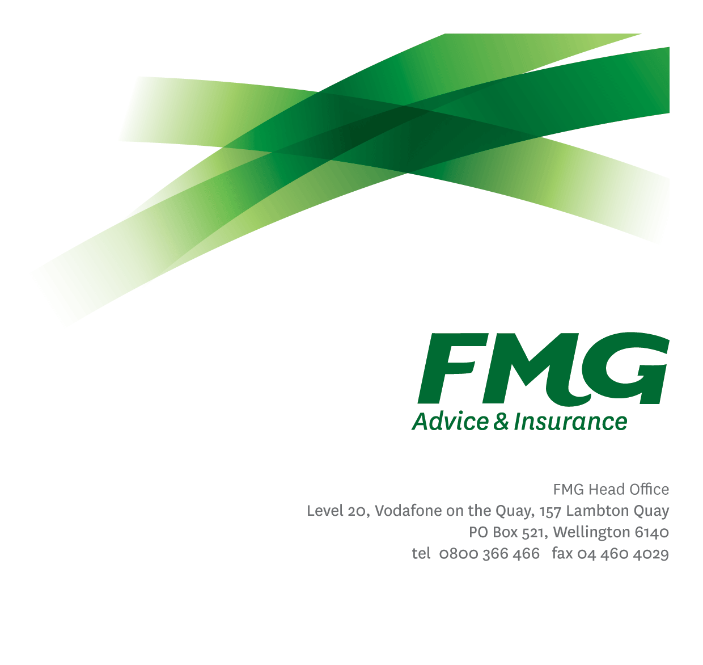Data & Information Governance Manager
Position Description

Location: Wellington
Reporting to: Head of Data, Information & Analytics
Business Unit: Digital & Data
Direct Reports: Variable
Date Last Reviewed: February 2026

About FMG
Formed by farmers for farmers over a century ago, FMG is New Zealand’s leading rural insurer providing risk advice and insurance solutions for farmers, growers, commercial businesses, the lifestyle sector and residential clients.
FMG is proudly 100% New Zealand owned and operated, and our focus is on helping our clients to achieve their goals. As a mutual organisation, FMG is all about giving rural New Zealanders a better deal, and part of this involves reinvesting all profits back into the business to keep premiums low and ensure the future sustainability of the Mutual.

FMG’s Values
FMG’s brand represents promises about what clients can expect from the Mutual and each FMG employee across our One Team is responsible for delivering on these promises. Living FMG’s Values means we all deliver the best brand experience for our clients. FMG’s Values are:
- Do what's right - Whāia te ara tika | - Make it happen - Whakatutukitia
- We're in it together - Ko tātau tātau | - Proud of who we are - Whakahīhī i te whakapapa

Work Environment
FMG strives to provide an environment that promotes and fosters achievement, placing importance on career development and training to provide our people with the tools they need to succeed.
FMG’s Head Office is located in Wellington and accommodates FMG’s Executive Leadership Team (ELT), Sales, Advice and Service, Claims, Marketing and Propositions, People and Culture, Finance and Investments, Insurance Solutions, Digital and Data, Risk and Compliance and Strategy and Enablement teams.
FMG’s largest regional office is in located in Palmerston North accommodating FMG’s National Sales and Advice Centre, People and Culture, Digital and Data, Claims, Operations and Payments functions. In addition to offices in Wellington, Palmerston North and Christchurch, FMG has regional offices in 30 locations throughout provincial New Zealand Aotearoa.

Purpose of the role
The Data & Information Governance Manager is responsible for leading FMG’s enterprise approach to data governance, information management, knowledge management, information protection, and privacy, ensuring that data, information, and knowledge assets are trusted, secure, and fit for purpose.
Reporting to the Head of Data, Information & Analytics, this role translates FMG’s Data, Information and Analytics (DIA) Strategy into practical governance frameworks, policies, standards, and ways of working that support operational effectiveness, regulatory compliance, and informed decision-making — including the responsible use of advanced analytics and AI-enabled capabilities.
The role provides leadership across the full information lifecycle — from creation and capture through to use, retention, and disposal — ensuring governance foundations support emerging technologies, automation, and AI while maintaining trust, transparency, privacy, and compliance.

Key Responsibilities

Area | Responsibilities
Enterprise Data Governance | - Lead FMG’s enterprise data governance capability, including data ownership, stewardship, accountability, and decision rights.  - Establish and maintain governance practices that ensure data quality, consistency, transparency, and appropriate use across the Mutual.  - Ensure data governance supports analytics, reporting, and AI-enabled use cases through clear standards, definitions, and controls.  - Provide guidance on ethical, responsible, and appropriate use of data in line with FMG policy and values.
Enterprise Information Governance & Records | - Lead enterprise information management and records practices, including retention, archiving, and disposal.  - Ensure information governance policies, standards, and procedures are practical, current, and consistently applied.  - Provide oversight of information classification, metadata, and lifecycle management across structured and unstructured information.  - Support compliance with legislative and regulatory obligations relating to information and records management.
Data & Information Protection, Privacy & Discovery | - Lead governance practices that ensure information and data are protected in line with FMG policies, privacy obligations, regulatory requirements, and risk appetite.  - Establish and maintain Information Protection frameworks, standards, and guard‑rails, including those enabled through Microsoft Purview, to support classification, retention, discovery, and protection of information and data assets.  - Ensure privacy‑by‑design and information protection principles are embedded into data, analytics, knowledge, and AI‑enabled initiatives.  - Provide governance oversight and advice for eDiscovery and external information sharing practices, ensuring they are managed in a compliant, proportionate, and defensible manner.  - Work closely with Privacy, Risk, Security, Legal, and Architecture teams to ensure appropriate controls, guidance, and assurance are in place.  - Provide advice on the appropriate handling, sharing, and use of sensitive, personal, and confidential information.
Knowledge Management | - Provide leadership for FMG’s approach to knowledge management, including enterprise knowledge bases and shared information repositories.  - Ensure knowledge assets are curated, accessible, accurate, and maintained to support employee effectiveness and client service.  - Work with Digital, Analytics, and AI-enabled initiatives to ensure knowledge sources used by automation and AI are governed and fit for purpose.  - Ensure lifecycle, quality, privacy, and protection controls are embedded for knowledge used in AI-assisted search, decision support, and automation.
Data Quality, Ethics & Responsible Use | - Lead enterprise data quality management practices, including identification, prioritisation, and remediation of data quality issues.  - Support ethical, responsible, and appropriate use of data, information, and knowledge in line with FMG policy and values.  - Provide governance oversight for data and information used in advanced analytics and AI-enabled use cases, ensuring transparency, explainability, privacy, and trust.  - Support alignment with FMG’s approach to responsible AI through clear standards, controls, and assurance.
Stakeholder Engagement & Advisory | - Act as a trusted advisor to business leaders, delivery teams, and product owners on data governance, information management, privacy, and protection matters.  - Work closely with Architecture, Data Engineering, Analytics, Privacy, Risk, Security, and Compliance teams to ensure alignment.  - Facilitate and support governance forums, working groups, and communities of practice as required.
People Leadership | - Lead, coach, and develop Information Management Analysts and related specialist roles.  - Foster a collaborative, service-oriented culture focused on enablement rather than enforcement.  - Build organisational capability through guidance, training, and practical support.
Ways of Working & Continuous Improvement | - Ensure data governance, information governance, privacy, and protection practices are embedded early in delivery and operational processes.  - Ensure governance foundations support initiatives involving automation, advanced analytics, and AI‑enabled capabilities.  - Continuously review and improve governance frameworks to ensure they remain proportionate, practical, and fit for purpose.
Service Mindset | - Demonstrate a strong service mindset by enabling teams to confidently and safely use data, information, and knowledge.  - Balance governance rigor with practicality, ensuring standards protect FMG while supporting delivery.  - Ensure advice and guidance is timely, clear, and focused on positive outcomes.
Other Duties | - Undertake other tasks as directed by the Head of Data, Information & Analytics from time to time
Health & Safety | - Comply with FMG’s safety and wellbeing policies and procedures, including hazard management and incident reporting.  - Work in a safe manner at all times and do not undertake activities without appropriate training.

COMPETENCIES
*see competency framework for behaviours expected at each level | Expected Level
Customer Driven (Internal & External)  A commitment to understanding the needs and best interests of both internal and external customers, in order to provide them with outstanding customer service and help them to make informed decisions. | Advanced*
Accountability  Taking personal ownership of decisions, behaviour, and development, and being responsible for how these actions impact on the wider organisation and customers. | Advanced*
Adaptability  Demonstrating a willingness to engage in a changing environment and being flexible and comfortable working with change. | Advanced*
Motivation and Drive  The determination to achieve goals and strive for excellence. | Intermediate*
Relationship Building  Developing and maintaining positive, professional relationships that are built on mutual trust and respect. | Advanced*
Team Work  Making a positive contribution to the FMG team and collaborating effectively with others to achieve objectives. | Advanced*
Critical Analysis  The capability to identify key issues, trends, or important facts from information and to question and probe. | Advanced*
Motivating and Developing Others  A commitment to getting the best out of people and motivating them to reach their full potential. | Intermediate *
Change Leadership  The drive to initiate opportunities to address FMG’s organisational needs and to communicate change in a way that gains buy-in and support from others. | Intermediate*
Strategic Thinking  The capacity to stand apart from the day-to-day and take a long-term, big picture view of the business. | Advanced*

KNOWLEDGE
Qualifications | Relevant tertiary qualification in data governance, information management, records management, privacy, or a related discipline, or equivalent experience.
Business Awareness | Understands the internal workings of FMG and how business works; understands FMG's position in the advice and insurance market and knows the competition.
Specialist Knowledge | - Enterprise data governance and information governance practices.  - Information protection and privacy principles, including secure handling of sensitive information.  - Data quality management, metadata, classification, and lifecycle management.  - Knowledge management principles and enterprise knowledge platforms.  - Relevant legislative and regulatory obligations (e.g. Privacy Act, records management requirements).

SKILLS
Written Communication Skills | Able to write clear, concise and persuasive proposals and reports.
Verbal Communications Skills | Communicates clearly in order to present information to persuade and influence others.
Technology Skills | Strong understanding of data, information, and knowledge management technologies and governance tooling.
Listening Skills | Demonstrates active listening skills through eye contact, paraphrasing, appropriate body language and checking understanding.
Risk Assessment Skills | Identifies, assesses, and mitigates data, information, privacy, and knowledge risks that may impact FMG’s compliance, reputation, or decision-making.
Financial Skills | Able to understand and interpret financial information such as budgets, forecasts, and cost considerations
Specialist Skills | Strong capability in leading analytics delivery, prioritising work, and translating business questions into meaningful insights and outcomes.

Relationship
External | Internal | Committees/Groups
- Data, Information Vendors & Service Providers  - Industry and professional groups | - DIA Leadership Team  - Mutual Leaders  - Delivery Leaders  - Enterprise Architecture  - Privacy, Risk, Security, Compliance and Legal  - Business & Product Owners  - Digital and Data teams  - Project Sponsors, Stakeholders, steering group members  - Working groups, committees and cross-functional groups supporting analytics and insight delivery | - Information and Data Governance Committee (as required)

Financial Authority Levels

This role does not have independent authority to approve or commit expenditure.

All financial commitments must be made in accordance with FMG’s Delegation of Financial Authority (DFA) and within approved budgets.

Any expenditure outside delegated authority must be escalated for approval in line with FMG policy

Human Resources Authority Levels
- May hire direct and indirect reports within approved FTE headcounts.
- May discipline direct and indirect reports in consultation with manager and Human Resources.
- No authority to dismiss staff, unless delegated by the Chief Executive and in consultation with the Chief Digital and Data Officer, Head of Data, Information & Analytics, and People and Culture.

Agreement
I agree to the outline of the role as contained in this document and recognise that the contents may need to be amended from time to time to reflect changing business requirements.

I as Job holder, allow my Manager to gather information from third parties where necessary for the purposes of performance management.

Data & Information Governance Managers’ Name:
Signature:
Date:

Head of Data, Information & Analytics’ Name:
Signature:
Date:

