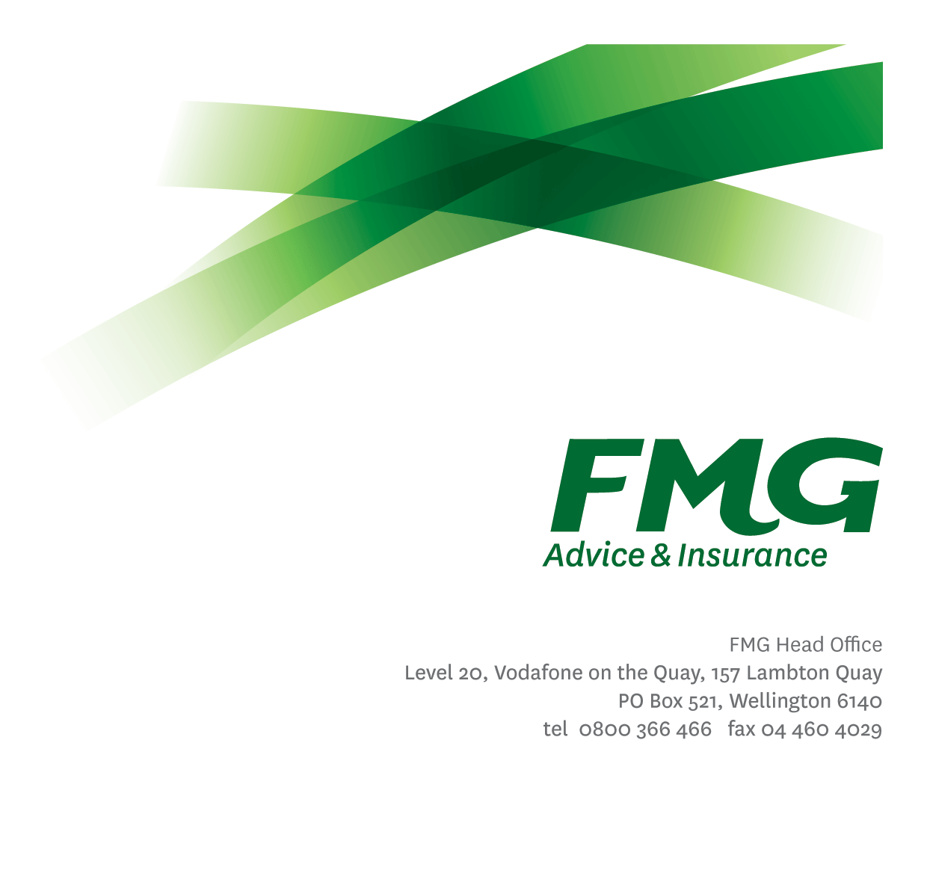
Senior Claims Adviser - Subrogation and Settlement
Position Description

Location: Palmerston North
Reporting to: Team Leader - Subrogation and Settlement
Business Unit: Claims
Direct Reports: 0
Date Last Reviewed: October 2026

About FMG
Formed by farmers for farmers over a century ago, FMG is New Zealand’s leading rural insurer providing risk advice and insurance solutions for farmers, growers, commercial businesses, the lifestyle sector and residential clients.
We’re proudly 100% New Zealand owned and operated and our focus is on helping our clients to achieve their goals. As a mutual organisation, we’re all about giving rural New Zealanders a better deal, and part of this involves reinvesting all profits back into the business to keep premiums low and ensure the future sustainability of the organisation.

FMG’s Values
The FMG brand represents promises about what clients can expect from us and each of us is responsible for delivering on these promises. Living our company values means we deliver the best brand experience for our clients. Our company values are:
- Do what's right - Whāia te ara tika | - Make it happen - Whakatutukitia
- We're in it together - Ko tātau tātau | - Proud of who we are - Whakahīhī i te whakapapa

Work Environment
We strive to provide an environment that promotes and fosters achievement. We place importance on career development and training to give our people the tools they need to succeed.
FMG’s Head Office is located in Wellington and accommodates FMG’s Executive Leadership Team (ELT), Client Propositions & Online Services, People & Culture and Communications, Financial Management, Product & Pricing and Underwriting, Reinsurance, Business Information and Analysis, Legal and Compliance.
FMG’s largest regional office is located in Palmerston North accommodating our National Sales & Advice Centre, Information Technology, Claims, Operations and Payments functions. In addition to the offices in Wellington, Palmerston North and Christchurch FMG has offices in 30 regional locations throughout New Zealand.

Purpose of the role
To role-model FMG’s values and provide technical leadership across subrogation and settlement. The role manages a portfolio of complex and high-value recovery matters, coaches Claims team members, supports consistent technical standards and contributes to process and service improvements that deliver fair, timely outcomes for clients and FMG.

Key Responsibilities

Area | Responsibilities
Team Support & Coaching | - Provide senior technical guidance on complex recovery, liability, settlement and administration matters, including disputed claims and escalations.  - Coach and mentor Claims team members by role-modelling good practice, supporting onboarding and ongoing capability development, and completing agreed quality reviews with constructive feedback.  - Identify and communicate emerging trends, risks and improvement opportunities, and lead practical changes that improve consistency, efficiency and client outcomes.  - Contribute to agreed individual, team and Claims performance measures and priorities.  - Contribute to an inclusive, accountable and high-performing team culture that supports the achievement of team and wider Claims goals.
Support for Claims Leadership | Undertake delegated operational tasks for Claims Leadership, including:  - Monitor relevant recovery, administration and settlement work queues, and support work allocation, reallocation and portfolio balancing within delegated responsibilities.  - Provide agreed operational continuity during leader absences, including workflow oversight, while escalating formal people matters, significant risks and decisions outside delegated authority to Claims Leadership.  - Support onboarding plans, targeted performance activities and other delegated workflow or technical-support tasks.  - Support team communication and engagement activities.  - Translate complex claim information into clear technical positions and provide material recovery updates for management, legal or Board reporting when required.  - Undertake other delegated Claims Leadership activities within the role’s capability and authority.
Claims Management | - Manage a portfolio of complex, high-value and large-loss recoveries effectively and efficiently. Assess liability, evidence, recovery prospects and dispute risk, and seek to restore the client’s financial position to the extent available under the policy and applicable recovery rights.  - Apply FMG Claims best practice, relevant policies and the Fair Insurance Code.
Client Focus | - Take ownership of delivering fair, timely and empathetic service, seeking practical outcomes for clients and FMG.  - Set and manage client expectations, communicate clearly and deliver on commitments through confident, evidence-based decision-making within delegated authority.
Problem Solving | - Gather and analyse relevant information, evaluate options and develop practical, sustainable solutions.  - Make sound, timely and well-informed decisions, escalating matters that fall outside delegated authority or carry material risk.
Relationship Management | - Build and maintain trusted, professional relationships with internal and external stakeholders to support effective claim and recovery outcomes.
Risk and Compliance | - Identify, assess and manage risks within the role’s responsibilities, and contribute to FMG’s risk management framework and control environment.  - Comply with applicable legislation, regulations, industry standards and FMG policies, and maintain accurate records using approved systems and processes.  - Apply agreed quality controls, maintain complete and accurate claim records, and promptly escalate control failures, emerging risks or material issues.
Claims Team & Individual Performance | - Contribute to Claims priorities and team objectives, take ownership of agreed performance expectations, and identify and act on development needs.
FMG Values | - Demonstrate FMG’s values in day-to-day decisions, behaviours and interactions.
Wellbeing & Safety | - Comply with FMG’s wellbeing and safety policies and procedures, including hazard, accident and incident reporting requirements.  - Work safely, support the wellbeing of others and undertake only activities for which appropriate information, instruction and training have been provided.

COMPETENCIES
*see competency framework for behaviours expected at each level | Expected Level
Customer Driven (Internal & External)  Understands and anticipates the needs and interests of internal and external clients, provides clear advice and service, and supports informed decisions and fair outcomes. | Advanced*
Accountability  Takes ownership of decisions, behaviour, commitments and development, and understands their impact on clients, colleagues and FMG. | Intermediate*
Adaptability  Responds constructively to change, adjusts priorities and ways of working, and remains effective in evolving circumstances. | Intermediate*
Motivation and Drive  Shows initiative and persistence, follows through on commitments and strives for high-quality outcomes. | Intermediate*
Relationship Building  Builds and maintains trusted, professional relationships based on openness, mutual respect and constructive challenge. | Intermediate*
Team Work  Contributes positively to the FMG team and collaborates across boundaries to achieve shared outcomes. | Competent*
Critical Analysis  Identifies material issues, patterns and risks from complex information, tests assumptions and reaches well-reasoned conclusions. | Competent*

KNOWLEDGE
Business Awareness | Understands FMG’s business model, operating environment, strategy and place in the New Zealand advice and insurance market.
Legal Knowledge | Applies working knowledge of relevant legal and regulatory requirements, including indemnity, liability, privacy, dispute resolution and recovery principles.
Product Knowledge | Understands FMG’s insurance policies and products, their differences and how they apply in different claim and recovery situations.
Systems Knowledge | Uses relevant claims, customer, document-management, communication and reporting systems effectively.  Key systems include ClaimsCenter, CRM, Genesys Cloud and OnBase.
Risk/Insurance Knowledge | Understands insurance and recovery principles, compliance obligations, claims practices, relevant risks, and the roles of industry partners and competitors.
Specialist Knowledge | Demonstrates advanced knowledge of complex claims, subrogation and settlement processes, together with effective coaching and quality-review practices.

SKILLS
Written Communication Skills | Produces clear, concise and audience-appropriate correspondence, technical positions, reports and emails.
Verbal Communication Skills | Communicates information clearly and confidently in one-to-one discussions, meetings and presentations.
Influencing Skills | Uses evidence, sound reasoning and an audience-appropriate approach to influence constructive outcomes.
Listening Skills | Listens actively, asks effective questions, checks understanding and responds respectfully to different perspectives.
Technology Skills | Uses Microsoft 365 and relevant claims, customer, communication and reporting technology effectively and securely.
Risk Assessment Skills | Identifies, assesses and responds to operational, legal, financial and reputational risks, and escalates material issues appropriately.
Financial Skills | Interprets financial information relevant to claims and recoveries, including calculating excesses and assessing material financial impacts.

Relationships
External | Internal | Committees/Groups
- External assessors  - Repairers  - Suppliers  - Brokers  - Other insurance providers | - Service Centre  - Loss Adjusters  - Rural Managers  - Other FMG Employees | - As required

Financial Authority Levels
- No authority to commit or approve expenditure unless specifically delegated in writing.

People and Culture Authority Levels
- No formal people-management authority. The role may provide coaching, technical guidance, quality feedback and delegated workflow support, but formal employment and performance decisions remain with the relevant people leader.

Agreement
I acknowledge the responsibilities and expectations described in this position description. The position description may be updated from time to time to reflect changes in business requirements, provided any material changes are discussed with the role holder.

I understand that information relevant to employment and performance may be gathered and used in accordance with FMG policy and applicable privacy requirements.

Name: ______________________
Signature: ____________________
Date: ________________________

