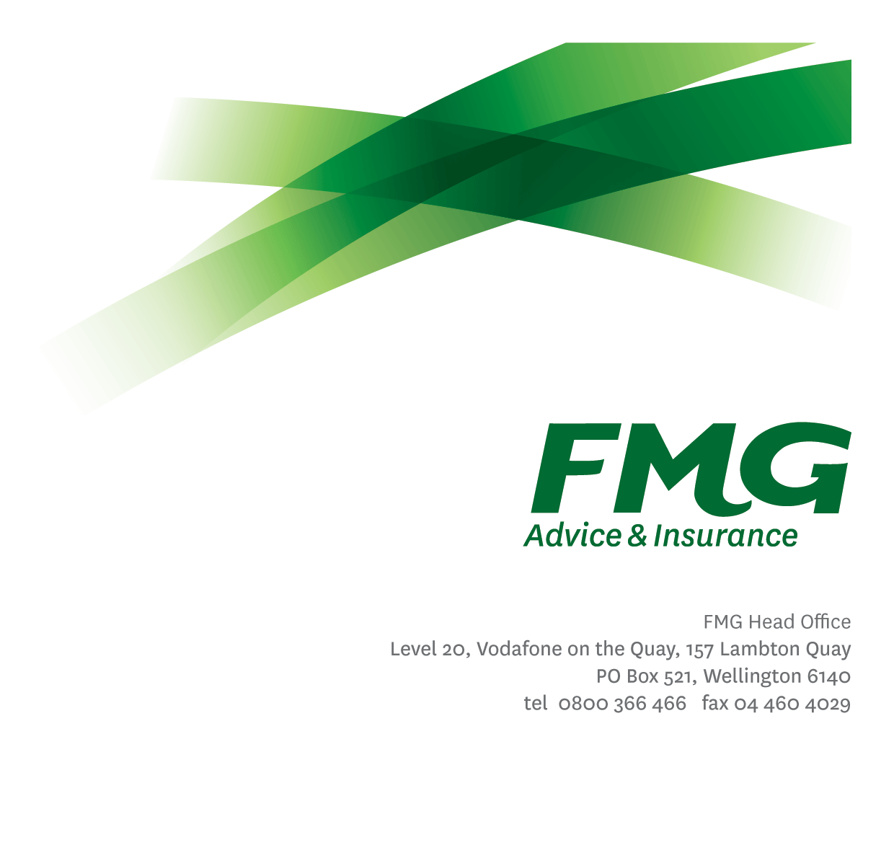
Senior Business Analyst
Position Description

Location: Palmerston North or Wellington
Reporting to: Delivery Manager
Business Unit: Digital and Data
Direct Reports: N/A
Date Last Reviewed: February 2026

About FMG
Formed by farmers for farmers over a century ago, FMG is New Zealand’s leading rural insurer providing risk advice and insurance solutions for farmers, growers, commercial businesses, the lifestyle sector and residential clients.
FMG is proudly 100% New Zealand owned and operated, and our focus is on helping our clients to achieve their goals. As a mutual organisation, FMG is all about giving rural New Zealanders a better deal, and part of this involves reinvesting all profits back into the business to keep premiums low and ensure the future sustainability of the Mutual.

FMG’s Values
FMG’s brand represents promises about what clients can expect from the Mutual and each FMG employee across our One Team is responsible for delivering on these promises. Living FMG’s Values means we all deliver the best brand experience for our clients. FMG’s Values are:
- Do what's right - Whāia te ara tika | - Make it happen - Whakatutukitia
- We're in it together - Ko tātau tātau | - Proud of who we are - Whakahīhī i te whakapapa

Work Environment
FMG strives to provide an environment that promotes and fosters achievement, placing importance on career development and training to provide our people with the tools they need to succeed.
FMG’s Head Office is in Wellington and accommodates FMG’s Executive Leadership Team (ELT), Sales, Advice and Service, Claims, Marketing and Propositions, People and Culture, Finance and Investments, Insurance Solutions, Digital and Data, Risk and Compliance and Strategy and Enablement teams.
FMG’s largest regional office is in located in Palmerston North accommodating FMG’s National Sales and Advice Centre, People and Culture, Digital and Data, Claims, Operations and Payments functions. In addition to offices in Wellington, Palmerston North and Christchurch, FMG has regional offices in 30 locations throughout provincial New Zealand Aotearoa.

Purpose of the role
The Senior Business Analyst leads business analysis across the change initiative lifecycle, from elaboration through to delivery and run state. The role leads the analysis and definition of complex, strategic initiatives and digital products. Partnering with project and product teams, this role defines outcomes and requirements, and ensures product delivery aligns with the Mutual’s strategy, architecture, and long‑term capability uplift, while enabling exceptional client experiences.

Key Responsibilities

Area | Responsibilities
Business Analysis | - Lead the analysis and definition of complex, strategic initiatives and digital products from discovery to business-as-usual.  - Elicit, analyse, and document current and future state business processes, data flows, and information needs to support the delivery of digital and data products, platforms, and change initiatives.  - Work with stakeholders, product and delivery teams to define clear business problems, outcomes, requirements, and acceptance criteria.  - Ensure functional and non‑functional requirements including service levels, data quality, security are identified and incorporated into solutions.
Consulting Services | - Provide trusted analysis and advisory support to project, product, and delivery teams.  - Produce fit‑for‑purpose business analysis artefacts (e.g. requirements, process models, business rules) appropriate to the delivery approach.  - Support delivery teams by translating business needs into clear, actionable inputs that enable effective design and delivery decisions.
Process Improvement | - Identify systemic process, data, and capability gaps and recommend opportunities for optimisation and simplification.  - Analyse business processes to improve efficiency, effectiveness, and client experiences.  - Support continuous improvement by identifying opportunities to simplify, automate, or digitally enable processes.
Standards and Quality Uplift | - Lead the application and evolution of business analysis standards, practices, and quality assurance.  - Coach and mentor Business Analysts, supporting capability uplift across the function.  - Ensure analysis outputs meet agreed quality, architecture, and governance expectations.
Delivery Outcomes and Client Experience | - Ensure initiatives and products align with enterprise architecture blueprint.  - Work closely with digital and data leaders to shape sustainable, future‑focused solutions.  - Consider long‑term data, integration, and information management impacts in analysis and recommendations.
Relationship Management | - Build and maintain strong working relationships with project managers, product owners, business stakeholders and delivery teams.  - Facilitate complex discussions and workshops to align stakeholders on priorities, outcomes, and delivery approaches.  - Support change adoption by engaging users throughout the delivery lifecycle.
Service Support | - Support initiatives across elaboration, discovery, delivery, release, and transition into business‑as‑usual.  - Provide flexible support to delivery outcomes, recognising occasional work outside standard hours.
Other Duties | - Undertake tasks as directed by management from time to time.
Health & Safety | - Complies with safety and wellbeing policy and procedures, including accident and incident reporting and hazard management requirements  - Works in a safe manner at all times and does not undertake activities without appropriate training

COMPETENCIES
*see competency framework for behaviours expected at each level | Expected Level
Customer Driven (Internal & External)  A commitment to understanding the needs and best interests of both internal and external customers, to provide them with outstanding customer service and help them to make informed decisions. | Advanced*
Accountability  Taking personal ownership of decisions, behaviour, and development, and being responsible for how these actions impact on the wider organisation and customers. | Intermediate*
Adaptability  Demonstrating a willingness to engage in a changing environment and being flexible and comfortable working with change. | Intermediate*
Motivation and Drive  The determination to achieve goals and strive for excellence. | Intermediate*
Relationship Building  Developing and maintaining positive, professional relationships that are built on mutual trust and respect. | Advanced*
Team Work  Making a positive contribution to the FMG team and collaborating effectively with others to achieve objectives. | Advanced*
Critical Analysis  The capability to identify key issues, trends, or important facts from information and to question and probe. | Advanced*

KNOWLEDGE
Qualifications | Relevant Tertiary Qualification or proven experience required.
Business Awareness | Understands the business of Insurance and how the appropriate business systems work. Understands FMG's position in the advice and insurance market and how the Mutual is strategically positioned.
Systems Knowledge | Knowledge of the systems that FMG is using.
Specialist Knowledge | Proven track record of conducting Business Analysis, and associated requirements management techniques.  A general knowledge of project and product management, testing, systems development and Architecture.

SKILLS
Written Communication Skills | Able to write clear, concise and persuasive proposals and reports.
Verbal Communications Skills | Communicates clearly to present information to persuade and influence others.
Listening Skills | Demonstrates active listening skills through eye contact, paraphrasing, appropriate body language and checking understanding.
Technology Management | Proficient in networking and programming and has broad systems knowledge.

Relationships
External | Internal | Committees/Groups
- External Product and Service Delivery Partners | - Digital and Data Leadership Team  - Delivery Teams  - Heads of Digital Product/ Product Owners  - Mutual Leaders/ Business Owners  - Subject Matter Experts | - Big Room Planning  - Communities of Practice

Financial Authority Levels
- No authority to commit or approve expenditure

Human Resources Authority Levels
- Not applicable

Agreement
I agree with the outline of the role as contained in this document and recognise that the contents may need to be amended from time to time to reflect changing business requirements.

I as Job holder, allow my manager to gather information from third parties where necessary for the purposes of performance management.

Agreement will be via electronic signature as evidenced on the acceptance form.

