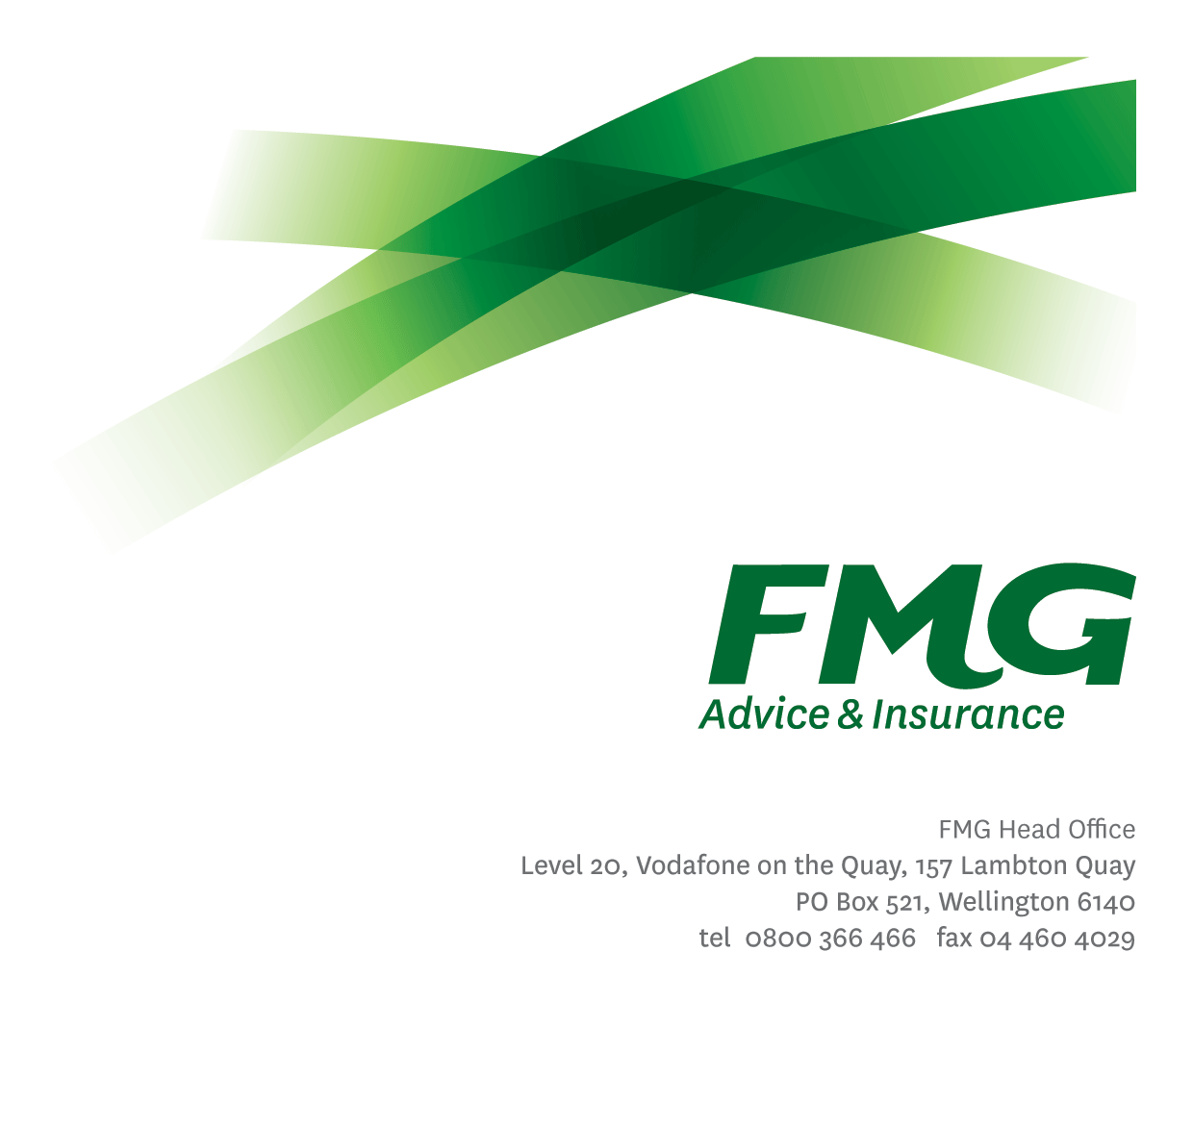Organisational Development Lead
Position Description

Location: Wellington
Reporting to: Head of Organisational Development
Business Unit: People & Culture
Direct Reports: Nil
Date Last Reviewed: October 2022

About FMG
Formed by farmers for farmers over a century ago, FMG is New Zealand’s leading rural insurer providing risk advice and insurance solutions for farmers, growers, commercial businesses, the lifestyle sector and residential clients.
We’re proudly 100% New Zealand owned and operated, and our focus is on helping our clients to achieve their goals. As a mutual organisation, we’re all about giving rural New Zealanders a better deal, and part of this involves reinvesting all profits back into the business to keep premiums low and ensure the future sustainability of the organisation.

FMG’s Values
The FMG brand represents promises about what clients can expect from us and each of us is responsible for delivering on these promises. Living our company values means we deliver the best brand experience for our clients. Our company values are:
- Do what's right - Whāia te ara tika | - Make it happen - Whakatutukitia
- We're in it together - Ko tātau tātau | - Proud of who we are - Whakahīhī i te whakapapa

Work Environment
We strive to provide an environment that promotes and fosters achievement. We place importance on career development and training to give our people the tools they need to succeed.
FMG’s Head Office is located in Wellington and accommodates FMG’s Executive Leadership Team (ELT), Client Propositions & Online Services, People & Culture and Communications, Financial Management, Product & Pricing and Underwriting, Reinsurance, Business Information and Analysis, Legal and Compliance.
FMG’s largest regional office is located in Palmerston North accommodating our National Sales & Advice Centre, Information Technology, Claims, Operations and Payments functions. In addition to the offices in Wellington, Palmerston North and Christchurch FMG has offices in 30 regional locations throughout New Zealand.

Purpose of the role

As a valuable member of the People and Culture Team, the Organisational Development Lead is responsible for partnering with the business to develop and implement key organisation-wide capability, talent and engagement initiatives which will build a better FMG. This will be done by providing insights, best practice and embedding knowledge of organisational design and development into the design, development and delivery of strategy and programs which are impactful, innovative and sustainable.
Delivery will occur working in close coordination across People and Culture and through FMG’s leadership teams.

Key Responsibilities

Area | Responsibilities
Organisational Development Strategy and Advice | - Develop and implement innovative and effective initiatives to drive organisational development particularly in the areas of talent, diversity, culture and engagement.  - Recommend and implement initiatives that reinforce the use and understanding of FMGs Competency Framework and other FMG development frameworks.  - Work with the Head of Organisational Development to progress and embed the Leadership Framework.  - Review, progress and keep current assigned OD frameworks (such as the FMG Performance Management, Talent and Succession).  - Support business projects with best practice OD advice as required.  - Work closely with the Head of Organisational Development and Chief People Officer to drive the delivery of the P&C Strategy.
Organisational Development Programs and Project Delivery | - Identify and develop initiatives to build leadership capability across all levels of the business and then work with the appropriate roles/partners to deliver into the business.  - Facilitate team building sessions across FMG.  - Provide coaching and support to the P&C team and to people leaders to increase understanding of and capability around OD initiatives to ensure they can be delivered into the business.  - Ensure best practice in OD is constantly addressed and incorporated into FMG policy and process.  - Establish and manage excellent supplier relationships with external providers to ensure that services meet the required needs of FMG.  - Continue to drive the embedding of Clifton Strengths within the Mutual.
Collaboration, Teamwork and Personal Development | - Act as a specialist advisor to key stakeholders and ensure excellence in the way you partner with and deliver to the business.  - Collaborate closely with others in P&C team and wider business to ensure effective implementation and realisation of benefits from OD related initiatives.  - Contribute to business and P&C team meetings and actively and constructively sharing knowledge, learning and insights.  - Take responsibility for and maintain ‘best practice’ knowledge about organisational development and organizational learning.  - Role-model the FMG capability development principles; Take ownership for your personal development, seek guidance from your people leader and colleagues, seize and create opportunities in your work and identify areas that FMG should invest which will build your capability and that of others.
Wellbeing and Safety, Policy and Statutory Compliance | - Comply with Wellbeing and Safety policy and procedures, including accident and incident reporting and hazard management requirements.  - Work in a safe manner at all times and do not undertake activities without appropriate training.  - Comply with corporate policies, guidelines and procedures.  - Comply with all legislation governing employment.

COMPETENCIES
*see competency framework for behaviours expected at each level | Expected Level
Client Driven (Internal & External)  A commitment to understanding the needs and best interests of both internal and external clients, in order to provide them with outstanding customer service and help them to make informed decisions. | Advanced
Accountability  Taking personal ownership of decisions, behaviour, and development, and being responsible for how these actions impact on the wider organisation and clients. | Advanced
Adaptability  Demonstrating a willingness to engage in a changing environment and being flexible and comfortable working with change. | Advanced
Motivation and Drive  The determination to achieve goals and strive for excellence. | Advanced
Relationship Building  Developing and maintaining positive, professional relationships that are built on mutual trust and respect. | Advanced
Team Work  Making a positive contribution to the FMG team and collaborating effectively with others to achieve objectives. | Advanced
Influencing  Using rationale argument and reasoning to convince others. To not be afraid to take a stand and sell a position while keeping the relationship intact. | Advanced
Change Leadership  The drive to initiate opportunities to address FMG’s organisational needs and to communicate change in a way that gains buy-in and support from others. | Intermediate
Strategic Thinking
The capacity to stand apart from the day-to-day and take a long-term, Intermediate
picture view of the business.

KNOWLEDGE
Qualifications | - Relevant Tertiary Qualification essential
Experience and Knowledge | - A minimum of five years’ experience in organisational development work including the development and implementation of organisational development strategies.  - Knowledge of organisational development best practice and methodologies.
Business Knowledge and Industry Awareness | - Understands the internal workings of FMG and how business works; understands FMG's position in the advice and insurance market and knows the competition.
Skills |  | - Able to write clear, concise and persuasive proposals and reports  - Communicates clearly in order to present information to persuade and influence others  - Demonstrates active listening skills through eye contact, paraphrasing, appropriate body language and checking understanding  - Can put in place plans to mitigate risks and manage issues  - Can expertly use relevant software and technology to its full capacity e.g. MS Word, Excel and PowerPoint

Relationship
External | Internal | Committees/Groups
- Consultants  - L&D providers  - OD providers | - Executive Leadership Team  - Senior Leadership Team  - All People Leaders  - People & Culture Team  - Employees | - Internal and External

Authority Levels
- No authority to commit or approve expenditure
- No HR authority levels

Agreement
I agree to the outline of the role as contained in this document and recognise that the contents may need to be amended from time to time to reflect changing business requirements.

I as Job holder, allow my Manager to gather information from third parties where necessary for the purposes of performance management.

Agreement will be via electronic signature as evidenced on the acceptance form.

