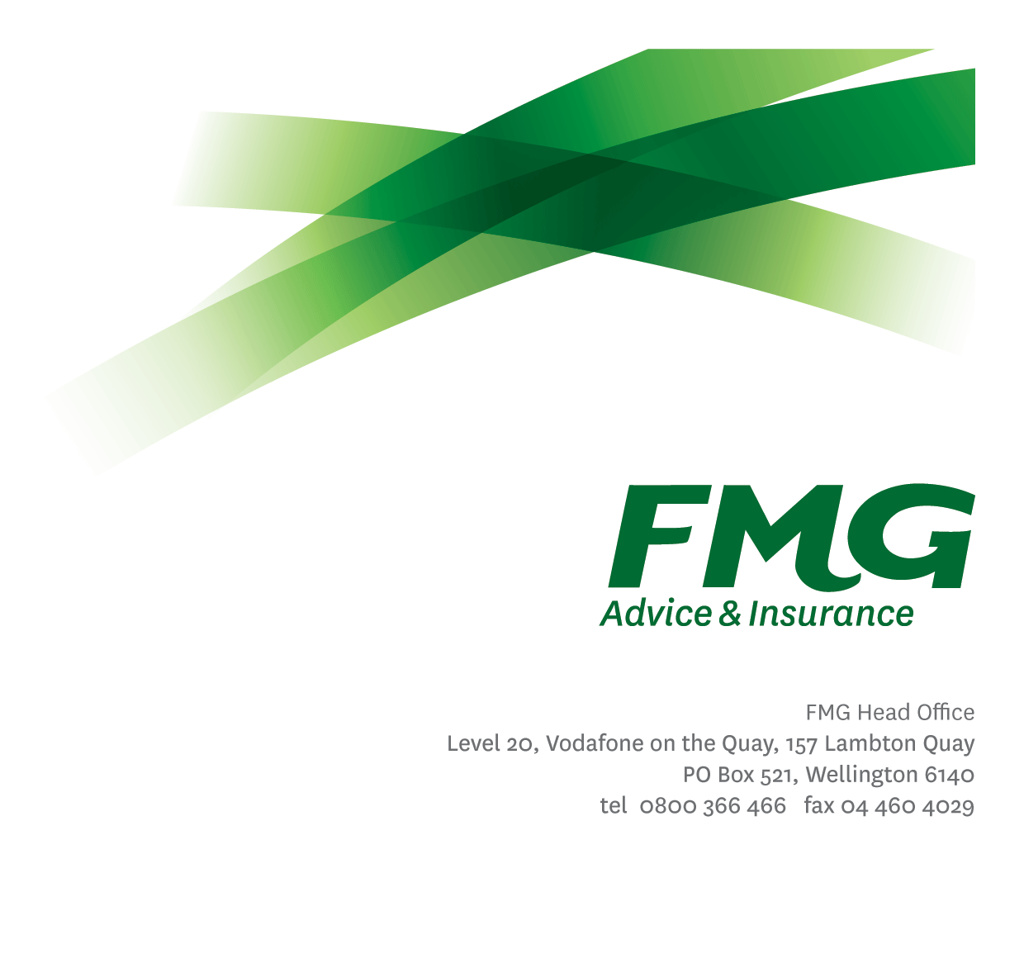
Head of Product
Position Description

Location: Wellington, Christchurch or Palmerston North
Reporting to: Chief Insurance Officer
Business Unit: Insurance Solutions
Direct Reports: Various
Date Last Reviewed: August 2026

About FMG
Formed by farmers for farmers over a century ago, FMG is New Zealand’s leading rural insurer providing risk advice and insurance solutions for farmers, growers, commercial businesses, the lifestyle sector and residential clients.
FMG is proudly 100% New Zealand owned and operated, and our focus is on helping our clients to achieve their goals. As a mutual organisation, FMG is all about giving rural New Zealanders a better deal, and part of this involves reinvesting all profits back into the business to keep premiums low and ensure the future sustainability of the Mutual.

FMG’s Values
FMG’s brand represents promises about what clients can expect from the Mutual and each FMG employee across our One Team is responsible for delivering on these promises. Living FMG’s Values means we all deliver the best brand experience for our clients. FMG’s Values are:
- Do what's right - Whāia te ara tika | - Make it happen - Whakatutukitia
- We're in it together - Ko tātau tātau | - Proud of who we are - Whakahīhī i te whakapapa

Work Environment
FMG strives to provide an environment that promotes and fosters achievement, placing importance on career development and training to provide our people with the tools they need to succeed.
FMG’s Head Office is located in Wellington and accommodates FMG’s Executive Leadership Team (ELT), Sales, Advice and Service, Claims, Marketing and Propositions, People and Culture, Finance and Investments, Insurance Solutions, Digital and Data, Risk and Compliance and Strategy and Enablement teams.
FMG’s largest regional office is in located in Palmerston North accommodating FMG’s National Sales and Advice Centre, People and Culture, Digital and Data, Claims, Operations and Payments functions. In addition to offices in Wellington, Palmerston North and Christchurch, FMG has regional offices in 30 locations throughout provincial New Zealand Aotearoa.

Purpose of the Role
The Head of Product leads the strategic direction, development and management of FMG’s Product Portfolio, supporting FMG’s business objectives while ensuring compliance with all applicable regulatory and legislative requirements. The role is responsible for leading the Product Team to implement FMG’s Product Strategy, undertake Product Reviews, Product development, delivery, and monitoring activities.
As a Mutual Leader, you are accountable for delivering FMG’s Business Plan in line with the Mutual’s overall strategic direction. You will bring FMG’s Purpose, Vision and Strategy to life as part of your accountability for running the Mutual day-to-day. Your role as a leader, guardian and kaitiaki means you focus on protecting and growing the Mutual and ensuring FMG remains relevant to our clients and Members in the face of a dynamic and fluid external environment

Key Responsibilities

Area | Responsibilities
Leadership | - Provides strategic and operational leadership of the Product Team ensuring clear role expectations and accountability that lifts performance and enables smooth and timely delivery of initiatives.  - Establishes a client-centric culture where Product Design and Management is aligned to client needs, ensuring fit for purpose products that support seamless service experiences and deliver fair client outcomes.  - Manages the ongoing coaching and professional development of individual team members to ensure they are successful in their roles.  - Works with People & Culture to implement an internal talent management process and a documented succession plan for key positions.  - Rewards and recognises employees who contribute to FMG’s success through informal and formal methods.
Strategy & Planning | - Lead the development and delivery of a Product Strategy and workplan that supports FMG’s strategic priorities and client outcomes.  - Implement strategies and initiatives to drive continuous product improvements.
Product Management | - Define and implement a product portfolio that ensures FMG’s product offering is relevant, fit for purpose, accessible to the market, and cost effective to administer (noting that some products are sourced from external third parties).  - Ensure the scheduled delivery of Product Reviews in line with the Product Design and Review Framework (PDaRF), to assess whether products are performing as intended and delivering fair client outcomes.  - Following Product Reviews, recommend (to the Insurance Risk Committee) and oversee the introduction of appropriate product innovations and improvements, having regard to market demands, regulatory requirements and risks and engaging with the wider business as required.  - Ensure regular monitoring of key Product Metrics, including wider market product positioning, offerings and activity. Understand key points of difference with competitors and the implications for clients and FMG.  - Undertake client research supporting new product initiatives and developments, considering the current and future needs of clients, features/benefits, risks, regulations, competitor offerings and distribution strategy.  - Ensure Policy Wordings and associated collateral is well managed and kept up to date.  - Support FMG’s Loss Prevention and employee training activities.  - Undertake tasks as directed by the Chief Insurance Officer.
Operational Efficiency & Effectiveness | - Maximise business effectiveness and efficiency by prioritising Product Team initiatives that are aligned with FMG’s strategic objectives and Business Plan and having regard to available resources across the business.  - Manage the implementation of any changes within agreed timeframes and budgets.  - Contribute to decision making across the wider Mutual which has a business change consequence for Product activities.  - Identify and deliver opportunities to reduce complexity and improve operational efficiency to support delivery of exceptional client experiences.  - Ensure that product process documentation is comprehensive and up to date, enabling rapid knowledge transfer to new employees and minimising key person dependencies.
Personal Proficiency | - Proactively acquires and develops appropriate skills, knowledge and techniques in relation to fulfilling the core functions of the role
Stakeholder Management | - Establish and maintain strong, trusted relationships across the Insurance Solutions Leadership Team and wider Mutual stakeholders, ensuring alignment of priorities and coordinated delivery.  - Proactively manage stakeholder expectations, navigate competing demands and influence decision making to achieve optimal outcomes for clients, employees and the Mutual.  - Proactively assist Insurance Solutions Leadership Team members and wider stakeholders to identify opportunities and celebrate successes.
FMG Values | - Promote and model FMG values and the “FMG Way” through displaying the values of FMG which are: Do what’s right; Make it happen; We’re in it together; and Proud of who we are.
Policy and Statutory Compliance | - Ensures overall compliance with legislation, regulations and FMG policies by using established processes and systems. Ensures appropriate controls are in place, and such systems and processes are continuously reviewed and improved.  - Ensures documentation is in place for critical processes.  - Manages Product initiatives to support Client Remediation activities
Wellbeing & Safety | - Demonstrates leadership and commitment to workplace wellbeing and safety practices.  - Promotes and supports initiatives that contribute to a healthy and safe working environment for employees, visitors and contractors.  - Ensures compliance with safety and wellbeing policy and procedures, including accident and incident reporting and investigation, hazard management, induction, training and supervision, employee participation and contractor management.

COMPETENCIES
*see competency framework for behaviours expected at each level | Expected Level
Customer Driven (Internal & External)  A commitment to understanding the needs and best interests of both internal and external clients in order to provide them with outstanding customer service and help them to make informed decisions. | Advanced*
Accountability  Taking personal ownership of decisions, behaviour, and development, and being responsible for how these actions impact on the wider organisation and clients. | Advanced*
Adaptability  Demonstrating a willingness to engage in a changing environment and being flexible and comfortable working with change. | Advanced*
Motivation and Drive  The determination to achieve goals and strive for excellence. | Advanced *
Relationship Building  Developing and maintaining positive, professional relationships that are built on mutual trust and respect. | Advanced*
Team Work  Making a positive contribution to the FMG team and collaborating effectively with others to achieve objectives. | Advanced*
Critical Analysis  The capability to identify key issues, trends, or important facts from information and to question and probe. | Advanced*
Change Leadership  The drive to initiate opportunities to address FMG’s organisational needs and to communicate change in a way that gains buy-in and support from others. | Advanced*
Strategic Thinking  The capacity to stand apart from the day-to-day and take a long-term, big picture view of the business. | Advanced*
Motivating and Developing Others  A commitment to getting the best out of people and motivating them to reach their full potential. | Advanced*
Leadership Courage  A dedication to leading the FMG team toward their vision and values, and communicating FMG’s future direction with clarity and enthusiasm. The awareness and courage to front up to difficult situations with sensitivity and integrity. | Advanced*

KNOWLEDGE
Qualifications | Relevant Tertiary and/or Professional Qualification required
Experience | 10+ years Insurance Industry experience  Product management/development, structures and systems experience  Significant client focussed General Insurance Product experience  Demonstrated planning experience at a business unit or corporate level  Demonstrated leadership skills, including a track record of building high performing teams
Business Awareness | Deep understanding of FMG’s operating model, strategy and value proposition, and how the Product Team contributes to enterprise outcomes.  Strong awareness of industry trends, competitive dynamics and emerging risks impacting insurance, client experience and service delivery.  Demonstrated ability to translate enterprise strategy into executable product strategies and initiatives.
Market Knowledge | Understands the rural and commercial community and keeps up to date with the economic, political, and environmental issues affecting FMG clients.  Strong understanding of FMG's position in the advice and insurance market, client segments, and distribution channels.  Maintains an active knowledge of competitors’ products, benefits and features.
Legal/Risk Knowledge | Has legal knowledge e.g., indemnity, liability, Health & Safety, the Privacy Act, FENZ, EQC, etc  Sound understanding of risk, compliance and regulatory requirements relevant to financial services (including General and Life & Health Insurance where applicable).
Product Knowledge | Is knowledgeable about FMG's insurance policies, the differences between them, and the appropriateness of each for different situations.  Is familiar with the product lifecycle process.
Insurance Knowledge | Strong understanding of insurance value chains (advice, underwriting, claims and service).  Knowledge across General Insurance and Life & Health highly desirable.  Knowledge of industry partners and competitors.
SKILLS
Written Communication Skills |  | Able to write clear, concise and persuasive proposals and reports.
Verbal Communications Skills |  | Communicates clearly in order to present information to persuade and influence others.
Listening Skills |  | Demonstrates active listening skills through eye contact, paraphrasing, appropriate body language and checking understanding.
Technology Skills |  | Can expertly use relevant software and technology to its full capacity e.g. MS Word, Excel and PowerPoint.
Change Leadership |  | Ability to lead and influence large-scale change and transformation initiatives.
Risk Assessment Skills |  | Identifies, understands and mitigates the risks that may impact on FMG's solvency, profitability, strategy, initiatives and reputation.

Key Relationships
External | Internal | Committees/Groups
- Key partners/external suppliers to the Product function | - Chief Insurance Officer / ELT  - Insurance Solutions LT  - Marketing & Propositions  - SAS LT  - Claims LT  - Digital and Data LT  - Risk & Compliance  - People & Culture  - Finance  - Chief Actuary | - Insurance Risk Committee

Financial Authority Levels

May approve routine expenditure within budget and within Financial Delegated Authority Limits.

Human Resources Authority Levels
- May hire direct and indirect reports within approved FTE headcounts.
- May discipline direct reports in consultation with Manager and People and Culture.
- No authority to dismiss staff, unless delegated by the Chief Executive and in consultation with Manager and People and Culture.

Agreement
I agree to the outline of the role as contained in this document and recognise that the contents may need to be amended from time to time to reflect changing business requirements.

I as Job holder, allow my Manager to gather information from third parties where necessary for the purposes of performance management.

Head of Product Name:
Signature:
Date:

