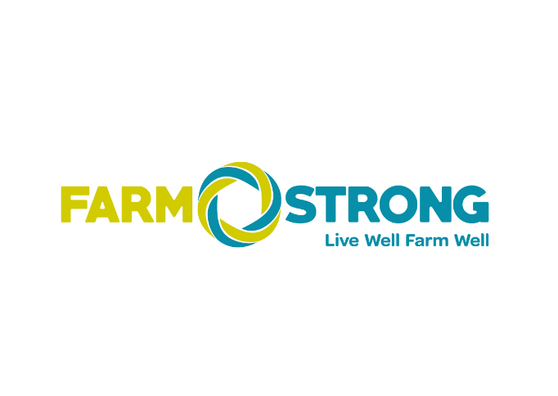

Farmstrong Coordinator
Position Description

Location: Wellington
Reporting to: Farmstrong Chief Executive for day-to-day reporting with annual reviews also involving FMG Head of Communications and Sustainability
FMG Business Unit: People & Culture and Communications
Direct Reports: Nil
Date: August 2026

About Farmstrong
Farmstrong is a nationwide wellbeing programme for farmers and growers to help them live well and farm well. Our aim is to increase the uptake of wellbeing behaviours so that farmers, growers, their teams, and families get the most out of life and work.
Farmstrong was jointly established in 2015 by founding partners rural insurer FMG and the Mental Health Foundation (MHF). Farmstrong became a Charitable Trust in July 2025.
Farmstrong Charitable Trust has a Management Agreement with FMG that includes secondment of two FMG employee roles to Farmstrong. The Farmstrong project co-ordinator role is one of these FMG roles seconded to Farmstrong. The day-to-day management and reporting line for the Farmstrong Project Co-ordinator is to the Chief Executive of Farmstrong. As a FMG employee the role sits within of the FMG communications team that is overseen by the FMG Head of Communications and Sustainability.

FMG’s values
The FMG brand represents promises about what clients can expect from us, each of us is responsible for delivering on these promises. Living the Mutual’s values means we deliver the best brand experience for our clients. Our values are:
- Do what’s right | - Make it happen
- We’re in it together | - Proud of who we are

Work environment
We strive to provide an environment that promotes and fosters achievement. We place importance on career development and training to give our people the tools they need to succeed.
FMG’s office in central Wellington houses the Executive Leadership Team and is the base for a number of core business units including Marketing, People & Culture and Communications, Finance and Underwriting.

Most members of the core Farmstrong team are also based out of the Wellington office.

Purpose of the role
This role will provide administrative support in the day-to-day running of the Farmstrong programme of work: including, but not limited to, partnership and events administration, general internal and external communication coordination, compiling quarterly and annual reports for the Board and external funders, organising Board meetings and recording minutes, supporting team planning project and financial planning, monitoring the info@farmstrong portal and responding to messages and other project co-ordiation services for members of the Farmstrong team.
The Farmstrong Coordinator will join the Farmstrong Team and be part of the FMG Communications function. The Farmstrong Coordinator is an FMG employee and has access to FMG employee benefits and is on secondment to the Farmstrong Charitable Trust.

Key responsibilities
Area | Responsibilities
Stakeholder engagement | - Working alongside the Farmstrong Team to support individuals and stakeholders to be involved in Farmstrong initiatives.  - Responsible for liaising with key external relationships that support the design and delivery of website material, merchandise, and marketing collateral.  - Maintain the CRM database (Hubspot) that contains contact information about individual Farmstrong participants, members, stakeholders and key organisations who we partner and collaborate with.
Event coordination | - Coordinate event and workshop activities including (but not limited to) invitations, RSVP’s and EDM distribution, booking venues and catering.  - Be a key liaison and support for local (regional) organisers, FMG Team and other involved parties.  - Print, collate and dispatch supporting event collateral.  - Support communication with attendees’ post event to send links for feedback survey, video clips etc.  - Collate post event feedback and drafts reports  - Maintain event calendar
Project Coordination | - Support the Farmstrong Chief Executive, Farmstrong Delivery Specialist and Farmstrong Marketing Specialist on Farmstrong related activity.  - Collate reports including quarterly reports for Farmstrong Board meetings and external funders.  - Provide and assist with budget forecasting for project and team planning.  - Manage the info@farmstrong.co.nz inbox for all incoming inquiries and action in a timely manner.  - Responsible for liaising with FMG Finance team with regard to invoices and payments as well as all fundraising donations  - Manage all Farmstrong collateral and merchandise  - Manage all orders of merchandise, collateral and signage from online systems in support of all Farmstrong event activity.  - Update progress in the Farmstrong work programme to ensure our workstream areas are all on track  - Responsible for minutes and document the actions agreed at the Farmstrong Board quarterly meetings.  - Review and maintain Farmstrong document storage and organisation.  - Respond and redirect emails resulting from social media campaign activity.
Communications | - Responsible for the Farmstrong website, to ensure all content remains up-to-date and relevant, this includes backend development for any new initiatives.  - Manage and facilitate all digital and paper advertisements for Farmers Weekly.  - Lead the coordination of Farmstrong newsletters.  - Support the Farmstrong Delivery Specialist to keep FMG employees informed with Farmstrong activity.  - As directed, assist with Farmstrong campaigns to increase awareness, involvement and behaviour change.  - Responsbile for basic social media activity i.e. load videos to YouTube
Team participation | - Proactively assists and supports the Farmstrong Team.  - Participate fully as a member of Farmstrong Team, Communications Team and broader FMG team through the effective and efficient performing of other duties as required.  - Shares information and resources and provides feedback in a positive and collaborative manner.
External relationships | - Establishes close working relationships with suppliers at an operational level to gain a solid working knowledge of the services they provide.
Internal relationships | - Develops effective working relationships with the Farmstrong Team, including employees of FMG.
Personal Development | - Build on your personal areas of strength and share learnings.
Risk and Quality | - Ensure overall compliance with legislation regulations and FMG policies through the use of established systems.
Wellbeing & safety | - Complies with safety and wellbeing policy and procedure, including accident and incident reporting and hazard management requirements.  - Works in a safe manner at all times and doesn’t undertake activities without appropriate training.

Competencies
*See competency framework for behaviours expected at each level. | Expected Level
Client Driven (Internal and External)  A commitment to understanding the needs and best interests of both internal and external clients, in order to provide them with outstanding customer service and help them to make informed decisions. | Competent*
Accountability  Taking personal ownership of decisions, behaviour, and development, and being responsible for how these actions impact on the wider organisation and customers. | Competent*
Adaptability  Demonstrating a willingness to engage in a changing environment and being flexible and comfortable working with change. | Competent*
Motivation and drive  The determination to achieve goals and strive for excellence. | Competent*
Relationship building  Developing and maintaining positive, professional relationships that are built on mutual trust and respect. | Competent*
Teamwork  Making a positive contribution to the FMG team and collaborating effectively with others to achieve objectives. | Competent*

Knowledge
Experience | Demonstrated experience in a similar administrative/coordinator level
Business awareness | Understands the internal workings of FMG and how the business works.
Rural knowledge | Empathetic and aware of the issues impacting the rural community.
Skills
Written communication |  | Able to write clear and concise communication.
Verbal communication |  | Communicates clearly in order to present information. Can apply the right questioning skills to elicit the required information.
Listening |  | Demonstrates active listening skills.
Technology |  | Can expertly use relevant software and technology to its full capacity e.g. Microsoft Office suite. Office 365, Hubspot, Excel

Key Relationships
External | Internal | Committees/Groups
- Farmstrong champions and supporters  - Event providers  - Members of the public  - Employees of Farmstrong funders  - Farmstrong suppliers | - Farmstrong Chief Executive  - Farmstrong Delivery Specialist  - Farmstrong Marketing Specialist  - Wider Farmstrong Team members  - FMG Communications Manager  - FMG National Sponsorship and Events manager  - Wider FMG People Culture & Communications Team  - Wider FMG Marketing Team  - Wider FMG Travel and Sponsorships Team | - Farmstrong Board

Financial authority levels
- No authority to commit or approve expenditure.

Human resources authority levels
- Not applicable.

Agreement
I agree to the outline of the role as contained in this document and recognise that the contents may need to be amended from time to time to reflect changing business requirements.
I as Job holder, allow my manager to gather information from third parties where necessary for the purposes of performance management.

Agreement will be via electronic signature as evidenced on the acceptance form.

