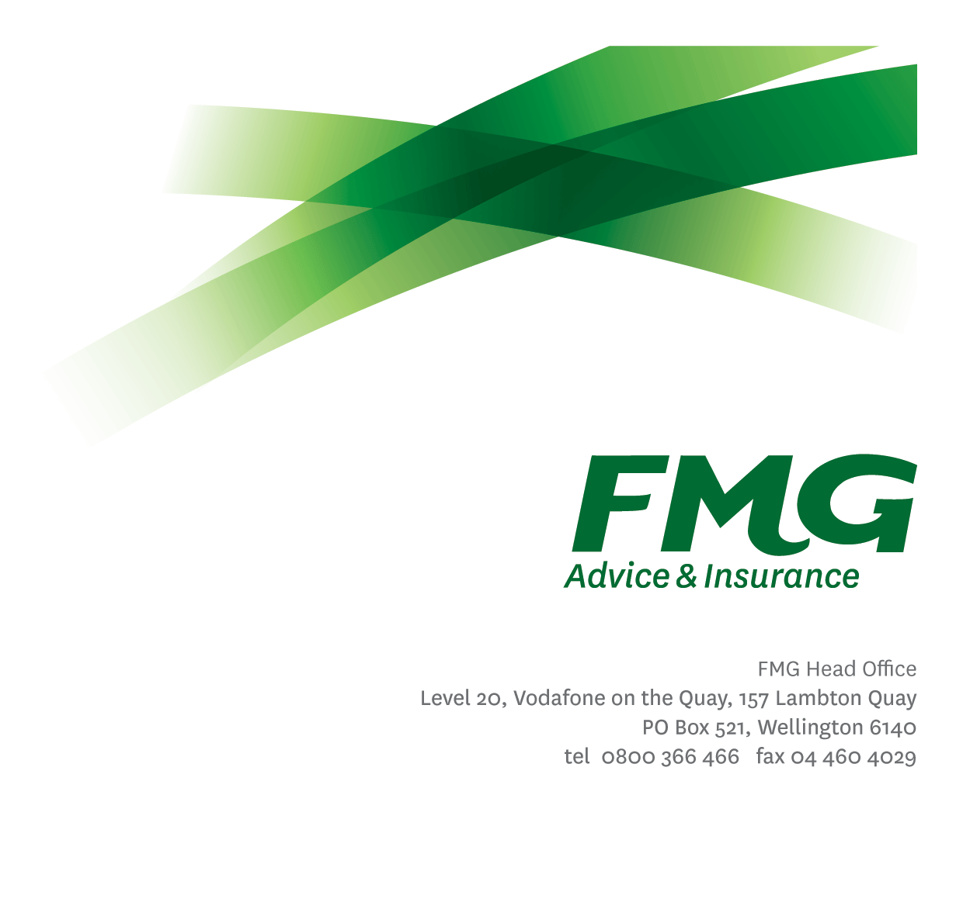Proposition Lead
Position Description

Location: As per Personal Terms
Reporting to: Client Propositions Manager
Business Unit: Client Propositions and Loss Prevention
Direct Reports: Nil
Date Last Reviewed: Mar 2026

About FMG
Formed by farmers for farmers over a century ago, FMG is New Zealand’s leading rural insurer providing risk advice and insurance solutions for farmers, growers, commercial businesses, the lifestyle sector and residential clients.
We’re proudly 100% New Zealand owned and operated and our focus is on helping our clients to achieve their goals. As a mutual organisation, we’re all about giving rural New Zealanders a better deal, and part of this involves reinvesting all profits back into the business to keep premiums stable and ensure the future sustainability of the organisation.

FMG’s Values
The FMG brand represents promises about what clients can expect from us and each of us is responsible for delivering on these promises. Living our company values means we deliver the best brand experience for our customers. Our company values are:
- Do what’s right - Whāia te ara tika | - Make it happen - Whakatutukitia
- We’re in it together - Ko tātau tātau | - Proud of who we are Whakahīhī i te whakapapa

Work Environment
We strive to provide an environment that promotes and fosters achievement. We place importance on career development and training to give our people the tools they need to succeed. Fostering a culture of Wellbeing and Safety is also a critical element.
FMG’s Head Office is located in Wellington and accommodates FMG’s Leadership Team, Marketing & Risk Services, Human Resources, Client Propositions, Financial Management, Underwriting and Risk Quality, Reinsurance, Business Information and Analysis, and Legal and Compliance.

FMG’s largest regional office is located in Palmerston North accommodating our National Service Centre, Insurance Consultants, Information Technology, Claims, Operations and Payment functions. Approximately 300 employees are located there. FMG’s largest office in the South Island is Christchurch. In addition to the offices in Wellington, Palmerston North and Christchurch – FMG has smaller offices in 30 regional locations throughout New Zealand.

Purpose of the role
Responsible for development and delivery of client sector and segment playbook initiatives. In this role you will lead the development and research of new propositions and undertake proposition reviews to FMG’s client segments to help contribute to the Mutual's strategic goals in the short, medium and long term.
You will work closely with the Client Proposition Manager to deliver on ‘how to win’ FMG’s priority segments. This role is focused on the operational delivery of client propositions.
Being a strong networker is a must both internally to drive collaboration and externally to gain intel within the industry, to do this does require travel to FMG’s regional offices and to attend industry events.

Key Responsibilities
Area | Responsibilities
Segment Planning and Implementation | - Lead the development and implementation of FMG’s long-term segment propositions by contributing to annual analysis of FMG’s position in the market for priority segments including a SWOT and ESTEMPLE analysis.  - Collaborate in the development, documentation and delivery of annual Client Proposition business plan with the Client Propositions Manager.  - Contribute to the development of strategies and plans to manage key relationships and partners directly involved with each segment alongside the Client Propositions Manager.  - Lead the development of new and enhancing existing client value propositions to drive net client growth through acquisition and retention plans and meeting more needs of existing clients, in collaboration with the Client Proposition Managers.  - Key liaison with planning, organising and monitoring of relevant marketing initiatives and customer events to explore new business sources, enhance brand awareness and establish client relationships.
Report and Analyse (Insights) | - Support the achievement of overall profitability and growth for each segment through proposition development and reviews using both quantitative and qualitative data and analysis.
Broader Propositions Context | - Contribute broadly to strategic and operational discussions and decisions as a member of FMG’s Marketing & Propositions team.  - Work with the Client Proposition Manager to ensure alignment with FMG’s overall strategy and plans.
Relationship Management | - Maintain and manage effective relationships with key FMG stakeholders  - Support the Client Proposition Manager to communicate segment related initiatives to the regional and local teams.
External Networking | - Attend events in local rural communities to support new proposition development and reviews as required.
Business Requirements | - Document the team’s approved requests for development and improvement that enhance FMG’s Client Proposition.
Team Membership | - Proactively assist the Client Propositions and Loss Prevention team colleagues and other stakeholders.  - Share information and resources and provide feedback in a positive and collaborative manner.
Self-Development | - Maintain own knowledge base of best practice act as an expert resource
FMG Values | - Promotes the “FMG Way” through displaying the values of FMG which are: Do what’s right, Make it happen, We’re in it together, Proud of who we are.
Other Duties | - Undertakes tasks as directed by the Client Propositions Manager from time to time.
Compliance | - Ensure assigned products and overall work is compliant with legislation, regulations and FMG policies through the use of established systems.
Wellbeing & Safety | - Comply with the Safety & Wellbeing policy and procedures, including accident and incident reporting and hazard management requirements  - Work in a safe manner at all times and do not undertake activities without appropriate training
COMPETENCIES
*see competency framework for behaviours expected at each level |  |  | Expected Level
Client Driven (Internal & External)  A commitment to understanding the needs and best interests of both internal and external clients, in order to provide them with outstanding customer service and help them to make informed decisions. |  |  | Advanced*
Accountability  Taking personal ownership of decisions, behaviour, and development, and being responsible for how these actions impact on the wider organisation and customers. |  |  | Intermediate*
Adaptability  Demonstrating a willingness to engage in a changing environment and being flexible and comfortable working with change. |  |  | Advanced*
Motivation and Drive  The determination to achieve goals and strive for excellence. |  |  | Intermediate*
Relationship Building  Developing and maintaining positive, professional relationships that are built on mutual trust and respect. |  |  | Intermediate*
Team Work  Making a positive contribution to the FMG team and collaborating effectively with others to achieve objectives. |  |  | Intermediate*
Critical Analysis  The capability to identify key issues, trends, or important facts from information and to question and probe. |  |  | Advanced*
KNOWLEDGE
Qualifications |  | Relevant Tertiary Qualification required
Experience |  | 5+ years in a product management or agribusiness or commercial role ideally within the Financial Services Sector.  Experience relevant segment eg. Rural and Provincial business, Farming.  Proven ability to navigate complex data and gain insights.  Business Development  Internal and External Stakeholder Management.
Business Awareness |  | Understands the internal workings of FMG and how business works; understands FMG's position in the advice and insurance market and knows the competition.
Market Knowledge |  | Understands the insurance industry. Maintains an active knowledge of competitors’ products benefits, features and pricing.
Rural Knowledge |  | Understands the insurance products relevant to rural communities.
Product Knowledge |  | Is knowledgeable about FMG's insurance policies and packages, the differences between them, and the appropriateness of each in different situations.
Risk/Insurance Knowledge |  | Understands risk and how to apply FMG's policies to situations; is knowledgeable about compliance requirements; understands the insurance process and how claims are managed; knows industry partners and competitors.
Specialist Knowledge |  | Understands the roles of underwriting, sales, claims etc and is able to use their viewpoint in analysing product performance

SKILLS
Written Communication Skills | Able to write clear, concise and persuasive proposals and reports.
Verbal Communications Skills | Communicates clearly in order to present information to persuade and influence others.
Listening Skills | Demonstrates active listening skills through eye contact, paraphrasing, appropriate body language and checking understanding.
Technology Skills | Can expertly use relevant software and technology to its full capacity e.g. MS Word, Excel and PowerPoint.
Project Management Skills | Can manage projects to deliver agreed outcomes across the business within agreed timeframes.

Relationship
External | Internal | Committees/Groups
- Relevant Industry Groups  - Insurance Industry Groups  - Outsourced Product Providers | - Client Proposition Manager  - Client Propositions & Loss Prevention team  - Marketing and Propositions  - SAS Senior Leadership Team  - Area Managers  - Head of Underwriting  - Head of Product & Planning

Financial Authority Levels

No authority to commit or approve expenditure

People and Culture Authority Levels
- Not applicable

Agreement
I agree to the outline of the role as contained in this document and I recognise that the contents may need to be amended from time to time to reflect changing business requirements.
I as Job holder, allow my Manager to gather information from third parties where necessary for the purposes of performance management.

Proposition Lead’s Name
Signature:
Date:

