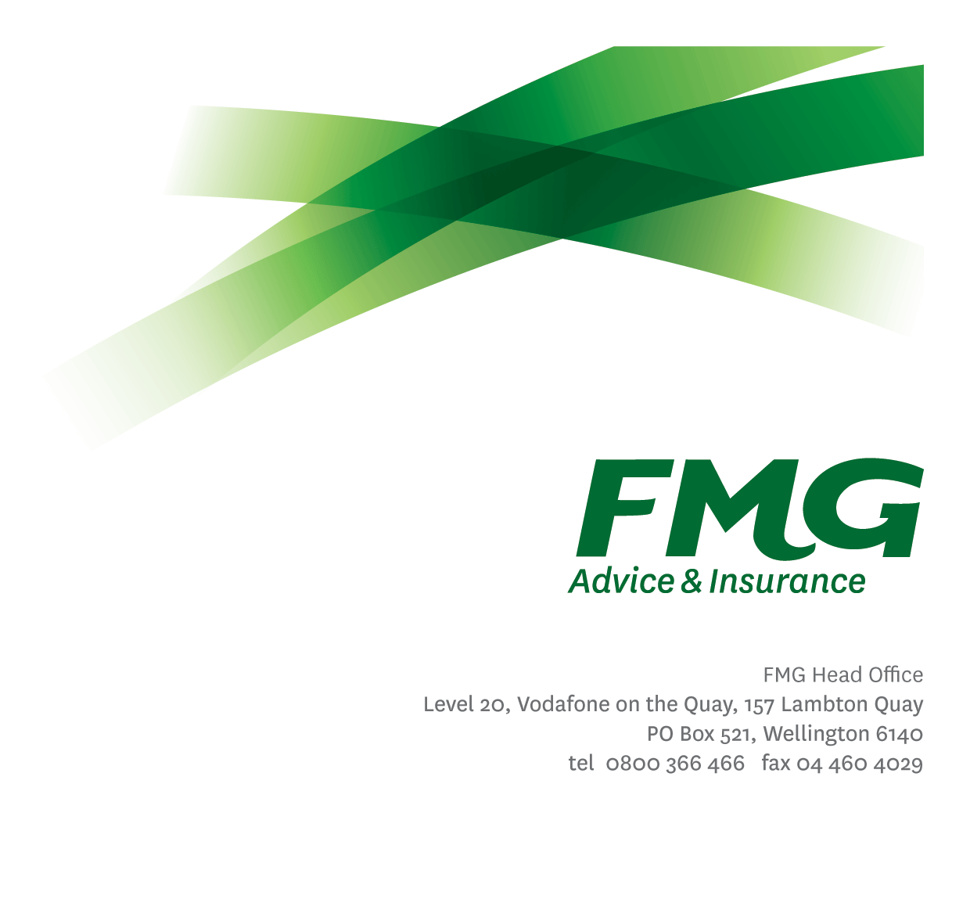
Business Improvement Lead
Position Description

Location: Wellington / Palmerston North
Reporting to: Head of Operational Excellence
Business Unit: Strategy and Enablement
Direct Reports: Nil
Date Last Reviewed: August 2025

About FMG
Formed by farmers for farmers over a century ago, FMG is New Zealand’s leading rural insurer providing risk advice and insurance solutions for farmers, growers, commercial businesses, the lifestyle sector and domestic clients.
We’re proudly 100% New Zealand owned and operated, and our focus is on helping our clients to achieve their goals. As a mutual organisation, we’re all about giving rural New Zealanders a better deal, and part of this involves reinvesting all profits back into the business to keep premiums low and ensure the future sustainability of the organisation.

FMG’s Values
The FMG brand represents promises about what customers can expect from us and each of us is responsible for delivering on these promises. Living our company values means we deliver the best brand experience for our customers. Our company values are:
- Do what's right - Whāia te ara tika | - Make it happen - Whakatutukitia
- We're in it together - Ko tātau tātau | - Proud of who we are - Whakahīhī i te whakapapa

Work Environment
We strive to provide an environment that promotes and fosters achievement. We place importance on career development and training to give our people the tools they need to succeed.
The Operational Excellence team culture is based on open and honest communication, where authority and accountability are clear. Both challenges and opportunities are shared to bring about delivering the best solution to FMG, whilst improving FMG’s core capabilities in Continuous Improvement.

Purpose of the role
The Business Improvement Lead (part of the Operational Excellence team) drives continuous improvement across FMG by evaluating new ideas, identifying process failures and improvement opportunities, leading strategic and operational initiatives, and building the foundations that support on-going improvement efforts. This role plays a key part in building organisational capability in improvement and structured decision-making methods, while also contributing to the maintenance of our process governance standards.
The Operational Excellence team is key to consistently delivering value to our Clients, Members and Employees by enhancing the efficiency, productivity and overall performance of our operations.

Key Responsibilities
Area | Responsibilities
Feasibility Assessment | - Define/confirm the problem statement and the root cause before assessing the value of new improvement ideas. For promising ideas, assess options and suggest business solutions, considering benefits, risks, assumptions, trade-offs, and unintended consequences.
Building Improvement Foundations | - Develop the essential tools, systems, and frameworks that enable and sustain ongoing improvement across FMG. This may include, for example: establishing performance metrics and measures, creating feedback loops to support targeted improvement efforts, design reporting dashboards for visibility and accountability.
Identify process failures and Improvement opportunities. | - Review current business processes to uncover risks, inefficiencies, and areas for improvement. This includes mapping workflows, utilising process data, observing operations, and applying root cause analysis to detect and understand recurring issues.
Strategic Improvements | - Lead targeted improvements that contribute to Strategic goals.  - When required, act as a specialised improvement resource on projects to lead or mentor others in assessing ideas and executing process improvements.  - Place emphasis on simplicity, efficiency and appropriate risk management.
Operational Improvement Support | - Deliver improvements that help individual business units operate more effectively. Lead and implement changes that respond to specific needs and improve performance.
Culture and Capability Development | - Provide training, resources, and support to help teams make better decisions and continuously improve their work. Promote the use of structured decision-making and improvement methods across the Mutual.
Process Governance | - Contribute to the maintenance of the organisation’s process framework and standards. Manage the process register for your designated partnership area. Support clear accountability and enable measurement of process efficiency across the organisation.
COMPETENCIES
*see competency framework for behaviours expected at each level |  | Expected Level
Customer Driven (Internal & External)  A commitment to understanding the needs and best interests of both internal and external customers, in order to provide them with outstanding customer service and help them to make informed decisions. |  | Advanced*
Accountability  Taking personal ownership of decisions, behaviour, and development, and being responsible for how these actions impact on the wider organisation and customers. |  | Advanced*
Adaptability  Demonstrating a willingness to engage in a changing environment and being flexible and comfortable working with change. |  | Advanced*
Motivation and Drive  The determination to achieve goals and strive for excellence. |  | Advanced*
Relationship Building  Developing and maintaining positive, professional relationships that are built on mutual trust and respect. |  | Advanced*
Team Work  Making a positive contribution to the FMG team and collaborating effectively with others to achieve objectives. |  | Advanced*
Critical Analysis  The capability to identify key issues, trends, or important facts from information and to question and probe. |  | Advanced*

KNOWLEDGE
Qualifications | Relevant Tertiary Qualification or equivalent experience required.
Business Awareness | Understands the internal workings of FMG and how business works; understands FMG's position in the advice and insurance market and knows the competition.
Legal Knowledge | Has legal knowledge e.g. indemnity, liability, the Privacy Act etc.
Specialist Knowledge | Knowledge and experience in business process and business process improvement methodologies (Lean Six Sigma, BPMN), Human-Centred design, business change management, Business and Data analysis.

SKILLS
Written Communication Skills | Able to communicate ideas in a convincing manner through writing clearly and concisely.
Verbal Communications Skills | Communicate clearly in order to present information to persuade and influence others.
Listening Skills | Demonstrates active listening skills through eye contact, paraphrasing, appropriate body language and checking understanding.
Technology Skills | Proficient in Microsoft Office and has a good understanding of how FMG’s systems are used to support its people and processes.  Skilled in using process modelling and presentation tools.
Analytical and Evaluation skills | Feasibility Assessment: Ability to evaluate ideas against strategic goals to determine value and scope.  Business Process Modelling: Ability to map and visualise current and future state processes to identify inefficiencies and opportunities for improvement.  Root Cause Analysis: Skilled in techniques such as 5 Whys, Fishbone diagrams, and Pareto analysis to uncover underlying issues.
Data & Measurement skills | Performance Metrics Design: Ability to develop and apply performance and efficiency measures (e.g. Productivity, Client satisfaction, Financial) to monitor and guide improvement efforts.  Data Analysis skills: Proficiency in using analytical tools and techniques to clean, organise, and visualise data.  Data Interpretation: Ability to use quantitative and qualitative data to inform decision-making and track benefits realisation.  Process Baseline: Ability to establish baseline performance levels to measure progress and organisational efficiency  Benchmarking: Ability to compare the Mutuals performance, processes, and practices against industry standards, best-in-class organisations, or internal targets.
Improvement & Delivery skills | Improvement methods: Ability to apply structured methodologies such as Lean and Lean Six Sigma to drive efficiency, quality, and cost improvements.  Human-Centered Service Design: Ability to deliver meaningful client experiences and measurable business outcomes using service design techniques such as empathy mapping and customer journey mapping.  Leadership: Ability to lead improvement initiatives, working with cross-functional teams to deliver targeted outcomes.  Foundations for Continuous Improvement  Skilled in establishing the core metrics, measures, and processes—such as process monitoring and feedback loops—that create the right conditions for continuous improvement to succeed across FMG.
Training & Capability Development skills | Learning Resource Development: Ability to design and deliver training materials to build capability in Continuous Improvement and RAPID decision-making.  Facilitation & Coaching: Ability to partner with teams to embed improvement methods and techniques and support effective decision-making.

Relationship
External | Internal | Committees/Groups
- Six Sigma Consultants  - Industry Groups (ICNZ, PEX)  - Equivalent positions with FMG’s partners (e.g. Farmlands, NFU) | - Mutual and Delivery leaders (esp. those within your partnership area)  - Pillar leads  - All Employees (esp. Continuous Improvement Community of Practice attendees)  - Head of Operational Excellence – for delivery and practice  - Other teams undertaking improvements (e.g. SAS Ops, Claims best practice team) | - Continuous Improvement Community of Practice

Financial Authority Levels
- As defined within each scope of work.

Human Resources Authority Levels
- None

Agreement
I agree to the outline of the role as contained in this document and recognise that the contents may need to be amended from time to time to reflect changing business requirements.

I as Job holder, allow my Manager to gather information from third parties where necessary for the purposes of performance management.

Business Improvement Lead Name:
Signature:
Date:

Head of Operational Excellence Name: | Danella Dunning
Signature:
Date: | 02/10/2025

