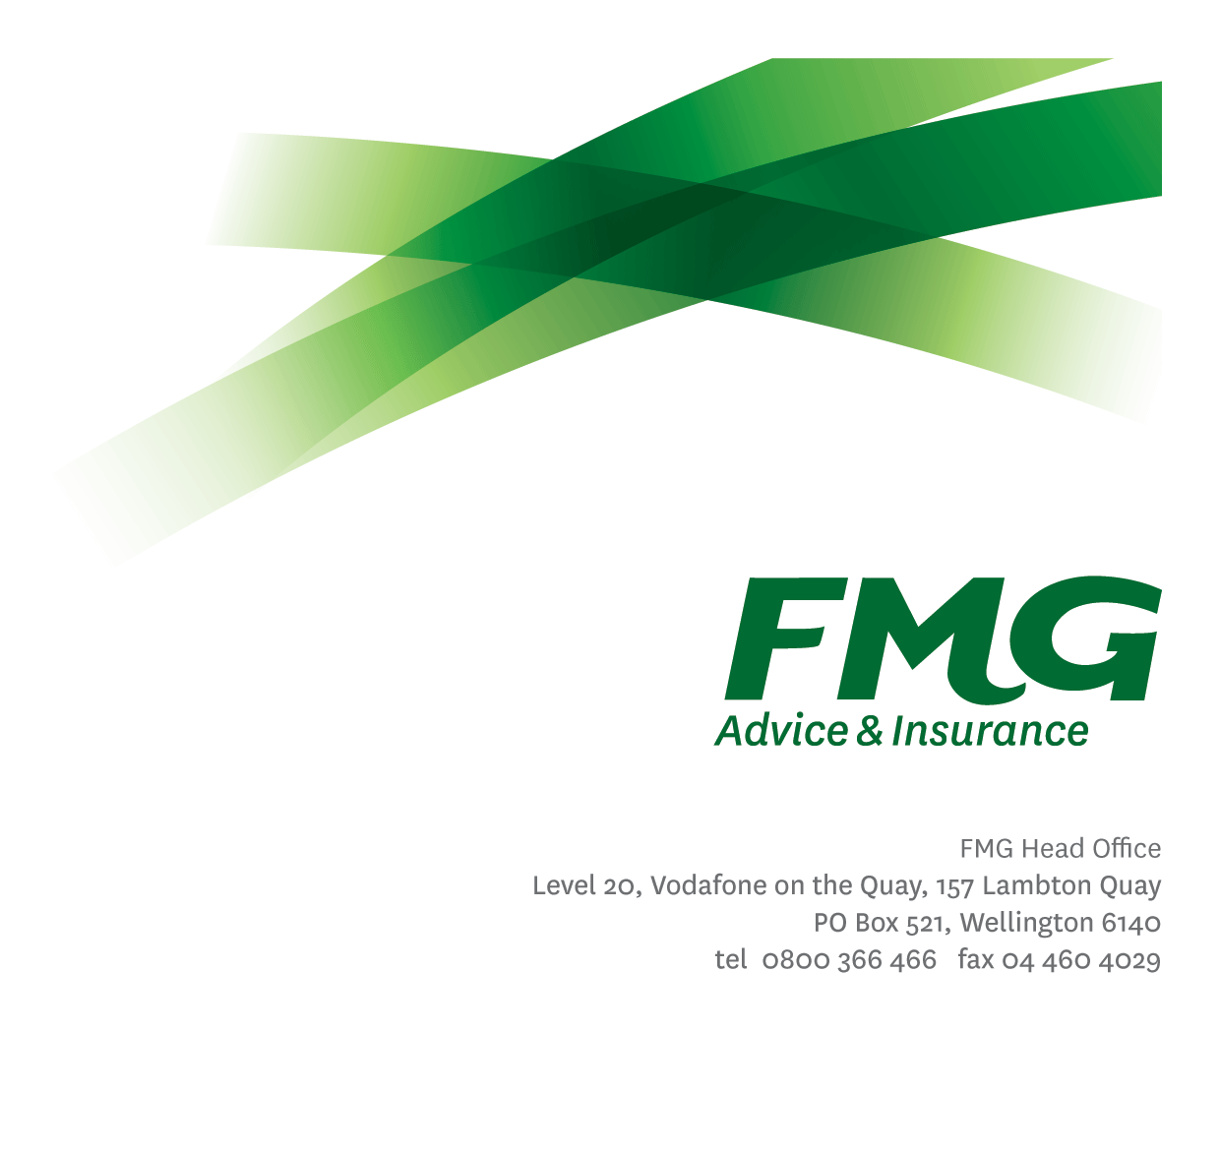Senior Claims Adviser
Position Description

Location: Palmerston North
Reporting to: Team Leader Claims
Business Unit: Claims
Direct Reports: 0
Date Last Reviewed: July 2024

About FMG
Formed by farmers for farmers over a century ago, FMG is New Zealand’s leading rural insurer providing risk advice and insurance solutions for farmers, growers, commercial businesses, the lifestyle sector and domestic clients.
We’re proudly 100% New Zealand owned and operated and our focus is on helping our clients to achieve their goals. As a mutual organisation, we’re all about giving rural New Zealanders a better deal, and part of this involves reinvesting all profits back into the business to keep premiums low and ensure the future sustainability of the organisation.

FMG’s Values
The FMG brand represents promises about what clients can expect from us and each of us is responsible for delivering on these promises. Living our company values means we deliver the best brand experience for our clients. Our company values are:
- Do what's right - Whāia te ara tika | - Make it happen - Whakatutukitia
- We're in it together - Ko tātau tātau | - Proud of who we are - Whakahīhī i te whakapapa

Work Environment
We strive to provide an environment that promotes and fosters achievement. We place importance on career development and training to give our people the tools they need to succeed.
FMG’s Head Office is located in Wellington and accommodates FMG’s Executive Leadership Team (ELT), Client Propositions & Online Services, People & Culture and Communications, Financial Management, Product & Pricing and Underwriting, Reinsurance, Business Information and Analysis, Legal and Compliance.
FMG’s largest regional office is located in Palmerston North accommodating our National Sales & Advice Centre, Information Technology, Claims, Operations and Payments functions. In addition to the offices in Wellington, Palmerston North and Christchurch FMG has offices in 30 regional locations throughout New Zealand.

Purpose of the role
To live and role model the FMG values and lead by example, providing guidance, coaching and mentoring to other Claims team members. To be an active member of the team responsible for providing an exceptional claims service. Senior Claims Advisers will be role models have excellent claims knowledge and a focus on improving current processes to ensure a better service is provided.

Key Responsibilities

Area | Responsibilities
FMG Values | - To promote the “FMG Way” through displaying the values of FMG which are do what’s right, make it happen, we’re in it together and proud of who we are.
Team Support & Coaching | - Provide technical expertise for other Claims team members.  - Coach/mentor/set an example for Claims team members.  - Supports the achievement of agreed wider Team (and Claims) KRA’s (along with individual KRA’s).  - Actively participates and contributes to the development and maintenance of a performance culture and achieving team goals within the Team; along with the wider Claims team.
Support for Claims Leadership | - Undertake delegated tasks as required by the Claims Leadership team relating to:  - Claims allocation and administration,  - Work flow management,  - Technical support,  - Staff development and performance, and  - Team building  - Undertake activities and responsibilities of Claims leadership if required.
Claims Management | - Effective and efficient management of a claims portfolio while to the greatest extent possible administering the reinstatement of our customers’ financial position to the same level prior to the loss occurring.  - Ensures FMG Claims Best Practices are followed in conjunction with the Fair Insurance Code.
Customer Focus | - Takes responsibility and is accountable for delivering superior customer service with a Can Do Attitude, achieving “win win” outcomes.  - Manages customer expectations, satisfies their needs and delivers on promises through an empowered & confident decision making approach.
Problem Solving | - Uses initiative to gather, analyse and evaluate options and develop innovative working solutions.  - Uses a common sense approach to make sound, well-informed decisions which are mutually agreeable.
Relationship Management | - Establishes and maintains professional relationships with internal and external stakeholders.
Risk Management | - Understands, supports and contributes to FMG’s Risk Management strategy.
Compliance | - Ensures compliance with legislation, regulations and FMG policies through the use of established systems.
Claims Team & Individual Performance | - Actively participates and contributes to the development and maintenance of a performance culture, achieving team goals; including the Claims Strategic Plan and Objectives while identifying personal training and development needs.
Risk & Quality | - Ensures overall compliance with legislation regulations and FMG policies through the use of established systems.
Wellbeing & Safety | - Complies with Wellbeing & Safety policy and procedures, including accident and incident reporting and hazard management requirements.  - Works in a safe manner at all times and does not undertake activities without appropriate training.

COMPETENCIES
*see competency framework for behaviours expected at each level | Expected Level
Customer Driven (Internal & External)  A commitment to understanding the needs and best interests of both internal and external customers, in order to provide them with outstanding customer service and help them to make informed decisions. | Advanced*
Accountability  Taking personal ownership of decisions, behaviour, and development, and being responsible for how these actions impact on the wider organisation and customers. | Intermediate*
Adaptability  Demonstrating a willingness to engage in a changing environment and being flexible and comfortable working with change. | Intermediate*
Motivation and Drive  The determination to achieve goals and strive for excellence. | Intermediate*
Relationship Building  Developing and maintaining positive, professional relationships that are built on mutual trust and respect. | Intermediate*
Team Work  Making a positive contribution to the FMG team and collaborating effectively with others to achieve objectives. | Competent*
Critical Analysis  The capability to identify key issues, trends, or important facts from information and to question and probe. | Competent*

KNOWLEDGE
Business Awareness | Understands the internal workings of FMG and how business works; understands FMG's position in the advice and insurance market and knows the competition.
Legal Knowledge | Has legal knowledge e.g. indemnity, liability, the Privacy Act etc.
Product Knowledge | Is knowledgeable about FMG's insurance policies and packages, the differences between them, and the appropriateness of each in different situations.
Systems Knowledge | Knowledge of the following systems is required:  ClaimsCenter, CRM, Genesys Cloud, Onbase.
Risk/Insurance Knowledge | Understands risk and how to apply FMG's policies to situations; is knowledgeable about compliance requirements; understands the insurance process and how claims are managed; knows industry partners and competitors.
Specialist Knowledge | Understand the Claims process to get claims settled and Coaching best practice.

SKILLS
Written Communication Skills | Able to write clear and concise letters, reports and emails.
Verbal Communications Skills | Effectively presents information to others, both informally and in meetings.
Verbal Communications Skills | Communicates clearly in order to present information to persuade and influence others.
Listening Skills | Demonstrates active listening skills through eye contact, paraphrasing, appropriate body language and checking understanding.
Technology Skills | Can expertly use relevant software and technology to its full capacity e.g. MS Word, Excel and PowerPoint.
Risk Assessment Skills | Can put in place plans to mitigate risks and manage issues.
Financial Skills | Able to calculate excesses.

Relationship
External | Internal | Committees/Groups
- External assessors  - Repairers  - Suppliers  - Brokers  - Other insurance providers | - Service Centre  - Internal Assessors  - Rural Managers  - Other FMG Staff | - As required

Financial Authority Levels
- No authority to commit or approve expenditure

Human Resources Authority Levels
- Not applicable

Agreement
I agree to the outline of the role as contained in this document and recognise that the contents may need to be amended from time to time to reflect changing business requirements.

I as Job holder, allow my Manager to gather information from third parties where necessary for the purposes of performance management.

Name: ______________________
Signature: ____________________
Date: ________________________

