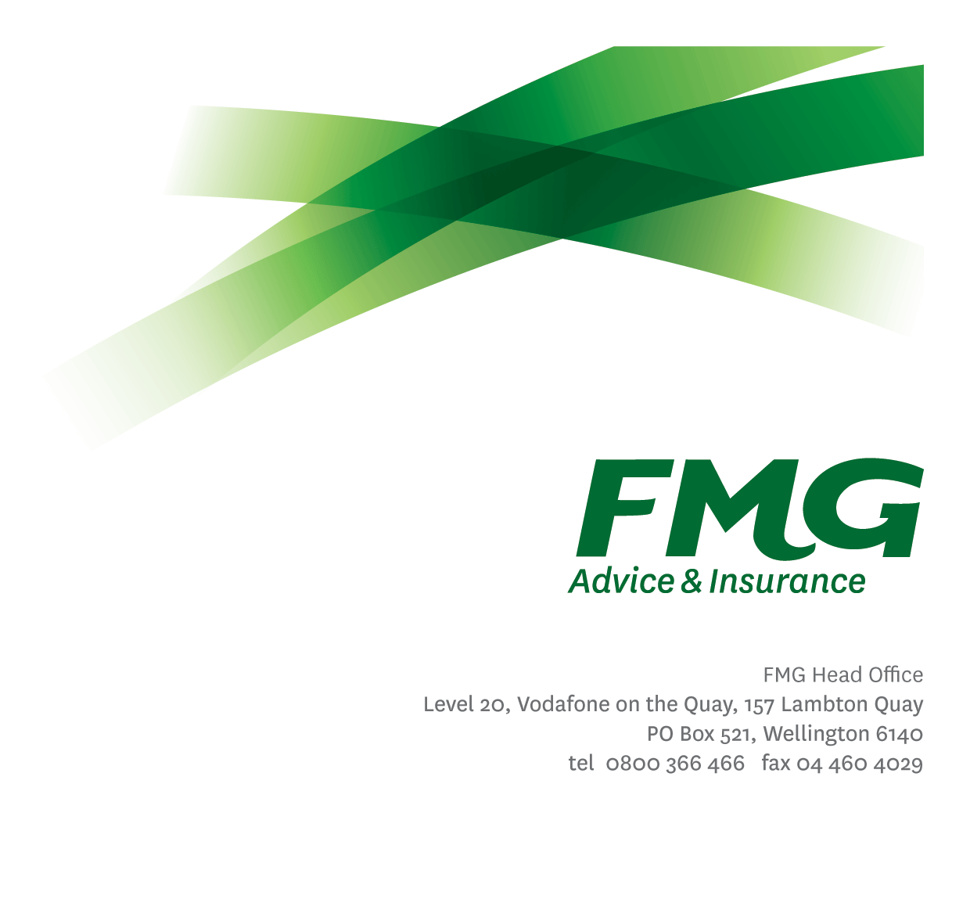
Senior Product Manager
Position Description

Location: As per personal terms
Reporting to: Head of Product
Business Unit: Product
Direct Reports: 3
Date Last Reviewed: May 2025

About FMG
Formed by farmers for farmers over a century ago, FMG is New Zealand’s leading rural insurer providing risk advice and insurance solutions for farmers, growers, commercial businesses, the lifestyle sector and domestic clients.
We’re proudly 100% New Zealand owned and operated and our focus is on helping our clients to achieve their goals. As a mutual organisation, we’re all about giving rural New Zealanders a better deal, and part of this involves reinvesting all profits back into the business to keep premiums low and ensure the future sustainability of the organisation.

FMG’s Values
The FMG brand represents promises about what clients can expect from us and each of us is responsible for delivering on these promises. Living our company values means we deliver the best brand experience for our clients. Our company values are:
- Do what's right - Whāia te ara tika | - Make it happen - Whakatutukitia
- We're in it together - Ko tātau tātau | - Proud of who we are - Whakahīhī i te whakapapa

Work Environment
We strive to provide an environment that promotes and fosters achievement. We place importance on career development and training to give our people the tools they need to succeed.
FMG’s Head Office is in Wellington and accommodates FMG’s Executive Leadership Team (ELT) and other teams including Risk, Client Strategy, People & Culture, Communications, Financial Management, Product & Pricing and Underwriting, Reinsurance and Business Information Services.
FMG’s largest regional office is in Palmerston North accommodating our National Sales & Advice Centre, Business Information Services, Claims, Operations and Payments functions. In addition to the offices in Wellington, Palmerston North and Christchurch FMG has offices in 28 regional locations throughout New Zealand.

Purpose of the role
The Senior Product Manager will lead and actively manage the performance of assigned projects, products or product discipline areas against agreed targets in relation to client outcomes, regulatory compliance, efficiency, profitability or innovation.

The role is also responsible for identifying and managing product related risks and issues and potential improvements. Leading product change initiatives ensuring that any change to policy wording is both precise and technically robust, avoiding ambiguity and providing clarity regarding the product intent. Following the Product Development and Review Framework (PDARF) in fulfilling opportunities, developing business cases; securing supply of resources from other business units; owning and driving successful outcomes and managing the delivery of product change impacts on other units including identifying and measuring success factors.

The Senior Product Manager is responsible for the day-to-day leadership, coaching and direction to the Product Specialists and in assigning their duties (including but not limited to market research, product reviews and product change actions) to assist in the delivery le of FMG’s business plan objectives.

As a Delivery Leader, you will play a critical role in the development and delivery of Business Unit plans through their accountabilities of operational excellence and the provision of exceptional service to Members and clients (both external and internal).

Key Responsibilities

Area | Responsibilities
Leadership of the Product Specialists | - Provide direction, clarity, and people leadership for the Product Specialists to drive delivery of Product related research, reviews and change initiatives.  - Ensure the development of a high-performing Product Specialists by setting and communicating high standards of performance and behaviour and coaching team members to meet or exceed agreed KRA’s  - Monitor and report individual and team performance as well as impact of team and individuals in the business.  - Provide feedback, coaching and professional development to the team to develop their skills and competencies to deliver on agreed plans.  - Drive a culture which is underpinned by individual accountability, client focus and collaboration.  - Promotes a collaborative work environment that enables engaged employees to deliver a high performance and quality service in line with FMG values.
Product Management | - Lead a continuous review of product performance across the product lifecycle to ensure fair client outcomes and optimal product performance.  - Identify and investigate areas of under-performance, develop and present improvement initiatives in response, including preparation of recommendations for the Insurance Risk Committee.  - Apply industry expertise to strategically direct product development and implement modifications to the product(s) to maximise product performance and efficiency.  - Leads liaison and instructions to stakeholders across the Mutual (including but not limited to sales, and communications , client advice and strategy, compliance, risk and legal) to direct and improve product delivery.  - Lead product team support for business units on product interpretation and product intent including technical product response support to the Client Resolution, Compliance and Risk teams.  - Provide support to the wider business on product interpretation and product intent including technical product response support to the Client Resolution, Legal, Compliance and Risk teams.  - Proactively put forward product ideas that:  - simplify products, processes and practices without compromising client outcomes or product performance  - amplify FMGs position without compromising client outcomes or product performance  - contribute to FMG products remaining innovative as well as meeting market demands and emerging risks.  - Continually build expertise in specialist areas e.g. case law, regulatory impacts or market opportunity into which assigned products can be sold  - Support the definition and implementation of a product structure that makes FMG’s products and services easily available in the marketplace  - Manage the implementation of approved product changes across the business within agreed timeframes.
Product Development | - Lead the undertaking of research into new product initiatives and developments, considering features, risks, potential market and fit with the product strategy, the FMG organization strategy and alignment with the FMG product range.  - Recommend whether FMG should pursue these product initiatives and developments.  - Lead and manage the end-to-end implementation of the development of new products or product changes.  - Lead and collaborate with the wider business on delivery of all product changes or initiatives.
Process Improvement | - Establishes, review and update agreed product guidelines  - Continuously looks for process and efficiency improvements in our approach to products, always ensuring that our approach is sales enabling, consistent and objective, and based on robust analysis.  - Identifies and assists with the updating and maintenance of policies database to ensure that up-to-date policy information and archived information is available
Relationship Management | - Take proactive steps to build excellent relationships with key stakeholders both internal and external.  - Establish regular monitoring of the performance of areas of responsibility including seeking feedback from key stakeholders  - Establishes and maintains regular meetings with other Teams across the Mutual (including but not limited to SAS Ops, Underwriting, Client Advice & Strategy) to ensure close alignment and collaboration between Product and sales and advice functions.
Collaboration and Teamwork | - Contributes to FMG through participation in operational activities including product reviews and policy wording changes to enable better portfolio performance.  - Contribute to Product team meetings and actively share knowledge, learning and insight.  - Undertaking additional duties as directed by the Head of Product.  - Role-model the FMG capability development principles; Take ownership for your personal development, seek guidance from your people leader and colleagues, seize and create opportunities in your work and identify areas that FMG should invest which will build your capability and that of others.
Risk and Quality | - Ensure assigned products and overall work is compliant with legislation, regulations and FMG policies through the use of established systems.
Wellbeing & Safety | - Comply with safety and wellbeing policy and procedures, including accident and incident reporting and hazard management requirements.  - Work in a safe manner at all times and do not undertake activities without appropriate training.
Delivery Leader | As a Delivery Leader, you will be expected too –  - Turn strategy into action – input into the development and delivery of Business Unit Plan(s), with a focus on delivering excellence in day-to-day operational management. They understand and can articulate their team’s role in the delivery.  - Make good decisions - use critical thinking and appropriate decision-making frameworks to get to the heart of the opportunity, issue and/ or risk.  - Manage priorities – deliver on a range of work priorities. They manage short and longer-term initiatives simultaneously and effectively balance planned and unplanned work priorities - which includes effectively delegating and maintaining oversight of work priorities.  - Lead change - champion change in their teams and actively create a team culture that embraces and enables change.  Enhance organisational outcomes – see organisational issues through a range of lenses and perspectives, recognising broader Mutual-wide implications and connections between issues. They lead process improvements across their team, function, systems or process to enhance outcomes and performance for clients, Members and employees.  - Enhance system-wide performance – contribute to their Leadership cohort, creating opportunities for Mutual-wide collaboration and knowledge-sharing with their peers and colleagues. They break down silos, think Mutual and system-wide and focus on aligned outcomes for FMG’s success.  - Communicate with purpose – communicate proactively, with clarity, consistency, and transparency, including when faced with ambiguity and/ or challenging circumstances.  - Build trust and influence – build strong internal and external relationships based on trust and mutual respect to positively influence and achieve through their team.  - Enhance people & team performance – build cohesive and high performing teams, creating an inclusive environment where everyone can contribute and do their best work and ensuring accountability for outcomes.  - Develop talent – coach for people success, amplifying individual and team capability and strengths, motivating them to reach their full potential.

COMPETENCIES
*see competency framework for behaviours expected at each level | Expected Level
Client Driven (Internal & External)  A commitment to understanding the needs and best interests of both internal and external clients, in order to provide them with outstanding customer service and help them to make informed decisions. | Advanced*
Accountability  Taking personal ownership of decisions, behaviour, and development, and being responsible for how these actions impact on the wider organisation and clients. | Advanced*
Adaptability  Demonstrating a willingness to engage in a changing environment and being flexible and comfortable working with change. | Advanced*
Motivation and Drive  The determination to achieve goals and strive for excellence. | Advanced*
Relationship Building  Developing and maintaining positive, professional relationships that are built on mutual trust and respect. | Advanced*
Team Work  Making a positive contribution to the FMG team and collaborating effectively with others to achieve objectives. | Advanced*
Critical Analysis  The capability to identify key issues, trends, or important facts from information and to question and probe. | Advanced*
Motivating and Developing Others  A commitment to getting the best out of people and motivating them to reach their full potential. | Intermediate*
Change Leadership  The drive to initiate opportunities to address FMG’s organisational needs and to communicate change in a way that gains buy-in and support from others. | Intermediate*
Strategic Thinking  The capacity to stand apart from the day-to-day and take a long-term, big picture view of the business. | Intermediate*

KNOWLEDGE
Qualifications | Relevant Tertiary Qualification required
Experience |  | 10+ years Financial/Insurance Industry experience  Demonstrated product delivery management experience
Business Awareness | Understands the internal workings of FMG and how business works; understands FMG's position in the advice and insurance market and knows the competition.
Market Knowledge | Understands the insurance industry. Maintains an active knowledge of competitors’ products benefits, features and pricing.
Rural Knowledge | Understands the rural community and keep up to date with the economic, political, and environmental issues affecting our customers.
Product Knowledge | Is knowledgeable about FMG's insurance policies and packages, the differences between them, and the appropriateness of each in different situations.
Risk/Insurance Knowledge | Understands risk and how to apply FMG's policies to situations; is knowledgeable about compliance requirements; understands the insurance process and how claims are managed; knows industry partners and competitors.
Specialist Knowledge | Understands the roles of underwriting, sales, claims etc and is able to use their viewpoint in analysing product performance

SKILLS
Written Communication Skills | Able to write clear, concise and persuasive proposals and reports.
Verbal Communications Skills | Communicates clearly in order to present information to persuade and influence others.
Listening Skills | Demonstrates active listening skills through eye contact, paraphrasing, appropriate body language and checking understanding.
Technology Skills | Can expertly use relevant software and technology to its full capacity e.g. MS Word, Excel and PowerPoint.
Project Management & Change Management Skills | Can autonomously drive and manage projects to deliver agreed outcomes across the business within agreed timeframes.

Relationships
External | Internal | Committees/Groups
Nil | - Pricing  - Client Strategy and Advice Services  - Compliance  - Legal, Compliance & Risk Quality  - Underwriting  - Reinsurance  - Claims  - Sales  - Training  - Marketing  - Business Information Systems (BIS)  - Online Services | - Operational Risk and Compliance Committee  - Insurance Risk Committee  - Executive Leadership Team

Financial Authority Levels
- No authority to approve or commit expenditure

Human Resources Authority Levels
- May hire direct and indirect reports within approved FTE headcounts.
- May discipline direct and indirect reports in consultation with manager and Human Resources.
- No authority to dismiss staff, unless delegated by the Chief Executive and in consultation with manager and Human Resources.

Agreement

I agree to the outline of the role as contained in this document and recognise that the contents may need to be amended from time to time to reflect changing business requirements.
I as Job holder, allow my Manager to gather information from third parties where necessary for the purposes of performance management.

Senior Product Manager Name:
Signature:
Date:

